Motor Test Report
Motor No: 06
Generated: 2026-08-20 11:26:19

NO LOAD TEST
Stat | VOLTAGE1 | VOLTAGE2 | CURRENT | RPM | TORQUE | BODY_TEMP | COIL_TEMP | COMM_TEMP | FRONT_BEARING_TEMP | REAR_BEARING_TEMP
min | 31.93 | 3.8 | 1.08 | 660.0 | 0.0 | 0.0 | 0.0 | 0.0 | 0.0 | 0.0
max | 32.12 | 6.08 | 1.31 | 3300.0 | 0.0 | 0.0 | 0.0 | 0.0 | 0.0 | 0.0
mean | 31.97 | 5.51 | 1.1 | 3014.36 | 0.0 | 0.0 | 0.0 | 0.0 | 0.0 | 0.0
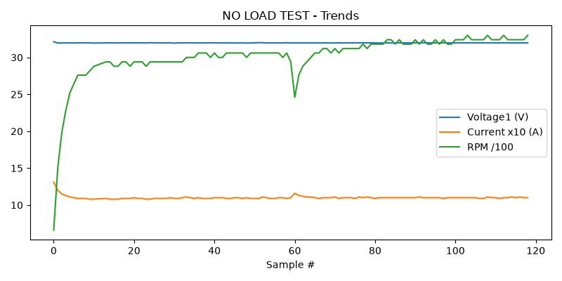

HIGH SPEED TEST REPORT
Stat | VOLTAGE1 | VOLTAGE2 | CURRENT | RPM | TORQUE | BODY_TEMP | COIL_TEMP | COMM_TEMP | FRONT_BEARING_TEMP | REAR_BEARING_TEMP
min | 31.93 | 4.92 | 1.08 | 3240.0 | 0.0 | 0.0 | 0.0 | 0.0 | 0.0 | 0.0
max | 31.99 | 6.41 | 1.11 | 3480.0 | 0.0 | 0.0 | 0.0 | 0.0 | 0.0 | 0.0
mean | 31.97 | 5.64 | 1.1 | 3376.0 | 0.0 | 0.0 | 0.0 | 0.0 | 0.0 | 0.0
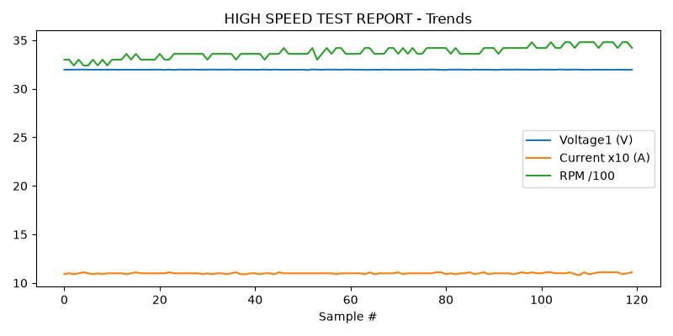

PERFORMANCE TEST
Could not read this sheet: Length mismatch: Expected axis has 0 elements, new values have 11 elements

HEAT RUN TEST
Stat | VOLTAGE1 | VOLTAGE2 | CURRENT | RPM | TORQUE | BODY_TEMP | COIL_TEMP | COMM_TEMP | FRONT_BEARING_TEMP | REAR_BEARING_TEMP
min | 31.97 | 5.02 | 1.09 | 3480.0 | 0.0 | 0.0 | 0.0 | 0.0 | 0.0 | 0.0
max | 31.97 | 5.18 | 1.1 | 3480.0 | 0.0 | 0.0 | 0.0 | 0.0 | 0.0 | 0.0
mean | 31.97 | 5.1 | 1.1 | 3480.0 | 0.0 | 0.0 | 0.0 | 0.0 | 0.0 | 0.0
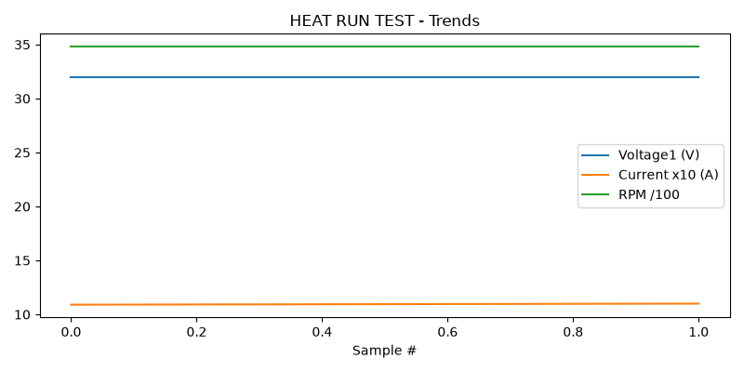

STAGE 5
Could not read this sheet: Worksheet named 'STAGE 5' not found

