Motor Test Report
Motor No: 10
Generated: 2026-08-20 14:33:56

NO LOAD TEST [FAIL]
Evaluation Remark: Voltage avg (31.95V) out of spec [27.0-27.0V]; RPM avg (4295) out of range [12740-13260]
Stat | VOLTAGE1 | VOLTAGE2 | CURRENT | RPM | TORQUE | BODY_TEMP | COIL_TEMP | COMM_TEMP | FRONT_BEARING_TEMP | REAR_BEARING_TEMP
min | 31.78 | 0.4 | 0.63 | 0.0 | 0.0 | 0.0 | 0.0 | 0.0 | 0.0 | 0.0
max | 32.11 | 15.87 | 2.53 | 10560.0 | 0.0 | 0.0 | 0.0 | 0.0 | 0.0 | 0.0
mean | 31.95 | 7.22 | 1.3 | 4295.45 | 0.0 | 0.0 | 0.0 | 0.0 | 0.0 | 0.0
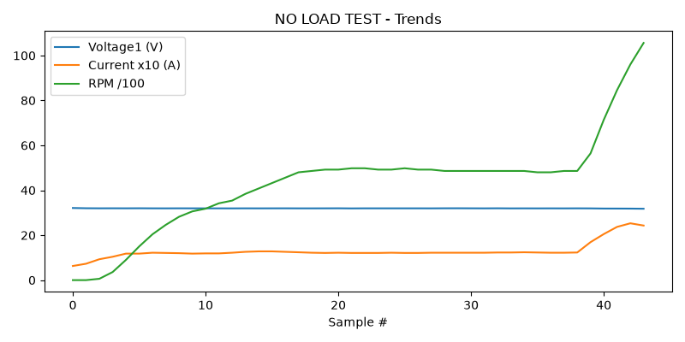

HIGH SPEED TEST REPORT [FAIL]
Evaluation Remark: Voltage avg (31.82V) out of spec [27.0-27.0V]; RPM avg (14501) out of range [8820-9180]
Stat | VOLTAGE1 | VOLTAGE2 | CURRENT | RPM | TORQUE | BODY_TEMP | COIL_TEMP | COMM_TEMP | FRONT_BEARING_TEMP | REAR_BEARING_TEMP
min | 31.63 | 8.5 | 0.95 | 7320.0 | 0.0 | 0.0 | 0.0 | 0.0 | 0.0 | 0.0
max | 31.97 | 27.12 | 4.33 | 17820.0 | 0.0 | 0.0 | 0.0 | 0.0 | 0.0 | 0.0
mean | 31.82 | 20.91 | 2.62 | 14501.25 | 0.0 | 0.0 | 0.0 | 0.0 | 0.0 | 0.0
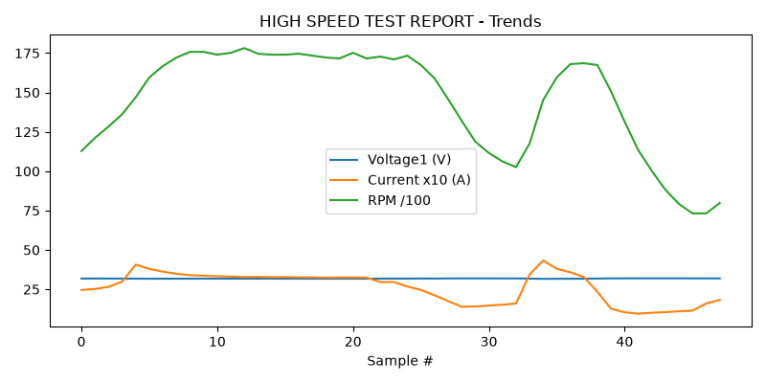

PERFORMANCE TEST [FAIL]
Evaluation Remark: Voltage avg (31.92V) out of spec [26.0-28.0V]; RPM avg (6746) out of range [7400-8200]
Stat | VOLTAGE1 | VOLTAGE2 | CURRENT | RPM | TORQUE | BODY_TEMP | COIL_TEMP | COMM_TEMP | FRONT_BEARING_TEMP | REAR_BEARING_TEMP
min | 31.72 | 1.14 | 0.59 | 960.0 | 0.0 | 0.0 | 0.0 | 0.0 | 0.0 | 0.0
max | 32.01 | 23.88 | 3.32 | 15240.0 | 0.0 | 0.0 | 0.0 | 0.0 | 0.0 | 0.0
mean | 31.92 | 9.39 | 1.5 | 6745.71 | 0.0 | 0.0 | 0.0 | 0.0 | 0.0 | 0.0
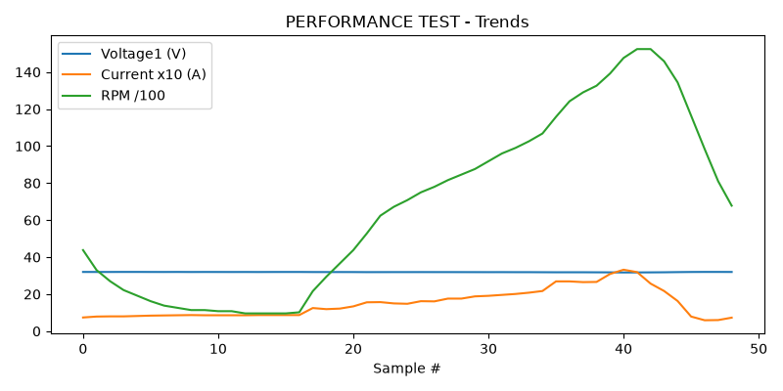

HEAT RUN TEST [FAIL]
Evaluation Remark: Voltage avg (31.92V) out of spec [26.0-28.0V]; RPM avg (7620) out of range [8820-9180]
Stat | VOLTAGE1 | VOLTAGE2 | CURRENT | RPM | TORQUE | BODY_TEMP | COIL_TEMP | COMM_TEMP | FRONT_BEARING_TEMP | REAR_BEARING_TEMP
min | 31.64 | 0.0 | 0.59 | 0.0 | 0.0 | 0.0 | 0.0 | 0.0 | 0.0 | 0.0
max | 32.02 | 26.94 | 4.26 | 14880.0 | 0.0 | 0.0 | 0.0 | 0.0 | 0.0 | 0.0
mean | 31.92 | 9.19 | 1.52 | 7620.0 | 0.0 | 0.0 | 0.0 | 0.0 | 0.0 | 0.0
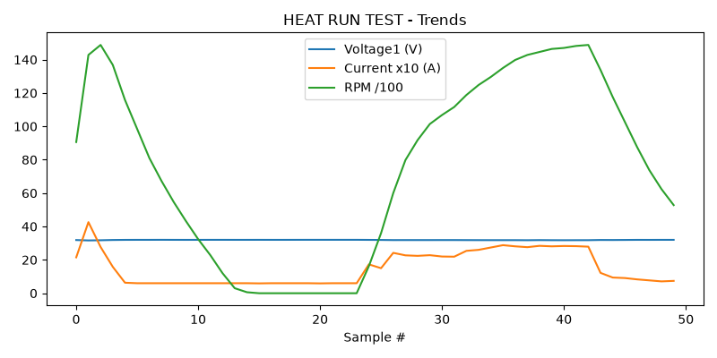

ENDURANCE TEST [FAIL]
Evaluation Remark: Voltage avg (31.98V) out of spec [27.0-27.0V]; RPM avg (2640) out of range [7400-8200]
Stat | VOLTAGE1 | VOLTAGE2 | CURRENT | RPM | TORQUE | BODY_TEMP | COIL_TEMP | COMM_TEMP | FRONT_BEARING_TEMP | REAR_BEARING_TEMP
min | 31.92 | 2.46 | 0.74 | 1020.0 | 0.0 | 0.0 | 0.0 | 0.0 | 0.0 | 0.0
max | 32.02 | 8.19 | 1.58 | 5700.0 | 0.0 | 0.0 | 0.0 | 0.0 | 0.0 | 0.0
mean | 31.98 | 3.92 | 0.94 | 2640.0 | 0.0 | 0.0 | 0.0 | 0.0 | 0.0 | 0.0
