1. Double click the NFB-GUI.exe.

1. Click the “scan button”, it will detect and find the available com port.

1. Click the “open button”, it will connect to the selected com port.

1. Click the “close button”, it will disconnect from the selected com port.

1. Tick “receive checkbox” to allow the message received from selected com port and display the message in the “receive textbox”.

Receive textbox

1. Click the “clear button” to clear the message in the “receive textbox”.

Receive textbox

1. If want to edit the t1, t2, T1, T2, puff no, and puff target, can edit the parameters in the text setting. Then click the “send button” to send the all the setting to the board.

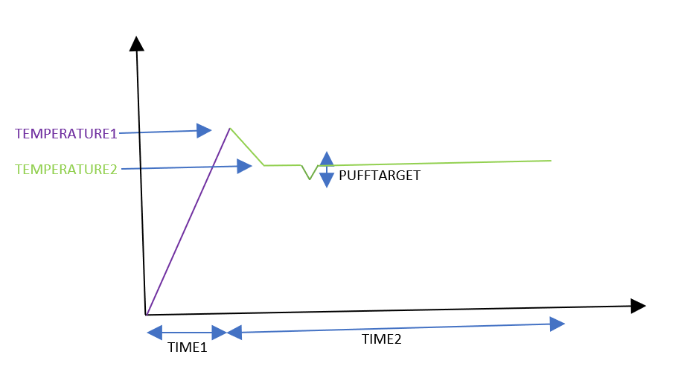

If temperature difference value is more

than puff target, puff number+1.

1. Click the “show checkbox” to enable the graph and data display.

1. Click the “clear button” to clear the graph and data display.

1. 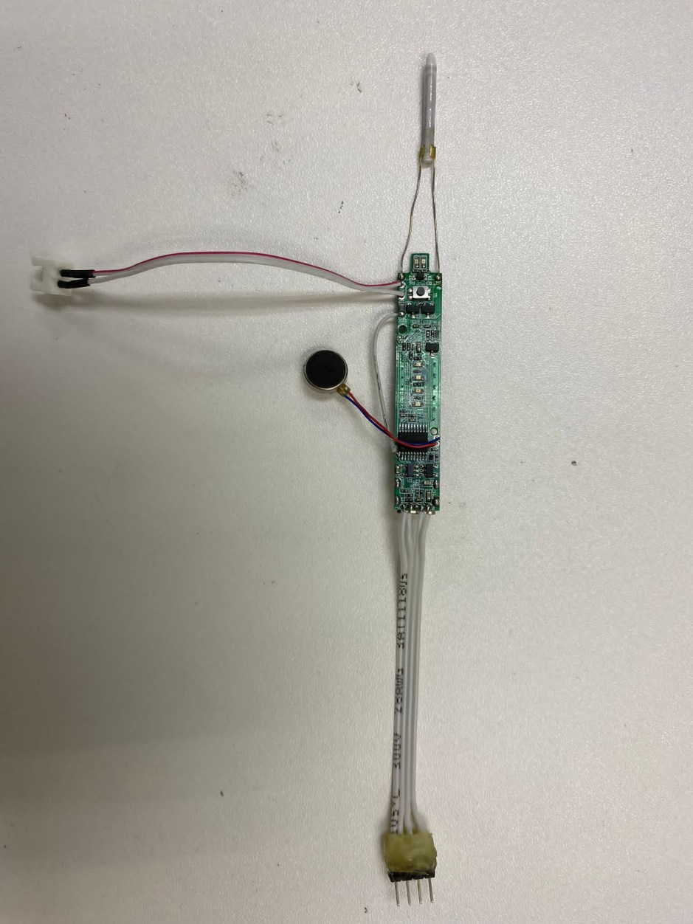Long press (1.5second) the power button to switch on the program. Long press again the power button will switch off the program.

Battery Level LED

UART Connector

Vibrator

+ -

Battery Holder

Power LED

Power Button

Heater Pin

1 GND

2 5V

3 RX

4 TX

1. After program start, the power LED will light on, battery level LEDs will light on, and vibrator will vibrate.
2. Then will start heating up the heater pin. The power LED will start blinking (1second).
3. If the time reach time1 or the temperature reach the temperature1, the heating process will off, power LED will keep light on, battery level LEDs will light off, and vibrator will vibrate.
4. After that, program will decrease the temperature until reach the tempearature2 and then remain the temperature.
5. If the temperature difference value is more the puff target, then it will consider one puff.
6. If puff no. reaches the puff number or the time reach the time2, then the program will stop.

**Default setting:**

Time1:22

Time2:310

Temperature1:320

Temperature2:295

PuffNumber:15

PuffTarget:5