**User Manual**

1. Double click the NFB-GUI.exe.

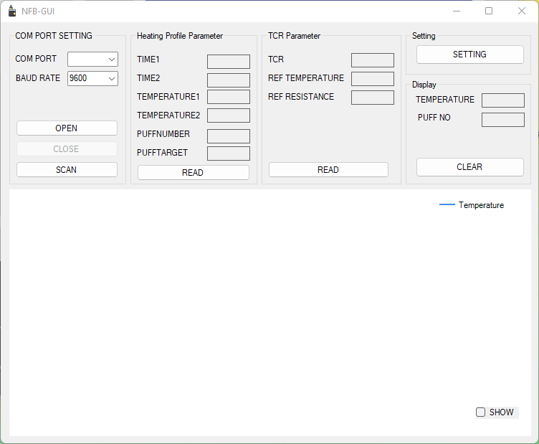

1. Click the “scan button”, it will detect and find the available com port.

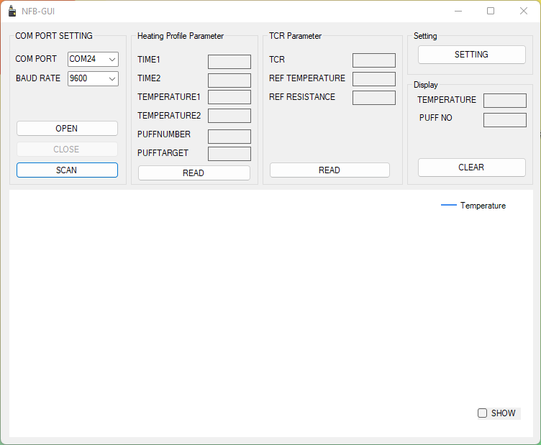

1. Click the “open button”, it will connect to the selected com port.

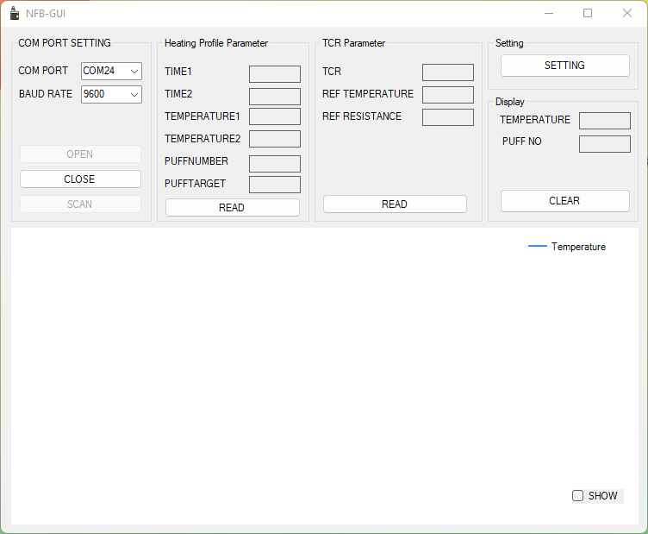

1. Click the “close button”, it will disconnect from the selected com port.

1. Click the “READ” button which under heating profile parameter group box, it will read and show the time1, time2, Temperature1, Temperature2, puff number, and puff target in each text box.

1. Click the “READ” button which under TCR parameter group box, it will read and show the TCR, Ref Temperature, and Ref Resistance in each text box.

1. Click the “SETTING” button under setting group box, it will allow the user to edit the parameters. A setting window will pop up. Graphical user interface, application

   Description automatically generated

If temperature difference value is more

than puff target, puff number+1.

1. For modified the heating profile parameters, user can fill in the wanted value to the numeric text box under the heating profile parameter group box (Setting Window). Then click the “SEND” button. User should be able to notice that the value changed in the text box under the heating profile parameter group box (NFB-GUI Window).

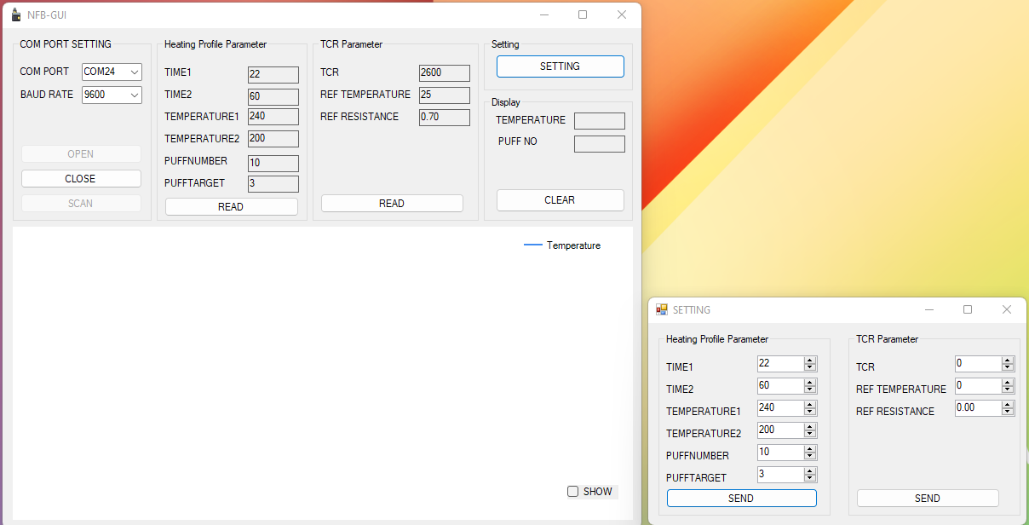

1. For modified the TCR parameters, user can fill in the wanted value to the numeric text box under the TCR parameter group box (Setting Window). Then click the “SEND” button. User should be able to notice that the value changed in the text box under the TCR parameter group box (NFB-GUI Window).

1. 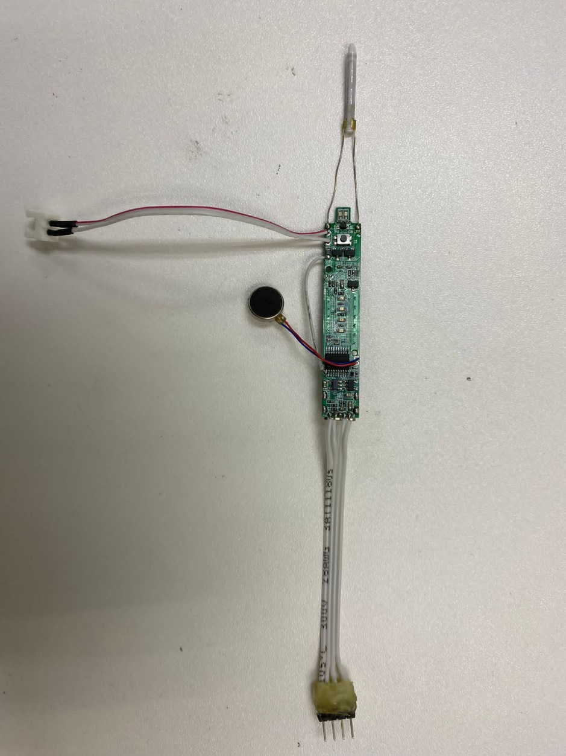Long press (1.5second) the power button to switch on the program. Long press again the power button will switch off the program.

Battery Level LED

UART Connector

Vibrator

+ -

Battery Holder

Power LED

Power Button

Heater Pin

1 GND

2 5V

3 RX

4 TX

1. After program start, the power LED will light on and vibrator will vibrate. Battery level LEDs will light on for a while.
2. Then will start heating up the heater pin. The power LED will start blinking (1second).
3. If the time reach time1 or the temperature reach the temperature1, the heating process will off, power LED will keep light on, and vibrator will vibrate.
4. After that, program will decrease the temperature until reach the tempearature2 and then remain the temperature.
5. If the temperature difference value is more the puff target, then it will consider one puff.
6. If puff no. reaches the puff number or the time reach the time2, then the program will stop.
7. Short press the power button will trigger battery level checking. Battery level LEDs will light on based on the battery voltage level.

