# Graphing with Excel

**Plotting Single Data Sets**

# *The skill was of plotting data - sometimes more than one set – is valuable in science. A plotted data set is an easy way to notice and/or demonstrate relationships between variables. For example, as a Grade 9 student, the skill of graphing is used for such things as determining density for confirming Ohm’s law.*

**Step 1: Data Entry in Excel**

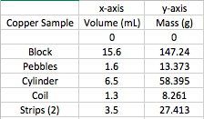

* Appropriately title the needed columns; include units enclosed in brackets.
* Enter the measured data in the appropriate columns.

**NOTE:**

Since 0 g of copper fills 0 mL of space, it is appropriate to include the data point (0mL, 0g).

**Step 2:** Create a Scatterplot of the Initial Data Set

* Highlight the two columns of data. **NOTE:** Do *not* grab the column titles, just the numbers.

* Select *Insert*. Then next to *Recommended Charts*, choose the scatterplot, and finally choose *Scatter*

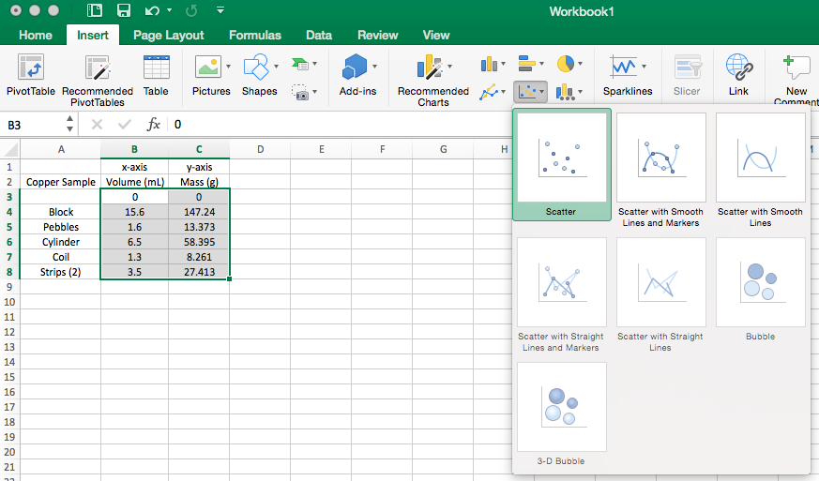

* 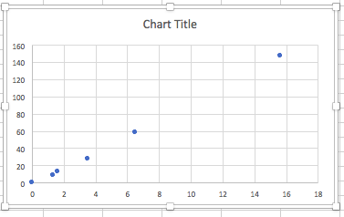Now you should have a scatterplot like this:
* Expand/Stretch your scatterplot as you see appropriate, by selecting the graph (click anywhere on it), and moving your cursor to hover over one of the corners, or a midpoint along one of the edges; an arrow appears; click and drag.

**Step 3: Edit**

* When your scatterplot is selected (click anywhere on it), the menu bar adjusts to include *Chart Design* and *Format*:

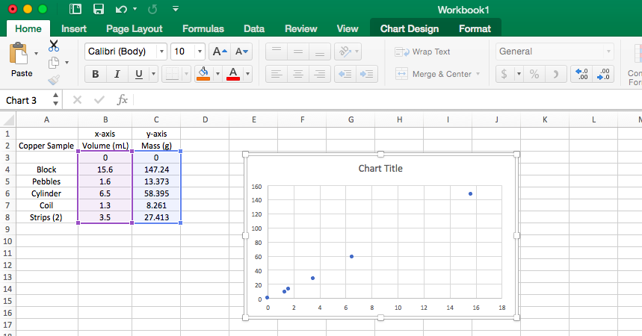

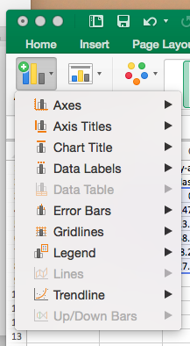

* Select *Chart Design*, then select the drop-down menu for *Add Chart Element*. Many helpful options appear:
* Select *Axis Titles* to insert/adjust both *Primary Horizontal* and *Primary Vertical* axes titles. **NOTE**: Include units (enclosed in brackets)
* Select *Chart Title* to insert/adjust title *Above Chart*
* Select *Gridlines* to insert *Primary Minor* and *Primary Major* gridlines both vertically and horizontally
* Select *Trendline* to insert a *Linear* trendline for each data set
* Example final graph:

**Step 4: Create a Word Document for Printing & Submission**

* Take a selection capture of your data table, including descriptive column and/or row headers (simultaneously hold command – shift – 4; cross hatch lines appear; use them to select your table; the selection appears on your desktop)
* Take a selection capture of your graph, including descriptive title and axes labels (simultaneously hold command – shift – 4; cross hatch lines appear; use them to select your graph; the selection appears on your desktop)
* Open Word. Drag your selection captures from your desktop into the Word document. Format/centre/adjust as you see fit.
* Insert a header including your name, lab partner’s name(s), course code, investigation title
* Print your Word document
* Complete any further analysis as required before submission