PlantGrowth One-Way ANOVA Report
Authors: Clores & Espiritu

1. Introduction
In this report, we analyze the PlantGrowth dataset from the {datasets} package in R to determine whether mean dried plant weight differs significantly across three treatment groups (ctrl, trt1, trt2). A one-way ANOVA was performed to test whether the treatment has an effect on plant weight.

2. Checking of Assumptions
Assumption #1 – Continuous Dependent Variable
The dependent variable (weight) is measured on a continuous scale.
Assumption #2 – Categorical Independent Variable
The independent variable (group) has three categorical, independent levels: ctrl, trt1, and trt2.
Assumption #3 – Independence of Observations
Each plant belongs to only one treatment group; measurements are independent.
Assumption #4 – Outliers
A boxplot was inspected to identify outliers.
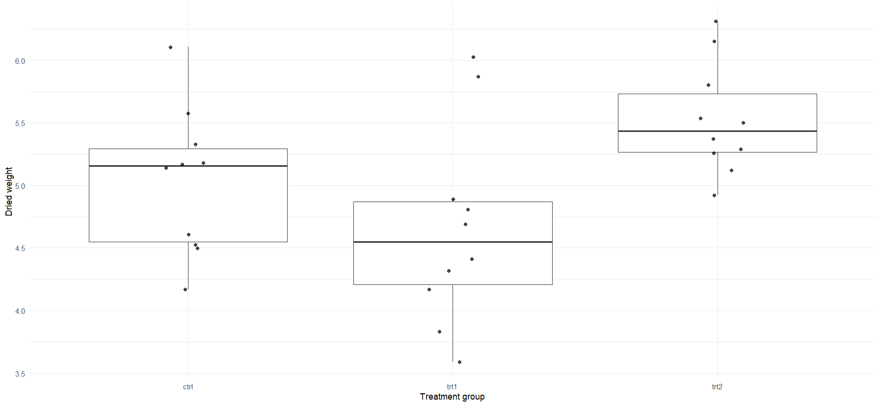
Assumption #5 – Normality
Shapiro–Wilk tests for each group showed p > .05, indicating normality.
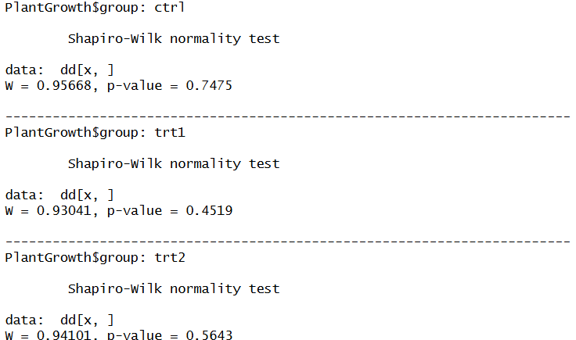
Assumption #6 – Homogeneity of Variances
Levene’s test indicated that variances are equal across groups.
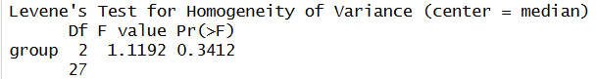
3. Descriptive Statistics
Below are the descriptive statistics for each treatment group:
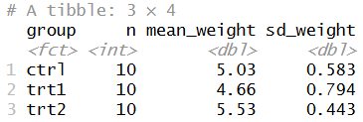
4. ANOVA Results
The one-way ANOVA was performed in R using:
aov(weight ~ group, data = PlantGrowth)
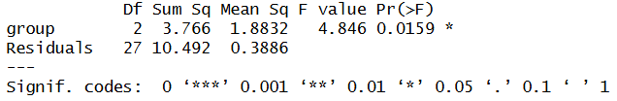
5. Post Hoc Tests (Tukey HSD)
Tukey’s HSD test was used to compare all pairs of group means.
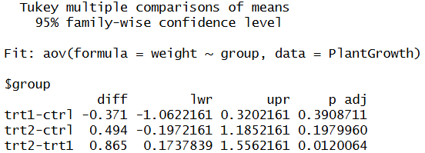
6. Effect Size
The effect size (eta squared) was computed to evaluate the magnitude of the group effect.
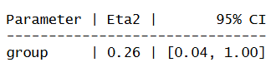
7. APA-Style Reporting
A one-way ANOVA was conducted to compare plant weight across the three treatment conditions. There were no serious outliers, normality and homogeneity assumptions were met. Plant weight differed significantly between treatment groups, F(2, 27) = 4.85, p = .016, η² = .26. Tukey post hoc tests showed that treatment 2 produced significantly higher plant weights than treatment 1 (p = .012). Differences involving the control group were not statistically significant.

