**1. Introduction**

Social networking has been the 21st century’s new tool for socializing. People are almost used to with this type of communication system that it is easier for people to find them in social network rather than in real life. Social network is popular in every field not because it is effective means to communicate between people but also to share the knowledge between them. This case can be explained with possibly in the scenario like university, offices, school.

In the proposed system, it is planned to develop the social network for the developers/programmers. The project focuses on mainly on things such as sharing the user content through the posts known as blogs, asking and getting the support for the problems form the forum section.

**2. Problem Statement**

In today’s context, there is group divided into two sections that either have online presence or wish to seem totally ghost. It is because people are searching from site to site for the information they need. For eg, One have to use a platform for posting his experience using site A, while for asking for some help he has to go through site B. Sites like medium.com, stackoverflow.com would provide these type of service but often provide specialized services only. This would make people very annoying because many people believe that even though being addicted to social network, it is waste of time to spend on too many social networks. Countries like ours have even worse problem scenario because the developers and the programmers who are city apart are unable to recognize the group of similar interest without actual being connected. With the idea of this in our mind the project to develop the Codersanjal was born.

**3. Literature Review**

There are some sites that exist providing similar features as of codersanjal. Some of them are explained are as follow:

3.1 medium.com

Medium.com offers the user to post the lengthy post on the user experience[]. Currently it offers this type of service to general user. Similar to the medium, codersanjal provides user the capacity to share their stories.

3.2 Stack overflow

Stack overflow offers the complete forum alike site for the developers and the general people on various topics. User can follow such topics and problems in the field of computer programming[].

**3. Objective**

The following are the objectives of the proposed social network:

* To make a platform for sharing the developer’s stories
* To help user find the appropriate community
* To get and provide support to themselves and other users.

**4. Scope and Limitation**

The proposed system is intended to unite the programmers and developers to the common platform for the sharing the knowledge and idea. Also the user would be able to get and offer support other developer. Currently there is no user online viewing system. Users are also unable to share posts within the social network.

**6. Methodology**

The methodology that is going to be followed for the project development, documentation and testing process is going to be the Software Development Life Cycle with Test Driven process.

**6.1 Requirement Identification**

User will need to have the internet access and the browser. Since it is web app, the user will need just them in order to access the network and use.

**6.2 Feasibility Study**

**6.2.1 Technical**

The web app will have responsive design. In the development perspective, the tools and frameworks are easily usable.

**6.2.2 Operational**

The user needs an active internet connection and the browser to have complete access to the social network.

**6.2.3** **Economical**

The social network is completely free to sign up/login beside the cost of accessing which depends on the user device.

**6.3 Tools**

**6.3.1** **Front-End**

As it is a web-based application, the front-end of the application is going to implemented using HTML, CSS, JavaScript and Bootstrap.

**6.3.2** **Back-End**

The server side programming language of the application is Ruby and MySQL as database. The Ruby programming language is rich in various libraries that can be used within the application.

**6.3.3** **Editor**

Any editor supporting Rails framework can be used. Mainly we will be using Emacs and Atom throughout the process.

**7. Design of Proposed System**

**7.1 System Context diagram**

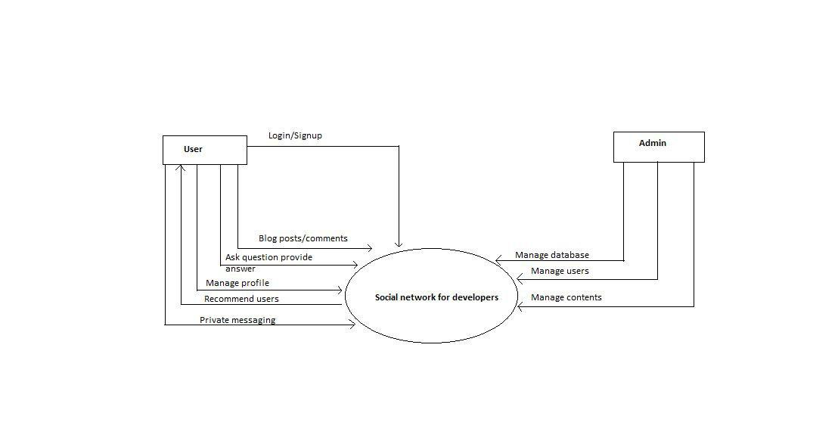

Figure 1: System Context Diagram

The system context diagram of the proposed system is as above. User can basically have the login/signup, blog and question posting while managing the profile and making some private messaging features. Also the system recommends the user based on the interest. On the other side the admin can have the role of managing the database, user as well as contents.

**7.2** **System Activity Diagram**

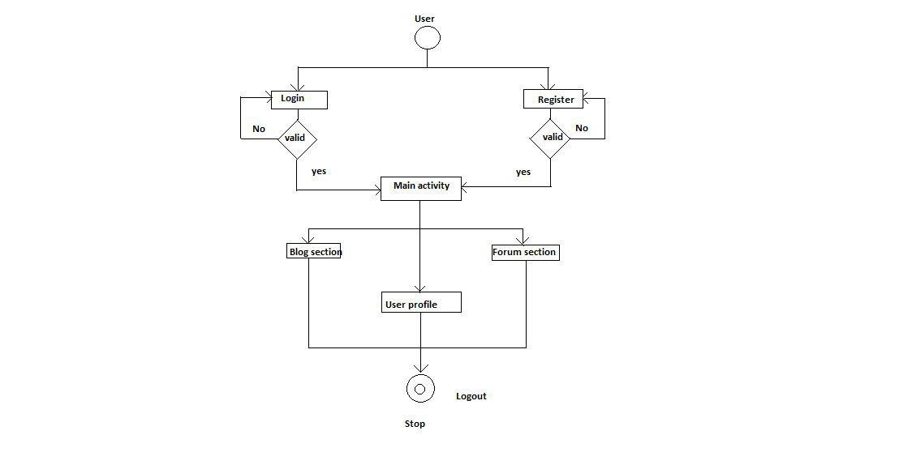

Figure 2: Activity Diagram of the proposed system

The activity diagram mainly focuses on the user perspective. User those who have registered directly can login and go to the main activity section which enables them to go to sections like blog section, user profile and forum section. Unregistered user need to register at first.

**7.3** **Use-CASE diagram**

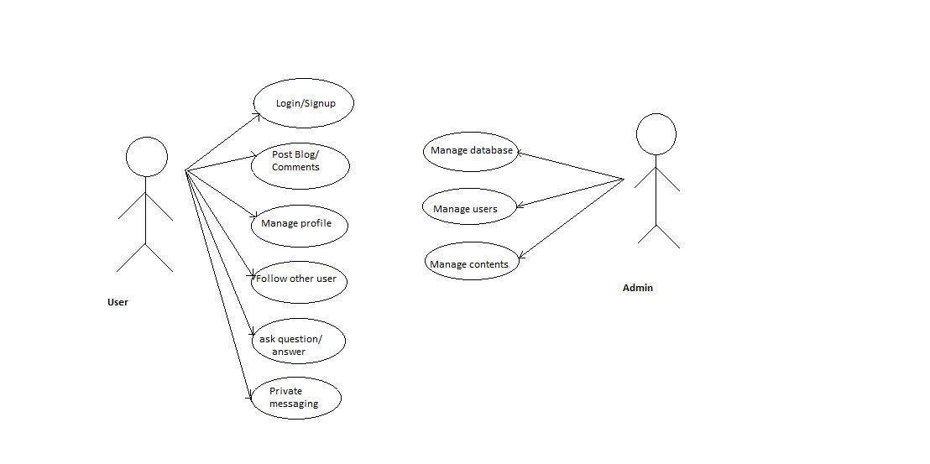

Figure 3: Use Case diagram

Use Case diagram focuses on the user and admin with user having features like login/signup., blog managing and the profile managing as well as the forum feature. Admin can have the major three roles of managing the database, users and the contents

**8. Gantt chart**

Table 1: Gantt chart for proposed system timeline

|  |  |  |  |  |  |  |  |  |  |  |  |  |  |  |  |  |
| --- | --- | --- | --- | --- | --- | --- | --- | --- | --- | --- | --- | --- | --- | --- | --- | --- |
| Work/Week | 1 | 2 | 3 | 4 | 5 | 6 | 7 | 8 | 9 | 10 | 11 | 12 | 13 | 14 | 15 | 16 |
| System Analysis and Design |  |  |  |  |  |  |  |  |  |  |  |  |  |  |  |  |
| Coding and Database |  |  |  |  |  |  |  |  |  |  |  |  |  |  |  |  |
| Testing |  |  |  |  |  |  |  |  |  |  |  |  |  |  |  |  |
| Documentation |  |  |  |  |  |  |  |  |  |  |  |  |  |  |  |  |

**9. Implementation**

The social network is written in Ruby programming language using the Rails framework.The framework is a Model View Controller framework. MySQL is the primary database for storing data and we also used Redis to perform job queue operations. Some of the models we have used has the following code:

**Tasks accomplished:**

1. **Blog stories and commenting system**
2. **User login/signup/validation**
3. **User search**
4. **Private messaging feature**
5. **Forum QnA basic**

**To be done**

1. **Web responsive design**
2. **Profile Buildup**
3. **User and Post recommendation’**
4. **Question Recommendation**

**9.1 Models**

**User model:**

class User < ApplicationRecord

# Include default devise modules. Others available are:

# :confirmable, :lockable, :timeoutable and :omniauthable

devise :database_authenticatable, :registerable,

:recoverable, :rememberable, :trackable, :validatable, :confirmable

has_many :posts, dependent: :destroy

has_many :comments,dependent: :destroy

has_many :questions,dependent: :destroy

has_many :answers,dependent: :destroy

acts_as_voter

has_many :authored_conversations, class_name: 'Conversation', foreign_key: 'author_id'

has_many :received_conversations, class_name: 'Conversation', foreign_key: 'receiver_id'

has_many :personal_messages, dependent: :destroy

def self.search(search)

if search

where(["email LIKE ?","%#{search}%"])

else

all

end

end

end

**Post model:**

class Post < ActiveRecord::Base

validates :title,:body, presence: true

belongs_to :user

delegate :email, to: :user

has_many :comments,dependent: :destroy

acts_as_votable

end

**Comment model:**

class Comment < ApplicationRecord

belongs_to :user

validates :body, presence: true

end

**conversation model:**

class Conversation < ApplicationRecord

belongs_to :author, class_name: 'User'

belongs_to :receiver, class_name: 'User'

validates :author, uniqueness: {scope: :receiver}

has_many :personal_messages, -> { order(created_at: :asc)}, dependent: :destroy

scope :participating, -> (user) do where("(conversations.author_id = ? OR conversations.receiver_id = ?)", user.id, user.id)

end

def with(current_user)

author == current_user ? receiver: author

end

def participates?(user)

author == user || receiver == user

end

scope :between, -> (sender_id,receiver_id) do where(author_id: sender_id,receiver_id: receiver_id).or(where(author_id: receiver_id,receiver_id: sender_id))

end

end

**personal_message:**

class PersonalMessage < ApplicationRecord

belongs_to :conversation

belongs_to :user

validates :body, presence: true

end

**Question model:**

class Question < ApplicationRecord

has_many :answers

belongs_to :user

end

**Answer model:**

class Answer < ApplicationRecord

belongs_to :post

belongs_to :user

end

[3]

**10. Expected Outcome**

The system in current is expected to be a complete platform for the developers for sharing the user stories and forum for asking the question and answers. Currently the scope of the project will be the web app for social networking.

**11. References**

[1] Andale, (2017-06-12), Jaccard Index / Similarity Coefficient, Available http://www.statisticshowto.com/jaccard-index/

[2] Wikipedia, ( 2017-06-12), Jaccardian Index ( Online) , Available: <https://en.wikipedia.org/wiki/Jaccard_index>

[3] Marcel Caraciolo, (2017-06-12), Recommender Systems with Ruby (Online), Available: http://www.slideshare.net/marcelcaraciolo/recommender-systems-with- ruby-adding-machine-learning-statistics-etc