**Table of Contents**

1.INTRODUCTION4

1.1Background4

2.PROBLEM STATEMENT4

3.OBJECTIVE5

4.SCOPE AND LIMITATION OF PROJECT5

4.1 Scope……………………………………………………………………………………………………………………………………………………

4.2 Limitation…………………………………………………………………………………………………………………………………….

5.REQUIREMENT ANALYSIS AND FEASIBILITYSTUDY5

5.1Requirement Analysis……………………………………………………………………………….......…5

5.1.1Functional Requirements……………………………………………………………........5

5.1.2Non Functional Requirements…………..………………………………………………………5

5.1.3User Interface Requirements…..………………………………………………………………..6

5.2Feasibility study……………………………………………………………………………………............6

5.2.1Technical Feasibility...…………………………………………………………………………..6

5.2.2Economic Feasibility…………...……………………………………………………………….6

5.2.3Social Feasibility……………………………........……………………………………………...6

5.2.4Operational Feasibility…………………………………………………………………………..6

6.SYSTEM DESIGN……………………...…………………………………………………………………………7

6.1Data Flow Diagram……………………………………………………………...........................................7

6.2Use Case Diagram………………………………………………………………………………….......…..7

6.2.1Login/SignUp………………………,,,,,,……………………………………...........…………..8

6.2.2Profile page………………………………………………………...............................................9

6.2.3Search User Page………………………………………….…………………………………….9

6.2.4Friend List Page……………………………………………………...……………………..….10

6.3Sequence Diagram………………………………………...……………………………………………….9

6.3.1SignUp Sequence……………………………………………………………………………...10

6.3.2Login Sequence………….…………………………………………………………………….11

6.3.3Friend Request Sequence…………………………..…………………………………………..12

6.4 Database

6.4.1 Database design……………………………………………………………………………….

6.4.2 Database Management System Files…………………………………………………………

6.5 User Design…………………………………………………………………………………………….

7.IMPLEMEMTATION……………………………………………………………………………...…….13

7.1 Implementation technology used…………………………………………………………..

8. TESTING…………………………………………………………………………………………………..

8.1 Unit Testing……………………………………………………………………………………..

8.2 Integration Testing………………………………………………………………………………

8.3 System Testing…………………………………………………………………………………..

9. CONCLUSION AND FUTURE ENHANCEMENT……………………………………………….........

9.1 Conclusion………………………………………………………………………………………..

9.2 Future Enhancement………………………………………………………………………………

References

**LIST OF FIGURES**

Fig6-1: Client Screen Flow…………………....………………………………………….……………..7

Fig6-2: Login/Signup……………………...………………………………....………………………….8

Fig6-3: Profile Page…...……………………………………………..…………………..………………9

Fig6-4:Search User Page…………………………………………………………..…………...………...9

Fig6-5: Friend List Page………………………………………………………………...…………..........10

Fig6-6 : Sequence diagram for Register User…………………………………………………………….10

Fig6-7 : Sequence diagram for Login User……………..………………………………...………………11

Fig6-8: Sequence diagram for Friend Request………………………………………...………………….12

**ACKNOWLEDGEMENT**

As the provided syllabus of “Project Work” as prescribed by Tribhuvan University (T.U) for the fulfillment of semester-project, we have prepared this project named” Online Nepali Food Recipe”.

Along with our effort, there are some other people who support us for completion of this project.

We would like to express great sincere and thanks to the Department of Computer Science and Information Technology from NIST, National School of Science and Technology for providing us this golden opportunity to work and develop this project.

We wish to acknowledge our deepest gratitude to our supervisor for his insight and encouragement for our project.

We are also grateful to our teachers for their constant support and guidance.

We would also like to extend our thanks toward our friends and other for their useful help us in our project.

**ABSTRACT**

Online Nepali Food is a web-Based networking site, which is implemented in php platform. The main purpose of this site is to create the collection of variety of Nepali Food and allow the users to interact with each other. Users of this system can post their recipes on their profile as well.

This website is mainly developed to promote Nepali Food Recipes so, people who love Nepali Food and want to promote Nepali food can be the expected user of this system. Users who have internet access can access this site from anywhere and anytime. People who have interest on cooking can see and use the available recipe to try, can create their profile on website, add other friend and interact with each other to share their recipes.

We have also literature review section to read and use the available websites and resources related to Nepali Food Recipes from where we extract some background information and limitation about Nepali Food Recipes Sites. The basic goal of this section is to identify how to achieve this system and what can be the additional features that can be added on developing system to make it better than existing one. Each steps and process is clearly defined by sequence diagram, use case diagram that is designed.

1. **INTRODUCTION**

This project is about developing a website for networking among the people who are interested in Nepali Food, named as “Online Nepali Food Recipe” .Online Nepali Food Recipe is a web-based networking site that is developed to promote Nepali Food Recipes among the Nepali food lovers.

People who have internet facility can access this site anywhere and anytime because of that user don’t need to waste their time in manuals and books and time to buy it.

This project deals about promoting Nepali Food Recipe which will bring the food loving people together from separate community. Users who use this site can see the recipes on the home page. User, who want to be the part of this site can sign-in and login into the website. After login, user profile gets created. User can add other user, interact with each other through private messaging and user can post their recipe on their profile as well. Validation is done through username and password entered by the user. It will also work on major browser like- Google Chrome, Internet Explorer, and Mozilla Firefox and so on.

* 1. **Background**

Online Nepali Food Recipe is a website, which provides the facility to its users to post and access the information about Nepali Food Recipe. Online Nepali food Recipe is the Web-based networking site which can be beneficial for people interested in cooking and people who want to explore and promote Nepali Food Recipes. It provides access to the huge range of Nepali Recipes.

1. **PROBLEM STATEMENT**

In present context, some people who are interested in cooking uses manual system which is somehow time consuming and irritating in the busy schedule.

In existing system of Nepal, there is no facility of direct user interaction and content sharing in terms of food recipe site. So, to make cooking site interactive and to promote and explore Nepali recipe we are trying to develop this open system for food connoisseur.

When it comes to Nepali food recipe sites, they only provide limited recipes and does not allow people to share their ideas and connect to people with same interest as theirs. So the main reason behind this project is to build an interactive site where people can share their ideas about Nepali dish and learn some new from other.

1. **OBJECTIVE**

* To provide a user friendly platform where people can learn different recipes and share their own.
* To allow user to create their own profile and customize their profile. User can also add other user and can have private messaging too.
* To promote Nepali food and recipes around the world.
* To allow user to interact with each other, so they can share their own recipes and ideas that may lead to the new community for cooking interested people.
* To encourage people to use technical resources and to discourage manual working for finding recipe.

1. **SCOPE AND LIMITATION OF PROJECT**

**4.1 Scope**

This website is expected to be very useful for people who have interest in cooking. People having internet access and familiar with modern technology and internet usage are the expected user of this site. People interested in cooking can find this website very useful. Once the user create their profile they can customize it according to their preference. It will be open source site so, anyone that has interest in cooking and considering to learn recipes around Nepal can be the part of this site.

**4.2 Limitation**

As this site is web-based application so users requires Internet access to use this site. This site will be dedicated to food connoisseur of Nepali food so, it may not be convenient for other foreign recipes.

1. **REQUIREMENT ANALYSIS AND FEASIBILITY STUDY**
   1. **Requirement Analysis**
      1. **Functional Requirements**

- Users can search for other users

- Users can add other users

* + 1. **Non-Functional Requirements**

- Security: Software must have proper security for any imposing threats for the website.

- Cost: The cost of the website should be feasible and proper balance.

- Flexibility: The website is flexible as it is built using bootstrapping and is compatible in any tablets, mobiles and other mobile devices.

* + 1. **User Interface Requirements**

As User Interface is an important part of any software so is Surprise.

Online Nepali Food Recipe is:

- Easy to operate.

- Quick in response

* 1. **Feasibility Analysis**

Feasibility study is an assessment of the practicality of a proposed project. Feasibility study helps to know about the ‘strengths’ and ‘weakness’ of project [1]. Types of feasibility study included in our project:

-Technical Feasibility

-Economical Feasibility

-Operational Feasibility

-Legal Feasibility

-Social Feasibility [9]

* + 1. **Technical Feasibility**

Technically, the project is built using PHP as the programming language. Sublime Text is the IDE used for the development of the project. The website is built using bootstrapping technique which includes HTML5, CSS3 and also JavaScript for the front end. This can be accessed by using any modern browser (like Chrome, Mozilla, Opera, etc.). This project website is built using bootstrapping which makes the website responsive.

* + 1. **Economic Feasibility**

Economically the website is bound to do well. The cost of operation is low only the cost for server is needed. The project is expected to bring profit as there are only limited websites that can provide services like Online Nepali Food Recipe can. Economically Online Nepali Food Recipe will be stable. The system is built using existing technology and resources so, it is economically feasible

* + 1. **Social Feasibility**

Socially, the contents in the website are acceptable and does not content inappropriate content. Online Nepali Food Recipe is a web application built on purpose of connecting people so it is bound to be socially feasible.

* + 1. **Operational Feasibility**

Online Nepali Food Recipe is to rub by all the users with basic knowledge of internet access and computers. Online Nepali Food Recipe is solely purposed system to the people interested in Nepali Food Lovers and willing to share their own recipes. The operation of Online Nepali Food Recipe is simple; the customer can make their account, post their recipes, add other user and can respond to the request from other user.

1. **SYSTEM DESIGN**

A system architecture is a conceptual model that defines the structure, behavior, and more views of the system. An architecture description is a formal description and representation of a system. A system architecture can comprise system components that will work together to implement the overall system.

System Architecture is basically breaking down of system into components, hoe these components interact and technology

**6.1. Data Flow Diagrams**

Data flow diagrams model the flow of data into, through, and out of an information system:

• shows the processes that change or transform data

• shows the movement of data between processes

• represents a system as a network of processes which transform data flowing between them

The user screen flow shows what a user of the system will see. After successfully logging on, the user will be accessed to a profile page, and be able to search users, view recipe or go back to their home.

Login page login button

Profile Page

Login

Home Page

Login failed search users

Signup button

Error Page

Search Users

View recipes

Signup

Add as friend

View Recipe

Signup failed Select Users

Add as Friend

View User Information

Select recipe

Send Requests

Read Recipe

Add as Friend

Send Friend Request

Fig6-1: Client Screen Flow

**6.2 Use case diagrams**

A use case diagram is a graphic depiction of the interactions among the elements of a system. A use case is a methodology used in system analysis to identify, clarify, and organize system requirements. The diagram consists of actors (users) involved in system and relationships among the actors with the use cases.

**6.2.1 Login/Signup**

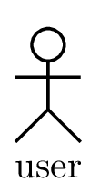 **<<**include**>>**

Fig6-2: Login/Signup

**Scope**: Online Nepali food recipe site

**Level**: User level

**Primary** **actor**: user

**Stake** **holders** **and** **interests**:

• **Customer**: Login to the website and go to the website’s homepage.

**Preconditions**: User must open the browser and enter Nepalifood.com and select signup or login menu.

**Success** **Guarantee** (**or** **Post** **conditions**): user profile.

**Main** **Success** **Scenario** (**or** **Basic** **Flow**):

1. User enters fullname, username, email, password for signing up and username and password for logging in.

2. System verifies if the given user name is available.

8. User can is now successfully registered to the system.

**Extensions** **or** **Alternative** **Flows**

1. User enters the username already taken by another User

a. System asks the User to enter another username.

b. User has unique username.

2. User enters with empty fields

**6.2.2 Profile Page**



,

Fig6-3: Profile Page

**Scope**: Online Nepali food recipe site

**Level**: User level

**Primary** **actor**: user

**Stake** **holders** **and** **interests**:

• **Customer**: Login to the website and go to the website’s homepage.

**Preconditions**: User must be logged in.

**Success** **Guarantee** (**or** **Post** **conditions**): user profile.

**Main** **Success** **Scenario** (**or** **Basic** **Flow**):

1. User can upload their profile picture.
2. User can post new recipe.
3. User can search for other users.
4. User can add and cancel request from other user and can also delete other user from friend list.

**Extensions** **or** **Alternative** **Flows**

1. User upload picture other than jpeg, png, gif and picture size greater than 50kb.
2. System ask user to upload picture with jpeg or png or gif extension with size less than 50kb.

**6.2.3 Search User Page**



Fig6-4:Search User Page

**Scope**: Online Nepali food recipe site

**Level**: User level

**Primary** **actor**: user

**Stake** **holders** **and** **interests**:

• **Customer**: Login to the website and go to the website’s homepage.

**Preconditions**: User must be logged in.

**Success** **Guarantee** (**or** **Post** **conditions**): List of searched user.

**Main** **Success** **Scenario** (**or** **Basic** **Flow**):

1. User can type the user’s name they want to search.
2. User can view the profile of searched user.
3. User can add the searched user.

**Extensions** **or** **Alternative** **Flows**

1. User type the name not in database
2. System respond with no result

#### 6.2.4 Friend List Page



Fig6-5: Friend List Page

**Scope**: Online Nepali food recipe site

**Level**: User level

**Primary** **actor**: user

**Stake** **holders** **and** **interests**:

• **Customer**: Login to the website and go to the website’s homepage.

**Preconditions**: User must be logged in.

**Success** **Guarantee** (**or** **Post** **conditions**): Friend list.

**Main** **Success** **Scenario** (**or** **Basic** **Flow**):

1. User can view the information about their friend.
2. User can delete the friend from the list.

**Extensions** **or** **Alternative** **Flows**

**6.3 Sequence Diagram**

Sequence diagram is the interaction diagram that emphasizes how objects communicate and the time ordering the messages between objects.

**6.3.1 Signup Sequence**

System

User

Sign up

Creates Profile

Display User Profile

Fig6-6 : Sequence diagram for Register User

**6.3.2 Login Sequence**

System

User

Login

Display User Profile

Fig6-7 : Sequence diagram for Login User

**6.3.3 Friend Request Sequence**

User 2

System

User 1

Search query

Responds with available users

Sent Friend Request

Gets request

Add or Cancel Request

Updates Friend Request

Gets updated friend list

Fig6-8: Sequence diagram for Friend Request

**6.4. Database**

**6.4.1 Database Design**

After the completion of the system architecture, it is time to step into the design stage. Design of database is done to show the functionality. Entities such as user can be created and deleted. Once the data are analyzed, and the relationships between the data understood, the ER model is established, and then the concept structure and logic structure of database designed. We use phpMyAdmin. phpMyAdmin is a free software tool written in PHP, intended to handle the administration of MYSQL over the web. phpMyAdmin supports a wide range of operations on MYSQL. Frequently used operations (managing databases, tables, columns, relations, indexes, users, permissions, etc.) can be performed via user interface, while you still have the ability to directly execute any SQL. Its graphical user interface allows intuitive and simple system and database, provide support for most MYSQL features, allow to import data from SQL, export data to various format, and it was used for storage management and maintenance in this project.

**6.4.2 Database Management System Files**

This topic reveals the final design of the DBMS files that includes the entities involved in the system and their relationship. This step is the key to database design.

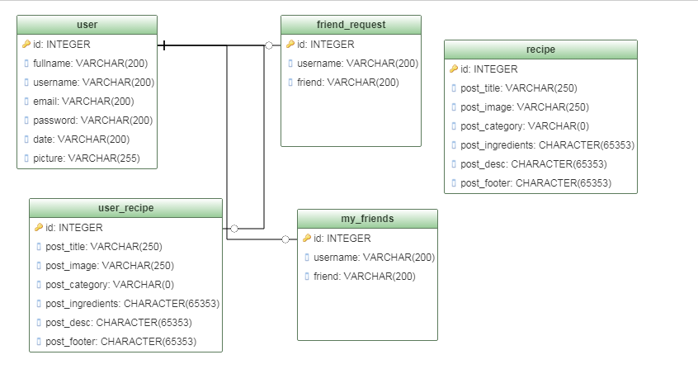

**6.5 User Design**

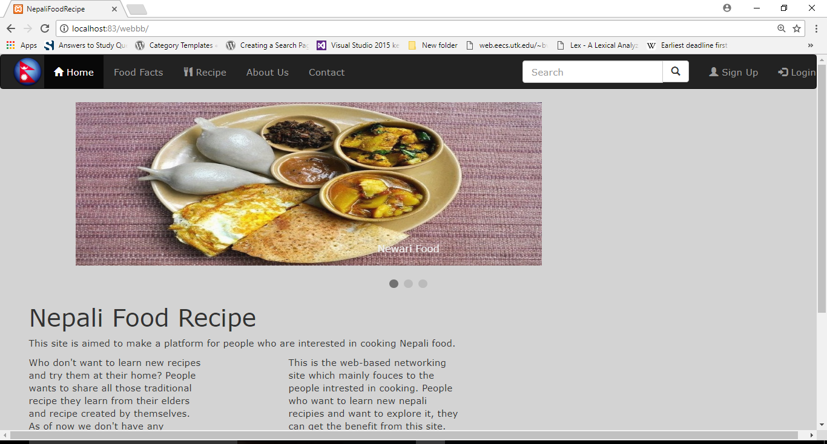

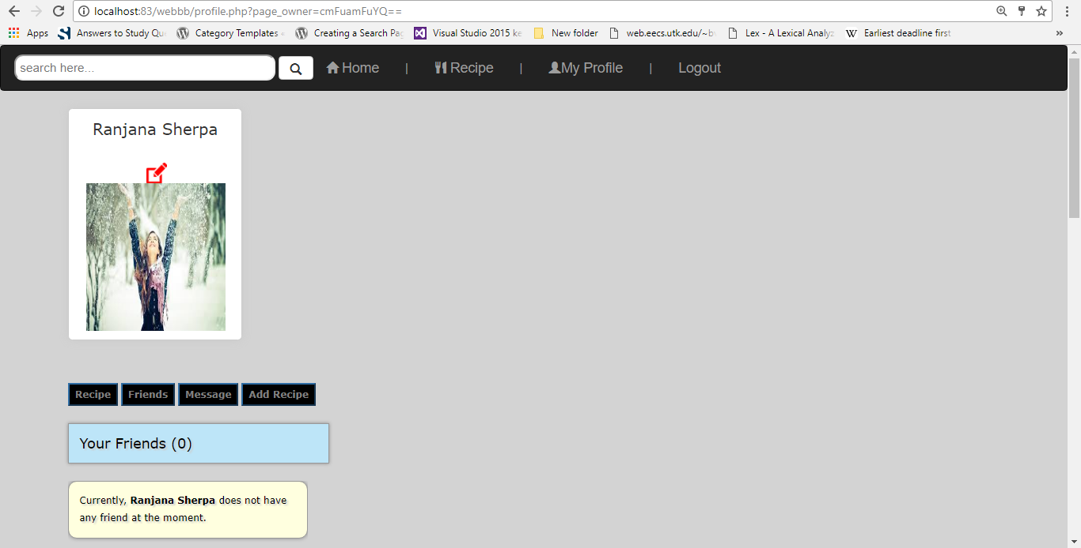

**7.IMPLEMENTATION**

Implementation has been done according to the design process of the system i.e. the design of the system from the previous chapter is implemented. The fundamental goal of this stage is to determine how to achieve the required system, and give an internal process description of module. This chapter will give a presentation of some interfaces, sub-modules, algorithm of the system implementation.

Online Nepali Food Recipe has been developed on Sublime Text using PHP. Back end has been developed in phpMyadmin MySQL. Information are created and retrieved from the database. All the business logic has been managed by the use of SQL of database. So major database related operations, logical decisions, calculations have been carried out from this layer. The designing of the software is done through front end tools.

The frontend i.e. presentation layer of the project is created using HTML5, CSS, bootstrap. CSS is used to change the style of html and asp elements. Bootstrap is used for developing responsive website. It has been used to create menu, navigation bar, buttons etc.

**7.1** **IMPLEMENTATION TECHNOLOGY USED**

Sublime text editor is used because it uses a custom UI toolkit, optimized for speed and beauty, while taking advantage of native functionality on each platform as it is cross platform as it is cross platform and is available for OS X, Windows and Linux with just one license needed to use it on every computer, no matter what operating system it uses. Along with built-in feature (multi-edit and vim mode), it support plugins, snippets, and many other things. Package control, command pallets, snippets, multi-edit are some features of sublime text editor. It is a tool that delivers a fast editor, expandability and stability.

**PHP:** It is used for the development of this project because it is simple to understand and we can use bootstrap for design and so on. The use of Bootstrap drastically reduces the amount of code required to build large applications. Also the website can be accessed by using any modern browser (like Chrome, Mozilla, Opera, etc.) and more over the website will be responsive.

**CSS:** The properties of CSS has been used to make the website responsive to be usable in all devices like smartphones, tablets and PC. The CSS classes of bootstrap have been assigned to buttons and form fields to automatically manage their layout and colors.

**HTML:** It is the standard markup language for creating web pages and wen application. HTML can embed programs written in a scripting language such as JavaScript which affect the behavior and content of web pages and also the inclusion of CSS defines the look and layout of content.

**JavaScript:** It is and interpreted language that is used to make web pages interactive. As part of web browsers, implementations allow client-side scripts to interact with the user, control the browser, communicate asynchronously, and alter the document content that is displayed.

**7. TESTING**

At the completion time of this system, entire testing has been done and system has been made free as far as possible. For testing purposes, following testing methods has been used:

**8.1 Unit Testing**

Each of the modules of the system are tested separately in unit testing. The functionality of a specific section of code, usually at the function level are verified. Recipe, users are some modules of Surprise. So each functionality has been tested and compared with desired output. The test explorer has been used to check and manage each tests. In the recipe add module, it has been tested that all the images of the recipe with detail information are displayed properly. Similarly, user add module has been tested to check new user are registered each time after filling the form through test explorer and the image of the recipe with detail information are displayed properly.

|  |  |  |  |  |  |  |  |
| --- | --- | --- | --- | --- | --- | --- | --- |
| Test no. | Fullname | Username | Email | Password | Expected result | Actual result | Remarks |
| 1 | Ranjana sherpa | ranjana | [ranjana@gmail.com](mailto:ranjana@gmail.com) | Ranjana | User profile | User profile | No error |
| 2 | Babita thapa | Babita | [babita@gmail.com](mailto:babita@gmail.com) | Babita | User profile | User profile | No error |
| 3 | Rubina thapa | Rubina | [rubina@gmail.com](mailto:rubina@gmail.com) | Rubina | User profile | User profile | No error |
| 4 | Shristy mahat | Shristy | [shristy@gmail.com](mailto:shristy@gmail.com) | Shristy | User profile | User profile | No error |

Table 8.1: unit testing table

**8.2 Integration Testing**

After unit testing the modules are integrated one by one and then tested the system for problems arising from component interaction. In integration testing, modules are combined and tested as a group to make sure that one unit does not cause problems to other unit. During integration testing phase, recipe add and user add module are tested to ensure proper functionality. Similarly, all other modules are also integrated and tested. Test cases for integration test between displaying user details:

|  |  |  |  |  |
| --- | --- | --- | --- | --- |
| Test no. | User profile | Expected result | Actual result | Remarks |
| 1. | Ranjana | Display details and posted recipe,friend list and messages | Display details and posted recipe,friend list and messages | No error |
| 2. | Rubina | Display details and posted recipe,friend list and messages | Display details and posted recipe,friend list and messages | No error |
|  |  |  |  |  |
| 3. | Babita | Display details and posted recipe,friend list and messages | Display details and posted recipe,friend list and messages | No error |

Table 8.2: Integration testing table

**8.3 System Testing**

System testing is done after all the units and integration testing are successfully completed,. Entire system test has been done to verify that it meets its requirements and if any problems are found, they are fixed and the system is tested again.

|  |  |  |  |  |
| --- | --- | --- | --- | --- |
| Test no. | Test name | Expected result | Actual result | Remarks |
| 1. | Registration test | Registration successful | Registration successful | No error |
| 2. | Login test | Access to user profile | Access to user profile | No error |
| 3. | Post recipe test | Recipe posted on the site and user profile | Recipe posted on the site and user profile | No error |
| 4. | Add friend test | Friend request send and accept request | Friend request send and accept request | No error |

Table 8.3: System testing table

**8.CONCLUSION AND FUTURE ENHANCEMENT**

**8.1 Conclusion**

The project is about developing a site through which people can know and share various Nepali food recipes. User of our system can use this interactive system for promoting and accessing Nepali recipe from other people. One user of system can add another user and can communicates through private messaging. This website allow user to view recipes, create their own profile, add other user and view their profile and post their own recipe. This system will be open to all so it can be the best platform to promote Nepali food recipes.

After studying about the existing system and various feasibility studies, the system is designed using designing tools and is implemented. Also various testing was done such as unit testing, integration testing and system testing to ensure that the requirement were full filled. Issues arises during the development process were solved with repeated system testing. Overall as research and planning for the project were not done enough which delay the project activities and also because the actual design were not very clear so it took longer to create the prototype.

**8.2 Future Enhancement**

Current scope of our project is only as web based application for social networking, but in future we are planning to launch a mobile app too for our project.

**References**

[1] <https://en.wikipedia.org/wiki/Feasibility_study>