NIST COLLEGE

**Tribhuvan University**

**Institute of Science and Technology**

**social networking**

**A** **PROJECT report**

**Submitted to**

**Department of Computer Science and Information Technology**

**NIST COLLEGE**

***In partial fulfillment of the requirement for the Bachelor Degree in Computer Science and Information Technology***

**Submitted by**

Achyut Dahal (/070)

Aruna Shrestha (/070)

Rajan Bhattarai (/070)

Sabin Nepal (/70)

NIST COLLEGE

Tribhuvan University

LETTER OF APPROVAL

This is to certify that this project prepared by Sabin Nepal, Rajan Bhattarai, Achyut Dahal and Aruna Shrestha entitled “Social networking” in partial fulfillment of the requirements for the degree of B.Sc. in Computer Science and Information Technology has been well studied. In our opinion, it is satisfactory in the scope and quality as a project for the required degree.

Signature of the Supervisor Signature of the HOD/Coordinator

SIGNATURE SIGNATURE

Name and Academic designation Name and Academic designation

Department name and fulfillment of the Department name and fulfillment of the

college college

Signature of the External Examiner Signature of the Internal Examiner

SIGNATURE SIGNATURE

Name and Academic designation Name and Academic designation

Department name and full address of Department name and full address of the institution the institution

NIST COLLEGE

Tribhuvan University

Supervisor’s Recommendation

I hereby recommend that this project prepared under my supervision by Achyut Dahal, Aruna Shrestha, Rajan Bhattarai and Sabin Nepal entitled “Social Networking” in partial fulfillment of the requirements for the degree of B.Sc.in Computer Science and Information Technology be processed for the evaluation.

<<Signature of the Supervisor>>

SIGNATURE

<<Name>>

SUPERVISOR

<<Academic Designation>>

<<Department>>

<<Full address of the Dept. & College>>

ACKNOWLEDGEMENT

The success of this project would not have been possible without the support and guidelines of many individuals, and we are very thankful to those who helped us during our project. We are highly indebted to NIST College for constant guidance and supervision, as well as for providing all the necessary infrastructures and friendly environment for the successful completion of the project. First and foremost, we like to thank Mr. Chetan Bista, principal, NIST COLLEGE, for his moral support towards completing our project work.

We would also like to thanks for the efforts of Mr. Tara Bahadur Thapa B.Sc. CSIT coordinator for his support, advice and guidance. We would like to thank our project supervisor Mr. Indra Chaudhary who guide us throughout the project and provide us help and support and provide many ideas for the development of our project

ABSTRACT

Social networking is a networking site to communicate between people but also to share the knowledge between them.It provides platform for programmers and developers for the sharing the knowledge and idea. Also the user would be able to get and offer support other developer. Currently there are not much sites for developers where they can get help from forum and also still programmers/developers are not .

So in our project work, we develop a social network for the developer/programmer. The project focuses on mainly on things such as sharing the user content through the posts known as blogs, asking and getting the support for the problems from the forum section. User can signup/login to the site and will have their profile and settings.User can post problems and other can reply and also it gives private messaging feature between users

The proposed system is intended to unite the programmers and developers to the common platform for sharing the knowledge and idea. . The methodology that we follow for the project development documentation and testing process is Software Development Life Cycle with Test Driven process. Our project will be helpful for those people who have similar interest and in the similar field and they can get help from each other, can share problems and solutions with each other.

Chapter 1: Introduction

* 1. Background

Social networking has been the 21st century’s new tool for socializing. People are almost used to with this type of communication system that it is easier for people to find them in social network rather than in real life. Social network is popular in every field not because it is effective means to communicate between people but also to share the knowledge between them. This case can be explained with possibly in the scenario like university, offices, school.

In the proposed system, it is planned to develop the social network for the developers/programmers. The project focuses on mainly three things, sharing the user content through the posts known as blogs, asking and getting answers for the questions.

* 1. Problem Definition

In today’s context, there is group divided into two sections that either have online presence or wish to seem totally ghost. It is because people are searching from site to site for the information they need. For eg, One have to use a platform for posting his experience using site A, while for asking for some help he has to go through site B. Sites like medium.com, stackoverflow.com would provide these type of service but often provide specialized services only. This would make people very annoying because many people believe that even though being addicted to social network, it is waste of time to spend on too many social networks. Countries like ours have even worse problem scenario because the developers and the programmers who are city apart are unable to recognize the group of similar interest without actual being connected. With the idea of this in mind the project was born.

* 1. Objectives

The following are the objectives of the proposed social network:

* To make a platform for posting the user experience as blog stories
* To recommend similar user based on the interest of the user
* To ask and answer the questions for and by the users.
  1. Scope

The proposed system is intended to unite the programmers and developers to the common platform for the sharing the knowledge and idea.

1.5 Limitation

Currently there is no user online viewing system. So, for the messaging platform users will have to use private messaging features. Sharing features will also not be available for now. Also the system has no question searching feature.

Chapter 2: Requirement

2.1 Study of Existing System

Even though there are a lot of social network for developers, some popular platform for developers are: Stack Overflow, medium.com which are quite popular in the foreign countries but in the local context, such system were not in the highlight.

medium.com :Medium.com offers the user to post the lengthy post on the user experience [1]. Currently it offers this type of service to general user. Similar to the medium, it provides user the capacity to share their stories but is focused on the developer’s side.

Stack overflow :Stack overflow offers the complete forum alike site for the developers and the general people on various topics [2]. User can follow such topics and problems in the field of computer programming [3].

2.4 Feasibility Analysis

Feasibility Analysis is an assessment of the practicality of a proposed project. It provides the degree of viability of a proposed project. A feasibility analysis helps us determine the value of the proposed project, determine whether or not there is a market for the proposed project, determine if the proposed project is financially viable, and eventually, decide whether or not it is worth investing time and money into the proposed project.

In short, a feasibility analysis evaluates the project‟s potential for success. Following Feasibility Analysis was performed prior to working on the project:

2.4.1 Technical Feasibility

The technical issue usually raised during the feasibility stage of the investigation includes the following:

* Does the necessary technology exist to do what is suggested?
* Does it can be accessible by both large and small devices?

The web app will have responsive design. In the development perspective, the tools and frameworks are easily usable. Website can be hosted on the Rails supporting platform. Because of the use of the bootstrapping technique, any modern browser can be used to access the site.

Operational Feasibility:

The proposed project is beneficial only if it meet operating requirements. Operational feasibility aspects of the project are to be taken as an important issues raised are to test the operational feasibility of the project include

* Will the system be used and work properly if it is being developed and implemented?

The user needs an active internet connection and the browser to have access to the social network. After onwards, user can go the site, follow other developers, browse the topic of their interest and get support.

Economical Feasibility:

The social network is completely free to sign up/login beside the cost of accessing which depends on the user device.

2.2 Software Requirement Specification

Before the development of our system , following requirements are taken into consideration

2.2.1 Functional Requirements

Functional requirements are the main functions which the system is supposed to have. The functional requirements of our system are

a) Messaging

In our system, private messaging feature is available, users can send and receive messages.

b) Blog stories

User can post blogs and also comment in the blog posts.

c) Forum

Users can get help from forum where they can ask question and get answers from other users of the related field.

2.2.2 Non Functional Requirements

a) user friendly

b) responsive

Our system is responsive; it uses Bootstrap, which improves the responsiveness of the web application. Since it uses Bootstrap, it also concur the mobile-first technology which would enhance the functionality of web application in mobile devices. This nature could prove to be extremely beneficial to people living in areas with limited access to computers.

c) reliability

With a reliable source and tools, the outcome would be reliable as

well.

d) speed

The response time of the system is fast.

e) performance

The performance of the system is determine by various factor like response time, throughput, resource utilizations etc.

Tools

**Front-End**

As it is a web-based application, the front-end of the application is going to implemented using HTML, CSS, JavaScript and Bootstrap.

**Back-End**

The server side programming language of the application is Ruby and MySQL as database. The Ruby programming language is rich in various libraries that can be used within the application.

System Architecture

System design is simply the design of systems. It is the process of defining the architecture, components, modules, interfaces and data for a system to satisfy specified requirements. Our system makes use of internet and computer peripherals. This system is supported by any different devices that can access the internet. The system architecture is shown below:

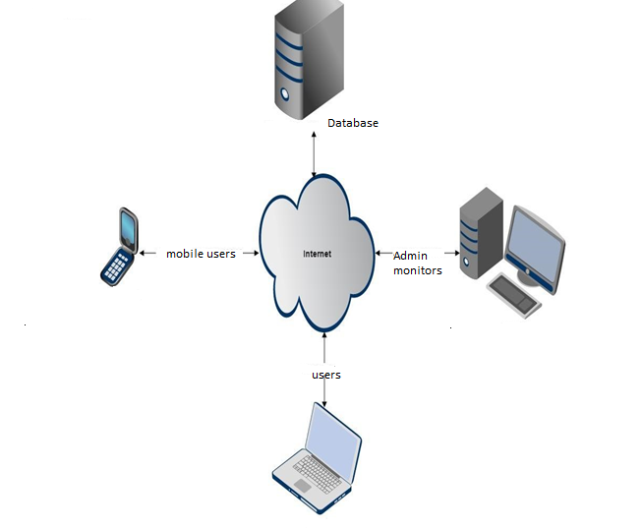

System Diagram

Context free diagram

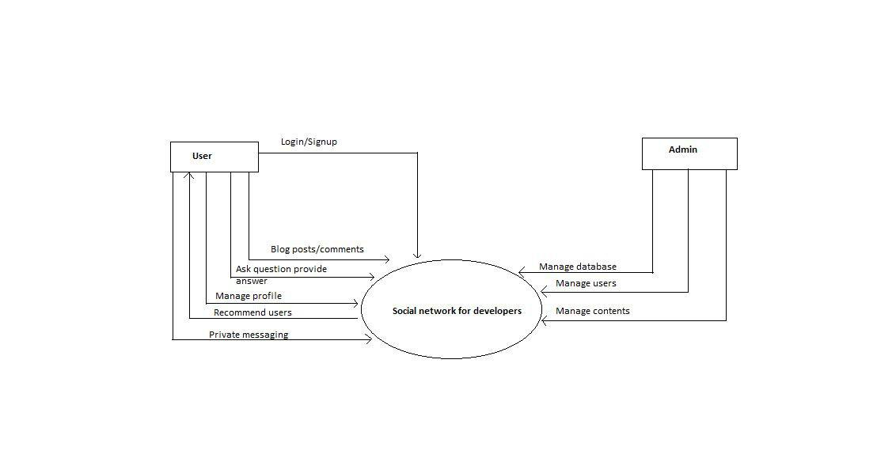

Use case Diagram

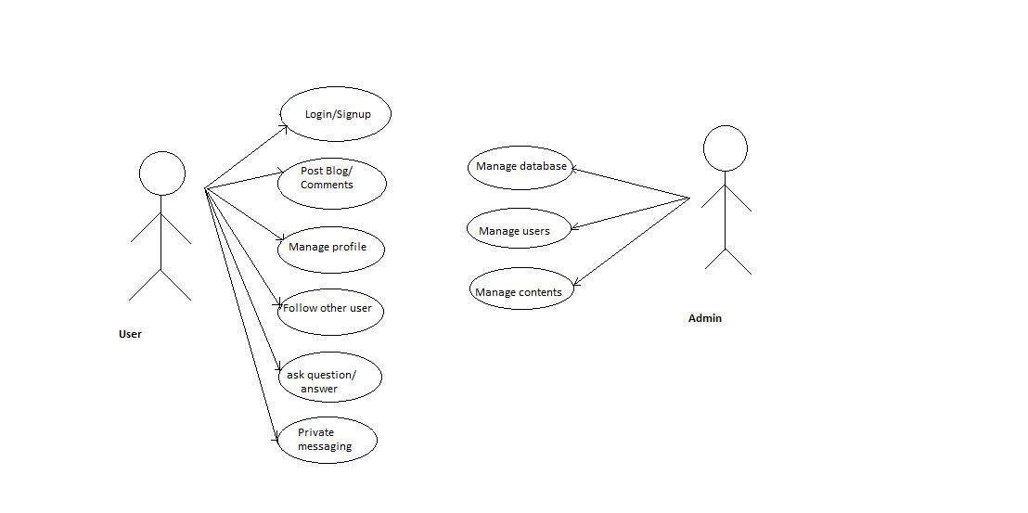

Activity Diagram

