**Names: Neza Eddy Kelly**

**Trade: Electrical automation technology (strem B)**

**Module title: Industrial sensor technology**

**PROJECT TITLE:Alcohol Detector (Using Arduino & MQ3 Sensor)**

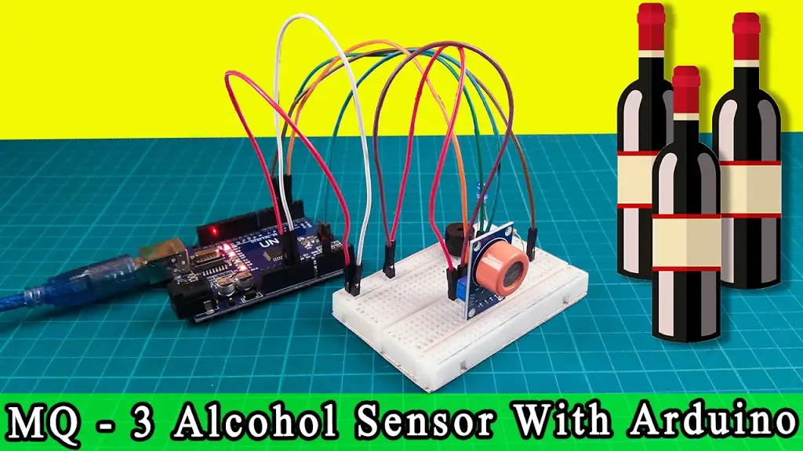

Nowadays drinking alcohol and driving are the most common threats to their lives and the lives of others. We can’t stop people from drinking alcohol but we can avoid such accidents by checking the person drinking and we can also keep such small devices in the vehicle to make sure there is no drink and drive. Today we are creating a simple Alcohol detector. We can use it in various application fields. So this is a small demonstration of a simple Alcohol detector using Arduino and MQ3 sensor.

Many advanced alcohol sensors are available in the market for a reasonable price, but we are here to make this project using some basic microcontroller like Arduino, LED, Buzzer and MQ3 alcohol sensors.

## What is an Alcohol detector using Arduino?

The equipment we use today to make alcohol detectors are Arduino, LEDs, Buzzer, and MQ3 alcohol sensors. There are many MQ-X sensors available in the market for different uses, but we are going to use MQ-3 sensor. Here as it is the best to detect alcohol. However, most MQ sensors work the same. They all contain a heating element that heats a layer of conductive material we constantly measure this resistance. Its resistance changes when the odor from smoking or alcohol comes into contact with the MQ-3 sensor.

The sensor also contains onboard power and status lead that blinks when the sensor detects alcohol fumes.

The sensor provides both digital and analog output. The difference between the two is simple. In the digital output, high or low (i.e. either 1 or 0) is transmitted to the microcontroller but a wide range of values ​​from 0 to 1023 in the analog signal is transmitted to the microcontroller which corresponds to the intensity of alcohol in a nearby environment. They build the sensor out of LM393 IC, which has an inbuilt amplifier that amplifies the voltage signal in the detectable range. Also, it has voltage comparators for efficient amplification. We can adjust the amount of amplification with the help of potentiometers given in the sensor.

## Components Required

The following is the list of all the components required for Alcohol Detector using Arduino project.

| **S.N** | **COMPONENTS NAME** | **DESCRIPTION** | **QUANTITY** |
| --- | --- | --- | --- |
| 1 | Arduino Uno | Arduino Uno board | 1 |
| 2 | MQ-3 Sensor | MQ-3 Alcohol Sensor | 1 |
| 3 | Buzzer | Small 2 pin Buzzer | 1 |
| 4 | LED | 5Mm RED LED | 1 |
| 5 | Jumper Wires | Jumper Cables breadboard friendly | 5 |
| 6 | Breadboard | Mini Breadboard | 1 |

**Circuit diagram of Alcohol Detector Using Arduino & MQ3 Sensor**

|  |  |  |
| --- | --- | --- |
| **S.N** | **MQ-3 Sensor** | **Arduino** |
| 1 | VCC | 5V |
| 2 | GND | GND |
| 3 | A0 | Pin A0 |
| **S.N** | **Buzzer** | **Arduino** |
| 1 | VCC | D8 |
| 2 | GND | GND |
| **S.N** | **LED** | **Arduino** |
| 1 | Anode (+) | D9 |
| 2 | Cathode (-) | GND |

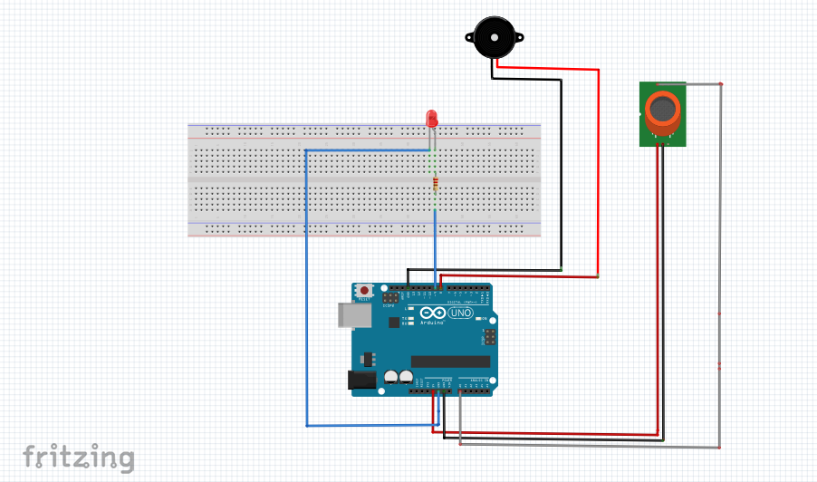

**PROGRAM CODE FOR ALCOHOL DETECTOR USING ARDUINO UNO&MQ3-sensor**

//Alcohol Detector based on MQ3

/* Here are the list of I/O pins*/

#define MQ3 A0

#define Buzzer 8

#define LED 9

//Threshold value of MQ3 reading above which it should trigger/

#define Thres_Val 460

//

// global int to store the analog reading from MQ3 (0 to 1023)

int value;

void setup() {

// declaring the input and output pins

pinMode(MQ3, INPUT);

pinMode(Buzzer, OUTPUT);

pinMode(LED, OUTPUT);

// Serial Output for debugging

Serial.begin(9600);

}

void loop() {

// reads the analog value from MQ3

value = analogRead(MQ3);

// sends the value to UART for debugging

Serial.println(value);

if ( value > Thres_Val ) //if alcohol is detected

{

digitalWrite ( LED , HIGH ); // turns the LED on

//digitalWrite(Buzzer,HIGH); // turns on (uncomment if buzzer is used)

tone(Buzzer, 1000); //Generate a 1000Hz tone only if you use speaker (comment out if buzzer is used)

}

else {

digitalWrite(LED, LOW); // turns the LED off

//digitalWrite(Buzzer,LOW); // turns off (uncomment if buzzer is used)

noTone(Buzzer); // Removes the tone from speaker (comment out if buzzer is used)

}

delay (500); // a 500ms delay before reading is taken again

}

## Why MQ3 sensor for Alcohol detection

* The sensitivity of Alcohol, Ethanol is good
* Easy to use and fix
* Adjustable value
* Low price
* Can be used in various alcohol detection projects

Here are some more useful specifications that we need to know before using this low cost MQ3 sensor.

|  |  |
| --- | --- |
| Operating voltage | 5V |
| Load resistance | 200 KΩ |
| Heater resistance | 33Ω ± 5% |
| Heating consumption | <800mw |
| Sensing Resistance | 1 MΩ – 8 MΩ |
| Concentration Scope | 25 – 500 ppm |
| Preheat Time | Over 24 hour |

The Arduino based alcohol detector using the MQ3 sensor is specified above.

### MQ3 Alcohol Sensor Module Pinout

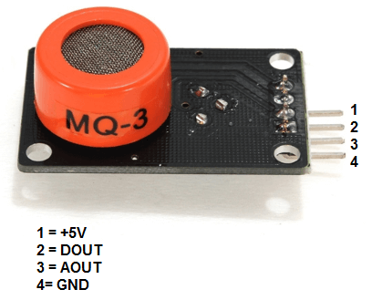

Now let’s have a look at the pinout.

|  |  |
| --- | --- |
| **VCC** | *Supplies power for the module. You can connect it to 5V output from your Arduino* |
| **GND** | *It is the Ground Pin and needs to be connected to GND pin on the Arduino* |
| **D0** | *Provides a digital representation of the presence of alcohol* |
| **A0** | Provides analog output voltage in proportional to the concentration of alcohol |

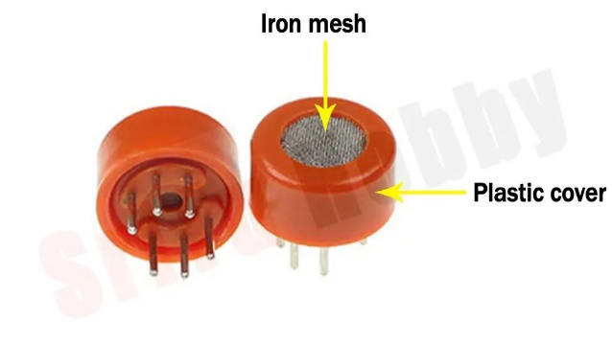

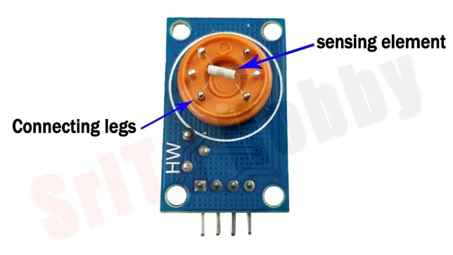

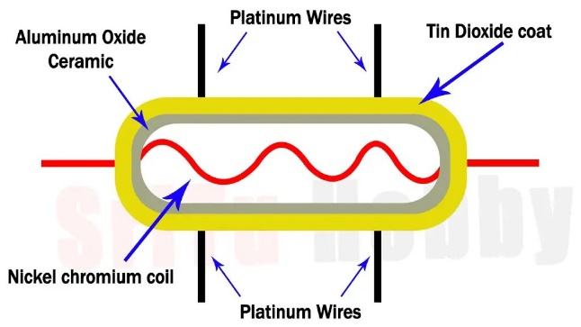

**Steps followed to make the project**

### Step 1

Firstly, identify these components.

#### Arduino UNO board.

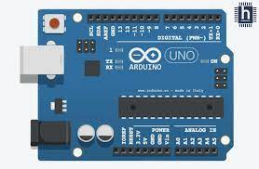

#### MQ3 sensor.

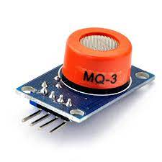

#### Breadboard.

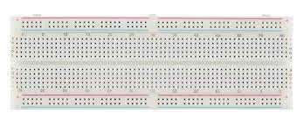

#### 5V buzzer.

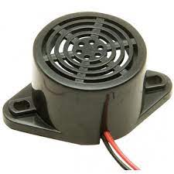

#### LED bulb

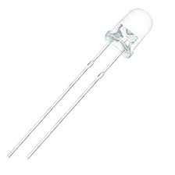

#### 180-ohm Resistor

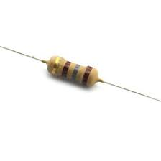

#### Jumper wires

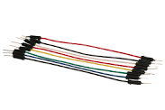

### Step 2

Secondly, connect these components.

### Step 3

Thirdly, let’s create a program for this project.

### Step 4

Lastly, select the correct board and port. Afterward, upload this program to the Arduino board.

### Step 5

OK, now test this project, For that, use Alcohol.

* Following is a link of my project!

<https://youtu.be/kDnbns3afPU>