1) every morning bot will run

2) bot will go and open current week file ‘wk041320.xls’



If todays date is 16-04-2020 then also bot will open this file(‘wk041320.xls’). Because 16 apr come under that week.

3) read todays date Total daily debits and total daily credits from weekly report ‘wk041320.xls’

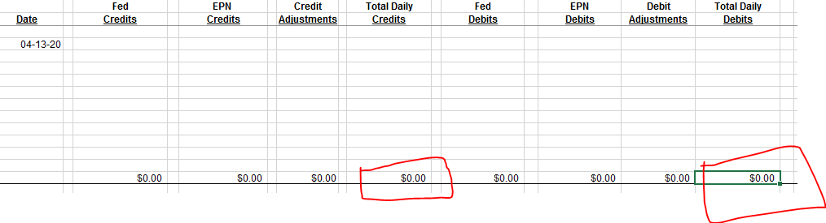

4)after that bot open master data file (‘New Simplified Reconciliation ACH Daily Work_**CurrentMonth.**xlsx’)



Ex : New Simplified Reconciliation ACH Daily Work_APRIL.xlsx

5)then bot search for a specific shit. If bot running today then writes data on next working day sheet

Ex: Today’s date: 15-04-2020 (Wednesday) then bot goes to **0416** sheet

If Friday then put data on Mondays sheet

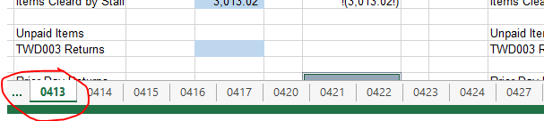

6)Adds data to those specific cells according to debit and credit

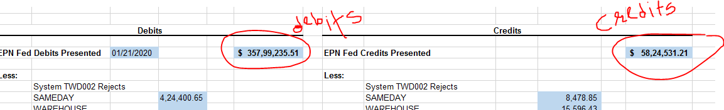

**That’s it!!!**

**Thank You Prashant Sir**

**Lavkar kara sir sandyakali dyayach ahe**