USQ CSC8415 2017 S2
Assignment 1 Report

Name: Stephen Braithwaite
Student Number: 0061234567890
26. Aug. 2017
Table of Contents
Part 1 1
Explain the difference between a HTTP 1.1 GET request and a HTTP 1.1 HEAD request. 1
Demonstrate your command line processing and your error handling. 1
Wrong number of arguments 1
Bad address 1
Bad port number 1
Bad file name 1
Missing file 1
All OK 1
Find the calls to socket() and connect() in the CscNetLib netCli.c 1
Explain the purpose, the arguments and the return values of each call. 1
socket() 1
connect() 1
Explain three major differences between write() and fwrite(). 1
Test the demonstration server 1
Demonstrate your configuration, your logging and your error handling, and a case where everything works. 1
Missing IP 1
Missing Port number 1
Bad IP 1
Bad port number 1
Busy Port 1
All OK 1
Find calls to bind(), listen() and accept() 1
Explain the arguments to bind(), listen(), and accept() 1
bind 1
listen 1
accept 1
Part 3 1
Demonstrate code 1
Successful case 1
Requested file not present 2
Part 4 2

Part 1

Explain the difference between a HTTP 1.1 GET request and a HTTP 1.1 HEAD request.
A GET request asks for a file to be sent to the client from the server. The whole request is in a message, that may have several header fields. The response also has several header fields, followed by the requested file or a simple document with and error message for human consumption. A HEAD request is identical to a GET request, except that the server will not send the request file, or the error document. Only the headers will be sent.

Demonstrate your command line processing and your error handling.

Wrong number of arguments
$ ./client example.com /index.html

Usage: ./client addr portNum fileName
Where
* 'addr' is a valid domain name
* 'portNum' is a valid port number.
* 'fileName' is a valid file name.

Bad address
$ ./client example@com 80 /index@html
Error, Invalid domain name "example@com"

Usage: ./client addr portNum fileName
Where
* 'addr' is a valid domain name
* 'portNum' is a valid port number.
* 'fileName' is a valid file name.

Bad port number
$ ./client example.com 8a0 /index.ht
Error, Invalid port number "8a0"

Usage: ./client addr portNum fileName
Where
* 'addr' is a valid domain name
* 'portNum' is a valid port number.
* 'fileName' is a valid file name.

Bad file name
$ ./client example.com 80 /index@html
Error, Invalid absolute file name "/index@html"

Usage: ./client addr portNum fileName
Where
* 'addr' is a valid domain name
* 'portNum' is a valid port number.
* 'fileName' is a valid file name.

Missing file
$ ./client example.com 8a0 /index.ht
Sent: HEAD /index.ht HTTP/1.0
Sent: Host: example.com
Sent: Connection: close
Sent:
Got 1: "HTTP/1.0 404 Not Found"
Got 2: "Cache-Control: max-age=604800"
Got 3: "Content-Type: text/html"
Got 4: "Date: Sat, 26 Aug 2017 02:54:36 GMT"
Got 5: "Expires: Sat, 02 Sep 2017 02:54:36 GMT"
Got 6: "Server: EOS (lax004/2812)"
Got 7: "Vary: Accept-Encoding"
Got 8: "Content-Length: 1270"
Got 9: "Connection: close"
Got 10: ""

All OK
$ ./client example.com 80 /index.html
Sent: HEAD /index.html HTTP/1.0
Sent: Host: example.com
Sent: Connection: close
Sent:
Got 1: "HTTP/1.0 200 OK"
Got 2: "Accept-Ranges: bytes"
Got 3: "Cache-Control: max-age=604800"
Got 4: "Content-Type: text/html"
Got 5: "Date: Sat, 26 Aug 2017 02:31:32 GMT"
Got 6: "Etag: "359670651""
Got 7: "Expires: Sat, 02 Sep 2017 02:31:32 GMT"
Got 8: "Last-Modified: Fri, 09 Aug 2013 23:54:35 GMT"
Got 9: "Server: ECS (rhv/8183)"
Got 10: "X-Cache: HIT"
Got 11: "Content-Length: 1270"
Got 12: "Connection: close"
Got 13: ""

Find the calls to socket() and connect() in the CscNetLib netCli.c
int csc_cli_connect(csc_cli_t *this)
{ struct addrinfo *res = this->servAddresses;
int sockfd;
int result;

// Get a socket for the connection.
sockfd = socket(res->ai_family, res->ai_socktype, res->ai_protocol);
if (sockfd == -1)
{ setErrMsg(this, csc_alloc_str3("netcli_connect(): obtaining socket: ", strerror(errno), NULL));
return -1;
}

// Make the connection.
result = connect(sockfd, res->ai_addr, res->ai_addrlen);
if (result == -1)
{ setErrMsg(this, csc_alloc_str3("netcli_connect(): ", strerror(errno), NULL));
return -1;
}

return sockfd;
}

Explain the purpose, the arguments and the return values of each call.

socket()
The purpose of this is to create a file descriptor that will be used to connect.
- arg1 - This is the address family. For network programming it will normally be AF_INET.
- arg2 - This is the type of the socket. For network programming it will normally be SOCK_STREAM, which would indicate TCP, or it would be SOCK_DGRAM, which would indicate UDP.
- arg3 - This is the protocol. For network programming, it will normally be zero.
- Return value - This is the file descriptor, which will be a non negative integer on success, or -1 on failure.

connect()
The purpose of this is to connect a file descriptor to a server.
- arg1 - This is the socket, a file descriptor that we want to connect to the server.
- arg2 - This is the address to connect to. It is a structure.
- arg3 - This is the length of the structure passed as the previous argument.
- Return value - An integer that returns success or failure. 0 on success, or -1 on failure.

Explain three major differences between write() and fwrite().
- fwrite() is a level 3 library function, while write() is a system call.
- fwrite() takes FILE*, while write() takes a file descriptor.
- fwrite() takes the number of objects and their size, while write() takes the number of bytes to write.

Part 2

Test the demonstration server
Server:
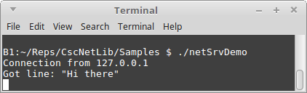

Client
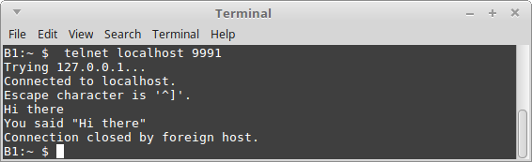

Demonstrate your configuration, your logging and your error handling, and a case where everything works.

Missing IP
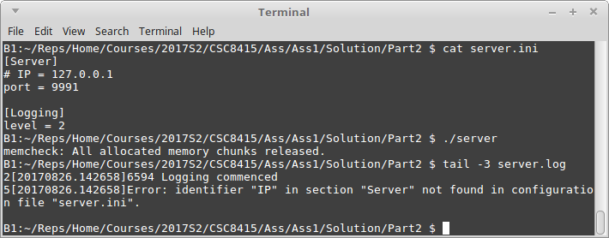

Missing Port number
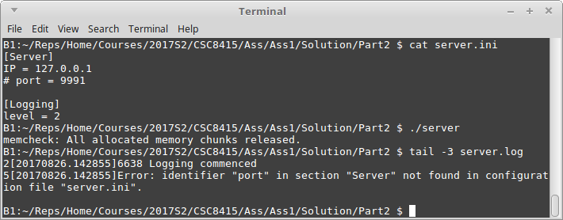

Bad IP
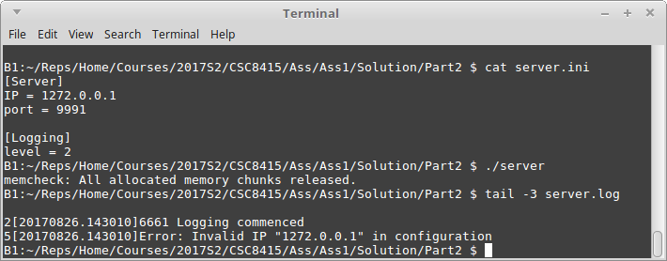

Bad port number
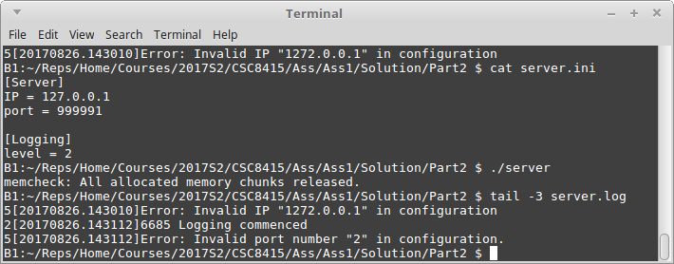

Busy Port
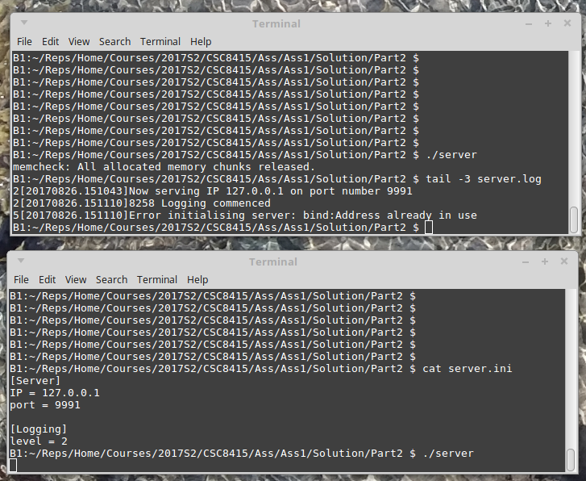

All OK
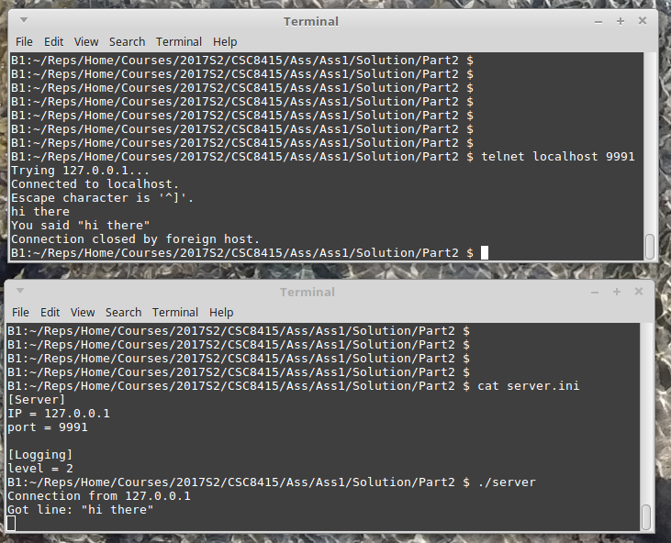

Find calls to bind(), listen() and accept()

int csc_srv_setAddr(csc_srv_t *this, const char *conType, const char *addr, int portNo, int backlog)
{ int result;
char portStr[MaxPortNoStrSize + 1];
struct addrinfo *addrInfo;
int sockfd;

...

// Resolve the address.
result = getaddrinfo(addr,portStr,&this->sockHints,&this->servAddresses);
if (result != 0)
{ setErrMsg(this, csc_alloc_str3("getaddrinfo:", gai_strerror(result), NULL));
return 0;
}
addrInfo = this->servAddresses;

// Get a socket for the connection.
sockfd = socket(addrInfo->ai_family, addrInfo->ai_socktype, addrInfo->ai_protocol);
if (sockfd == -1)
{ setErrMsg(this, csc_alloc_str3("socket: ", strerror(errno), NULL));
return 0;
}
this->listenSock = sockfd;

// Bind the socket to the address.
result = bind(sockfd, addrInfo->ai_addr, addrInfo->ai_addrlen);
if (result != 0)
{ setErrMsg(this, csc_alloc_str3("bind:", strerror(errno), NULL));
return 0;
}

// Set the socket properties to listen, and set the backlog.
if (backlog < 1)
backlog = 10;
result = listen(sockfd, backlog);
if (result != 0)
{ setErrMsg(this, csc_alloc_str3("listen:", strerror(errno), NULL));
return 0;
}

// Return the result.
return 1;
}

int csc_srv_accept(csc_srv_t *this)
{ int cliDetailsSize = sizeof(this->cliDetails);
int rwSock;

// Accept the connection.
rwSock = accept(this->listenSock, &this->cliDetails, &cliDetailsSize);
if (rwSock == -1)
{ setErrMsg(this, csc_alloc_str3("accept:", strerror(errno), NULL));
if (errno == EINTR)
rwSock = -2;
}

// Return the socket or error indication.
return rwSock;
}

Explain the arguments to bind(), listen(), and accept()

bind
int bind(int sockfd, const struct sockaddr *addr, socklen_t addrlen);

The purpose of this routine is to associate or bind a particular port number to a file descriptor of the current process.
- arg1 - This is the file descriptor that is to be bound to the port number.
- arg2 - This is a structure containing the address and port number that is to be bound to the to this file descriptor of this process.
- arg3 - The length of the structure of the previous argument.
- returns - 0 on success, an error number otherwise.

listen
int listen(int sockfd, int backlog);
The purpose of this function is to tell the O.S. that the server is ready to accept connections on the file descriptor that is already bound to a port number.
- arg1 - This is the file descriptor that is already bound.
- arg2 - This is the size of the queue of connections to be accepted.
- returns - 0 on success, an error number otherwise.

accept
int accept(int sockfd, struct sockaddr *addr, socklen_t *addrlen);
The purpose of this function is to accept a single system call.
- arg1 - This is the file descriptor that this process is listening for connections on.
- arg2 - This is a structure to be filled in by the system call so the routine can tell us something about the client to be connected. It may be NULL.
- arg3 - This is the length of the previous argument. It should be NULL if the previous argument was NULL.
- returns - a file descriptor on success. -1 on failure.

Part 3

Demonstrate code

Successful case
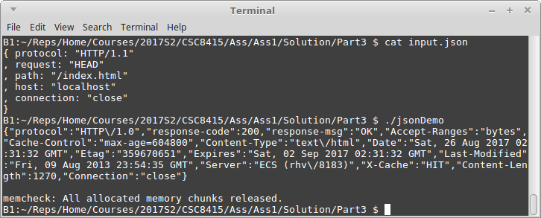

Requested file not present
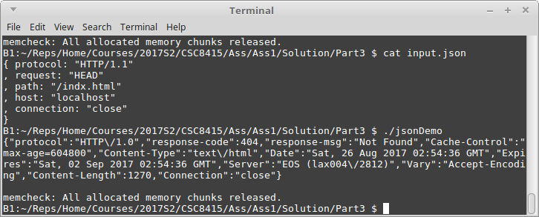

Part 4

Successful case, followed by unsuccessful case
