Employee HEAD

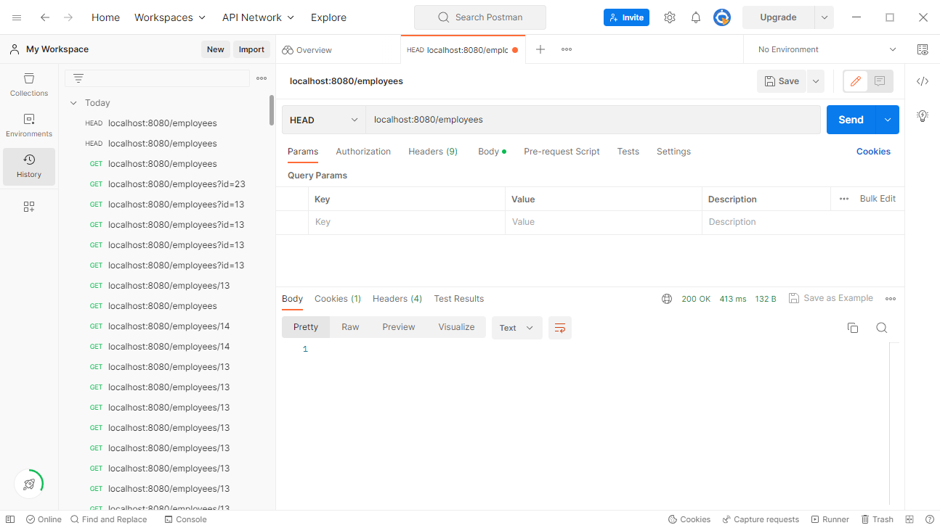

Employee GET

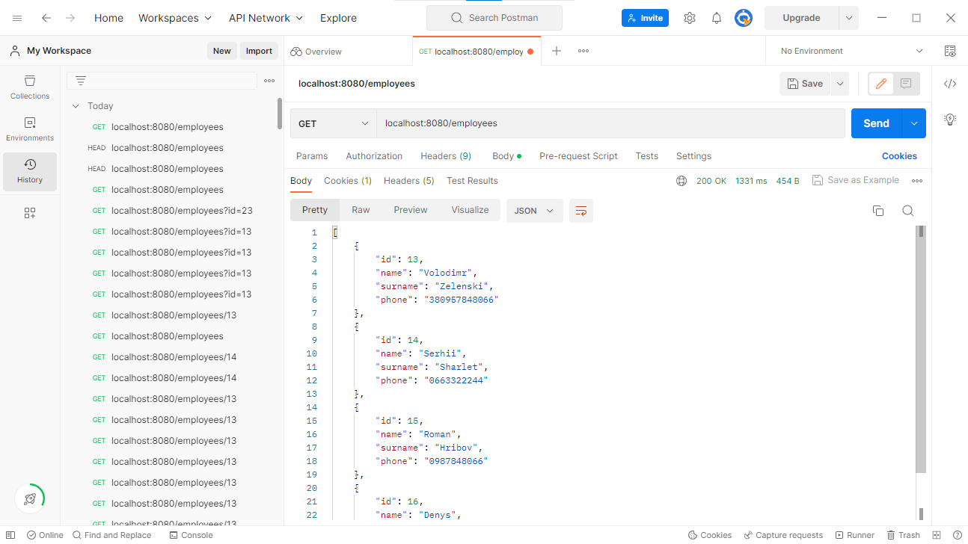

Employee GET id

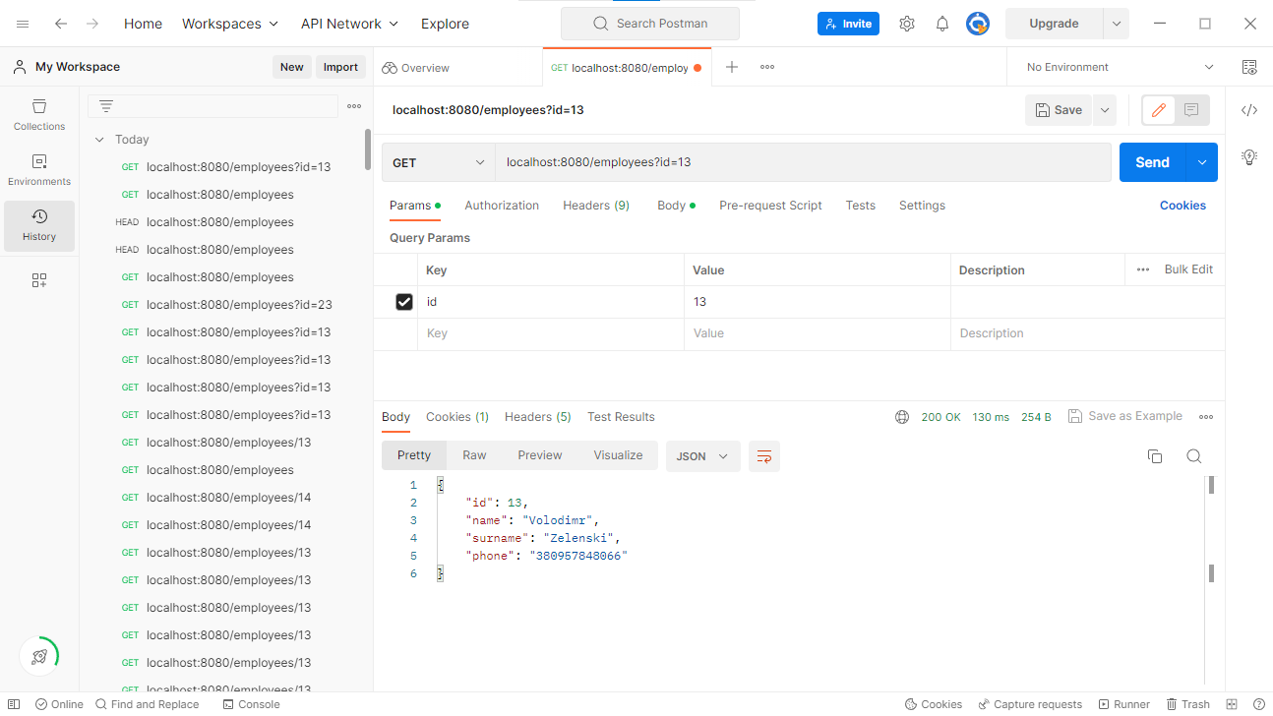

Employee POST

{

        "name": "Danil",

        "surname": "Kozlov",

        "phone": "380915143166"

    }

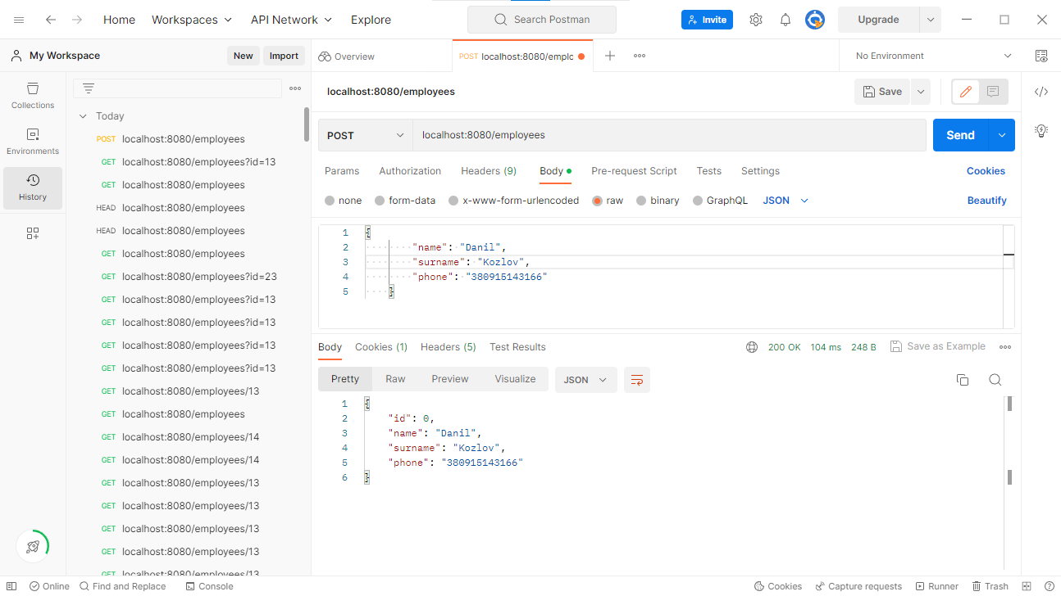

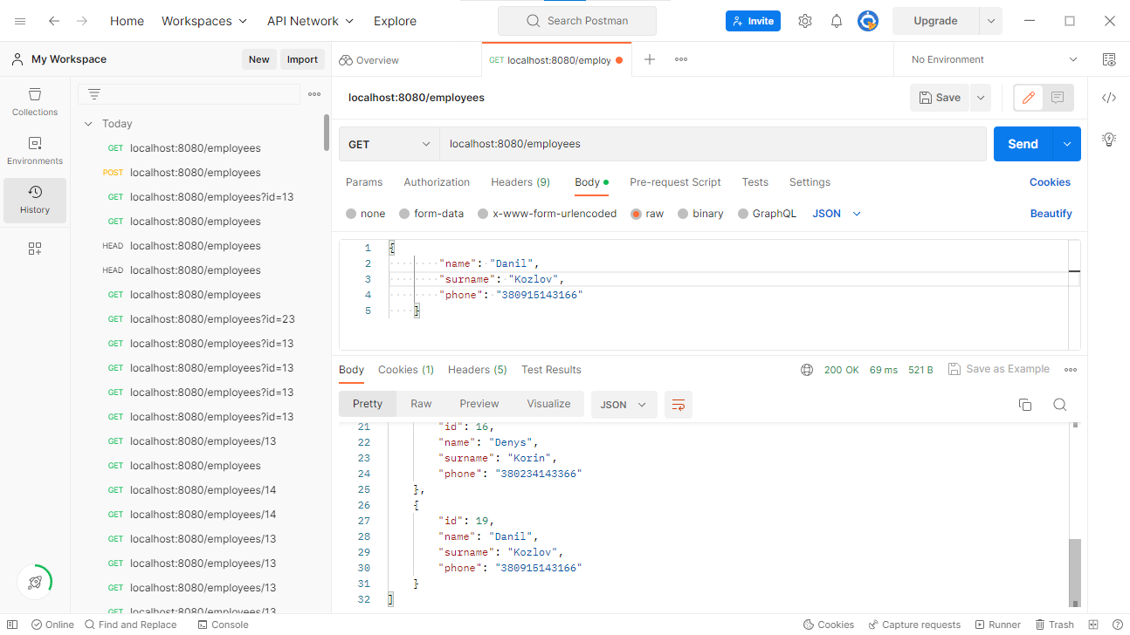

Employee PUT

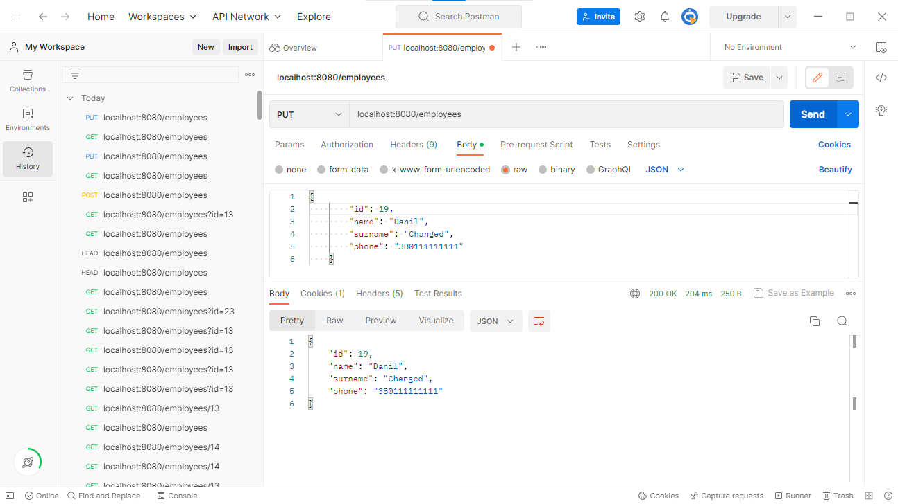

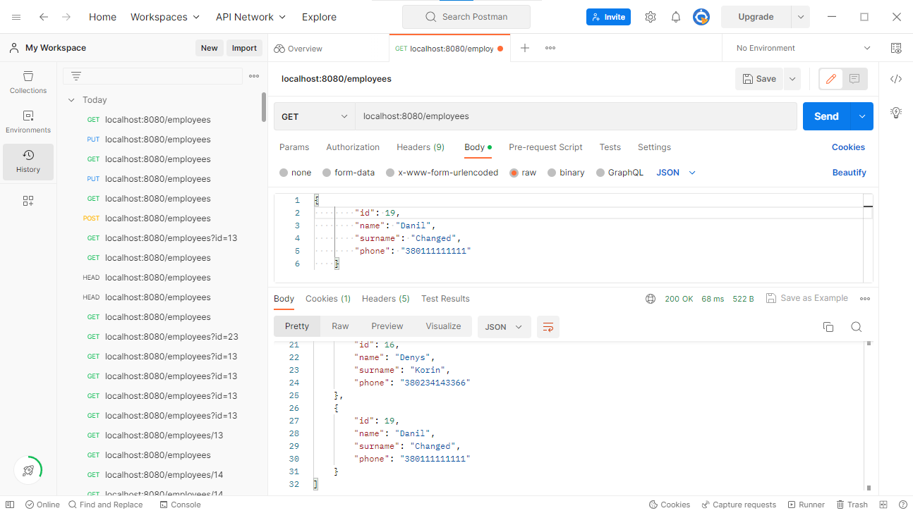

Employee DELETE

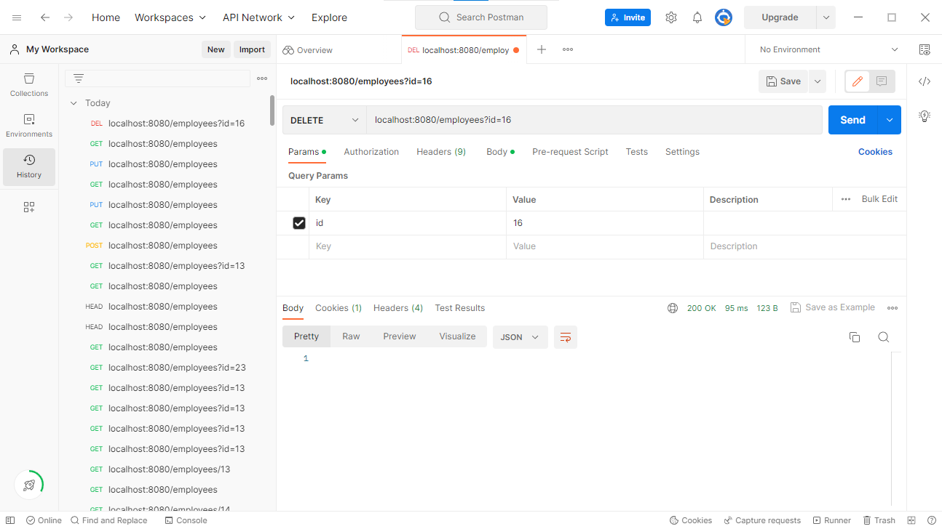

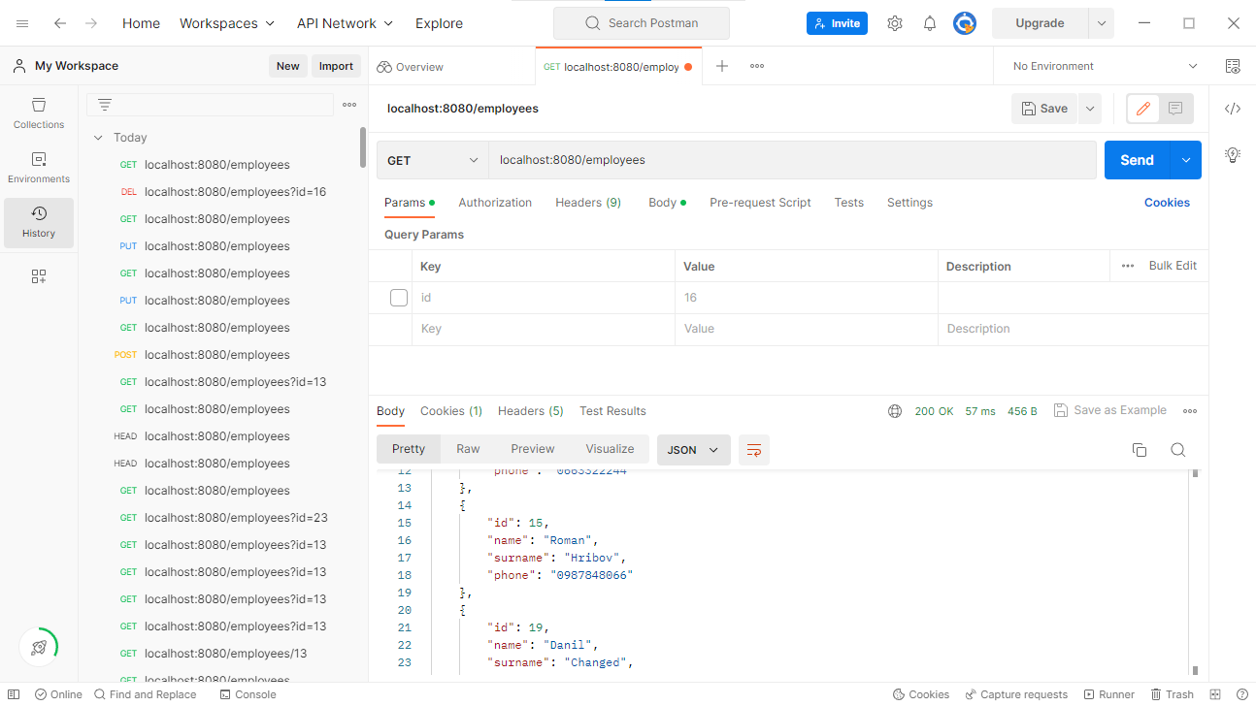

Vacancy HEAD

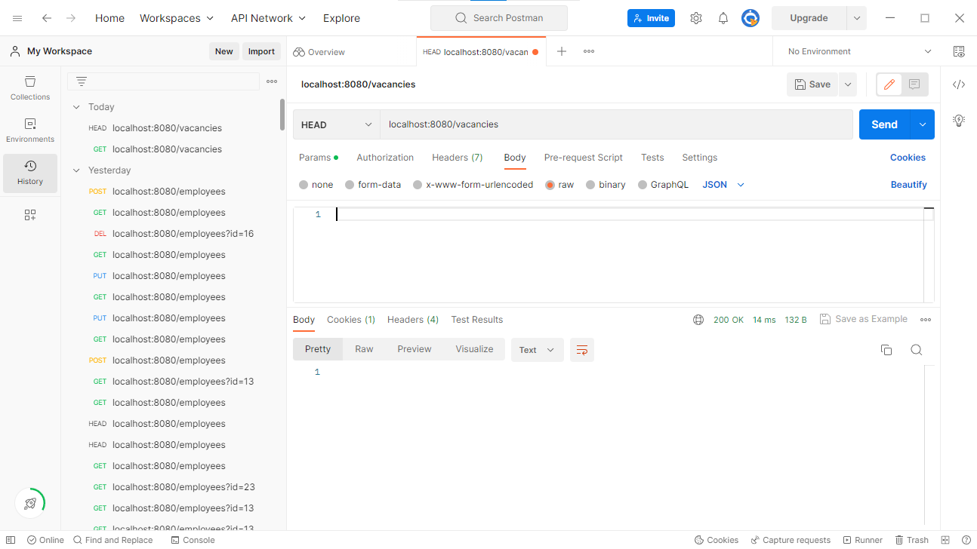

Vacancy GET

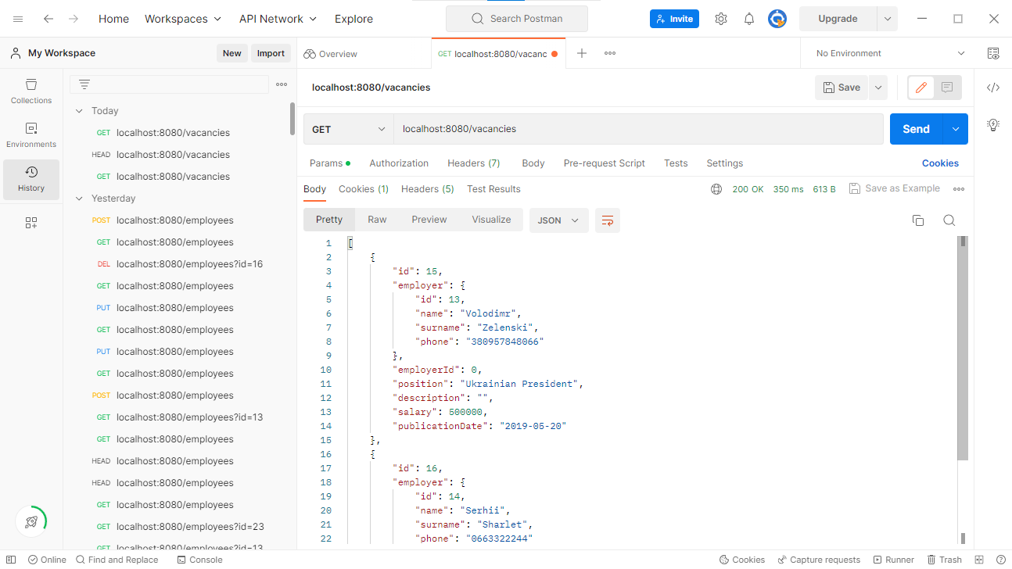

Vacancy GET id

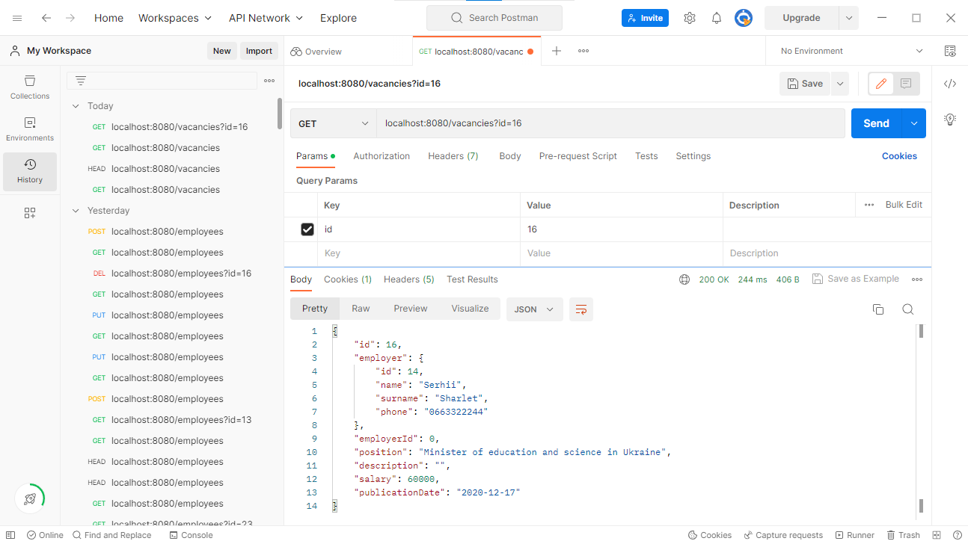

Vacancy POST

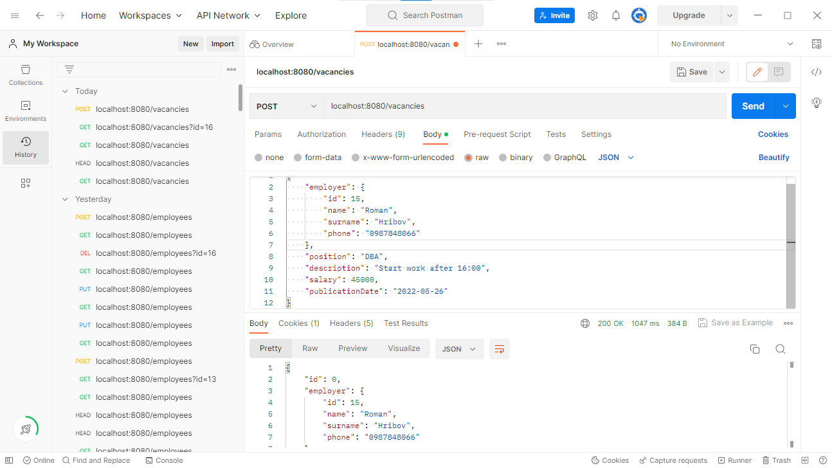

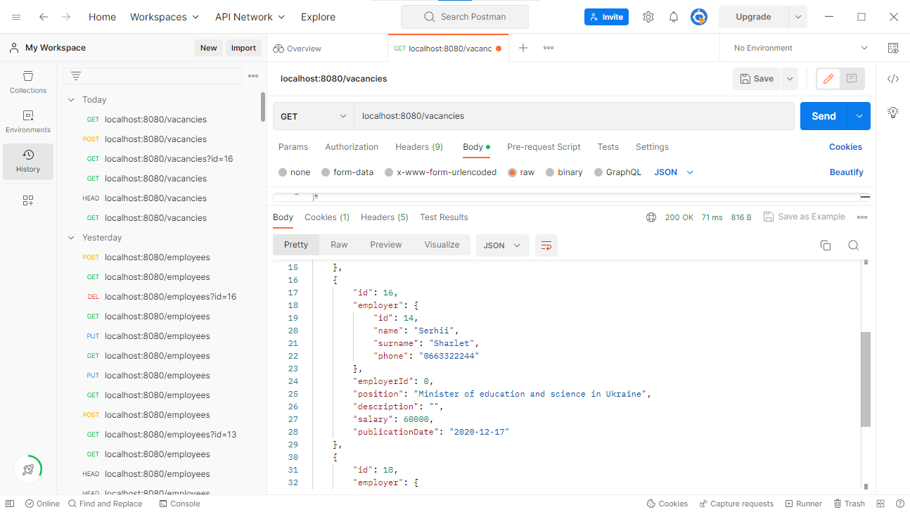

Vacancy PUT

{

        "id": 16,

        "employer": {

            "id": 14,

            "name": "Serhii",

            "surname": "Sharlet",

            "phone": "0663322244"

        },

        "employerId": 14,

        "position": "Actor",

        "description": "Acting master",

        "salary": 37000,

        "publicationDate": "2021-06-15"

    }

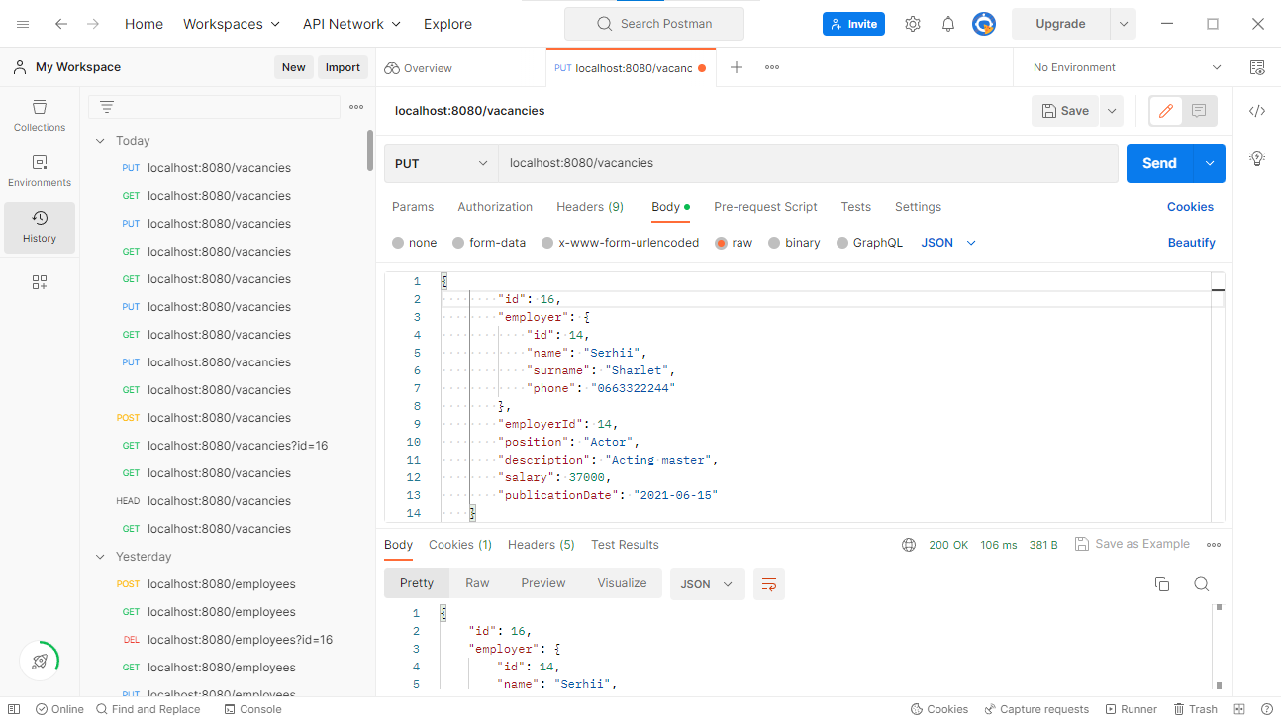

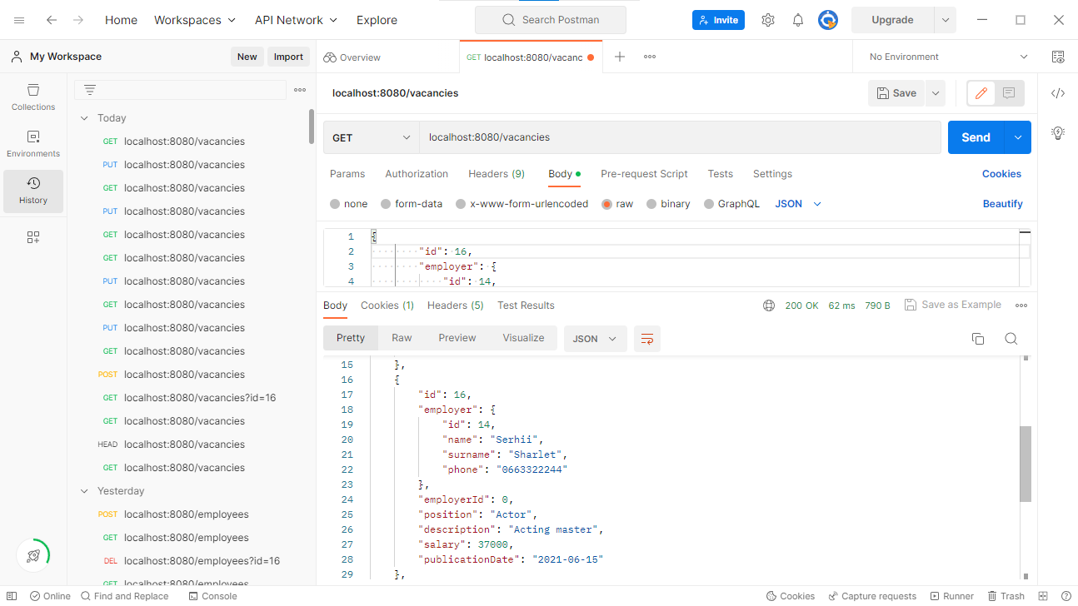

Vacancy DELETE

{

        "id": 15,

        "employer": {

            "id": 13,

            "name": "Volodimr",

            "surname": "Zelenski",

            "phone": "380957848066"

        },

        "employerId": 0,

        "position": "Ukrainian President",

        "description": "",

        "salary": 500000,

        "publicationDate": "2019-05-20"

    }

