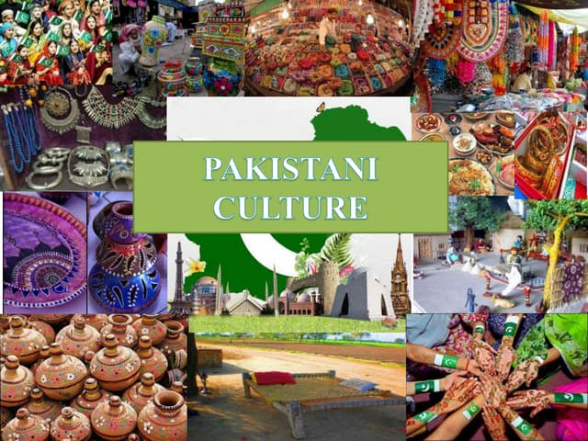

**PAKISTANI CULTURE**

Culture is the shared beliefs, values, customs, and practices of a group of people.Culture is a complex whole that includes knowledge, belief, art, law, morals, custom, and other capabilities and habits acquired by people as members of society.

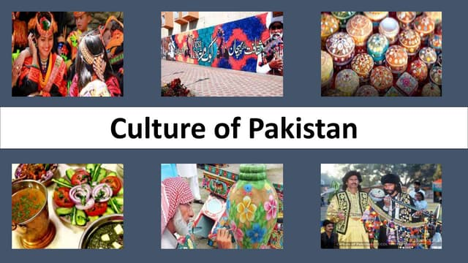

Pakistan is a culturally rich and diverse country with a history that dates back over 5,000 years.

The country has a strong Sufi cultural heritage, with thousands of Sufi shrines and mausoleums. Pakistan celebrates a wide variety of festivals throughout the year, reflecting the country's diversity. The existence of Pakistan as an Islamic state  has led to the large-scale injection of Islam into most aspects of Pakistani culture.The **culture of Pakistan**  is based in the Indo-Persian cultural matrix that constitutes a foundation plank of South Asian Muslim identity. The region has formed a distinct cultural unit within the main cultural complex of South Asia, Middle East and Central Asia ,where pre-Islamic customs differ from Islamic practices.

**Punjabi culture**

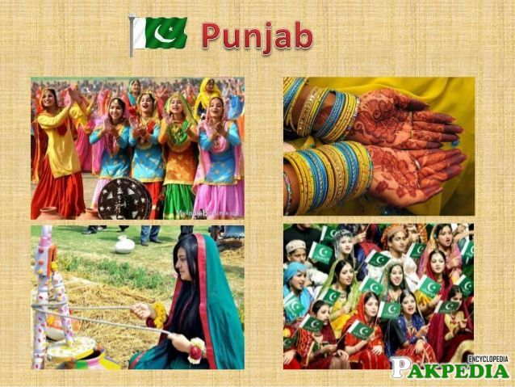**Punjabi culture** grew out of the settlements along the five rivers (the front two Persian words,Panj meaning "Five" and *Âb* meaning "Water") which served as an important route to the Near East as early as the ancient Indus Valley civilization.

Agriculture has been the major economic feature of the Punjab and has therefore formed the foundation of Punjabi culture, with one's social status being determined by landownership.

There are many dialects used diverse region to region. Some of the local dialects are Doabi, Ghebi, Malwai, Pahari, Shahpuri, Rachnavi, Hindko, etc

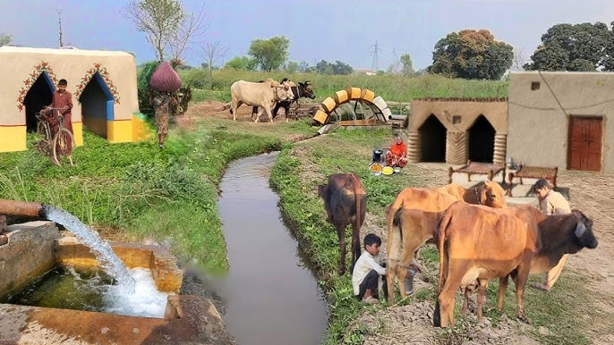

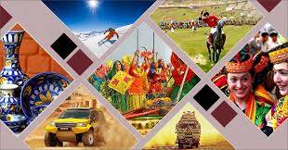

Punjabis are high spirited and liberal people. They are lively and vibrant with a vibrant history and culture. They celebrate their festivals across the globe and welcome others to be part of their culture.

**Dresses in Punjabi Culture**

The traditional dresses of Punjab are very colourful, unique and vibrant. Women wear Salwar kameez (Salwar is the bottom wear and kameez upper). These clothes are intricately designed and beautifully embroidered at homes in multi colours. Footwear preferred is Jooti which has been the traditional footwear worn by men and women for many years.

**Punjabi Food**

Punjabi food is rich in flavours and spices. With overflowing ghee on the chapattis, the food here is considered for the strong-hearted! Lassi is the refreshing drink here and is also known as the welcome drink.

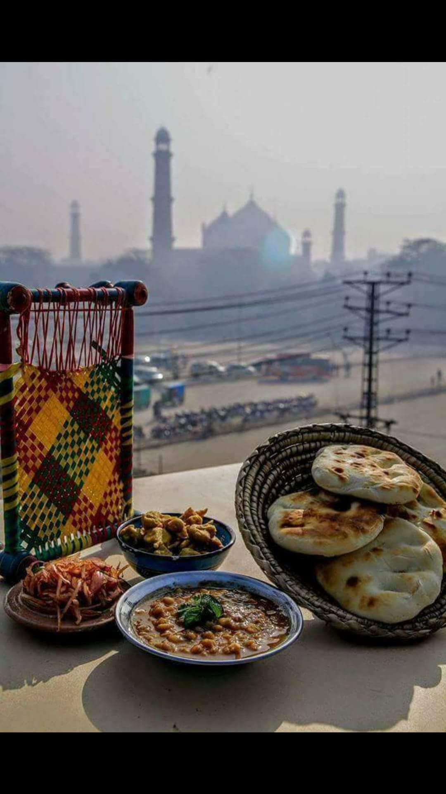

There are many religions which exist in Punjab. But the major population

comprises in the Indian state of Punjab are of Hindus and Sikhs. . The Sikh population is particularly high in the state owing to the origin of Sikhism.

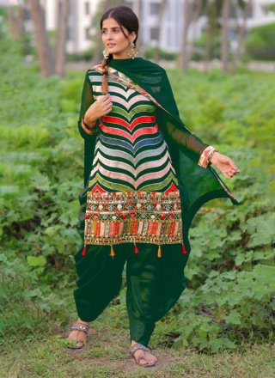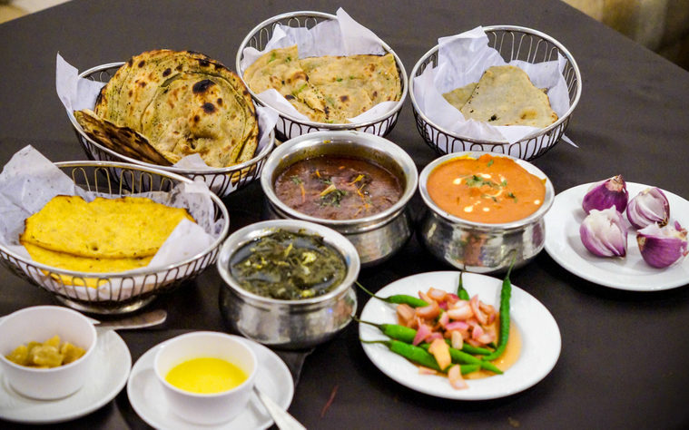

Makke di Roti (maize bread) and Sarson da Saag (mustard leaf curry) is traditional dish of Punjab.There are many other foods like Chole bhathure ,Rajma Chawal and Paneer naan ,but one of the humongous favourite is Tandoori Chicken.

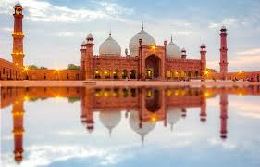

**SINDHI CULTURE**

Sindhi culture is rich and one of the oldest cultures in the world. It is renowned as the land of Sufis, peace, romance, and great cultural values Research has proved that it began from Mohenjo-Daro, some researchers even consider before that.

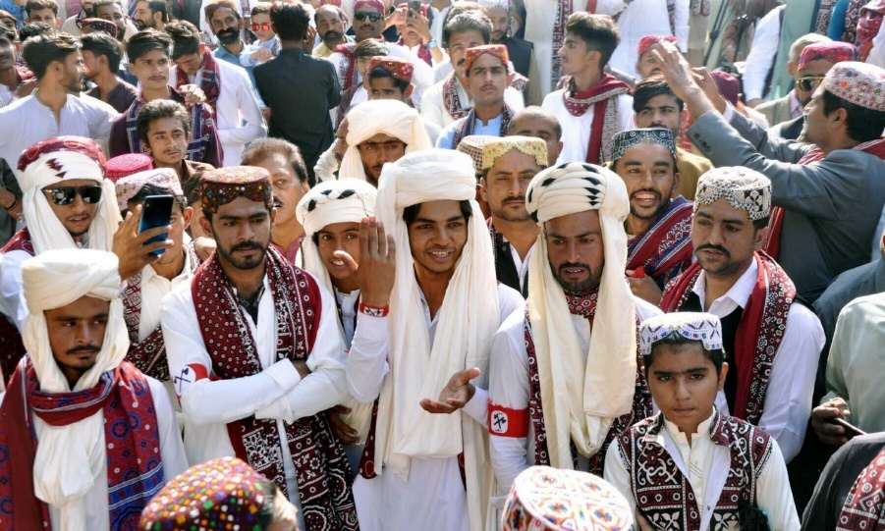Sindhi Ajrak is a shawl with blue and red floral patterns. Women wear Ajrak made clothes as well. Sindhi Topi (cap) is also a most used item.

The people of Sindh are skilled in a variety of arts and crafts. The province boasts of exquisite pottery, variegated glazed tiles, lacquer-work, hand-woven textiles like susi and ajrak and a variety of leather and straw products.

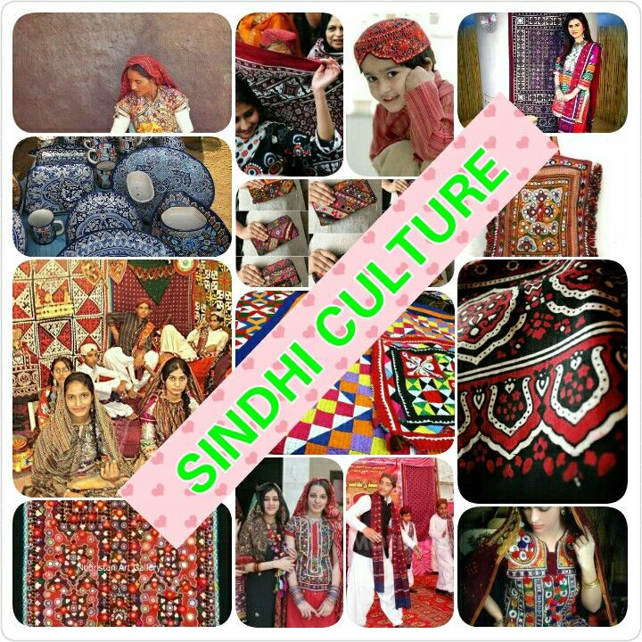

Sindhi females wear traditional embroidered clothes, while Sindhi men usually wear kurta and pajama.

People give cultural stuff to each other. Women wear Ajrak made clothes in marriges and other events.In marriges singer sings sindhi songs which show love and progress.

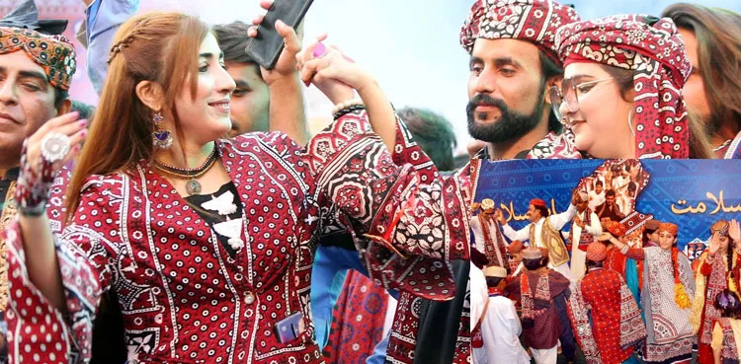

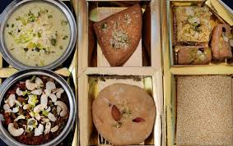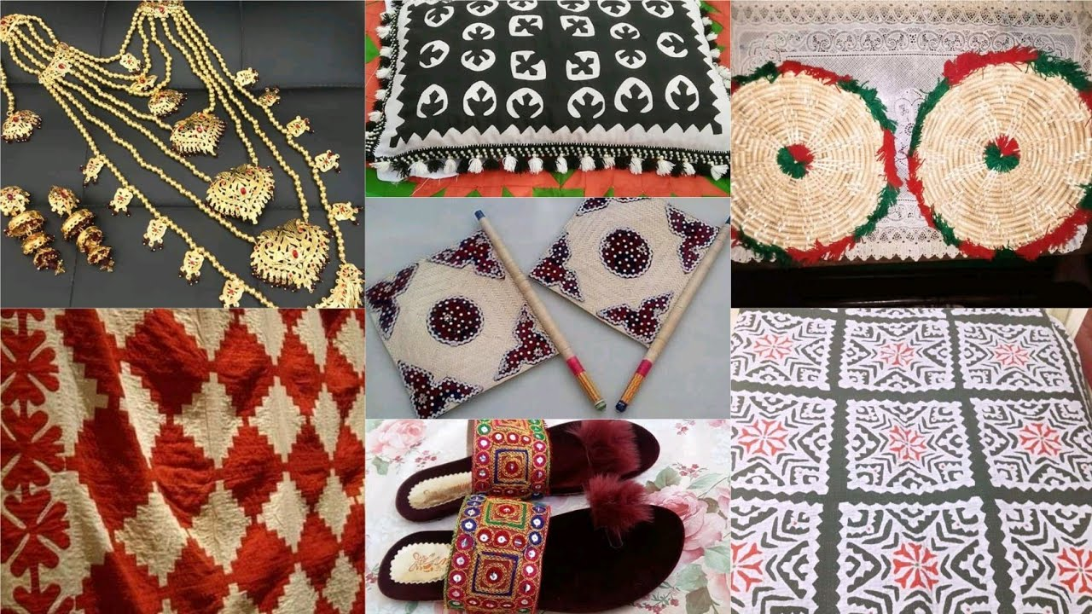**Sindhi Halwo** made with corn flour, water, ghee and dry fruits, it has jelly like texture

**Mao:** is a sweet dish made out of milk and sugar, milk is cooked until it becomes thick paste, then it is served with dry fruits and nuts.

**Mehar** city is famous for making Sindhi mao.

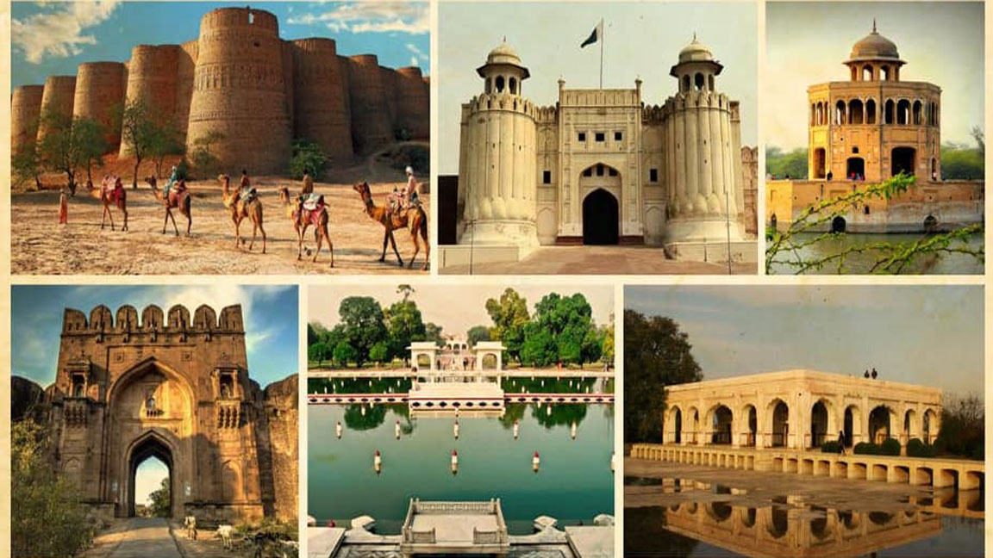

It is the **land of Sufis**, love, romance, and peace.Sindh is lucky that Sufis like Shah Abdul Latif bhittai, Lal Shabaz Qalandar, Sachal Sarmast, Abdullah Shah Ghazi, and many more belong to this area. Shah Abdul Latif has been the great Sufi poet known as the king of poets.

**BALOCHI CULTURE**

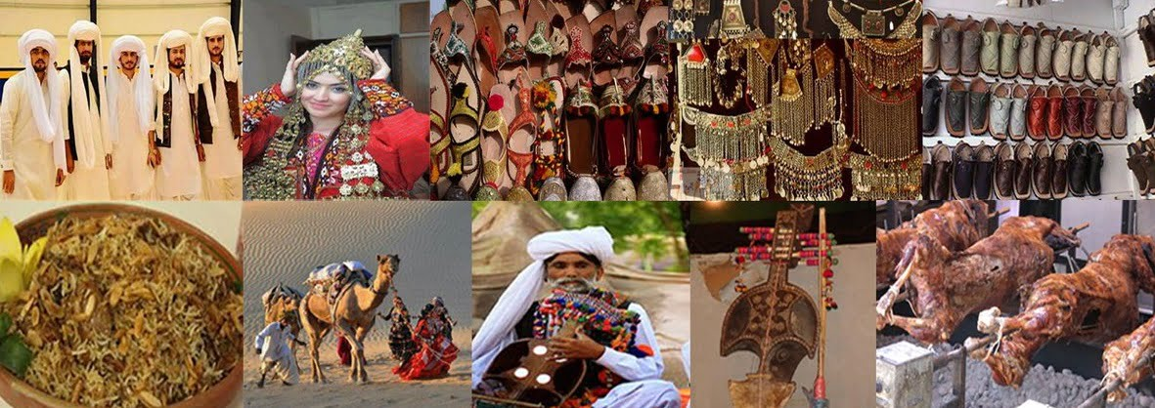

Balochi embroidery is one of the most popular arts and crafts that are done by the females. Balochi embroidery is known for its vibrant colour and design. Common motifs include flowers, diamonds, arrows etc. Balochi embroidery is one of the most popular arts and crafts which are done by the females

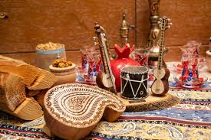

**Dressing** Turban is the common headwear of Bloch men along with wide loose shalwar along with knee-long shirts. Females dress consists of a shirt having a big pocket and embroidery and embedded round mirror work in front. A big Dupatta/ Chaddar is taken to cover the head and shoulders

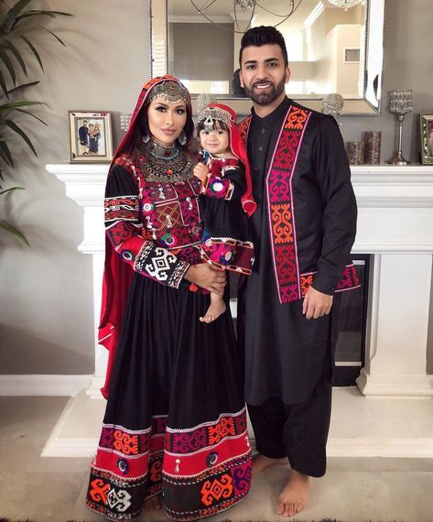

Though Balochistan is an area of barren lands, deserts and mountains, the Baloch culture is full of traditions, arts and crafts.

Baloch culture is full of many social festivals like Sibi festival which has folk music performance, cultural dances, handicrafts stalls, cattle shows and a number of other entertaining activities showing the colorful side of Baloch people.

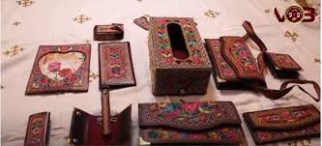

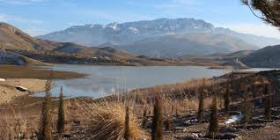The Kharan Desert is a sandy and mountainous desert situated in Balochistan province in south-western Pakistan. This desert was the site of Pakistan's second nuclear test, Chagai-II, which was carried out on 30 May 1998. The land is not fit for agriculture due to low irrigation.

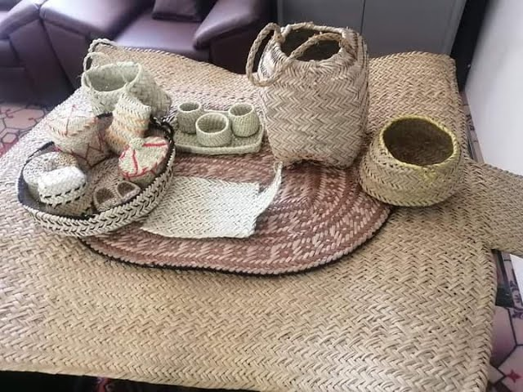

Usually Baloch people have meals in morning and evening. Wheat, millet and rice are part of the Baloch meal. Meat is also an important part; “Sajji” is the favorite dish of most people. Sajji is the food eaten with knife other than that Baloch people usually eat with hands.

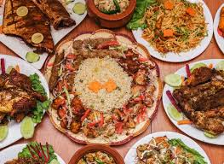

Milk, butter and vegetables are also part of Baloch cuisine. Baloch cuisine is noted for its traditional and unique food culture.

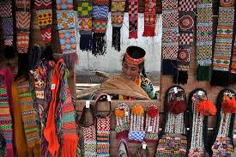**KPK CULTURE**

Khyber Pakhtunkhwa - The land of the Pashtuns, Pakistan's smallest province by land area but hosting unbelievably beautiful landscapes, drawing adventurers and explorers from all over

Khyber Pakhtunkhwa

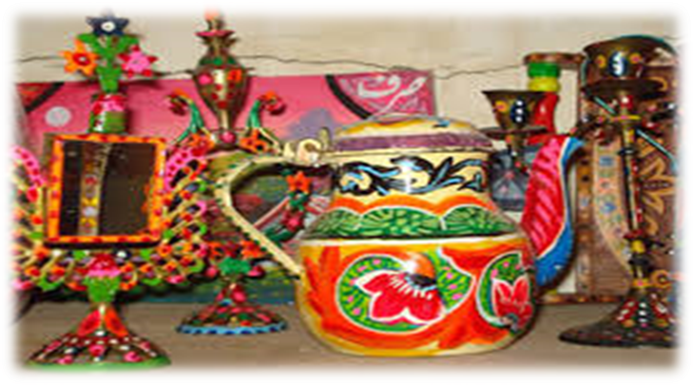The land of the Pashtuns, Pakistan's smallest province by land area but hosting unbelievably beautiful landscapes, drawing adventurers and explorers from all over.

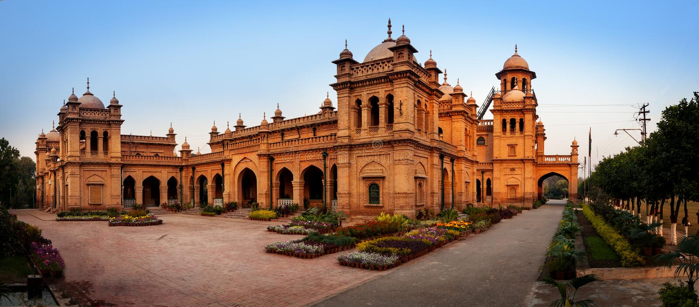

Traditional arts in the folk architecture maritime transport, weaving, folk performing arts, folk literature, folk graphic, plastic arts ornaments, textile or fiber art, pottery Philippines include , and other artistic expressions of traditional culture

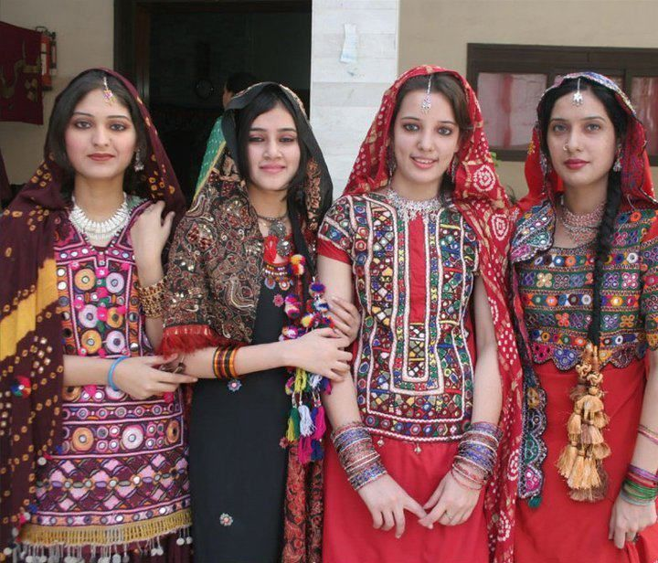The traditional dress for both men and women is the shalwar qamiz. Women also wear a burkha to cover themselves and sometimes a niqab or perda to cover their face

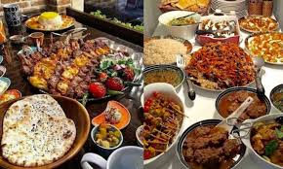

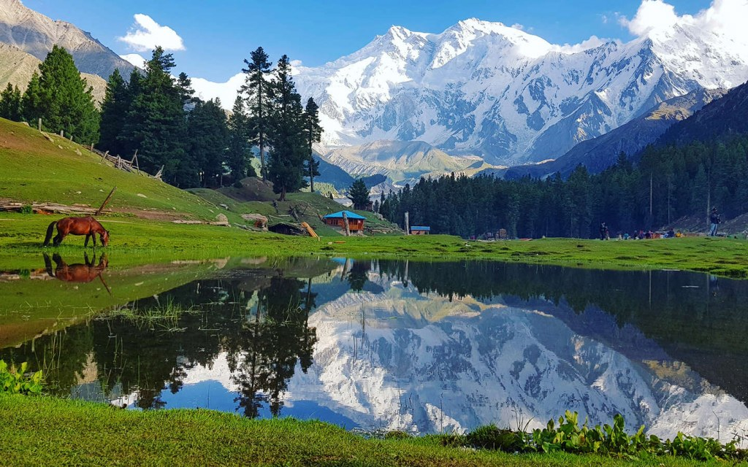Khyber Pakhtunkhwa is known for its natural beauty. The rugged mountains and lush greenery provide paradise-like views and the rich history

The traditional food delicacies of Khyber Pakhtunkhwa including Chappli Kabab, Roush, Mutton Karahi, BBQ and Painda are on the top list of foreign bloggers and U-tubers including Trevor James, Mark Weins and many more who visited the region

MADE BY

**NOOR FATIMA**

SECTION

**BCS 1A**

REG NO

**FA24B1-CS-010**

DEPARTMENT OF

**COMPUTER**

**SCIENCE**