**NAPPN Conference Proceedings Manuscript Template**

[NAPPN Conference proceedings template is based on [SPIE Proceedings Template](https://spie.org/conferences-and-exhibitions/photonics-west/presenters/manuscript-submission-guidelines). **Paper should be no longer than 4 pages without references**]

**Sample title: Mapping heat stress phenotypes in Maize**

[Center the paper title at the top of the page in 16-pt. bold. Only the first word, proper nouns, and acronyms are capitalized. Keep titles brief and descriptive. Spell out acronyms unless they are widely known.]

Jennifer Clarkea, **Malia A. Gehan**b

aUniversity of Nebraska, Lincoln, NE, USA; bDonald Danforth Plant Science Center, St. Louis, MO, USA

[The author list is in 12-pt. regular, centered. Omit titles and degrees such as Dr., Prof., Ph.D., etc. The list of affiliations follows. Each author's affiliation should be clearly noted, Please bold the presenting author]

**ORCiD:** [ORCiD of Presenting Author]

**ABSTRACT**

Begin the abstract two lines below author names and addresses. The abstract summarizes key findings in the paper. It is a paragraph of 250 words or less.

**Keywords:** select up to 8 key terms for a search on your manuscript's subject.

1. **INTRODUCTION**

Begin the Introduction two lines below the Keywords. The manuscript should have page numbers at the bottom right of each page. It should be in a one-column format. References are often noted in the text1 and cited at the end of the paper. Use Times Roman or another standard font to avoid font errors.

## 1.3 Section headings

Section headings are 12-pt. bold capitals, centered. Section numbers have whole numbers, e.g., 1, 2, 3… Do not number the “Data Availability Statement”, "Acknowledgements" and "References." Headings often used are: 1. Introduction, 2. Materials and Methods, 3. Results and Discussion, and 4. Conclusions.

## 

## 1.4 Subsection heading

Subsection headings are left-justified, 11-pt. bold. Capitalize the first word, acronyms, and proper nouns. For example you might have descriptive subsections for results and discussion.

## 

## 1.5 Paragraphs

Add a blank line above and below section headings and between paragraphs. Avoid headings or one-line paragraphs at the top or bottom of a page by using page breaks or extra blank lines. One method to preserve page breaks is to make the bottom margin a little larger than the specifications. Indentation is optional. This spacing is automatic if you are using the SPIE "section" styles in Word.

## 

## 1.6 Text

Unless otherwise specified, text is 11 point and justified. Each sentence ends with a period and a single space before the next sentence.

## 

## 1.7 Figures and captions

Figures are centered. Use or insert .png, .jpg, .tiff, or .gif illustrations instead of PowerPoint or graphic constructions. Captions go below figures. Indent 5 spaces from left margin and justify. Figures go within the text as close to their reference as possible. Center the figure within the page and do not wrap text. For example:

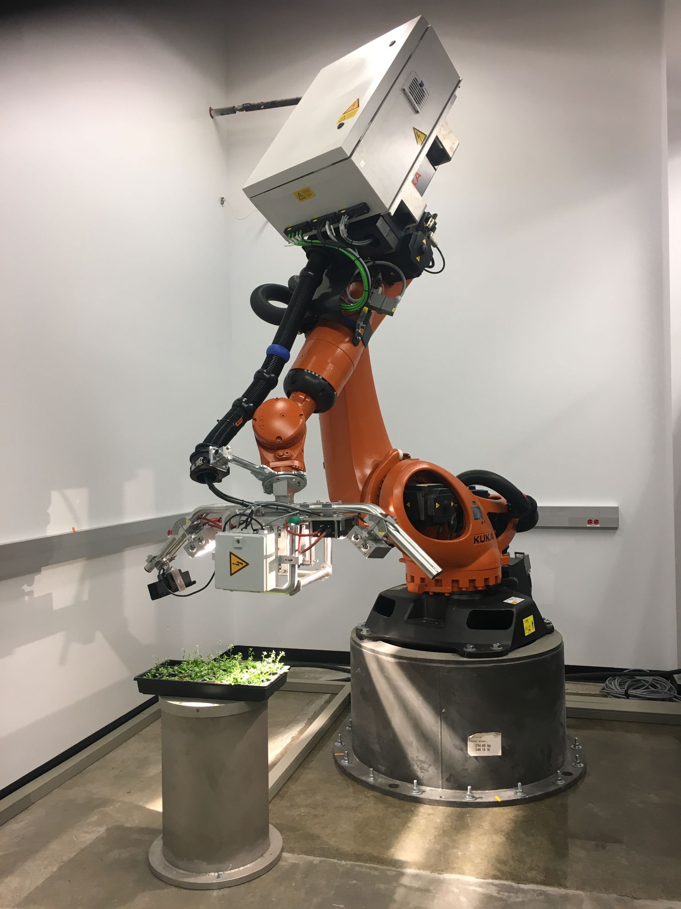

Figure 1. Figure captions are indented 5 spaces and justified. If you are familiar with Word styles, you can insert a field code called Seq figure which automatically numbers your figures.

**1.8 Tables and captions**

Tables are centered in the document. Make sure that all tables fit within paper margins. The caption goes above the table. The caption text should indent 5 spaces from the left margin and justify.

Table 1. Margins and print area specifications

|  |  |
| --- | --- |
| Letter |  |
| Top | 1.0 in |
| Bottom | 1.0 in |
| Left/Right | 1.0 in |

**1.9 Mathematical Equations**

Use common fonts like Times New Roman in your math equations.

Simple equations can appear in line with the text. Important equations should appear on their own line, centered, and numbered.

References to equations include the equation number in parentheses, for example, “Equation (1) shows ...”or “Combining Eqs. (2) and (3), we obtain...”

**DATA AVAILABILITY STATEMENT**

Please state the availability of data used in your project. We highly encourage all data sets to be made open and archived on appropriate repositories such as zenodo, figshare, etc.

**ACKNOWLEDGMENTS**

Please remember to acknowledge funding sources and include grant numbers.

**REFERENCES**

Denote reference citations within the text of your paper as shown below. List references at the end of the paper in numerical order, and enclose the reference number in square brackets. Include the following information (as applicable).

book: [1] Booth, N. and Smith, A. S., [Infrared Detectors], Goodwin House Publishers, New York & Boston, 241-248 (1997).

journal paper: [2] Davis, A. R., Bush, C., Harvey, J. C. and Foley, M. F., "Fresnel lenses in rear projection displays," SID Int. Symp. Digest Tech. Papers 32(1), 934-937 (2001).

proceedings paper:[3] Van Derlofske, J. F., "Computer modeling of LED light pipe systems for uniform display illumination," Proc. SPIE 4445, 119-129 (2001).

website: [4] Myhrvold, N., “Confessions of a cybershaman,” Slate, 12 June 1997, <http://www.slate.com/CriticalMass/97-06-12/CriticalMass.asp> (19 October 1997).

-OR-

[4] Myhrvold, N., “Confessions of a cybershaman,” Slate, 12 June 1997, http://www.slate.com/CriticalMass/97-06-12/CriticalMass.asp (19 October 1997).

[1] Booth, N. and Smith, A. S., [Infrared Detectors], Goodwin House Publishers, New York & Boston, 241-248 (1997).

[2] Davis, A. R., Bush, C., Harvey, J. C. and Foley, M. F., "Fresnel lenses in rear projection displays," SID Int. Symp. Digest Tech. Papers 32(1), 934-937 (2001).

[3] Van Derlofske, J. F., "Computer modeling of LED light pipe systems for uniform display illumination," Proc. SPIE 4445, 119-129 (2001).

[4] Myhrvold, N., “Confessions of a cybershaman,” Slate, 12 June 1997, <http://www.slate.com/CriticalMass/97-06-12/CriticalMass.asp> (19 October 1997). [www.optics4yurresearch.com/7752.html](http://www.optics4yurresearch.com/7752.html)

**REVIEWS**

Anonymous reviews will be published

**RESPONSE TO REVIEWERS**

Response to reviews will be published