**2.0 RESISTIVE NETWORKS**

**a.** intro to KVL and KCL

**b.** Use KVL and KCL to solve circuit

**2.1 TERMINOLOGY**

**a.** Junction where 2 + elements are connected = node

**b.** 2 + nodes connected= branch (aka edge)

**c.** Element = branch for only 2 elements

**d.** Since elements and branches are the same for circuits formed of two-terminal

elements, the **branch voltages and currents are the same as the corresponding terminal variables for the elements forming the branches.**

**e.** 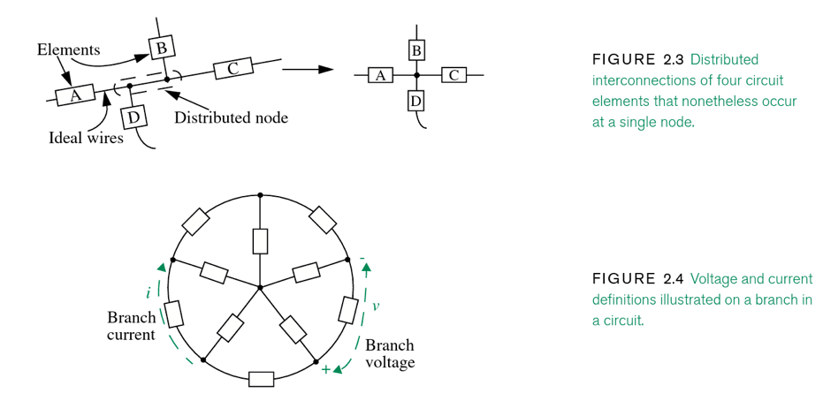

**2.2 KIRCHHOFF’S LAWS**

**a.** KVL and KCL derive from Maxwell’s equation.

**b.** They are lumped-parameter simplifications into a circuit

**2.2.1 KCL**

**a. What is KCL?** The current flowing out of any node in a circuit must equal the current flowing in. That is, the algebraic sum of all branch currents flowing into any node must be zero.

**b.** Current coming in through some branches = current going out through the other branches.

**c.** ia + ib + ic = 0

**d.** 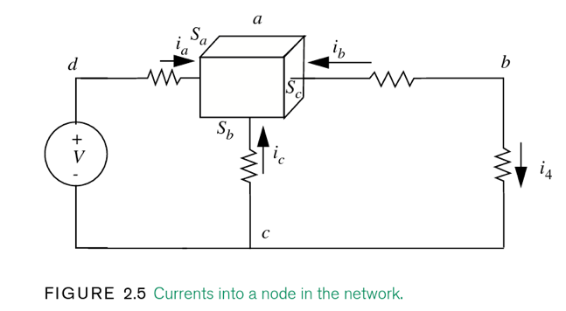

**in node a:** ia + ib + ic = 0

**in node b:** -ib – ic =0

**e.** 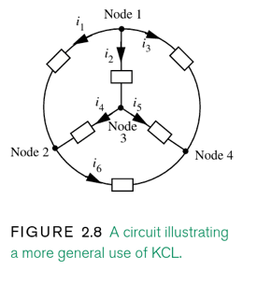

**f.** 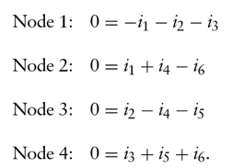

net current in = net current out. KCL analysis on this closed circuit. As such, adding all those equations sum to 0. A circuit with N node will have N-1 independent statements of KCL.

**2.2.2 KVL**

**a. What is KVL?** The algebraic sum of the branch voltages around any closed path in a network must be zero.

**i.** Voltage between two nodes is independent of the path along which it is accumulated.

**ii.** Like KCL, KVL is an expression of energy conservation.

**b. Look at the chpt book problems**

**2.3 CIRCUIT ANALYSIS: BASIC METHOD**

**a. Basics of circuit analysis:**

**i.** Define the branch and current voltage in the circuit in a CONSISTENT MANNER. IE. + VOLTAGE is CW flow into a + end of voltage.

**ii.** Assemble the element laws for the elements.

**iii.** Apply Kirchhoff’s current and voltage laws

**iv.** Jointly solve the equation assembled in Steps 2 and 3 for the branch

**2.3.1 SINGLE-RESISTOR CIRCUITS**

**a. How solve this single-resistor circuits:**

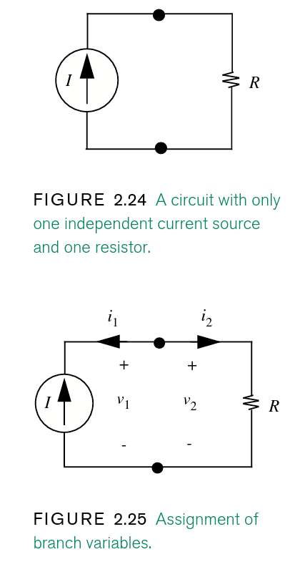

**i.** label the branch variables (figure 2.25)

**ii.** write the 2-element laws for these elements:

i1 =− I

v2 = Ri(2)

**iii.** i1 + i2 = 0 ; here i1 = -i2 (they are at opp.direction)

**clockwise motion:**

**iv.** v2 − v1 = 0

**Step 4:**

**v.** v1 = v2 = RI

− i1 = i2 = I

take the dots as nodes; see whether current is going away or towards it.

For the circuit in Figure2.25, there are four equations to solve for four unknown branch variables. In general, a circuit having B branches will have 2 B unknown branch variables: B branch currents and B branch voltages. To find these variables, 2 B independent equations are required, B of which will come from element laws, and B of which will come from the application of KVL and KCL. Moreover, if the circuit has N nodes, then N − 1 equations will come from the application of KCL and B − N + 1 equations will come from the application of KVL.

**2.3.3 ENERGY CONSERVATION**

**a.** Power has a (-) sign, current source actually supplies power.

**b.** Energy approaches:

**One energy approach:** equates the energy supplied by a set of elements in a circuit to the energy absorbed by the remaining set of elements in a circuit. Usually, this method involves equating the power generated by the devices in a circuit to the power dissipated in the circuit.

**Another energy approach:** equates the total amount of energy in a system at two different points in time (assuming that there are no dissipative elements in the circuit).

**c.**

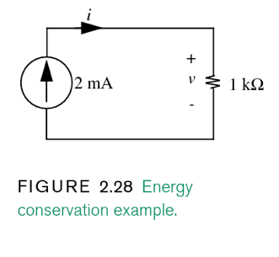

**Since the current source and the resistor share terminals, the voltage v appears across the current source as well.**

power dissipated by the resistor = power into the source

v × (−0.002) =− 0.002 v

v2/1k = 0.002v

Determine if i=3mA is correct:

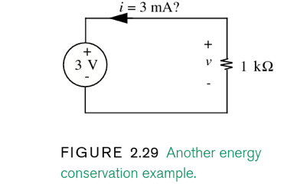

iv = i2R

i(3) = i2 (1000)

iv = 3(3) = 9mW

power into the source

i2R = 1000ohm x (3x10-3)2

= 9mW

it’s incorrect; power supplied by the source is -9mW; i should be (-):

-9mW + 9mW = 0

Look at chpt1 notes; Energy that is pumped into the source (voltage) is defined as +.

**2.3.4 VOLTAGE AND CURRENT DIVIDERS**

**a.** A divider comprise a single loop and 3 or + elements or two nodes and 3 + elements. Dividers produce fractions of input currents or voltages.

**i.** Useful for decreasing 10% of battery voltage at the terminals, ie v2.

**Voltage Dividers**

1. Voltage divider is an isolated loop that contains 2+ resistors and a voltage source is series.
2. **Deals with Voltages and resistors.**

**Question:**  find the relation between v2 and the battery voltage and resistor values

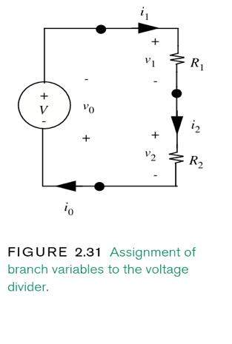

1. There are 3 elements and branches so there will be 6 branch variable (nodes) * 2 = number of branch variables. Label the graph.
2. Assemble KVL and KCL and solve them:

**KVL:**

v0 = -V

v1 = i1(R1)

v2 = i2(R2)

v0 + v1 + v2 = 0 (from CW direction, all hit + terminals)

**KCL**:

Take each node and see how current is flowing:

From far left:

i0-i1 = 0

i0 = i1

i1 – i2 = 0

i1 = i2

i2 – i0 = 0

i2 = i0

Thus i2 = i1 = i0

V = iR

i = V / R

i = V / R1 + R2 (resis. In series add)

because all I’s are equal, to find v2:

v2 = i2/r2

r2(v2) = V / R1 + R2

v2 = R2 (V) / R1 + R2

Let’s say we want to decrease v2 by 1/10 of the total voltage, R1 > R2 by 9x’s.

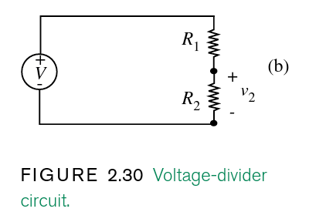

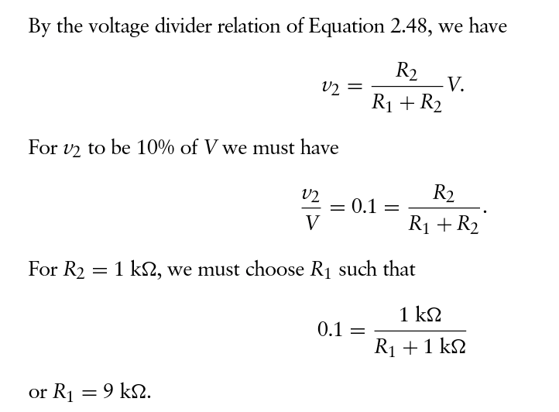

**Resistors in Series**

1. Rs = R1 + R2 + …
2. Conductances: 1/Gs = 1/G1 + 1/G2 + …
3. Problems

**Current Dividers**

**Current that is dividend proportionally to resistance**

1. Two nodes joining two or more parallel resistors with current going through.
2. **Deals with current and resistors**
3. Conductance:
   1. **i1 = G1/ (G1 + G2) I**
   2. **i2 = G2 / (G1 + G2) I**
4. 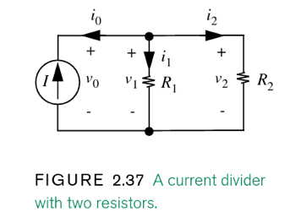

**Analysis of this circuit:**

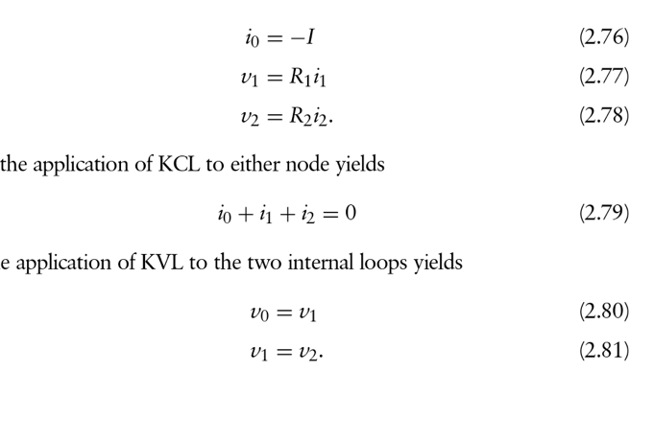

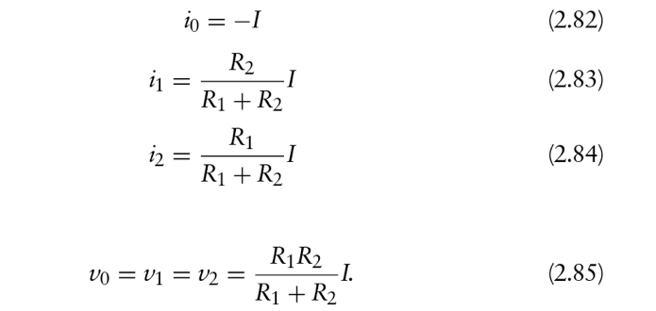

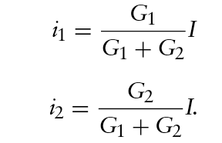

**Power into each resistor:**

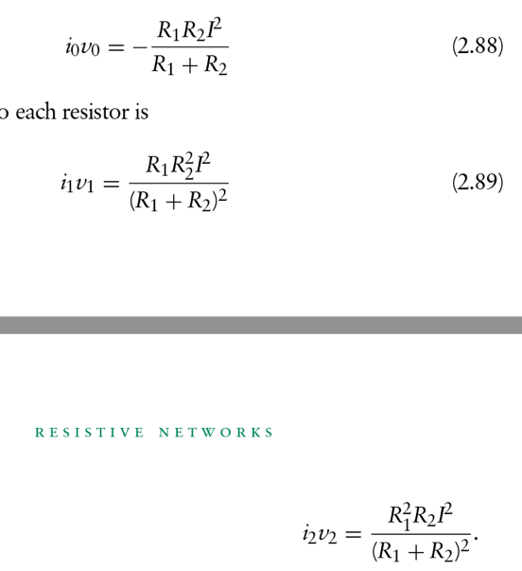

**Resistors in Parallel**

**a. v = R1(R2) / R1 + R2**

**b.** Resistors in parallel act as a single resistor and have a conductance of:

Gp = 1/Rp

**c.** Placing resistors in parallel essentially increases their combined

cross-sectional area:

GP = I/v = G1 + G2 .

1. <http://www.learningaboutelectronics.com/Articles/Current-divider-circuit.php>

**Differences between resistors in parallel and series:**

Series: The voltage you are trying to find is going to be the numerator of the resistor: V2 = (R2/R1+R2)Vmain_voltage

Parallel: Current you are trying to find is going to be the opposite of the resistor:

i2 = (R1/R1 + R2)Imain_current

**2.3.5 A MORE COMPLEX CIRCUIT**

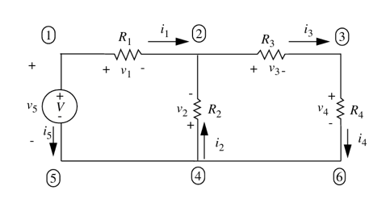

1. node 5 and 6 are not true nodes; they are just conductors (wire). A node should be
2. 2+ circuit elements, not just conductors, connected. Node 2 is a good example.

**2.4 INTUITIVE METHOD OF CIRCUIT ANALYSIS: SERIES AND PARALLEL SIMPLIFICATION**

1. 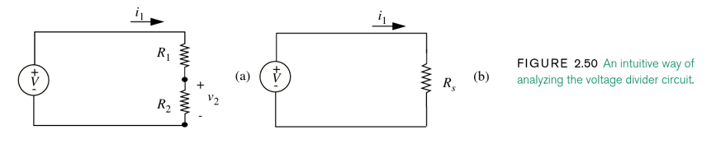

* we can sum R1 + R2 = Rs
* V = i1Rs

**i1 = V/Rs**

Because i1 is the same for both circuits:

* v2 = i1(R2)

**sub for i1 from eq. above:**

v2 **=** V(R2/R1+R2)

rest of chpt goes over problem of how to expand pg 91 in book.

**2.6 DEPENDENT SOURCES AND THE CONTROL CONCEPT**

**a.** Independent and dependent elements:

Independent: V and i: independent of circuit operations

Dependent: small v and I = dependent on the voltage and resistance (circuit elements)

**b.** MOSFET: in which a control voltage between one pair of terminals of the device determines the MOSFET’s behavior between another pair of terminals. Thus, when the multi-terminal dependent source is connected in a circuit, the behavior of the device can be controlled by a voltage or current in some other part of the circuit.

**c. VCC:** voltage controlled current source.