**DVB–SIS**

**(Single Illumination System)**

**Concept and Implementation**

Revision History 5

1. Introduction 6

2. Scope 7

3. Concept 8

3.1 Concept behind the SIS Standard – parent and daughter sites 8

3.2 Specification of Parent Signals 9

3.2-1 Service information (PSI/SI) 9

3.2-2 SIS Services carrying PCRabs 10

3.2-3 Layer 1 signaling 10

3.2-3-1 DVB-T2 case 10

3.2-3-2 DVB-T case 10

3.2-4 Other T2-MI packet types (DVB-T2 case) 10

3.2-5 Framing & Timing Information (F&TI) 10

3.2-5-1 DVB-T2 case 11

3.2-6 DVB-T case 11

3.2-7 DSA configuration information (DSACI) 11

3.2-7-1 DSA structure 11

3.2-7-1-1 XML schema representation 11

3.2-7-2 XML types and XML elements of the DSA configuration information 12

3.2-7-2-1 global configuration 12

3.2-7-2-2 Input configuration 12

3.2-7-3 Remultiplexing 12

3.2-7-4 PID processing 12

3.2-7-5 Service and PMT processing 12

3.2-7-6 PSI/SI processing 12

3.2-7-7 PAT processing 12

3.2-7-8 CAT processing 13

3.2-7-9 SDT and BAT processing 13

3.2-7-10 EIT processing 13

3.2-7-11 Output configuration 13

3.2-8 DSA schema 13

3.2-9 In-band carriage of the DSACI XML file 13

3.2 Carriage of signal components within the parent transport streams 13

3.3 Daughter site processing 14

3.3-1 Bootstrapping 15

3.3-1-1 Gaining access to DSACI provided in-band 15

3.3-1-2 Out-of-band DSACI provision 16

3.3-2 Input processing 16

3.3-2-1 Reception of parent transport streams 16

3.3-2-2 Arrival timestamping 16

3.3-2-3 Calculation of virtual timestamps (VATs) 16

3.3-2-3-1 CBR operation mode 16

3.3-3 TS re-multiplexing 16

3.3-3-1 TS DVB-T2 case 17

3.3-3-2 TS DVB-T case 17

3.3-3-2-1 Extraction of F&TI packets 17

3.3-4 Selection of relevant content from input TSs 17

3.3-5 Processing and generation of layer 2 signaling (PSI/SI) 17

3.3-5-1 Pass-through remultiplexing of selected parent tables/sections 18

3.3-5-2 conversion of parent table/sections on the fly (patching) 18

3.3-5-3 static table regeneration 18

3.3-5-3-1 SDT and BAT regeneration 19

3.3-5-4 Dynamic table regeneration 20

3.3-6 Placement of incoming packets in the outgoing TS 20

3.3-6-1 Deterministic scheduling 20

3.3-3 Framing 21

3.3-3-1 DVB-T2 case 21

3.3-3-1-1 TS splitting (optional) 21

3.3-3-1-2 Partial mode adaptation 21

3.3-3-1-3 Allocation of TS bits to interleaving frames 22

3.3-3-1-4 Null packet deletion 22

3.3-3-1-5 ISSY generation 22

3.3-3-1-6 Generation of BBFRAMEs 22

3.3-3-1-6-1 Allocation of bits to the BBFRAMEs of the interleaving frame 23

3.3-3-1-6-2 Mapping of mode-adapted bits into the BBFRAMES 23

3.3-3-1-6-3 BBHEADER generation 23

3.3-3-2 DVB-T case 23

3.3-4 Extraction of T2-MI packets 23

3.3-5 Output processing 24

3.3-5-1 DVB-T2 case 24

3.3-5-1-1 T2-MI multiplexing 24

3.3-5-1-2 Transport of T2-MI packets in MPEG-TS 24

3.2 Preparation of metadata and content on parent site: 25

3.3 Processing of metadata and content received on daughter site 27

3.4 Output to T2 modulators: 28

3.5 timing 28

3.6 Clock referencing from DSA in- to output 29

3.7 Environment of standard around SIS 30

3.8 Layer 1 signaling, another T2-MI packet types 32

3.9 Structure of the SIS standard (Parent Site): 34

3.10 Structure of the SIS standard (Daughter Site): 35

3.11 Bootstrapping 36

3.12 TS Remultiplexing 36

3.13 Framing 39

3.14 Extraction of T2-MI packets from signal received via interface H 40

3.15 Output process 40

4. HW Modules Used 40

5. SW Used 42

6. OS Used 42

# Revision History

|  |  |  |
| --- | --- | --- |
| **Revision History** | | |
| **Date** | **Description** | **Modified By** |
|  |  |  |
|  |  |  |
|  |  |  |

# Introduction

DVB-SIS (Single Illumination System) allows for terrestrial retransmission of signals addressing DTH satellite receivers. SIS stands for single illumination system, referring to the fact that a single satellite beam can be used simultaneously for DTH and to feed terrestrial networks.

Since the standard has been designed in a generic way, the satellite/terrestrial use case is just one possibility; in the future other use cases could be realized using DVB-SIS, e.g., a cable/terrestrial combination. The common denominator for all use cases is the deployment of MPEG-2 transport streams.

The DVB-SIS concept consists in deriving content and metadata from one delivery path (e.g., satellite) for re-delivery via another path (e.g., terrestrial). The video content for both paths is assembled into a single transport stream at a so-called parent site and broadcasted on the single network path; the video content for the other path is derived at the so-called daughter sites.

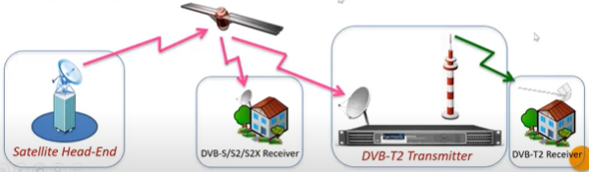

Figure 1.1: DVB-SIS (Single illumination System)

# Scope

This document will cover only the implementation of DVB-SIS from the software point of view, device driver of the modules being used, operating system, plug-in tools, and other software involvement.

The hardware or module using high level functionality will be discussed but not at the circuitry level.

# Concept

Concept behind the DVB-SIS Standard

Deriving content and metadata from delivery path A (e.g., satellite) for re-delivery via path B (e.g., terrestrial)

A chain consists of parent and daughter sites (generic concept, i.e., works for different A/B combinations)

Concepts cover SFN needs, i.e., enable output of bit-by-bit the same T2-MI stream from each DSA belonging to the same SFN.

At central interface H the following data is available:

* Service content (TV/Radio) and related PSI/SI
* Metadata produced by the CSG

In the end it is irrelevant how the content and metadata is produced for interface H

The metadata enables deterministic processing on daughter site.

## 3.1 Concept behind the SIS Standard – parent and daughter sites

* Control signal generator (CSG):
  + Produces all metadata required:
    - Framing & timing information (F&TI)
    - DSA configuration information (DSACI)
    - SIS services
* Daughter site adapter (DSA):
  + Receives n TSs at its input (interface J)
  + Allows for "out of band" input of DSACI via other paths (interface K)
  + Produces a single T2-MI stream at its output (interface L)

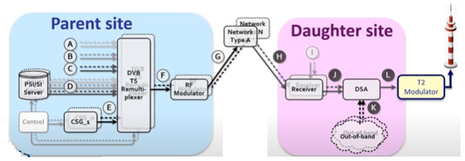

Figure 3.1-1: Parent and Daughter Site

## 3.2 Specification of Parent Signals

The parent signals at interface H shall comprise one or more DVB transport streams to ISO/IEC 13818-1 [5] and suitable for direct reception by DVB-compliant consumer receivers. Those transport streams contain DVB services as defined in ETSI EN 300 468 [6] and SIS metadata for generation of the T2-MI or mega-frame stream at the output of the DSA, i.e., Framing & timing information as well as DSA configuration information for the generation of the DTT multiplex.

### 3.2-1 Service information (PSI/SI)

PSI/SI signaling as defined in ISO/IEC 13818-1 [5] and ETSI EN 300 468 [6] shall be part of the parent signals for the types of services present in the multiplexes addressing the daughter site adapter:

* Parent network-only services
* Common services addressing parent network receivers and terrestrial transmitters:
  + The parent signal shall also include supplementary PSI/SI for DTT and DSACI configuration information, which is combination with the PSI/SI for the parent network enables the DSA to generate PSI/SI for the same services when re-transmitted terrestrial. The supplementary DTT PSI/SI is sent compliment to ISO IEC 13818-1 [5] and ETSI EN 300 468 [6].

The present document describes different approaches for the generation of DTT PSI/SI. These approaches will require the following information as part of the parent signal:

* Tables whose provision as stopped:
  + The parent signa; shall contain indication for stopping the provision of CATs as part of DSACI.
* Tables passed through with no change:
  + The parent signal shall contain DSACI signaling for PID remapping of the parent network PSI/SI table (PID remapping with same PID on parent network and DTT may be used).
* Tables which are modified using section patching:
  + The parent signal shall include parent network PSI/SI sections and DSACI signaling for the patching modification.
* Tables that are regenerated by the DSA:
  + The parent signal shall include parent network PSI/SI section and DSACI signaling for the table regeneration and multiplexing.
* DTT-only services, for which PSI/SI is carried as for all other services – with this exception:
  + SDT-DTI-only services shall be declared in the service description table as data services,
  + i.e., characterized by service_type 0C16 (data broadcast service)

### 3.2-2 SIS Services carrying PCRabs

Each parent signal shall include a generated SIS service. This service carries PCRabs using the transport packet adaptation mechanism (see ISO/IEC 13818-1 [5]) on a PID that is designated as the PCR_PID in the PMT

The primary SIS service shall consist of the F&TI component, while in other SIS services from other parent signals the F&TI component is optional. In a single DSACI, a unique SIS services as flagged as primary. Hence the F&TI component of other SIS services may be ignored. In the case that the parent signal includes the F&TI component, this F&TI component may be sent on the PCRabs_PID.

A CSG shall be able to generate a DSACI file for configuration of re-transmitted services in the terrestrial modulation. That DSACI file shall – if provided – be part of the primary SIS services. Other SIS services may include DSACI for other terrestrial multiplexes.

Any SIS services may also consist of terrestrial PSI/SI for sheer terrestrial and hybrid services.

### 3.2-3 Layer 1 signaling

#### 3.2-3-1 DVB-T2 case

L1 signaling consists of T2-MI packets of type 1016 (L1-current) and, if applicable. Type 1116 (L1-future), as defined in ETSI TS 102 773 [1], T2-MI packets of type 1016 are used for DSA processing. T2-MI packets of type 1116 are simply piped through the DSA

#### 3.2-3-2 DVB-T case

L1 signaling for DVB-T shall be carried in an F&TI packet – based on the MIP structure (see ETSI TS 101 191 [4]).

### 3.2-4 Other T2-MI packet types (DVB-T2 case)

For DVB-T2 use case, a single CSG prepares all T2-MI packet types – except for the baseband frame type 0016. T2-MI packets of type BBF are created by the DSA and are inserted by the T2-MI multiplexer on daughter site. the same CSG shall provide T2-MI packets of type F016 carrying framing & timing information. The latter packets shall not be part of the T2-MI stream output as interface L, they are dedicated to DSA process only.

### 3.2-5 Framing & Timing Information (F&TI)

The framing & timing information provides metadata required by the DSA for building – in the DVB-T2 case – BBFRAMEs. Interleaving frame and T2-frames. In the DVB-T case mega-frames are built. The details of this deterministic process.

#### 3.2-5-1 DVB-T2 case

F&TI for DVB-T2 shall be carried in a T2-MI packet of type F016. The T2-MI packet shall be coded as shown in table 2. one such packet shall be sent for each T2-frame – prior to the provision of the data and metadata that T2-frame.

### 3.2-6 DVB-T case

Framing & timing information (F&TI), for DVB-T shall be carried in a MIP packet (see ETSI TS 101 191 [4]), to which the megaframe_timestamping function is added. The transport_packet_header has its PID defined by DSACI. I.e., the details PID for MIPs is not used. This way an F&TI packet is formed by the CSG.

This packet follows the MIP payload syntax shall carry a megaframe_timestamping function that belongs to a function loop broadcast to all transmitter (000016 is used as tx_identifier). On daughter site. The DSA shall remove the function when building actual MIP packets for the DVB-T transmitter.

Exactly one such packet shall be sent for each T mega-frame.

### 3.2-7 DSA configuration information (DSACI)

The definition of DSA Configuration information is applicable to both terrestrial transmission systems covered by the present document. i.e., DVB-T2 (ETSI-EN 302 755 [2]) and DVB-T (ETSI EN 300 744 [3])

The DSA is configured on the basis of the DSA configuration information (DSACI) provided by the CSG. DSACI is formatted as an XML. File, which provides all parameter settings required. Below all elements belonging to DSACI are outlined, namely the global configuration, the input configuration, the re-multiplexing and the output configuration.

This XML file may be provided to the DSA either in-band or out-of-band. In the latter case the transfer of the file to the DSA is user-defined and not covered by the present document. For in-band provision a carousel approach based on private section is used.

#### 3.2-7-1 DSA structure

##### 3.2-7-1-1 XML schema representation

Table 4 outlines by the top-level XML. Schema structure of the DSA configuration information.

#### 3.2-7-2 XML types and XML elements of the DSA configuration information

##### 3.2-7-2-1 global configuration

The XML type_global_configuration consists of the XML elements current_DSA_group_id. Global_version_number, global_application_time and SIS_edition.

##### 3.2-7-2-2 Input configuration

The XML type_input_configuration identifies the transport streams at the input stage of the DSA services and service components are to be extracted from the daughter site re-transmission. This XML type also assigns a replacement identifier – source_id – to the double input_TS_id/input_ON_id. Furthermore, it identifies the PID of the PMT belonging to the SIS service and indicates the single primary SIS service

#### 3.2-7-3 Remultiplexing

The XML type_remultiplexing assigns output transport stream to physical layer pipes – in the case of DVB-T2. In the DVB-T case the PLP_ID has no meaning and should be ignored. Each PLP/TS assignment also consists of the elements pid_processing. Service_pmt_processing and psisi_processing. The latter element, in turn, consists of the element <pat>, <cat>, <sdt_bat> and <eit>/

#### 3.2-7-4 PID processing

The XML type_pid_processing replaces packet identifiers at the input of the DSA by PIDs as they shall appear at the output of the DSA. Packet identification being part of subsequent DSACI XML type is in almost all cased base on the element output_PID.

#### 3.2-7-5 Service and PMT processing

The XML type_service_pmt_processing maps service identifiers, service names and provider names from the related input settings to the corresponding output settings – for all services belonging to a single output TS. It also defines how PMTs are to be processed and identifies the still applicable CA systems for each service component. Note that descrambling for free-to-air terrestrial provision of service components takes place in the receivers being part of DSA machinery.

#### 3.2-7-6 PSI/SI processing

The XML type_psisi_processing consists of the XML elements pat, cat, sdt_bat and eit.

#### 3.2-7-7 PAT processing

The XML type_pat_processing_mode covers the processing of program association tables – see ISO/IEC 13818-1 [5] - and indicates the repetition period of those, their time offset to the beginning of the insertion windows. For the insertion window mechanism – as well as the version number of regenerated PATs.

#### 3.2-7-8 CAT processing

The XML type_cat_processing_mode covers the processing of conditional access tables – see ISO/IEC 13818-1 [5] - and indicates in the case of the patching the CAS identifiers as well as the EMMs to be retained, and in the case of regeneration this XML type assigns the repetition period of those, their time offset to the beginning of the insertion window. For the insertion window mechanism – as well as the version number of the CATs to be regenerated and output.

#### 3.2-7-9 SDT and BAT processing

The XML type_sdt_bat_processing_mode covers pass-through, patching and regeneration of service description tables and bouquet association tables – see ETSI EN 300 468 [6] - and indicates in the case of patching the DSACI sets for other multiplexes as well as it maps input bouquet identifiers to output ones. In the case of regeneration this XML type assigns an integer multiplier M_actual of the different repetition periods of SDT_other's as well as assigning further parameters making up the regenerated SDTs and BATs

#### 3.2-7-10 EIT processing

The XML type_eit_processing_mode covers pass-through, patching and regeneration of event information tables – see ETSI EN 300 468 [6].

#### 3.2-7-11 Output configuration

The XML type_output_processing configures the output TS(s) of the DSA as either a DVB-T-mega-frame stream (DVB-T case) or encapsulates the T2-MI packets at the output of the DSA into TS packets (interface L)

### 3.2-8 DSA schema

The DSACI schema, i.e., the mandatory XML syntax of the configuration information for the daughter site adapter is defined in annex A.

### 3.2-9 In-band carriage of the DSACI XML file

The DSACI XML file built on the basis of the schema described in clause 5.7.4 is gzipped prior to provision to the DSAs – in compliance with RFC1952 [12]

## 3.2 Carriage of signal components within the parent transport streams

Service components and PSI/SI intended for direct reception of the parent signal by commercial receivers shall be carried using the normal DVB mechanisms as specified in DVB-S, ETSI EN 300 421 [8], DVB-S2/S2X, ETSI EN 302 307-1 [9], ETSI EN 302 307-2 [10], DVB-T, ETSI EN 300 744 [3], DVB-T2, ETSI EN 302 755 [2] and DVB-SI, ETSI EN 300 468 [6].

## 3.3 Daughter site processing

The daughter side adapter (DSA) consists of the following stages that perform the listed operation (DVB-T2-specific operations appear in bold character, DVB-T-specific operations in *Italic characters*):

* Bootstrapping
  + Locate DSACI in-band or out-of-band (manual configuration)
* Input processing
  + Identification of the transport streams at the input stage of the DSA services and service components are to be extracted from for daughter site re-transmission.
  + Identification of the PIDs of the PMTs belonging to the SIS Services (one per Parent Signal)
  + Identification of the single Primary SIS Service beneath all SIS Services being part of the Parent Signals
  + (Virtual) arrival timestamping
* TS remultiplexing
  + Assigning output Transport Streams to Physical Layer Pipes - in the case of DVB-T2
  + Generation of Reference Transport Stream(s).
  + Selection of relevant content from input TSs
  + PSI/SI selection and insertion (optionally also generation of PSI/SI tables/sections).
  + Deterministic re-multiplexing.
* DVB-T mega-framing
  + Remove megaframe_timestamping function
* DVB-T2 baseband framing
  + TS splitting (optional).
  + Terrestrial Framing.
  + Null Packet Deletion (optional).
  + Baseband Frame generation.
* T2-MI packet handling
* Output processing

The aforementioned stages and tasks are illustrated with figures 5 and 6 for the DVB-T2 and -T cases respectively and are explained in the following clauses. Input processing and TS re-multiplexing are widely common for both broadcast systems - T2 and T. Framing, T2-MI packet handling and output processing, in turn, are T2- and T-specific. The structure of clause 6 reflects these circumstances

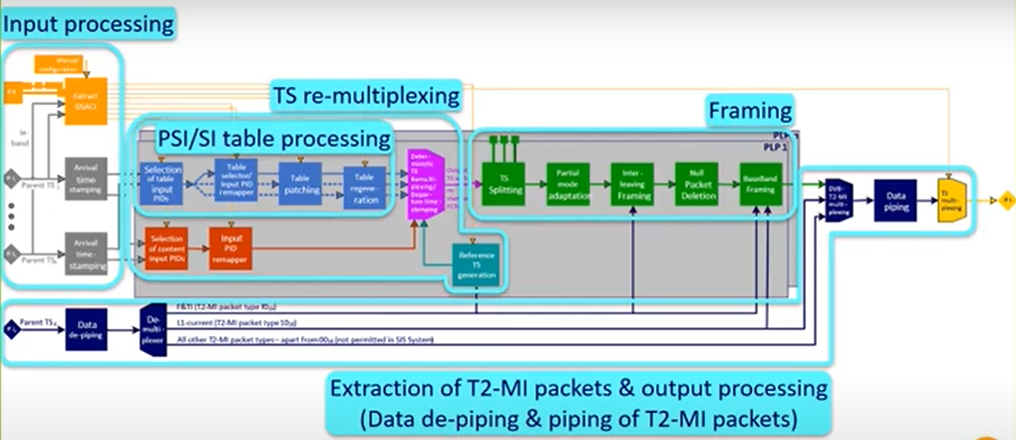

Figure 3.3a: DSA processing (DVB-T2 case)

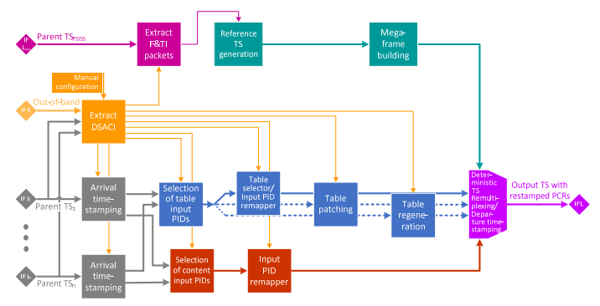

Figure 3.3b: DSA processing (DVB-T case)

### 3.3-1 Bootstrapping

The configuration of the receivers providing the Parent Signals to the DSA is out of scope of the present document. The described operations either for bootstrapping or any other later processing are based on the assumption that the different involved Parent Signals (Transport Streams) have been made available to the DSA.

The bootstrapping operation for the DSA consists of providing the DSA the path to the DSACI. Two cases are described - whether the DSACI is provided in-band (i.e. in one of the Parent Signals) or out-of-band.

#### 3.3-1-1 Gaining access to DSACI provided in-band

The initial manual configuration of the DSA consists of providing to the DSA the following:

* The [TSid/ON ID/Program Id] triple corresponding to the Primary SIS Service in the relevant Parent Signal where the DSA will find the current DSACI component.
* The current_DSACI_group_id identifying the current DSACI that this particular DSA shall use.

#### 3.3-1-2 Out-of-band DSACI provision

When DSACI is provided out-of-band, the initial manual configuration of the DSA consists of providing to the DSA the following:

* The path or location (eg URL, address, ..) where the DSA can find the current DSACI file.
* The current_DSACI_group_id identifying the current DSACI that this particular DSA shall use.

### 3.3-2 Input processing

#### 3.3-2-1 Reception of parent transport streams

The Daughter Site Adapter (DSA) receives one or several parent multiplex(es). Those are indicated by the DSA Configuration Information (DSACI) the DSA receives from the CSG.

The Daughter Site Adapter receives one or several parent Transport Streams. These DVB TS packets may be received over any standard DVB Transport Stream interface, such as DVB-S, -S2 or S2X, ASI or encapsulated within IP packets in accordance with ETSI TS 102 034 [7].

#### 3.3-2-2 Arrival timestamping

For each input TS on interface(s) H, packets shall have a timestamp (packet_arrival_time) computed according to the incoming PCRabs values:

#### 3.3-2-3 Calculation of virtual timestamps (VATs)

The Virtual Arrival Timestamping method enables insertion of TS packets that are not present in the Parent Signal or of TS packets that are regenerated by the DSA. This may be done to save bandwidth in the Parent Signal, for example by generating DTT PMT or EIT sections on daughter site as an alternative to receiving those from the CSG. The mechanism for the generation of a stream of TS packets ensures that multiple DSAs generate identical packets and an identical packet sequence.

Below, the method for insertion of TS packets generated with constant packet rate is defined. This method is intended for use for e.g. the insertion of regenerated PMTs.

##### 3.3-2-3-1 CBR operation mode

The Virtual Arrival Timestamp of TS packets is calculated by the DSA based on a time interval indicated as part of the DSA Configuration Information. The time interval in question is equivalent to the indicated table_repetition_period. The DSA converts that table_repetition_period into a time interval for the insertion of TS packets carrying the corresponding PSI/SI table sections as follows:

### 3.3-3 TS re-multiplexing

The TSs for each PLP shall be created by first generating a Reference TS (see clause 6.4.2), and then replacing null packets with selected packets from the incoming parent TSs, with packets stemming originally from the incoming parent TSs but were modified, and with packets generated locally by the DSA. Figure 6 illustrates the TS remultiplexing in detail, because for the DVB-T case that represents a major part of the DSA processing.

#### 3.3-3-1 TS DVB-T2 case

There shall be one RTS for each data PLP, but the RTSs for the PLPs within the same PLP_GROUP shall be identical in case a common PLP is present, see ETSI EN 302 755 [2].

The RTS shall include packets with PCRabs values equal to values of the PCRFTSP signaled in the F&TI signaling packets for the relevant PLP. Between these packets there shall be further Null packets with equally spaced PCRabs values (as defined below), such that the total number of packets including the packet with a given PCRFTSP value up to but excluding the packet with the subsequent PCRFTSP value shall be equal to the frame_packet_count in the T2-MI packet carrying F&TI containing the first PCRFTSP value.

#### 3.3-3-2 TS DVB-T case

In the case of DVB-T, a mega-frame building block, see ETSI TS 101 191 [4], sits between the Reference Transport Stream generator and the TS remultiplexer, see figure 6. The latter remultiplexer is directly connected to interface L.

##### 3.3-3-2-1 Extraction of F&TI packets

The F&TI packets are extracted by the DSA. The modulation parameters TPS are derived from the F&TI packets.

The DSA shall remove the megaframe_timestamping function when building the MIP packet for the DVB-T transmission and shall change the PID to the standardized PID 1516.

PCRabs is then assigned to the MIP packet.

The bitrate of the Reference Transport Stream, and therefore the number of packets in a mega-frame, NMF, is defined by the modulation parameters TPS.

The PCRabs value associated with the MIP packet for mega-frame n, denoted PCRmf (n), shall be equal to the value given by the PCR_ABS_BASE and PCR_ABS_EXT fields signaled in the megaframe_timestamping function of the MIP packet

### 3.3-4 Selection of relevant content from input TSs

The services and service components that shall be extracted for terrestrial re-transmission are determined by the DSA Configuration Information (DSACI). Within a Transport Stream, the TS packets are selected by PID.

The PID component selection shall also be used for remapping of PSI/SI sent on hidden PIDs.

### 3.3-5 Processing and generation of layer 2 signaling (PSI/SI)

Terrestrial PSI/SI is inserted into the output TS in a way that enables the receiver/decoder to select and locate the broadcast services and the components of the services. PSI/SI is partly dynamic and time-accurate to support changes in the service status and changes in the service composition.

PSI/SI for the terrestrial multiplex also assists the viewer in selecting services and the related events.

The following clauses detail the four methods available for insertion of terrestrial PSI/SI by the DSAs - depending on instructions being part of DSACI.

#### 3.3-5-1 Pass-through remultiplexing of selected parent tables/sections

When a Parent Signal component is also applicable to a DTT multiplex, it may be passed to the output without content modification. When the CSG builds a DSACI that complies with this situation. the DSA shall pass through all packets of the target PSI/SI component. According to the DSACI, the output PID may be modified to match the DTT PSI/SI consistency.

The CSG may also use this method to send DTT PSI/SI sections in Parent Signal on non-default PIDs and build the DSACI so that the DSA will remap the PIDs to match DTT PIDs. These sections are part of an SIS Service.

#### 3.3-5-2 conversion of parent table/sections on the fly (patching)

In addition to the method described above, the conversion mechanism may be used to modify table attributes according to the DSACI inserted by CSG. This method is applicable when the modified table does not need repacketization: Only CRC updates and section invalidation using stuffing sections are allowed. To ensure Continuity Counter consistency, no incoming packet of the same component shall be discarded. Depending on DSACI, the output PIDs may be modified.

#### 3.3-5-3 static table regeneration

* PAT, PMT, SDT, CAT regeneration:
  + The PAT table is created in compliance with ISO/IEC 13818-1 [5]. The DSACI configures the TS_id, version_number and lists the output program_number and the associated PMT_PIDs. The services are asserted in ascending order based on the output program_number.
  + The CAT table is created in compliance with ISO/IEC 13818-1 [5]. DSACI configures the version number and the list of CA_system_id /EMM_PID pairs. The CA_descriptors are inserted in ascending order of CA_system_id and ascending order of EMM_PID.
  + The PMT skeletons for services not making use of remapping or patching original PMTs their PMTs are created in compliance with ISO/IEC 13818-1 [5], clause 2.4.4.8. The fields program_number, PCR_PID, and the list of elementary streams are provided as part of DSACI. DSACI also indicates if conditional access information is to be removed. The following processing shall be implemented:
    - Extract the incoming PMTs identified by their related PMT_PID provided as part of DSACI.
    - Create the new PMT using information given by DSACI up to the program_info loop.
    - Compute the program_info loop, including a copy of the relevant descriptors in the same order as in the incoming table. When ca_providers are removed, the matching descriptors shall be removed from the loop too. The ones that are kept shall follow the same order as the corresponding input CA_descriptors.
  + Compute the elementary stream loop: Copy the required elementary streams in the same order as in the incoming table, while also keeping the desired descriptor in their original input order. When some of the ca_provider's are removed, the retained CA_descriptors shall appear in the same order as in the input PMT.
* Version Number of regenerated tables:
  + The Version Number of such a table is either part of the DSACI, i.e. provided by parent site, or it is identical to the Version Number of the incoming table.
  + The DSACI consists of an indication regarding the source of the Version Number.
* Insertion of tables into the output TS:
  + For SI specified within the present document the minimum time interval between the arrival of the last byte of a section to the first byte of the next transmitted section with the same PID, table_id and table_id_extension and with the same or different section_number shall be 25 ms. This limit applies for TSs with a total data rate of up to 100 Mbit/s.
* TS packetization:
  + The regenerated tables are composed of sections and the sections are packetized in TS packets according to the document ISO/IEC 13818-1 [5].
  + TS packetization shall be restricted to set the pointer_field to zero. In order to fill a TS packet after the end of a section, stuffing bytes 0xFF shall be added.
  + Padding based on using the adaptation_field shall not be used.

##### 3.3-5-3-1 SDT and BAT regeneration

The SDT table is created in compliance with ETSI EN 300 468 [6]. DSACI supplies the transport_stream_id, the version_number, the ONID, and the list of input service to select. Each service_id_is associated with the output service_id with EIT_schedule_flag, EIT_present_following_flag, running status, free_CA_mode_ and the output provider name. The following processing is implemented:

* Extract the SDT tables from the different inputs used to generate the output stream
* Create the new SDT using information given by DSACI.
* For each required service copy from the incoming table, the parameters linked to the input service, update the information using the DSACI.
* Insert in ascending order based on the output service_id the computed parameters.

The BAT table is created in compliance with ETSI EN 300 468 [6].

DSACI lists the different bouquets to manage. The following processing is implemented:

* Extract the BAT tables from the different inputs used to generate the output stream.
* For each extracted BAT, update, if necessary, the bouquet_id.

The SDT actual, SDT others and BAT generated sections are then played out using an insertion window. This insertion window is defined using the restriction that all SDT others and BAT repetition periods are the same (given by DSACI, as 90 kHz tick count). Additionally, the SDT actual repetition period shall be a multiple value of the SDT other repetition period (integer M_actual given by DSACI).

Thus, the insertion window is defined as the duration of the SDT other repetition period. The very first window started at SIS epoch + offset (given by DSACI).

In this window the priority of insertion content is SDT actual, SDT others from smallest to greatest transport stream id, and BAT from smallest to largest bouquet_id.

All sections are packetized as described in clause 6.4.4.4. Stuffing sections are added so that the resulting number of packets is a multiple of 16. This way, packets of PID 1116 have a continuity counter equal to zero at the beginning of each insertion window.

#### 3.3-5-4 Dynamic table regeneration

The Event Information Tables (EITs) shall provide the output (DTT) transport streams with information about:

* the Present/Following events for the Actual / Others DTT Transport Streams; and
* the Scheduled events for the Actual / Others DTT Transport Streams.

The repetition rates of the EIT tables for DTT systems shall be reduced as DTT transmission offers a lower bandwidth than is provided by DTH systems.

An algorithm shall guarantee that all DSAs regenerate deterministically all the EIT tables in order to produce identical output (DTT) transmission, which is the condition to operate Single Frequency Network.

The algorithm described in this clause provides a method to guarantee that every DSA will perform the regeneration of the EIT tables similarly, in order to fulfil the SFN condition.

The algorithm shall be implemented in three phases:

* Phase (A): creation of a list of EIT_slots evenly spread over the EIT insertion window.
* Phase (B): creation of a database of EIT_sections extracted from the input (DTH) Transport Stream(s).
* Phase (C): playout of the EIT_slots list by mapping of the extracted EIT_sections_data in a series of TS packets to be inserted in the output (DTT) transport stream.

### 3.3-6 Placement of incoming packets in the outgoing TS

The deterministic scheduling of incoming packets is based on the arrival timestamps computed at the input, in conjunction with the departure timestamps from the Reference TS generation. Incoming packets - and locally DSA-generated packets (belonging to PSI/SI tables regenerated by the DSA), which are equipped with Virtual Arrival Timestamps - replace null packets inside the Reference TS.

### 3.3-6-1 Deterministic scheduling

Scheduling is based on a first-in first-out process, with additional rules to solve packet collisions. The following rules apply for selecting an input TS packet for insertion into an output TS performed by the deterministic TS remultiplexer:

* An input TS packet that has to be played out replaces the first null packet of the target Reference Transport Stream that has a departure timestamp greater or equal to arrival timestamp of the input TS packet.
* When multiple TS packets (from single or multiple inputs) target the same null packet in the Reference Transport Stream, the input TS packet with the earliest arrival timestamp is chosen.
* When multiple TS packets with the same arrival timestamp (from multiple inputs) target the same null packet in the Reference TS, the packet with the greatest output PID is selected first.

All incoming packets not selected for play-out during the scheduling round described above shall join the set of packets candidate to the following scheduling round. A packet is removed from such set in case one of the following situations occurs:

* The TS packet is selected for insertion into the Reference TS on the basis of the mechanism described for the previous scheduling round in a following scheduling round (successful operation).
* The packet is not selected after being candidate for Nsteps_to_live scheduling steps (overflow condition).

As a consequence of the scheduling operation, an input TS packet n that holds a Program Clock Reference for a service, shall have its PCR value updated according to the following equation:

### 3.3-3 Framing

#### 3.3-3-1 DVB-T2 case

##### 3.3-3-1-1 TS splitting (optional)

The PLP_GROUP_ID and PLP_TYPE fields of the configurable L1-post signalling - see ETSI EN 302 755 [2] - shall be used to determine whether a data PLP belongs to a PLP group. Each group of PLPs may contain one common PLP. If a common PLPs belongs to a PLP group, the TS Splitting model defined in Annex D of ETSI EN 302 755 [2] shall be applied to the PLPs of the group in order to generate a TSPS for each data PLP together with a TSPSC for the common PLP.

##### 3.3-3-1-2 Partial mode adaptation

Mode Adaptation shall be performed on the TS (or TSPS) for a given PLP that was generated as described in clause 6.4 (if common PLPs are used, see also clause 6.5.1.1 and ETSI EN 302 755 [2], Annex D). The partial Mode Adaptation process shall comprise:

* SYNC byte removal.
* Dummy ISSY insertion (if applicable).
* Dummy DNP insertion (if applicable).
* Dummy CRC-8 insertion (if applicable).

The Null Packet Deletion process shall not be performed at this stage. The dummy ISSY, DNP and CRC-8 bytes are inserted to ensure correct allocation to the Interleaving Frames (see clause 6.5.1.3). If NPD is used, the actual value of these bits will be calculated later when the Null Packet Deletion is performed (see clause 6.5.1.4) and at this stage they may be set to zero. Similarly, ISSY will be generated once the framing has been finalized (see clause 6.5.1.5).

##### 3.3-3-1-3 Allocation of TS bits to interleaving frames

The bits of the partially Mode-Adapted Transport Stream (see clause 6.5.1.2) shall be allocated to Interleaving Frames according to the signalling in the T2-MI packet of type F016 (F&TI) extracted in clause 6.6.

If Null Packet Deletion (NPD) is not enabled, the bits shall be allocated such that the first complete packet in the first BBFRAME of the Interleaving Frame is the one whose PCRabs value is equal to the value of PCRFTSP for the relevant Interleaving Frame and PLP, and such that the value of SYNCD signalled in the first BBFRAME of the Interleaving Frame is equal to FIRST_SYNCD for the relevant Interleaving Frame and PLP.

If Null Packet Deletion is enabled, the FIRST_SYNCD and PCRFTSP fields indicate the PCRabs for the first complete packet and the SYNCD value for the first BBFRAME under the conditions that neither (a) the packet indicated by PCRFTSP nor (b) the packet immediately preceding it are deleted by the NPD process. If condition (a) does not apply, then the first complete packet will have PCRabs > PCRFTSP; if condition (b) does not apply, then SYNCD will be zero.

The description above identifies the first bit allocated to a given Interleaving Frame. The last bit allocated to an Interleaving Frame shall simply be the bit preceding the first bit of the subsequent Interleaving Frame.

##### 3.3-3-1-4 Null packet deletion

If enabled, Null Packet Deletion shall now be performed. The DSA shall perform the following process:

* The last complete packet of an Interleaving Frame shall always be transmitted, i.e. it shall not be deleted.
* Any other null packet shall be deleted unless 255 previous null packets have already been deleted, in which case it shall be transmitted together with a DNP count of 255.
* The dummy DNP counts inserted in the Partial Mode Adaptation process (clause 6.5.1.2) shall be replaced by the correct DNP counts.
* The dummy CRC-8 values inserted in the Partial Mode Adaptation process (clause 6.5.1.2) shall be replaced by the correct CRC-8 values.

##### 3.3-3-1-5 ISSY generation

The three ISSY variables are inserted according to ETSI EN 302 755 [2].

When BUFS is inserted, it shall have the value indicated by BUFS in the relevant F&TI T2-MI packet (see clause 5.6.2) for the relevant PLP. When ISCRlong is used, the third byte shall be coded as defined in ETSI EN 302 755 [2].

TTO is inserted once per Interleaving Frame and applies to the first complete packet carried in the Interleaving Frame. The TTO_E, TTO_M and (if present) TTO_L fields shall have the values indicated in the fields of the same name in the relevant F&T T2-MI packet applying to this Interleaving Frame and PLP (see clause 5.6.2).

##### 3.3-3-1-6 Generation of BBFRAMEs

The bits allocated to an Interleaving Frame shall be mapped onto the number of BBFRAMEs indicated in the dynamic L1 signalling for the relevant PLP and Interleaving Frame. The relevant L1 signalling will be contained in an L1-current T2-MI packet extracted as described in clause 6.6.

The number of bits allocated to an Interleaving Frame may be less than the total capacity of the BBFRAMES, therefore BBFRAME padding may be performed. Padding may also be used for In-Band Signalling

###### 3.3-3-1-6-1 Allocation of bits to the BBFRAMEs of the interleaving frame

In the case of not applying NPD, the number of payload bits in the Interleaving Frame number n is:

FIRST_SYNCD(n) is signalled by the FIRST_SYNCD field of the Framing & Timing Information for Interleaving Frame n. FIRST_SYNCD(n+1) is identical to the NEXT_FIRST_SYNCD field for Interleaving Frame n.

If NPD is enabled, the number of bits that were allocated to the Interleaving Frame as described in clause 6.5.1.3 but which refers to the deleted null packets shall be subtracted from NpayloadIF(n) before performing the following calculations. The resulting number of bits is given by.

###### 3.3-3-1-6-2 Mapping of mode-adapted bits into the BBFRAMES

The bits of the mode-adapted TS shall be mapped into the Data Fields of the BBFRAMEs of the Interleaving Frame according to the DFL values of the BBHEADERs calculated as described in clause 6.5.1.6.2.

###### 3.3-3-1-6-3 BBHEADER generation

BBHEADERs are part of each BBFRAME and are 10 bytes long. Depending on the mode used - Normal Mode (NM) or High Efficiency Mode (HEM), see ETSI EN 302 755 [2] - they consist of the parameters outlined below with figures 13 and 14, respectively. Those figures illustrate the two header formats. The related parameter definitions of ETSI EN 302 755 [2] apply for the present document in the same way - in addition to the definitions below.

#### 3.3-3-2 DVB-T case

As explained in clause 6.4.2.3, the DVB-T-related mega-framing takes place as part of the TS re-multiplexing stage - between the Reference Transport Stream generator and the TS re-multiplexer. Between the TS re-multiplexer and the DSA output interface L no further processing is applied to the stream of DVB-T mega-frames.

### 3.3-4 Extraction of T2-MI packets

T2-MI packets (see ETSI TS 102 773 [1]) are received by the DSA in encapsulated form, i.e. embedded in TS packets compliant to the data piping method specified in ETSI TS 102 773 [1]. All T2-MI packets are decapsulated from the aforementioned TS packets - should their PID identify a T2-MI stream whose content is required for configuring the T2-MI stream that the DSA provides at interface L. This step is needed for the identification of the T2-MI packet types. Depending on the T2-MI packet type, the DSA applies a different processing as follows:

* T2-MI packets of type 0016 (Baseband Frame) are not permitted for SIS usage and are dropped by the DSA should they occur.
* T2-MI packets of packet types not equal to 0016 (Baseband Frame), 1016 (L1-current) or F016 (F&TI) are simply piped through and are encapsulated again in TS packets as specified in ETSI TS 102 773 [1] for insertion into the output T2-MI stream.
* T2-MI packets of packet types 1016 are used for configuring the DSA output stream and are in the end encapsulated again in TS packets as mentioned above for the previous mode of operation.
* T2-MI packets of type F016 (F&TI) are also used for configuring the DSA output stream but are discarded after processing and do not become part of the DSA output stream.

### 3.3-5 Output processing

#### 3.3-5-1 DVB-T2 case

##### 3.3-5-1-1 T2-MI multiplexing

When addressing DVB-T2 modulators with a T2-MI stream, the DSA inserts the L1 signalling - received via one of its inputs - into the output T2-MI stream. All T2-MI packet types - apart from types 0016 and F016 - shall be inserted unmodified into the output T2-MI stream. The order of T2-MI packets at the related input of the DSA shall be kept at its output. The T2-MI packets of type 0016 - consisting of Baseband Frames produced by the DSA - are inserted in the order that ETSI TS 102 773 [1] defines. The related T2-frames and -super-frames are identified by header parameters of the T2-MI packets received, see ETSI TS 102 773 [1]. The T2-MI header packet_count and CRC shall be updated in order to comply with ETSI TS 102 773 [1].

##### 3.3-5-1-2 Transport of T2-MI packets in MPEG-TS

The encapsulation of the T2-MI packets into TS packets shall follow the data piping mechanism described in ETSI TS 102 773 [1]. The overall TS bitrate, the PID value of the encapsulated T2-MI stream, and the presence of PCR may follow the related DSACI parameter settings, but other user-defined values may be used.

For carriage over a managed distribution network to the modulator, the PSI/SI parameters may take the values defined by DSACI or other alternative user defined values.

## 3.2 Preparation of metadata and content on parent site:

* Different types of content and related PSI/SI are provided
  + AVD content (DTH only)
  + PSI/SI (DTH only)
  + AVD content (common DTT/DTH)
  + PSI/SI (DTT/DTH)
  + AVD content (DTT only)
  + PSI/SI (DTT only)
* Framing and timing information is generated and carried in T2-MI packets
  + F&TI
  + L1 signaling (T2-MI) packet type
  + Other T2-MI packets
* Remaining T2-MI packets carrying L1 signaling, T2 timestamps etc., are produced as well
* DSA Configuration information is composed of all instructions and all metadata required on daughter site for producing the desired T2-MI stream in a fully deterministic way
  + Global configuration
  + Input configuration
  + Re-multiplexing configuration
  + Output TS processing
  + PID processing
  + Service processing
  + PSI/SI processing
  + T2-MI output configuration

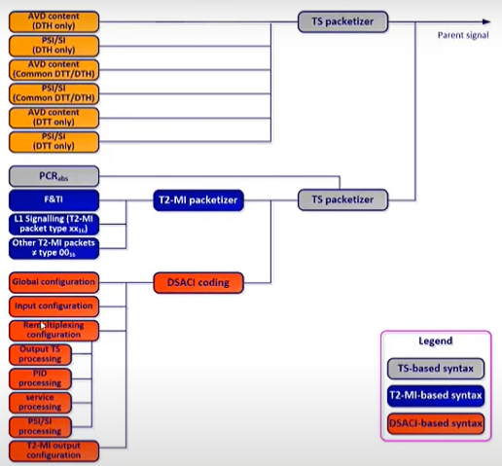

Figure 3.2-1: Preparation of metadata and content on parent site

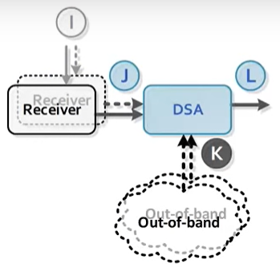

Figure 3.2-2: Daughter Site

## 3.3 Processing of metadata and content received on daughter site

* Extraction according to DSACI:
  + Of services
  + Of components
* Preparation of terrestrial PSI/SI
  + Frame building:
* According to framing & timing information
* Using deterministic multiplexing algorithm

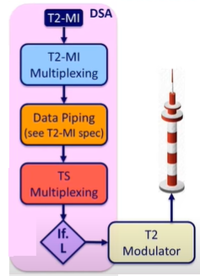

Figure 3.3-1: Processing of metadata and content received on daughter site

## 3.4 Output to T2 modulators:

* T2-MI packets are multiplexed – consisting of baseband frames, L1 signaling, T2 timestamps and optionally further T2-MI packet types
* T2-MI packets are then-piped, i.e., they are encapsulated in TS packets
* TS multiplexing stage enables the combination of TS packets carrying T2-MI packets and TS packet carrying PSI/SI for this stream
* DSA produces single T2-MI stream at interface L

## 3.5 timing

* Parent signals are timestamped
  + SIS services hold absolute PCRs that enable deterministic timestamping for all TS packets
  + CSGs use an absolute 27 MHz clock counter that started with 0 at SIS epoch (the same epoch for DVB-T2 time, i.e., 2000-01-01 T 00:00:00 UTC)
* DSA computes deterministic timestamp on output TS(s)
  + Framing & timing information from SIS service gives the parameters needed
* All scheduling decisions are based on those deterministic timestamps

## 3.6 Clock referencing from DSA in- to output

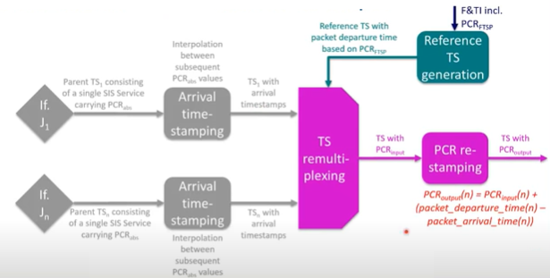

Figure 3.6-1: Clock referencing from DSA in- to output

* Environment of standards around SIS
  + S/S2/S2X, …, T2-MI/T-MF
* Structure of the SIS standard:
  + Parent site:
    - Service information (PSI/SI)
    - SIS services
    - L1 signaling
    - Other T2-MI packet types
    - Framing & timing information
    - DSA configuration information
    - Carriage of signal components within the parent transport stream
  + Daughter site:
    - Bootstrapping
    - TS re-multiplexing
    - Framing
    - Extraction of T2-MI packets from signal received via interface H
    - Output processing

## 3.7 Environment of standard around SIS

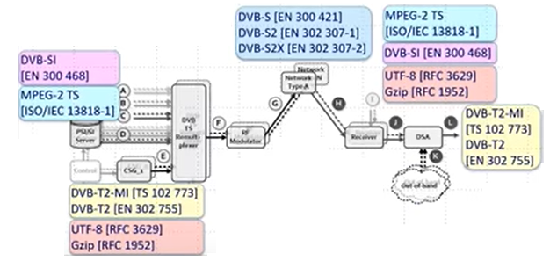

Figure 3.7-1: Environment of standard around SIS

SIS parent site elements – service information (PSI/SI)

* Terrestrial PSI/SI can be produced as follows based on the related satellite PSI/SI tables:
  + Passed through, i.e., no information
  + Patched, i.e., parts of tables are modified, replaced or stuffed (size of the table remains constant)
  + Regenerated, i.e., the DSA produces tables based on DSACI and satellite PSI/SI
    - Virtual arrival timestamps (VATs) are assigned to the regenerated tables
* The SIS standard defines the mechanisms for these PSI/SI tables:
  + PMT, PAT, CAT, SDT, BAT, EIT
  + Remapping, i.e., replacement of PID's can be applied to all tables (and to all service components)
  + CATs can also be stopped from retransmission – reflecting a change from encrypted to free-to-air provision
* All other tables required for the terrestrial transmission need to be provided by the CSG in a hidden way, i.e., invisible to the satellite receivers

SIS parent site elements – SIS services

* SIS services consist of:
  + PCRabs: provides absolute time reference
  + F&TI: gives instructions to build a deterministic framing structure for modulation
  + DSACI: enables configuration of DSA processing
  + SIS-specific PSI/SI: elements of signaling needed by terrestrial PSI/SI reconstruction
* There is a single "primary SIS service" for a targeted terrestrial modulation
  + F&TI comes from primary SIS service
  + On other (secondary) SIS services F&TI is not required

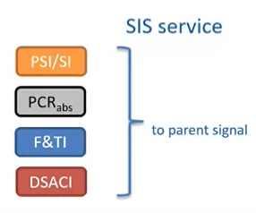

Figure 3.7-2: SIS Service

* PCRabs
  + Is it mandatory for all SIS services
    - Declared in SIS services PMT through PCR_PID
    - Carried with usual adaptation field mechanism
  + It is an absolute time reference that starts with value 0 at SIS epoch (1st January 2000, 00h00)
  + Enables deterministic packet arrival of all TS packets from parent signals
    - Used in deterministic multiplexing algorithm
    - Used in the arithmetic operations for PCR correction
* Framing & timing information (F&TI)
  + Hold framing structure of the terrestrial modulation
  + A single source of F&TI is used for a single terrestrial modulation
  + F&TI is optional for other parent signals that contribute to the same terrestrial modulation (but would be ignored by the DSA)
* DSACI
  + Is an XML configuration file for the DSA
  + It is structured by groups of configuration elements
  + Is either
    - Provided in-band on a dedicated PID of the primary SIS service
    - Provided out-of-band to the DSA

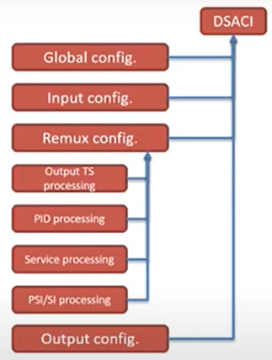

Figure 3.7-3: DSACI

* SIS-specific PSI/SI, e.g.,
  + PATs for terrestrial TSs (with PID 0016)
  + PMTs for sheer terrestrial services, that are not regenerated
  + In the extreme case, all terrestrial PSI/SI tables could be provided this way, but that is not an efficient solution

## 3.8 Layer 1 signaling, another T2-MI packet types

* L1 signaling is generated by the control signal generator (CSG) completely
  + The CSG produces T2-MI packets of types
    - 1016 (L1-current) and 1116 (L1-future, if needed
    - 2016 (DVB-T2 timestamps)
    - All others required T2-MI packet types (apart from 0016 (BBF's))
  + L1 signaling is relevant for the baseband frame builder being part of the DSA
  + The CSG also produces framing & timing information (F&TI) - T2-MI packet type F016 – for building interleaving and baseband frames on daughter site in a deterministic way.
* Provides metadata required by the DSA for:
  + Deterministic building of frames
    - DVB-T2: BBFRAMES, interleaving frames and T2-frames
    - DVB-T: mega-frames
  + Deterministic allocation of TS packets to interleaving frames

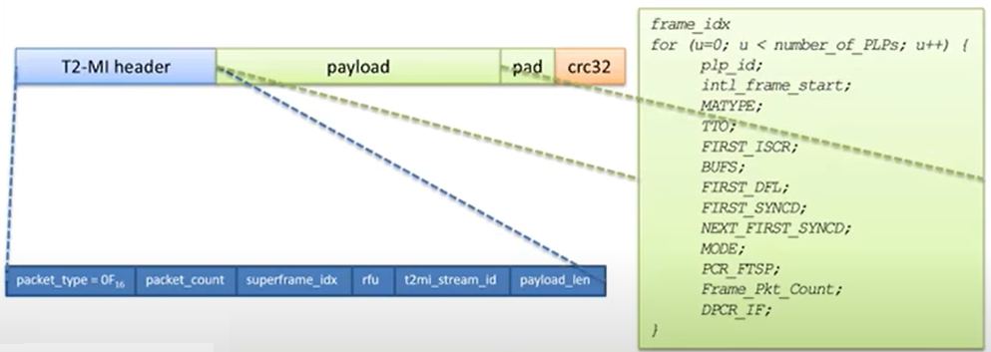

Figure 3.8-1: Packets to interleaving frames

* DVB-T2 case
  + SIS syntax for F&TI fits in the payload of a new T2-MI packet type (0F16)
  + F&TI transmitted through usual data piping with L1, DVB-T2 timestamp, FEF
* DSACI contains
  + Global configuration items
    - Target current DSA group id
    - Application time of the configuration
  + Input configuration items
    - Define the input TSs sources according to TS id, ON id
    - Contains the PMT PID of the SIS service (relevant for OOB delivery of DSACI)
    - Allow identification of primary parent signal
  + Re-multiplexing configuration items
    - Details on following slide
  + Output configuration items
    - Define which terrestrial standard is addressed
    - Add PSI/SI elements for DVB T2-MI

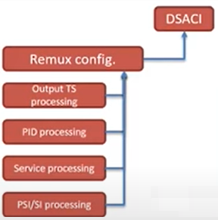

Figure 3.8-2: DSACI Re-mux configuration

* Output TS mapping
  + Global attributes of output TS
* PID level routing and processing
  + Routes and PID translations
* Service level processing
  + Service-related PSI/SI attributes and processing algorithm
* PSI/SI operations and/or regenerations
  + TS wide PSI/SI attributes and processing algorithm

## 3.9 Structure of the SIS standard (Parent Site):

* Parent site:
  + Service information (PSI/SI)
  + SIS services
  + L1 signaling other T2-MI packet types
  + Framing & timing information
  + DSA configuration information
  + Hiding SIS service and sheer terrestrial services away from DTH receivers



Figure 3.9-1: DSA-internal structure

## 3.10 Structure of the SIS standard (Daughter Site):

* Daughter site:
  + Bootstrapping
  + TS re-multiplexing
  + Framing
  + Extraction of T2-MI packets from signal received via interface H
  + Output processing

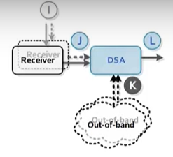

Figure 3.10-1 DSA-internal Daughter site

## 3.11 Bootstrapping

* The first step is to tune the receivers in from the DSA to those satellite channels, which provide the content & metadata required for composing the terrestrial multiplex(es)
  + This can e.g., be done manually and is not within the scope of the SIS spec
* Next step is to find DSA configuration information (DSACI)
  + In-band, the following parameter settings must be provided manually to the DSA:
    - The [TSid/ON ID/program Id] triple corresponding to the primary SIS service in the relevant parent signal where the DSA will find the current DSACI component
    - The current DSACI group id identifying the current DSACI that this particular DSA shall use
    - Out-of-band, the following parameter settings must be provided manually to the DSA:
      * The path or location – e.g., URL, drive and directory – where the DSA can find the current DSACI file
      * The current DSACI group id identifying the current DSACI that this particular DSA shall use

## 3.12 TS Remultiplexing

* Arrival timestamping
  + Packet arrival time is computed by PCRabs interpolation
* VAT
  + Virtual arrival time is used for regenerated (PSI/SI) packets VAT computation is configured by DSACI
* Selection and remapping of relevant content from input TS(s)
  + input PSI/SI tables
  + Input services component content
* Processing and generation of PSI/SI according to DSACI
  + Input table PID remapping
  + Input table patching
  + Table regeneration
* Generation of reference transport streams
  + RTS is a placeholder with timestamped null packets
    - Timestamps are packet departure times
    - Timestamps are computed according to F&TI
  + Parents TS content are regenerated PSI/SI will replace null packets of RTS
* Placement of incoming packets in the outgoing TS
  + Scheduling algorithm decisions based on computed:
    - Packets arrival times
    - Packet departure times
  + Deterministic PCR correction applied

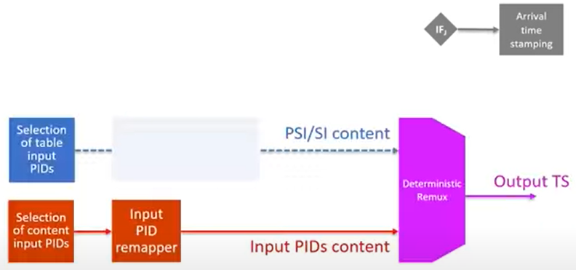

Figure 3.12-1: TS Remultiplexing

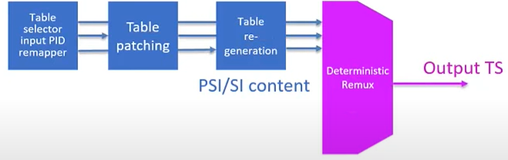

Figure 3.12-2: Generation of PSI/SIS

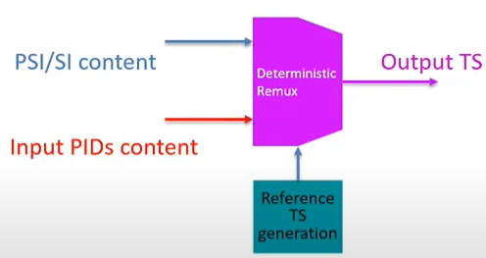

Figure 3.12-3: Generation of reference transport streams

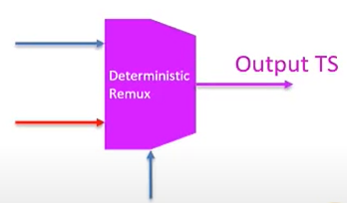

Figure 3.12-4: Placement of incoming packets in the outgoing TS

## 3.13 Framing

* Building interleaving frames and baseband frames (BBFs) - wide consisting of well-known T2 machinery:
  + TS splitting (optional)
    - When multiple input MPEG-2 TSs transmitted via a group of PLPs, splitting of input TSs into partial TSs (carried via data PLPs) and a partial TS carrying common data (carried via the associated common PLP) can be applied in order to save signaling overhead
    - Partial mode adaptation might consist of
      * Sync byte removal, dummy ISSY insertion (if applicable), dummy DNP insertion (if applicable) and/or dummy CRC-8 insertion (if application)
    - Interleaving framing
      * The bits of the partially mode-adapted transport stream are allocated to interleaving frames according to F&TI instructions
    - NULL packet deletion (optional)
      * In the case of transport streams consisting of a large percentage of null-packet (-> variable bitrate) TS null-packets shall be removed to avoid unnecessary transmission overhead.
      * The process is reversed at the receiving end in a fully deterministic way
    - Baseband framing
      * The bits allocated to an interleaving frame are mapped onto the number of BBFRAMEs indicated in the dynamic L1 signaling for the relevant PLP and interleaving frame

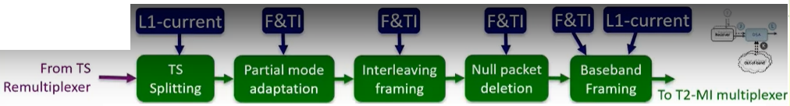

Figure 3.13-1: Framing

## 3.14 Extraction of T2-MI packets from signal received via interface H

* T2-MI packets are received by the DSA embedded in TS packets (-> data piping)
* All T2-MI packets are decapsulated from the aforementioned TS packets
* Depending on the T2-MI packet type, the DSA applies a different processing as follows:
  + Packet type 0016 (baseband frame) is not permitted of SIS usage and is trashed
  + Packet types not equal to 0016 (baseband frame), 1016 (L1-current) or F016 (F&TI) are simply piped through and are encapsulated again in TS packet for insertion into the output T2-MI stream
  + Packet type 1016 is used for configuring the DSA output stream and is in the end encapsulated again in TS packets as mentioned above
  + Packet type F016 (F&TI) is also used for configuring the DSA output streams, but is discarded after processing and does not become part of the DSA output stream

## 3.15 Output process

* T2-MI packets are multiplexed – consisting of:
  + Content-carrying packets (baseband frames) produced by the DSA
  + L1 signaling packets received from the CSG(s)
  + Optionally further T2-MI packet types also received from the CSG (but no BFF type packets)
* T2-MI packets are then data-piped, i.e., they are encapsulated in TS packets for provision to T2 modulator(s)
* TS multiplexing stage enables the combination of TS packets carrying T2-MI packets and TS packets carrying PSI/SI for this stream
* DSA produces single T2-MI stream at interface L, i.e., a stream of T2-MI packets contribution to T2 transmission frames of one type, i.e., T2 SISO (T2 base SISO)
  + Mix of frame types – e.g., T2-base SISO and T2-kite SISO – would conceptually require multiple DSA's

# HW Modules Used

This document will describe the implementation of DVB-SIS

# SW Used

This document will describe the implementation of DVB-SIS

# OS Used

This document will describe the implementation of DVB-SIS