**TABLE OF CONTENTS:**

1 Introduction 2

**1.1** **SFN network Satellite primary network technological challenges** 3

**1.1.1** **Centralized architecture – SFN Boost “C”** 3

**Technical highlights of Centralized SFN Boost “C”** 5

**1.1.2** **Distributed DVB SIS architecture SFN Boost “D”** 7

7

2 Metadata / reference stream 8

3 Use cases 14

**3.1** **Single transmission of DTT & DTH for both DVB-T and DVB-T2** 14

**3.2** **Regionalization for both DVB-T and DVB-T2** 16

4 Technology compliance with commercial requirements 18

5 Key code words format examples 32

# Introduction

SFN Boost C is solution with Centralized architecture is based on following MAINDATA patents pool:

English versions PCT (WIPO):

[WO2013025177A1 - WIPO (PCT)](https://patents.google.com/patent/WO2013025177A1/en?q=dušan&inventor=statelov&oq=statelov+dušan)

[WO2008111921A1 - WIPO (PCT)](https://patents.google.com/patent/WO2008111921A1/en?q=dušan&inventor=statelov&country=WO)

Slovak patents:

<https://wbr.indprop.gov.sk/WebRegistre/Patent/Detail/5021-2007>

<https://wbr.indprop.gov.sk/WebRegistre/Patent/Detail/5137-2007>

<https://wbr.indprop.gov.sk/WebRegistre/Patent/Detail/5138-2007>

<https://wbr.indprop.gov.sk/WebRegistre/Patent/Detail/5139-2007> <https://wbr.indprop.gov.sk/WebRegistre/Patent/Detail/5020-2008>

<https://wbr.indprop.gov.sk/WebRegistre/Patent/Detail/50032-2011>

* MPEG TS Information technology – ISO 13 818-1

Generic coding of moving pictures and associated audio information

* [DVB-T2 Second Generation Terrestrial](https://dvb.org/?standard=frame-structure-channel-coding-and-modulation-for-a-second-generation-digital-terrestrial-television-broadcasting-system-dvb-t2) ETSI EN 302 755
* [DVB-T2-MI Second Generation Terrestrial-Modulator Interface](https://dvb.org/?standard=modulator-interface-t2-mi-for-a-second-generation-digital-terrestrial-television-broadcasting-system-dvb-t2) ETSI TS 102 773
* DVB-DATA Data broadcasting EN 301 192
* DVB-T First Generation Terrestrial Network [EN 300 744 V1.6.2](http://www.etsi.org/deliver/etsi_en/300700_300799/300744/01.06.02_60/en_300744v010602p.pdf)
* DVB-T-SFN (SFN) Single Frequency Network TS 101 191 V1.4.1

Mega-frame for Single Frequency Network synchronization

* SMPTE 2022 Transport stream over IP networks

## **SFN network Satellite primary network technological challenges**

SFN transmitters shall emit identical bitstreams in the same time (within the guard interval) to avoid interference.

Deterministic SFN Boost Rx adapters do not have to care about the precise time synchronization as it is implemented by DTT transmitters / modulators by locking to the same central clock source (e.g. GNSS, GPS), what assures that all transmitters are modulating and emitting the same bits within guard interval.

## **Centralized architecture – SFN Boost “C”**

The main challenge is to achieve that bitstreams outputs at **SFN Boost Rx adapters**,within same SFN cell, are **bitwise identical,** what is the desired / mandatory feature of deterministic stream processing.

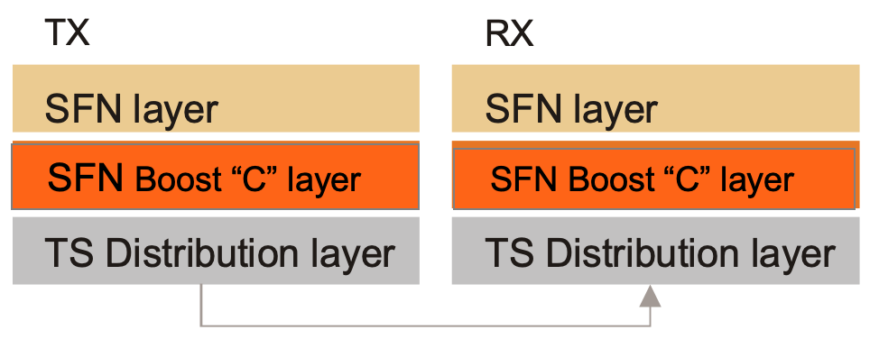SFN Boost “C” solution presents a transparent network adapter, which allows an easy network design. Deterministic DTT stream generator is placed between regional TV head-ends and distribution network. SFN Boost “C” Rx adapters are placed between distribution network and transmitters. SFN Boost “C” layer is between SFN layer and distribution network layer input to SFN Boost Tx adapter, shall be bitwise identical to SNF Boost Rx adapter output – then link is “transparent”. 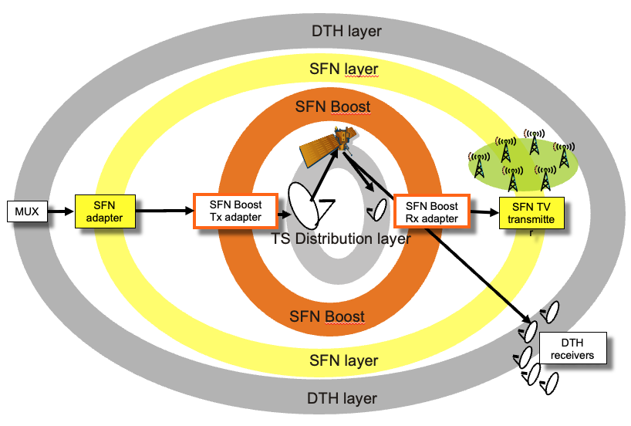

Figure 1 - SFN Boost layers

Figure 2 - Logical outline of DTH, SFN Boost & SFN layers

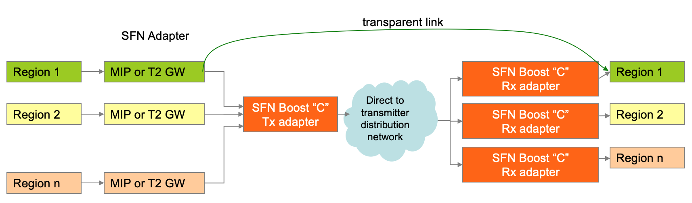

Figure 3 - SFN Boost „C“ transparency

Bitwise and time synchronization is mandatory requirement for SFN networks.

MFN networks do not require synchronization between transmitters, so there is no interference issue. This can be achieved by platforms with centralized or distributed architectures.

ETSI TS101 191 requires single SFN adapter per SFN cell. Single MIP inserter requirement per cell is met only by the centralized architecture. In opposite to the other solutions, OPTIMUX maintains SFN synchronization by placing single MIP inserter centrally at the digital TV head end, according to the SFN standard requirements.

SFN Boost “C” complies with single central clock for SFN cell.

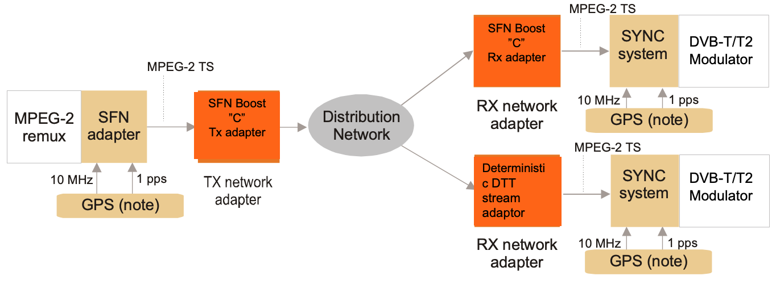

Figure 4 - Single clock per SFN cell

SFN adapted stream is composed at head-end before the distribution network.

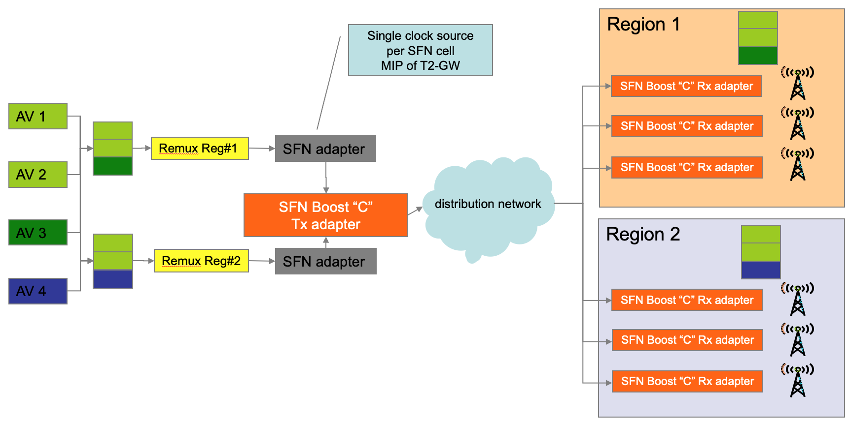

Figure 5 - SFN Boost „C“ use for regional programming

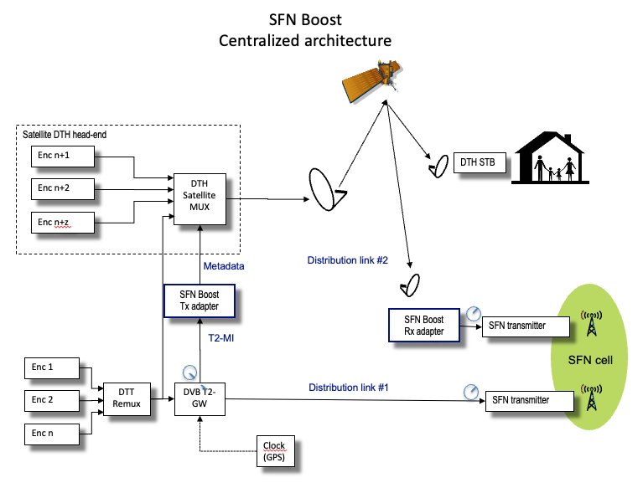

Figure 6 - SFN Boost "C" block diagram

## **Distributed DVB SIS architecture SFN Boost “D”**

Key feature: SFN adapted stream is composed at each Transmitter site, after distribution network. Distributed architecture was adopted by DVB SIS standard.

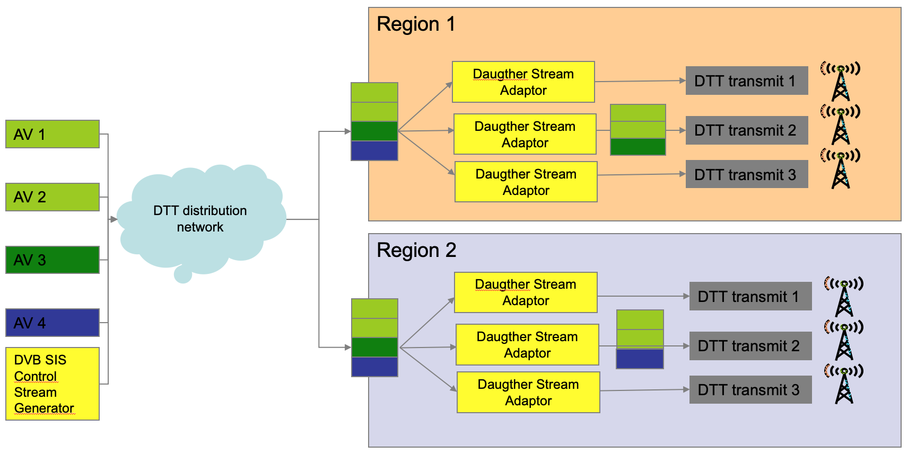

## 

Figure 7 – DVB SIS = SFN Boost „D“ (distributed)

# Metadata / reference stream

Metadata creation presents a centrepiece of the solution.

Metadata stream presents **compacted / fully** **referenced DVB-Ty stream composed of several code words.** (Note: compact = lossless compression).

**Key generic processes for both DVB-T and DVB-T2 are:**

* Packets of different stream layers are replaced (referenced) with their hash values (e.g. sha-1).
* Sha-1 strength is dynamically adjustable.
* In case of Packets of higher than MPEG-2 TS layer, e.g. PES, DSCMM, etc, codewords containing hashes are also coding details of their mapping into MPEG-2 TS packets.
* Original full-size packets are transmitted as part of the DTH stream (MPEG-2 TS).

**Referencing of packets at MPEG-2 TS level:**

* Results in the higher overhead (referencing of 188/204 bytes MPEG-2 TS packets is less efficient then e.g. 3 kB ones).
* Does not detect the same higher stream layer packet; mapped into MPEG-2 TS packets differently (applies mainly to DSMCC sections, e.g. IP traffic, with section packing) at different transport streams (keep in mind the need for regionalization)

These are the reasons why MPEG-2 TS packets, are whenever possible, DE mapped (defragmented/decapsulated) to the higher-layer stream packets e.g. PES, DSMCC etc, where the identical higher layer stream packets, e.g. PES, from different multiplexes/transport streams.

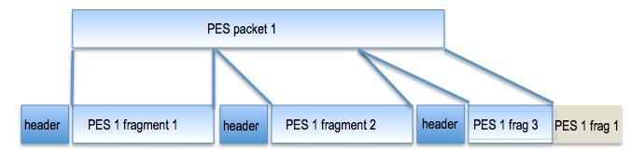

In case DE mapping is not possible or inefficient, referencing is performed at MPEG-2 TS level (e.g. in case of stream errors).

In case of DVB-T2 MI packets additional code words containing information about encapsulation to second-generation DVB-T2 layers such as BBF, T2-MI frames or final mapping to MPEG-2 TS via data piping are added to metadata.

Metadata stream contains streams IDs, allowing remote signalling to Deterministic DTT stream adapters, allowing their remote control, which stream it has to reconstruct (stream ID can belong to region).

1st step (for DVB-T)

Defragmenting PES packets

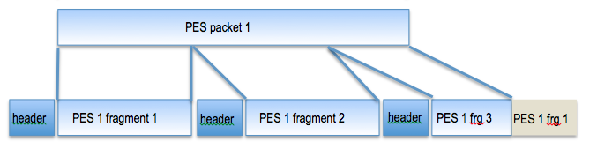

2nd step

Replacing packets with HASH (sha1)

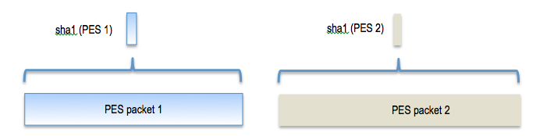

**3rd step**

Composing code words containing

* Sha1
* Details about packets mapping (fragmentation) to MPEG TS packets.

**4th step**

Sha1 for given time window are fed into **Dictionary**

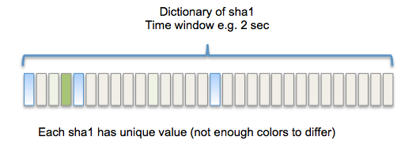

For parallel DTT & DTH

**5th step**

Sha dictionary is being transmitted to DTT adapters.

DTT adapter processing diagram

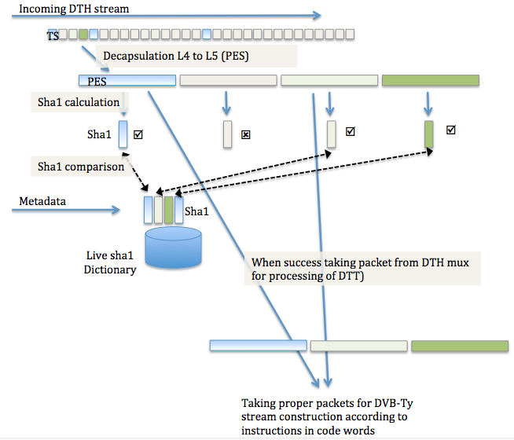

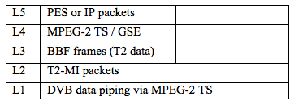

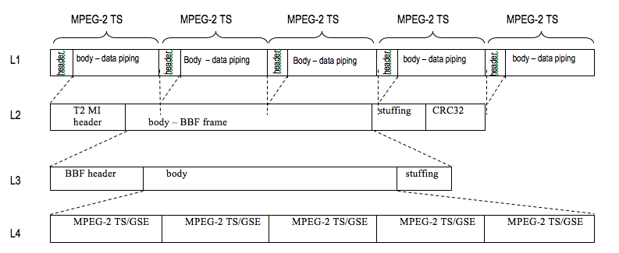

SFN Boost „C“ processing diagram

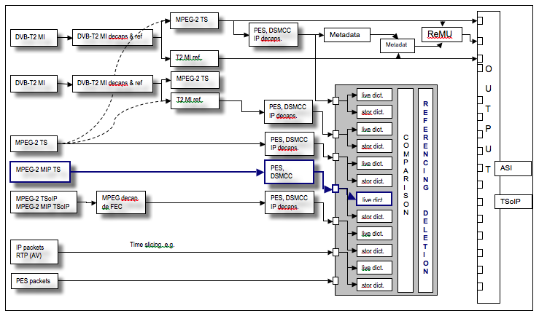**This way constructed metadata stream provides high level of**

* **Integrity**
* **Reliability**
* **Flexibility & future proof approach**
* **Determinism**

Information coded into code words allows Deterministic DTT Stream adaptor to detect correct full size packets from multiple DTH streams (for most being firstly DE capsulated) and deterministically maps them back into MPEG-2 packets.

In case of DVB-T2 also deterministic encapsulation to BBF, T2-MI frames and lastly mapping to MPEG-2 TS packets via data piping method is performed.

Deterministic DTT stream generator also remaps original PIDs into temporary PID values of metadata stream.

Technology transmits metadata as hidden stream, labelled as “private data”, ignored by any equipment in the satellite chain including DTH DVB-Sy STB.

Advantage of proposed technology is its **ability to perform regionalization by centralized architecture using the same algorithm for both DVB-T and DVB-T2 networks.**

In case of regionalized transport streams (part of services are region specific while others are national), this mechanism allows transmit (illuminate) single occurrence of packets bearing national services presented multiple times within different regionalized transport streams. Metadata stream for other regional SFN streams transmit (illuminate) only reference/hash and not the packet in its full size.

**This method of regionalization is significantly more granular than PLP replacement mechanism** (allows regional TV service along with national TV services within same PLP) and addresses both DVB-T and DVB-T2 standards the same way.

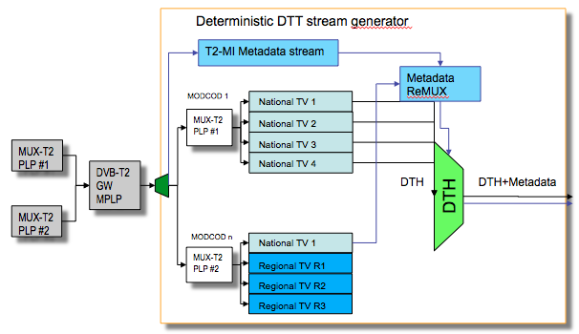

Deterministic DTT stream generator optionally creates DTH stream with completely new PSI/SI tables, while original ones are transmitted via metadata stream in full or compacted format.

When Deterministic DTT stream adapter regenerates SFN stream it first reads metadata stream (as the controlling one), and replaces packet references (hash) with full size packets transmitted in DTH stream. From DTH stream PES packets and DSMCC sections are DE mapped from MPEG-2 TS DTH stream.

**Adopting this technology supports both major use cases Parallel DTT and DTH as well as regionalization and both versions of DVB DTT standards are well served.**

This method complies with the “Single illumination” requirement as in both use cases repeatedly appearing packets (e.g. national TV services) are transmitted only once.

This method (we consider as centralized architecture) can be combined with distributed architecture by inserting special cue signals e.g. following SCTE035 standard showing start mark and end marks of timeslot to be replaced. What have to be defined are constraints for video audio services, which intend to be inserted locally.

By this way metadata stream can be generated also from GSE or any other future transport stream format.

# 

# Use cases



## **Single transmission of DTT & DTH for both DVB-T and DVB-T2**

Document Commercial requirements page 4, in Chapter 1.2. Scope states:

“... This additional information, called Metadata in this document, covers all what is needed at any transmitter site to build a signal as if it had been or as it had been built in a central place.“

**Diagram 1** addresses the alternative: “a signal as **if** it had been built at central place.

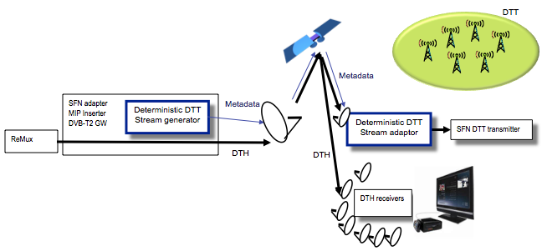

In this case SFN adapter such as MIP Inserter or DVB-T2 GW is not generating final SFN adapter DTT stream. Negative aspect of this solution is it is not network adapter, and cannot be freely combined with 3rd party e.g. DVB-T2 GW, so it is more logical for newly built DVB-T2 etworks. In this case Deterministic DTT Stream generator function is to generate metadata, which are further re-multiplexed within DTH stream as e.g. private data. Because final DTT stream is not generated here it is not possible to monitor output of Deterministic DTT Stream Generator for properly constructed SFN stream.

**Diagram 2** addresses the alternative: “a signal it had been built at central place.”

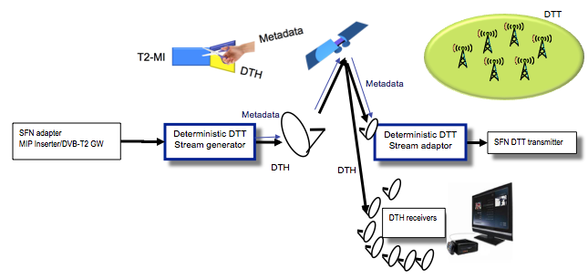

In this case SFN adapter such as MIP Inserter or DVB-T2 GW is generating final SFN adapter DTT stream. Deterministic DTT stream generator in case of DVB-T2 MI input performs decapsulation down to MPEG-2 TS (DTH) stream, as well as generating metadata with detail information about how packets from DTH stream must be processed to deterministically create a DTT stream within Deterministic DTT stream adaptor at Transmitter side. This architecture allows for network adapter architecture, allowing installing platform into already built-up DVB-T/T2 networks and can be freely combined with 3rd party e.g. DVB-T2 GW. Because SFN stream is completely generated at head-end side it can be also monitored at head-end side.

Metadata are transmitted within DTH stream as a private data, which are ignored by DTH receiver.

Metadata are used by Deterministic DTT stream adapters to be able precisely generate bitwise identical stream at all transmitters within SFN cell.

## **Regionalization for both DVB-T and DVB-T2**

Proposed technology performs regionalization the same way for DVB-T and DVB-T2 (and other standards). Same packets appearing multiple times within different regional streams are replaced by packet ID – hash (sha-1), while full size packets are transmitted once (single illumination).

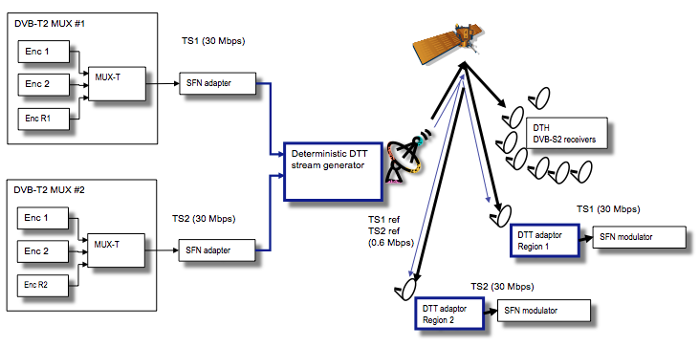

Example of 2 regionalized stream processing and bandwidth reduction.

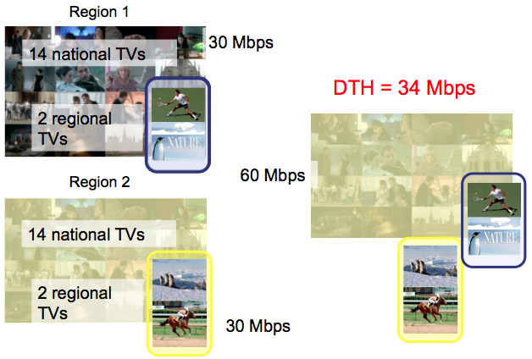

# Technology compliance with commercial requirements

Note: Numbering of commercial requirements follows CR document numbering.

Timeline Requirements

|  |  |  |  |
| --- | --- | --- | --- |
| Req 3.1.1. | Timeline. Date for a technical specification. | Agreed | 1 |

We believe therefore that a specification for DVB-Ty signal transmission via satellite should be ready until End of 2016.

Compliance: YES

Standard can be finalized by end of 2016.

Compatibility Requirements

|  |  |  |  |
| --- | --- | --- | --- |
| Req 3.2.1. | Compatibility. The satellite signal shall be compliant to a standard DTH signal | Agreed | 1 |

The Head-end shall deliver a signal fully compliant to the relevant DVB standards to the satellite modulator. This means that any additional metadata needed downstream to build the DTT signal and carried in the Satellite stream shall not affect the operation of any DVB-Sy compliant satellite Set Top Box: These DVB-Sy compliant satellite Set Top Box shall be able to decode the satellite services. The satellite signal shall provide to the satellite STB all the required signalisation that makes the service fully commercially operational.

Nevertheless, the solution shall not prevent the isolation (invisible to DTH receivers) of terrestrial services dedicated solely to terrestrial broadcasting.

The DTH signal compliance shall be guaranteed using the typical measurement guidelines described in TR 101 290 (note that the current version might evolve to take into account the new features brought by DVB-S2 and DVB-S2X).

Compliance: YES

Deterministic DTT stream generator output stream is MPEG-2 TS based, what allows reception by mass-market DTH DVB-Sy STB. DTH stream transmits metadata as private data, invisible / unprocessed by DTH STB, but allowing deterministic reconstruction off DTT signal by Deterministic DTT stream adaptor.

|  |  |  |  |
| --- | --- | --- | --- |
| Req 3.2.2. | Compatibility. The signal shall be compliant to a standard DVB-T signal at the modulator input | Agreed | 1 |

When the terrestrial network is using DVB-T standard, the reconstructed terrestrial multiplex shall be fully compliant with DVB-T standard EN 300 744 v1.6.2 and TS 101 191 v1.4.1. The signal shall include all the required DVB signalisation that makes the DVB-T service fully commercially operational.

Compliance: YES

Deterministic DTT stream adapter generates stream compliant with DVB-T modulator input.

|  |  |  |  |
| --- | --- | --- | --- |
| Req 3.2.3. | Compatibility. The signal shall be compliant to a standard T2-MI signal at the modulator input | Agreed | 1 |

When the terrestrial network is using DVB-T2 standard, the reconstructed terrestrial multiplex shall be fully compliant with DVB-T2 standard EN 302 755 v1.4.1 and TS 102 773 v1.3.1. More precisely the signal provided to the terrestrial modulator shall comply with DVB-T2 MI specification. The signal shall include all the required DVB signalisation that makes the DVB-T2 service fully commercially operational.

Compliance: YES

Deterministic DTT stream adapter generates stream compliant with DVB-T2 modulator input.

|  |  |  |  |
| --- | --- | --- | --- |
| Req 3.2.4. | Compatibility regarding media encoding standard | Agreed | 1 |

The proposed solution shall be codec agnostic. All stream manipulations are supposed to be made at the Transport stream level and thus should not be dependent on the media codec used for the essences (audio and video).

Compliance: YES

Technology is codec agnostic, does not perform any operation at uncompressed audio video layers.

|  |  |  |  |
| --- | --- | --- | --- |
| Req 3.2.5. | Compatibility regarding composite terrestrial signals | Agreed | 1 |

When the terrestrial network is using DVB-T2 standard, the proposed solution should support composite (e.g. T2-Base + T2-Lite) signals to terrestrial transmitters. DVB-Sy compliant satellite Set-Top-Boxes shall be able to receive at least the T2-Base services.

Compliance: YES

It supports network adapter architecture. This applies also to composite terrestrial signals.

Deterministic generation of a Ty-Modulator Interface signal from a DTH signal

|  |  |  |  |
| --- | --- | --- | --- |
| Req 3.3.1. | Generation of a DVB-Ty multiplex from a single DTH transponder | Agreed | 1 |

The technology shall make possible the generation of a DVB-Ty Multiplex built using all or a part of the services carried on a single satellite transponder

Compliance: YES

Technology goes beyond this requirement in much more gentle way, it allows to look for (pick-up) specific packets from DTH stream, so it supersedes this requirement.

|  |  |  |  |
| --- | --- | --- | --- |
| Req 3.3.2. | Generation of a DVB-Ty multiplex from several networks | Agreed | 1 |

The technology shall make possible the generation of a DVB-Ty Multiplex from services broadcast on several networks. For instance, the technology shall permit to build a DVB-Ty Multiplex from:

Several satellite transponders

1 or more satellite networks and other non-satellite network.

As several technical operators could be involved, the technology shall permit to use different and independent head-ends (each one broadcasting over a specific network) to build the DVB-Ty Multiplex.

Compliance: YES

Technology allows looking for (pick-up) packets from multiple streams delivered via various networks.

|  |  |  |  |
| --- | --- | --- | --- |
| Req 3.3.3. | Generation of a DVB-Ty multiplex in a MFN environment | Agreed | 1 |

The technology shall make possible the generation of a DVB-Ty Multiplex in a MFN environment.

Compliance: YES

|  |  |  |  |
| --- | --- | --- | --- |
| Req 3.3.4. | Deterministic construction of a DVB-Ty multiplex in a SFN environment | Agreed | 1 |

The technology shall make possible the generation of a DVB-Ty Multiplex compliant to TS 101 191 v1.4.1 for DVB-T and [TS 102 992 V1.1.1](http://www.etsi.org/deliver/etsi_ts/102900_102999/102992/01.01.01_60/ts_102992v010101p.pdf) for DVB-T2 in a SFN environment.

Compliance: YES

Technology supports regeneration of both DVB-T and DVB-T2 MI signal deterministically allowing SFN operations.

|  |  |  |  |
| --- | --- | --- | --- |
| Req 3.3.5. | Generation of several DVB-Ty multiplex from a single DTH signal | Agreed | 1 |

The system shall enable to generate several deterministic combinations of DVB-Ty multiplexes from a single DTH signal. It shall cover multiplexes with different content for the same DVB-Ty profile or for different DVB-Ty profiles.

Compliance: YES

Technology allows generation of multiple DVB-Ty streams from single DTH signal. Thus single Deterministic DTT stream adapter can output multiple DVB-Ty signals in parallel.

|  |  |  |  |
| --- | --- | --- | --- |
| Req 3.3.6. | Deterministic construction of a DTT transport stream from satellite distribution components | Agreed | 1 |

The metadata will enable deterministic stream construction to take place at the edge within the ‘Deterministic DTT stream adapter’. Satellite services and components shall be filterable to obtain the final DTT transport stream, and the metadata shall direct deterministic DTT stream construction. The metadata shall be defined such as it is possible to reference services within other transport stream and networks.

Compliance: YES

Technology allows to pickup from DTH stream even individual packets, superseding this requirement by another level.

Metadata purposes

In order to guarantee the use of standard DTH set top boxes, the primary satellite distribution feed will remain in a stream format which is able to be decoded by a standard DTH set top box. This means that metadata, bearing among others important DTT signalling (e.g. provided by T2-MI layer in case of DVB-T2 signal) shall be provided as part of DTH stream or transmitted via separate network to the Deterministic DTT signal adapters, located at transmitter sites.

The metadata will only be used by the Deterministic DTT signal adapters and shall not affect the operation of any equipment within DTH satellite link, mainly DTH set top boxes.

The metadata will be used for several purposes expressed below as separate requirements:

Compliance: YES

Technology allows deliver metadata stream either within a DTH stream, in hidden form for DTH DVB-Sy STB, as private data. This does not affect operation of any equipment within DTH satellite link including DTH STB.

Metadata stream can be also transmitted separately via other network and be combined with DTH stream deterministically by Deterministic DTT stream adaptor.

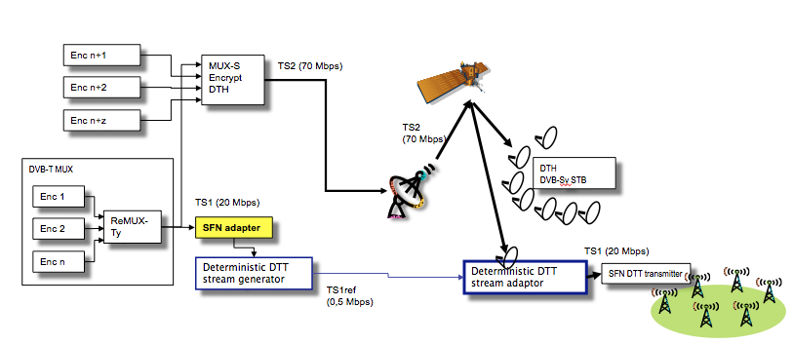

|  |  |  |  |
| --- | --- | --- | --- |
| Req 3.4.1. | SFN Synchronization and transmitter signalling | Agreed | 1 |

When the terrestrial network is using DVB-T standard, the metadata shall replace the SFN synchronization and signalling data that would normally be carried within the MIP packet For example, everything contained within the mega frame initialization Packet will need to be carried as metadata so that a fully populated MIP packet compliant to **Error! Reference source not found.** can be constructed at the network edge.

When the terrestrial network is using DVB-T2 standard, the metadata shall replace the signalling and SFN synchronization data that would normally be carried within the T2-MI encapsulation layer. For example, everything contained within the L1 signalling header will need to be carried as metadata so that a fully populated T2-MI encapsulation layer, compliant to TS 102 773 v1.3.1, complete with transmitter addressing / signalling can be constructed at the network edge. Multiple sets of Metadata may be present in order to build different T2 configurations

Compliance: YES

Technology was tested for its network adapter transparency in both standards DVB-T and DVB-T2. It also allows transmit multiple sets of metadata streams allowing built different DVB-T, DVB-T2 streams.

|  |  |  |  |
| --- | --- | --- | --- |
| Req 3.4.2. | T2-MI formatting | Agreed | 1 |

When the terrestrial network is using DVB-T2 standard, the metadata shall enable the ‘Deterministic DTT stream adapter’ that is re-constructing the T2-MI encapsulation layer for DTT transmission at the edge to re-build T2-MI frames correctly. For example, it shall support single or multiple PLP T2 frame structures.

For this reason, the metadata shall provide precise control over how the T2 frames and T2 super-frames are built at the network edge.

Compliance: YES

Technology contains specific T2-MI and BBF code words for this purpose.

|  |  |  |  |
| --- | --- | --- | --- |
| Req 3.4.3. | Triggering region-specific timeslots | Agreed | 1 |

The metadata shall not prevent precise region-specific triggers for applications like ad-insertion, local news or Emergency Warning System. The triggers shall fully respect the multi-regional properties of DTT networks, and the need to ensure the SFN regions remain cohesive when being triggered in and out.

Compliance: YES

Technology does not prevent to define code words for deterministic time-slot insertion, e.g. based at widely used SCTE 35 standard – mark in, mark out.

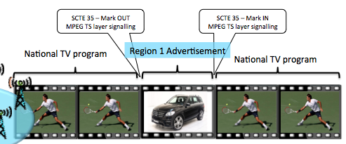

|  |  |  |  |
| --- | --- | --- | --- |
| Req 3.4.4. | Rebuild SI | Agreed | 1 |

The SI EN 300 468 V1.14.1 required for the DTT system shall be conveyed so that specific and very different SI can be provided on the DTT multiplex compared with the satellite parent.

The metadata shall therefore carry all the required information to allow the ‘Deterministic DTT stream adapter’ to build the full DTT signalisation.

For instance, in multi-regional DTT systems, a large national system could contain up to 100 different regions. Since unique SI will be required for each region, the metadata shall have an optimized structure allowing the transport of the various SI data to each ‘Deterministic DTT stream adapter’ located in the different regions.

Compliance: YES

It is possible to transmit full uncompact DVB-Ty SI via metadata stream, while new set of SI is generated for DTH stream.

It is also possible to reuse the same content of SI info for DVB-Ty stream and DTH stream, or between DVB-Ty stream Region1, and DVB-Ty Region2..N, by referencing SI hash values (centralized way).

It is also possible to add distributed method of SI tables generation for high number of regions.

|  |  |  |  |
| --- | --- | --- | --- |
| Req 3.4.5. | Configuring Deterministic DTT stream adapter | Agreed | 1 |

The ‘Deterministic DTT stream generator’ shall be able to insert all metadata that makes the ‘Deterministic DTT stream adapter’ able to construct a correct DTT stream (i.e. Transport Stream or T2-MI stream) solely on the basis of the metadata generated by the ‘Deterministic DTT stream generator’.

The ‘Deterministic DTT stream adapter’ shall be able to rebuild a correct DTT stream (i.e. Transport Stream or T2-MI stream) either solely on the basis of metadata generated by the ‘Deterministic DTT stream generator’ (means fully remote controlled configuration) or by a combination of the above metadata and metadata provided to the aforementioned ‘Deterministic DTT stream adapter’ by other means (could mean partial local configuration).

Compliance: YES

Control stream contains IDs of various transmitted metadata streams, what allows to address specific Deterministic DTT stream adapter with command with metadata stream ID to be reconstructed. All required info are contain in metadata stream.

Setting up metadata stream ID is also possible manually.

|  |  |  |  |
| --- | --- | --- | --- |
| Req 3.4.6. | Cascading DTT and DTH head-ends | Agreed | 1 |

The System shall allow DTT head end to Satellite DTH head end cascading. In other words, a Satellite DTH broadcaster shall be able to remux DTT services in DTH format coming from Terrestrial Remux along with the Metadata, keeping Satellite DTH head-end unaffected e.g. by DTT head-end failure.

The Satellite DTH Network operator may not control or modify the DTT multiplex reconstruction made on the ‘Deterministic Stream Adapter’.

The following scheme illustrates 2 possible network architectures for DTT signal reconstruction resulting in 2 different Deterministic DTT Stream adapter technical requirements.

Solution 1, technically more difficult, allows connect some Terrestrial SFN Transmitters within the same SFN cell via DTH satellite (using Deterministic DTT Stream adapter) and others directly (via WAN) from a DTT head end, without Deterministic DTT Stream adapter.

Solution 2, does not allow connect terrestrial transmitters directly from DTT head-end. Deterministic DTT Stream adapter has to be used for all terrestrial transmitters within the same SFN cell whether connected via satellite DTH or via WAN.

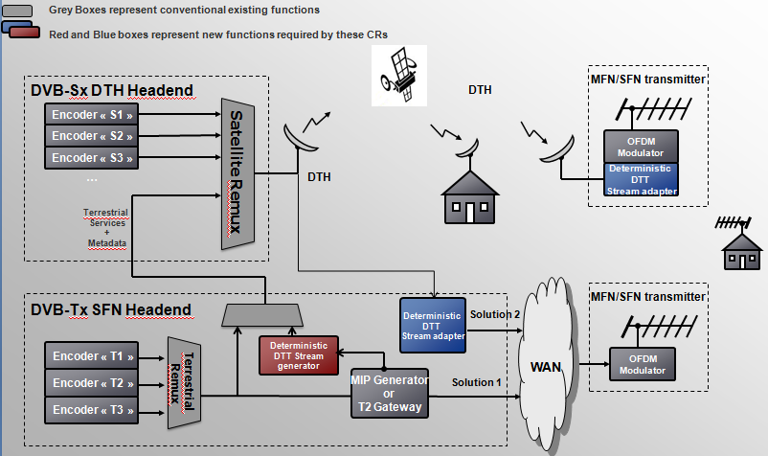

Figure 8 : Example of 2 possible DTT to DTH cascading solutions

The standard shall provide the tools to be able to set-up a system:

Using solution 1 described in the above figure, as a preferred scenario

Using solution 2 as a minimum scenario

Compliance: YES

Proposed technology supports both Solution 1 and 2 what is best described by following test configuration (performed by the large integrator in 2008).

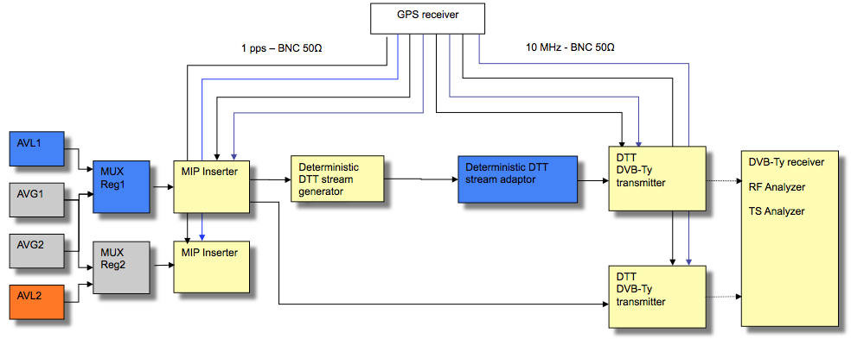

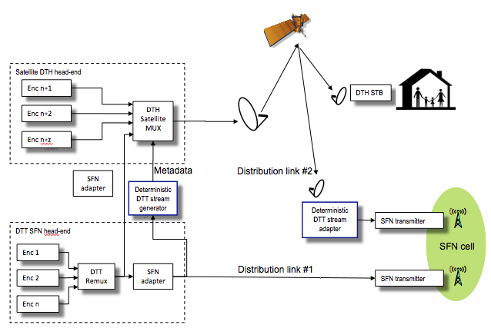

Other possibility of practical use case (preferred by broadcasters) of transmitting DVB-Ty signal via satellite DTH platform:

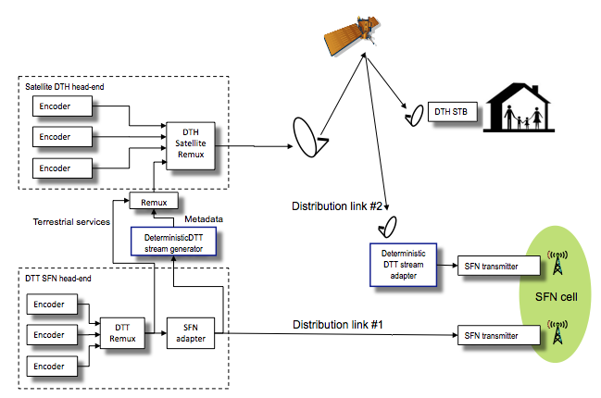

|  |  |  |  |
| --- | --- | --- | --- |
| Req 3.4.7. | Out of band Metadata transport | Agreed | 1 |

The standard shall make it possible to transport some parts of the metadata independently (on a different network) from the DTH services.

Compliance: YES

Proposed technology supports delivery metadata stream independently from DTH stream via a different network.

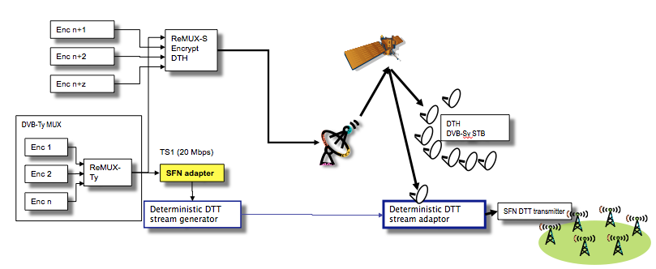

Bitrate Requirements

Since a national DTT system could require many metadata ‘sets’ to describe the way of deterministic DTT signal generation for each SFN region, the cumulative volume of data could become considerable. For this reason, the importance of maximising data transmission efficiency will be critical to minimise operational overheads within the satellite distribution platform. For example, the SI requirements for every region shall be carried. The metadata could carry the actual SI data, or it could carry a schema for configuring a local SI generator provided as part of the Deterministic DTT stream adapter. The mechanism used will impact the flexibility and data efficiency of the system considerably and shall therefore be chosen wisely.

Compliance: YES

Proposed technology can adopt either centralized or distributed architecture of generating regional sets of SI.

In case of centralized architecture compacting (“lossless compression”) can be applied to multiple sets of SI, what minimizes required bitrate for transmission.

|  |  |  |  |
| --- | --- | --- | --- |
| Req 3.5.1. | Bitrate overhead on the DTH signal. | Agreed | 1 |

The solution shall be designed having in mind that the extra-bitrate put on the Satellite DTH link shall be as small as possible.

Depending on several parameters like numbers of regions, specific DTT SI that shall be inserted in a central point, this extra bitrate will vary.

As an example, and just to illustrate one specific situation, here is the TDF /France recommendation. This can be used as targets or guides for similar systems:

If we assume that DTT signalling is not regenerated locally (SI repetition rate on DTH is not modified on DTT multiplex); if we assume T2-MI is generated thanks to Metadata; the additional overall bit rate that is specific for Deterministic Multiplexing reconstruction and which is not broadcast in the useful DTT signal should not exceed 3% of each DTT Multiplex.

Compliance: YES

Proposed technology provides heavy compact of original stream, which converts to metadata stream. Metadata stream bitrate is in a range of 3-5 % in case of uncompressed PSI/SI tables. In case of PSI/SI tables compression < 3%.

Service and components filtering Requirements

|  |  |  |  |
| --- | --- | --- | --- |
| Req 3.6.1. | Service level filtering requirements. | Agreed | 1 |

The solution shall provide the capability to make service selection (and removal) from the incoming Satellite DTH multiplex(es) before reconstruction of the DVB-Ty signal. The configuration is provided by the metadata.

Compliance: YES

Proposed technology allows selection of services from DTH multiplex as outlined at diagrams above.

|  |  |  |  |
| --- | --- | --- | --- |
| Req 3.6.2. | Component level filtering requirements. | Agreed | 1 |

The solution shall provide the capability to make components selection within a service (and removal) from the incoming Satellite DTH multiplex(es) before reconstruction of the DVB-Ty signal. The configuration is provided by the metadata.

Compliance: YES

Proposed technology allows selection of services, components up to packets from DTH multiplex as outlined at diagrams above, so it allows deepest granularity.

Regionalization Requirements

In order to ensure the capability to build several different Terrestrial multiplexes in different regions, the technology shall provide the mean to select and/or drop services and components from the incoming satellite DTH streams on a regional basis.

Several use case shall be possible:

Centralized architecture for National + regional program distribution

Distributed architecture for inserting regional or local services

Ad break insertion in region

|  |  |  |  |
| --- | --- | --- | --- |
| Req 3.7.1. | Centralized architecture for inserting regional services | Agreed | 1 |

In each region, the proposed solution shall ensure that the terrestrial multiplex can include national programs (ie used in all the regions) and regional programs distributed over the satellite DTH link.

Compliance: YES

Proposed technology supports centralized architecture for regional content distribution as described at diagram bellow:

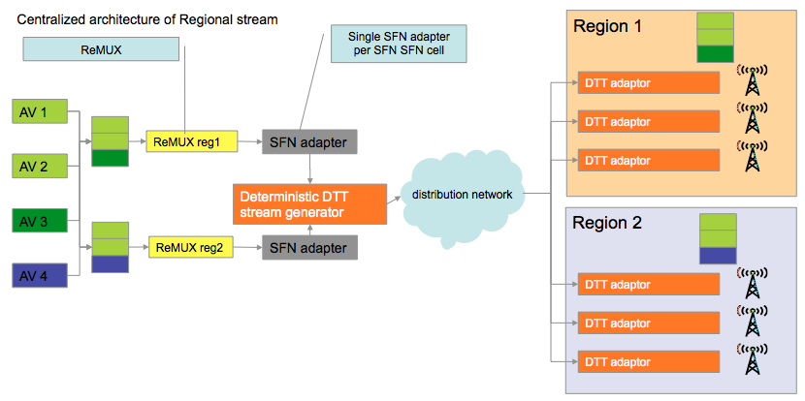

Comparing to PLP replacement method proposed technology allows apply regionalization inside PLP and is common for DVB-T as well as for DVB-T2.

|  |  |  |  |
| --- | --- | --- | --- |
| Req 3.7.2. | Distributed architecture for inserting regional or local services | Agreed | 1 |

In each region, the proposed solution shall ensure that the terrestrial multiplex can include services distributed over the satellite DTH link and services built in the region and inserted locally.

Compliance: YES

Proposed technology allows distributed deterministic re-multiplexing of regional or local services.

|  |  |  |  |
| --- | --- | --- | --- |
| Req 3.7.3. | Regional time slots insertion. | Agreed | 3 |

In each region, the proposed solution shall not prevent that national timeslots marked by triggers can be replaced by regional timeslots e.g. advertisements or Emergency warning messages (as per DVB fact sheet: DVB Emergency Warning System (EWS) in a distributed or centralized architecture.

Compliance: YES

Proposed technology allows deterministic re-multiplexing of regional or local time-slots using e.g. SCTE 035. However additional audio video constrains will have to be defined with respect of SFN streams.

Scrambling Requirements

The table below highlights some of the possible and most common CA scenarios

|  |  |  |  |  |
| --- | --- | --- | --- | --- |
| Use case | Satellite Distribution | DTT platform | Comments | Applicable requirement |
| 1 | All services scrambled | All services unscrambled | A common scenario considering that many free to air services are scrambled for rights protection over satellite distribution to limit the access to the intended territory only. | 3.8.1 |
| 2 | All, some or no services are unscrambled. | No change from satellite distribution | Not a common scenario but may be encountered in case it is not desired or required to protect the services over the satellite link. This is an easy case to handle technically since scrambled content, ECM’s and EMMs will be passed through. | 3.8.2 |
| 3 | All or some services scrambled with CA type 1*. | The scrambled services are changed to CA type 2 | This case sees a different CA type used on the DTT and DTH platforms. This could be a common requirement and should be supported. Use of Simulcrypt for the different CA types makes economic sense. | Req 3.8.3 |
| 4 | All services scrambled with CA type 1 | Some services unscrambled, some services scrambled with CA type 2 | This case represent a common case as scrambling is normally required for satellite distribution for rights protection, and Public broadcast services are often sent free to air while pay services shall be protected with another CA type. | Req 3.8.1. and Req 3.8.3 |

*Note: Simulcrypt support simultaneous usage of multiple CA vendors and also multiple systems from the same CA vendor. The CA systems in use are identified by CA_system_id and subsystem_id. CA type 1 and 2 is used to illustrate that the combination of CA_system_id and subsystem_id are different

|  |  |  |  |
| --- | --- | --- | --- |
| Req 3.8.1. | Scrambled services on the Satellite platform to be provided free to air on the DTT platform | Agreed | 1 |

Due to possible different copyrights requirements between satellite and terrestrial platforms, we will see at least some services scrambled on satellite, with all put in the clear for DTT transmission. This will be a common requirement and will require descrambling within the deterministic DTT stream adapter. Descrambling shall take place so that it is still possible to construct a new DTT transport stream deterministically, as defined by the accompanying metadata. Since all of the DTT services will be unscrambled, un-necessary components within the original satellite stream shall be dropped. This includes the EMM stream and CAT table. The PSI and SI tables should reflect the fact these are no longer present and the services are in clear.

Compliance: YES

Encrypted (“scrambled”) satellite DTH signal is decrypted at transmitter side by e.g. satellite receiver. Decrypted DTH signal incl. metadata enters DTT adaptor. Metadata contains references (pointers) only to packets, which form DVB-Ty signal, so all other components of DTH stream are ignored, incl. EMM stream and CAT table.

PSI/SI tables are also fully reconstructed from previously generated DVB-Ty stream.

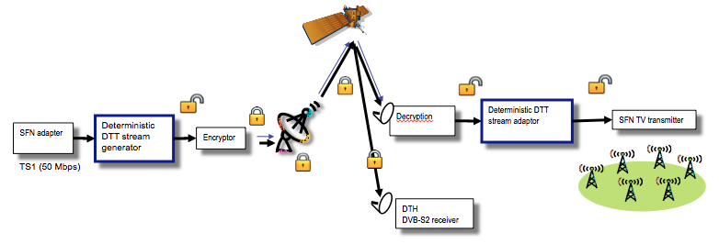

|  |  |  |  |
| --- | --- | --- | --- |
| Req 3.8.2. | Scrambled services on the Satellite platform to continue to be provided scrambled on the DTT platform, using the same CA type | Agreed | 1 |

At least some services will be scrambled with CA type 1 on both satellite and DTT. The implementation shall allow subscriber management to be performed separately if required, so that the satellite DTH and DTT platforms can have separate EMM streams. This is required to optimise bandwidth utilisation on the DTT system by allowing EMMs destined for satellite subscribers to be dropped. It also enables independent subscriber management on the satellite DTH and DTT systems if required.

Compliance: YES

Metadata contains references (pointers) only to packets, which form DVB-Ty signal, so all other components of DTH stream are ignored, incl. DTH related EMM stream.

Furthermore same content at Satellite and DTT EMM stream can be compact by the same processing algorithm.

|  |  |  |  |
| --- | --- | --- | --- |
| Req 3.8.3. | Support simulcrypt on the platform to make scrambled services on the Satellite DTH and DTT platforms available using multiple, different CA types | Agreed | 1 |

This will be a common requirement and makes it possible to use different access conditions for satellite reception and DTT receptions. The satellite and DTT PMT tables will point to the ECMs for the respective CA systems.

The option to filter EMMs and ECMs on the DTT platform to remove those destined only for satellite customers shall be retained to conserve bandwidth on the DTT system.

Compliance: Yes.

SI information management

|  |  |  |  |
| --- | --- | --- | --- |
| Req 3.9.1. | Building of a dedicated terrestrial signalisation | Agreed | 1 |

The system shall ensure that the Terrestrial multiplex built after the satellite link contains all the SI information needed for a terrestrial distribution.

This signalisation may come partly from the DVB-Sy signalisation (potentially from different networks) but also from additional information passed in the metadata transported on the satellite link.

Compared to the Satellite signalisation, the Terrestrial SI differences could be significant and may reflect;

Deleted services

Regionally added services

Services added from other satellite transponders

New NIT (actual) with new frequency descriptor, logical channel descriptor and NIT (other)

New EPG descriptors (EIT P/F and schedule)

New CAT

New TOT

This list is not exhaustive and is provided as an example only.

Compliance: Yes

As mentioned above proposed solution provides transparent link, what includes PSI/SI tables. Deterministic DTT adapter will reconstruct only PSI/SI tables being part of DVB-Ty stream, while compacting can be applied between DTH and DVB-Ty streams.

Latency

|  |  |  |  |
| --- | --- | --- | --- |
| Req 3.10.1. | Latency | Agreed | 1 |

The DTH/DTT mechanism shall add a minimum of latency. The ‘overall satellite delay’ is the delay between the output of the Terrestrial Head-End and the output of the terrestrial transmitter.

To better characterize the contribution of the ‘single feed system’ in the overall delay, the standard shall provide a clear definition of the different delays contributing to this ‘overall satellite delay’

Depending on the Terrestrial standard used the total latency between the Terrestrial Head-End output and the transmitter output can be:

In the DVB-T case : 1 second max

In The DVB-T2 case : 1 second max if the modulator works in a relative time

In The DVB-T2 case : xx second max if the modulator works in an absolute time. The value of the xx second total latency is linked to competitive aspects and therefore may depend on national implementations.

Compliance: Yes

Internal organization of DVB-T and DVB-T2 is very different from latency point of view.

So while delays are in DVB-T streams are mostly related to the time of reconstruction of PES packets, or DSMCC sections (bearing in mind related bitrates), processing delays at DVB-T2 streams are on top influenced by serialization of signal, when creating various PLPs (similar to time slicing in DVB-H).

There are different methods how to keep overall latency at acceptable level, however some processing latency will be always present. Latency is also dependent at individual T2-MI streams construction.

Coming with constraints for incoming streams may help to manage overall latency.

In case non Single Illumination technology processing presents around 350-450 msec., left part for additional latency e.g. for DVB-T and DVB-T2 relative scheme is 550-650 msec. While this processing latency is realistic for DVB-T it is not very much realistic for DVB-T2. We believe networks with single illumination technology will almost always end-up with DVB-T2 absolute time scheme.

Integration of Deterministic DTT stream generator with DVB-T2 gateway and remux will lead to the lowest head-end latency.

# Key code words format examples

1. **Generic**

**1. PES code word format:**

offset_from_base 1 or 2 bytes

tag 1 bytes (0x03)

code word length 1 or 2 bytes

hash_length 3 bits

pid 12 bits

hash according to the hash_length field value

header_flag 1 bit

undefined 2 bits

plp_flag 1 bits

cc 4 bits

if (header_flag) {

transport_error_indicator 1 bit

payload_unit_start_indicator 1 bit

transport_priority 1 bit

unused 1 bit

transport_scrambling_control 2 bits

adaptation_field_control 2 bits

if(adaptation_field_control=='10' || adaptation_field_control=='11'){

adaptation_field()

}

}

if (pkt_type == TS_204) {

isdb_payload 128 bits

}

while (more data to decode) {

TS_packet_delta 1 or 2 bytes

transport_error_indicator 1 bits

payload_unit_start_indicator 1 bits

transport_priority 1 bits

unused 1 bits

transport_scrambling_control 2 bits

adaptation_field_control 2 bits

if(adaptation_field_control=='10' || adaptation_field_control=='11'){

adaptation_field()

}

if (pkt_type == TS_204) {

isdb_payload 128 bits

}

}

Hash field points to the block in dictionary, containing PES packet.

Header_flag signalils, the need to reconstruct also MPEG-2 TS header.

Prefix_flag and suffix_flag indicate, whether code word contains data, which will come before or after referencne block content.

TS_packet_delta contains offset of another MPEG-2 TS packet from previous packet.

**2. DSMCC Section code word format:**

MPE DSMCC sections is almost identical with PES packets processing. Only difference is in MPET-2 TS header compression, which may contain PUSI pointer.

So the DSMCC Section codeword format is:

offset_from_base 1 or 2 bytes

tag 1 bytes (0x04)

code word length 1 or 2 bytes

hash_length 3 bits

pid 12 bits

hash hash_length

header_flag 1 bit

prefix_flag 1 bit

suffix_flag 1 bit

plp_flag 1 bit

cc 4 bits

if (prefix_flag) {

prefix_len 8 bits

prefix_data prefix_len

}

if (suffix_flag) {

suffix_len 8 bits

suffix_data suffix_len

}

if (header_flag) {

transport_error_indicator 1 bit

payload_unit_start_indicator 1 bit

transport_priority 1 bit

unused 1 bit

transport_scrambling_control 2 bit

adaptation_field_control 2 bit

if(adaptation_field_control=='10' || adaptation_field_control=='11'){

adaptation_field()

}

}

if (payload_unit_start_indicator) {

PUSI_pointer 8 bits

} else {

offset 8 bits

}

if (pkt_type == TS_204) {

isdb_payload 128 bits

}

while (more data to decode) {

TS_packet_delta 1 or 2 bytes

transport_error_indicator 1 bits

payload_unit_start_indicator 1 bits

transport_priority 1 bits

unused 1 bits

transport_scrambling_control 2 bits

adaptation_field_control 2 bits

if(adaptation_field_control=='10' || adaptation_field_control=='11'){

adaptation_field()

}

if (payload_unit_start_indicator) {

PUSI_pointer 8 bits

}

if (pkt_type == TS_204) {

isdb_payload 128 bits

}

}

**B. DVB-T2 MI related code words**

**3. BBFrame codeword**

unset bit #0

unset bit #1

crc bit #2

HEM bit #3

unset bit #4 - 7

pkt_pos 4 bytes

packet_type 1 byte

BBF_packet_count 1 byte

BBF_superframe_idx bit #0 - 3

BBF_rfu bit #4 - 12

t2mi_stream_id bit #13 - 15

payload_len 2 bytes

frame_idx 1 byte

plp_id 1 byte

intl_frame_start bit #0

rfu bit #1 - 7

if (crc) {

crc_32 4 bytes

}

if (HEM) {

MATYPE 2 bytes

ISSY 3 bytes

SYNCD 2 bytes

CRC-8 1 bytes

} else {

MATYPE 2 bytes

UPL 2 bytes

DFL 2 bytes

SYNC 1 bytes

SYNCD 2 bytes

CRC-8 1 bytes

for (i = 0;i<N;i++) {

if (!HEM and ISSYI) { -- MATYPE-1 && 0x08

issy 2 - 3 bytes

}

if (DNP) { -- MATYPE-1 && 0x04

dnp 1 bytes

}

}

}

**4. T2-MI codeword**

offset_from_base 1 or 2 bytes

tag 1 bytes (0x06)

code word length 1 or 2 bytes

BBframe bbframe - len

pid bits 0..12

seg_len 2 byte

header_flag bit #7

prefix_flag bit #6

suffix_flag bit #5

T2_MI bit #4

continuity_counter bits 0..3

if (prefix_flag) {

prefix_len 1 byte

prefix_data prefix_len bytes

}

if (suffix_flag) {

suffix_len 1 bytes

suffix_dat suffix_len bytes

}

if (header_flag) {

transport_error_indicator bit#7

payload_unit_start_indicator bit#6

transport_priority bit#5

unused bit#4

transport_scrambling_control bits 2..3

adaptation_field_control bits 0..1

if (adaptation_field_control is '10' or '01') {

af bytes 1 byte

af length 1 byte

af_data af_bytes bytes

}

if (pkt_type == TS_204) {

isdb_payload 128 bits

}

while (more data to decode in code word) {

TS packet delta 1 or 2 bytes

transport_error_indicator 1 bit

payload_unit_start_indicator 1 bit

transport_priority 1 bit

unused 1 bit

transport_scrambling_control 2 bits

adaptation_field_control 2 bits

if (adaptation_field_control is '10' or '01') {

af bytes 1 byte

af length 1 byte

adaptation field af bytes

}

if (pkt_type == TS_204) {

isdb_payload 128 bits

}

}