Department of Computing

CS 212: Object Oriented Programming

Class: BSCS-15

Lab01: Basic Programming in Java

Date: 21 January 2026

Lab Engineer: Daniyal Attiq

Lab01: Basic Programming in Java
Introduction
In this lab we will discuss the basics of programming in java.

Objectives
After completing this lab you will be able to do variable declarations and initializations with some printing and math in Java.

Your first activity will be creating the "Hello World" program using Java. We'll try a few experiments using it to see what happens for some basic errors. As you carry out the steps in this lab, it is important to think about what you are seeing and to understand what's going on. The more attentive you are here the fewer headaches you'll have later!

Tools/Software Requirements
NetBeans IDE , JDK

Description
Basic Lab Instructions!

- Talk to your classmates for help.

- You may want to bring your textbook to future labs to look up syntax and examples.

- Stuck? Confused? Have a question? Ask a Lab Engineer for help, or look at the book or past lecture slides.

Basic Java Project creation in NetBeans

Open File> New Project

As shown in below snapshot
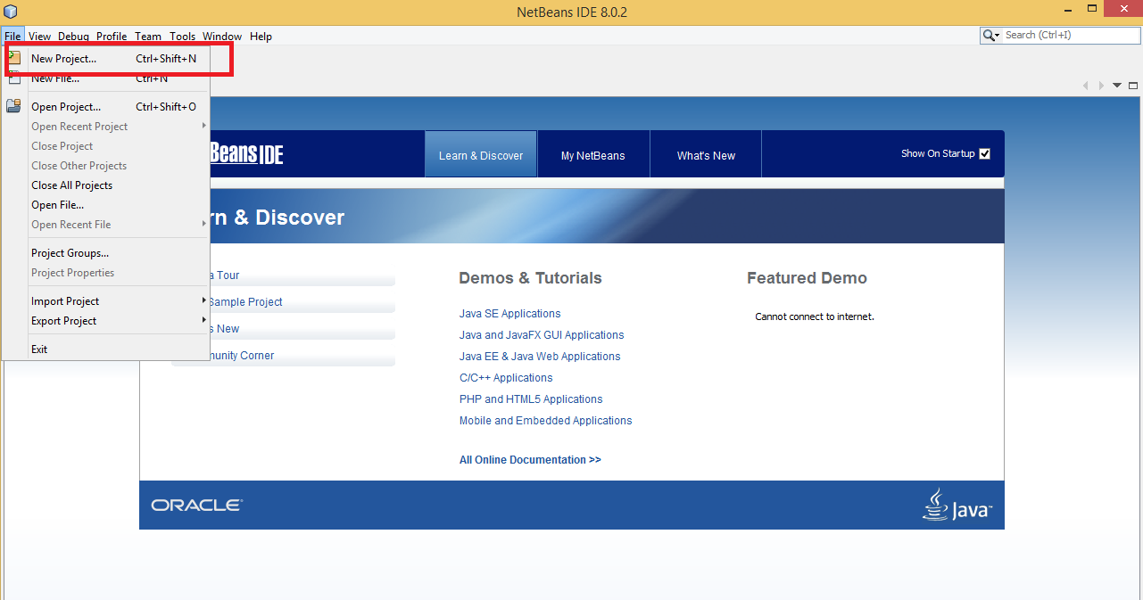

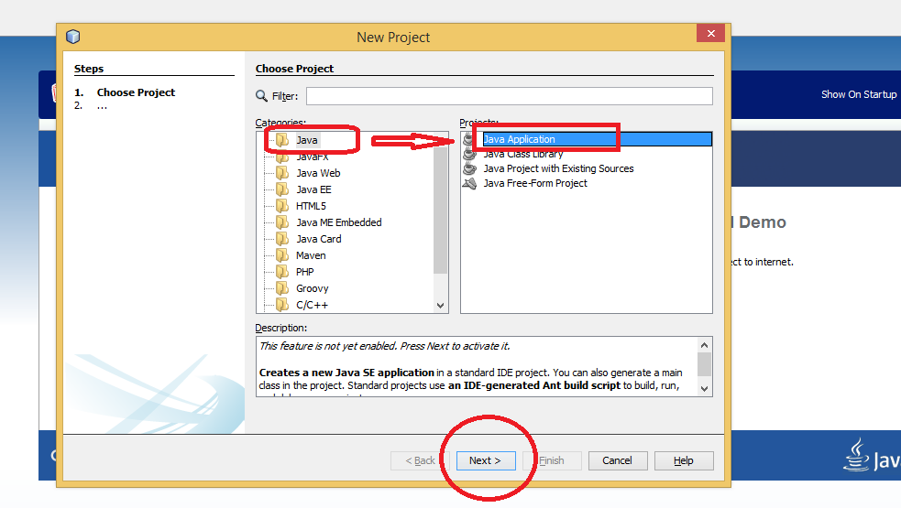
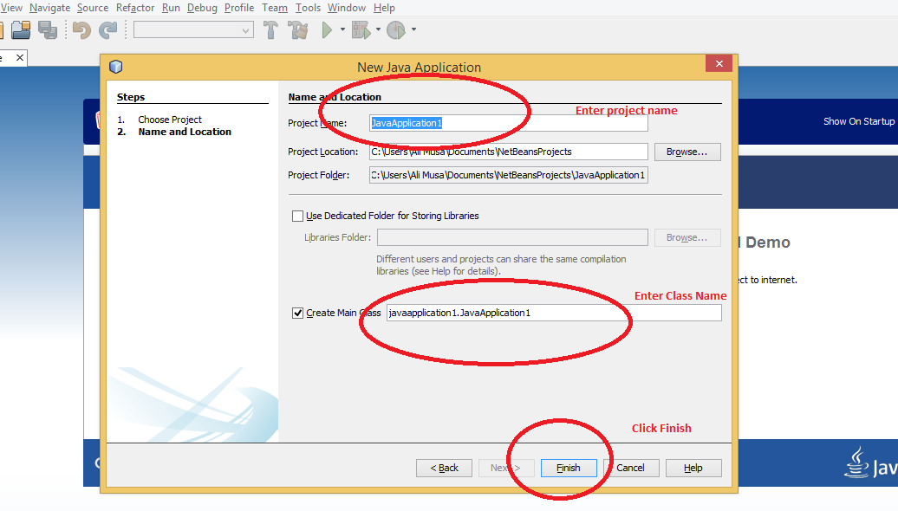
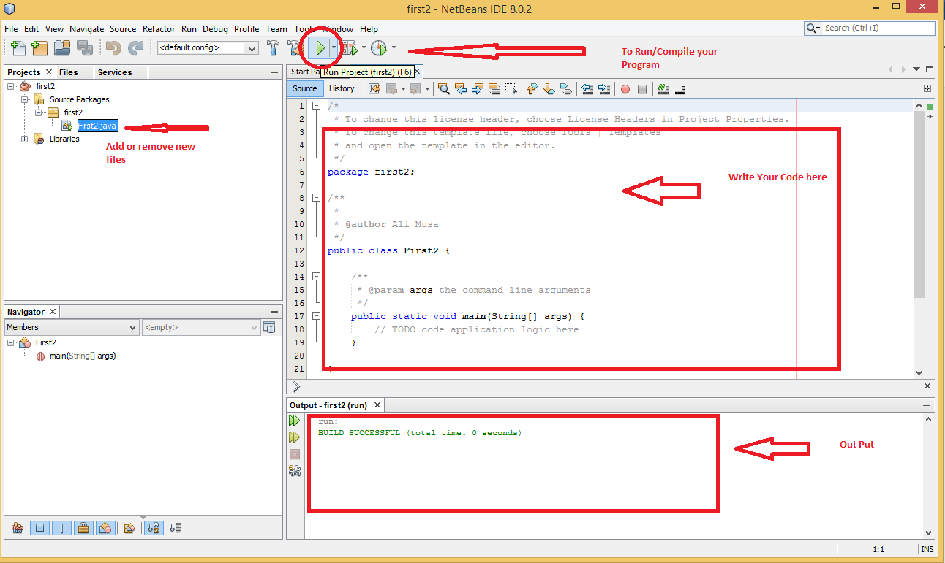

Activity #1.

Your first task will be creating the "Hello World" program using java.

// This program outputs the message "Hello World"
public class ActivityOne
{
public static void main (String args [])
{
System.out.println ("Hello World");
}
}

Save the file, and open command window to use for compiling and running your program. In the new window, navigate into your CS-212 directory and issue the following command to compile the program, if you are working on a Linux like environment (In case you are using NetBeans, just Build and Execute the project).

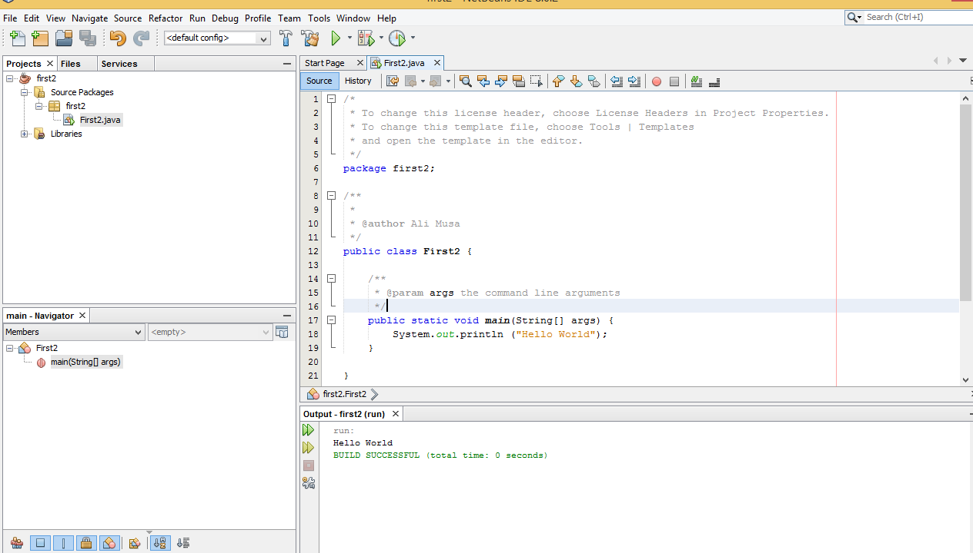

javac ActivityOne.java

If you get any compiler messages, then the learning process has already started! Make sure the name of the file and the name of the class are identical, that you're in the right place in the directory structure, and the code is exactly as shown above.

Once the program compiles, enter the command to run it.

java ActivityOne

You will see the output in the console window.

After getting the program to work, let's see what happens if we deliberately break it. We'll try several variations that violate java syntax to learn what happens. Watch carefully to see what message the compiler generates for each of these small errors—they are mistakes every programmer makes on a regular basis.

- Start by changing the name of the class in the first line, saving the file, and then attempt to re-compile it with the javac/NetBeans Build command. Observe what happens.
- Now restore the name in the class header and try removing one of the opening braces, then save and compile again. Put the brace back and remove the closing brace that matched it, and save and compile again. Make a note of the messages the compiler generates for each change.
- Try a version with a lowercase "s" at the beginning of the output statement instead of the uppercase "S."
- Finally, try a version where the only change is the removal of the semicolon at the end of the print statement. This is a mistake every programmer makes more than once—it's good to see how the compiler responds.

Activity #2.

Modify your ActivityOne file to produce the following console output. Note the blank lines; you should include those in your output.

Hello, world!
Welcome to CS 212.
It’s boring!

Activity #3.

Programs should be indented properly to make them easier to read.

{ brace -> increase indent of following lines by one tab
} brace -> decrease indent of that line and following lines by one tab

The following program has poor indentation. Fix it.

public class ActivityThree {
public static void main(String[] args) {
System.out.println("Properly indented programs");
System.out.println("look ever so much better!");
System.out.println("please fix me");
System.out.println("and make me beautiful again");
}
}

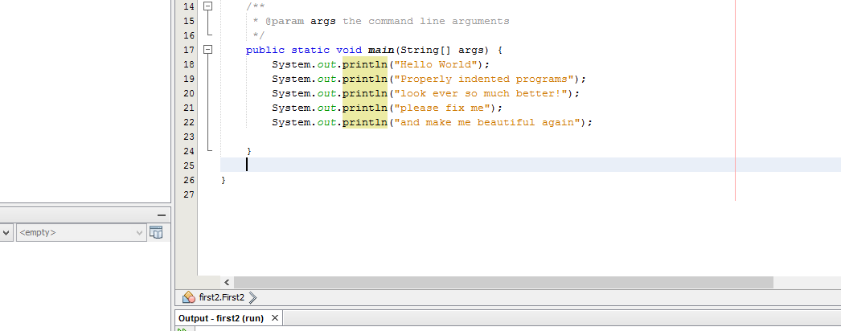

Activity #4.

How many lines of output are produced (including blank lines)?

public class ActivityFour {
public static void main(String[] args) {
System.out.println("Testing, testing,");
System.out.println("one two three.");
System.out.println();

System.out.println("How much output");
System.out.println();
System.out.println("will there be?");
}
}

Activity #5.

The following program contains 11 errors! What are they?

public class ActivityFive
public static main(String args) {
System.out.println(Hello world);
system.out.Pritnln("Do you like this program"?);
System.out.println()

System.println("I wrote it myself.";
{
}

Once you think you've found the errors, create/compile/run a corrected version of this program.

Activity #6.

Discover what error messages the compiler produces when you make each of the following mistakes. How many unique error messages are you able to cause the compiler to produce?

- Naming your file incorrectly, then compiling.
- Forgetting a keyword such as void or class
- Forgetting a quotation mark "
- Forgetting a parenthesis ( or )
- Forgetting a dot .
- Using too many or too few braces { or }

Notice that the error messages don't always make it obvious what is wrong. But they usually tell you the right line number to fix.

Activity #7.

Write a complete Java program that produces the following output (note the blank line):

A "quoted" String is
'much' better if you learn
the rules of "escape sequences."

Also, "" represents an empty String.
Don't forget: use \" instead of " !
'' is not the same as "

Activity #8.

Write a complete program that produces the following output:

\/
\\//
\\\///
///\\\
//\\
/\

Activity #9.

Change the following program to use compound assignments:

class ActivityNine {

public static void main (String[] args){

int result = 1 + 2; // result is now 3
System.out.println(result);

result = result - 1; // result is now 2
System.out.println(result);

result = result * 2; // result is now 4
System.out.println(result);

result = result / 2; // result is now 2
System.out.println(result);

result = result + 8; // result is now 10
result = result % 7; // result is now 3
System.out.println(result);
}
}

Lab Tasks:
Task #1:

Write a Java program to print the area and perimeter of a circle.

Task #2:

Suppose you have a real number variable x. Write a Java expression that computes the following value y while using the * operator only four times:

$$y=12.3x^{4}-9.1x^{3}+19.3x^{2}-4.6x+34.2$$

Task #3:
Write a Java program that accepts four integers from the user and prints equal if all four are equal, and not equal otherwise.

Hint: for input
import java.util.Scanner;
public class Solution {
public static void main(String[] args) {
Scanner in = new Scanner(System.in);
System.out.print("Input first number: ");
int num1 = in.nextInt();

}
}

Deliverables

- By showing up on time for lab.
- Do all tasks, include code and add screenshots of Output.

