**Math E-3 Assignment 9**

**Problems 1-9**

**Give the coordinates of each labeled point in the graph below. Note that the dots are quite large so give the points to the nearest WHOLE values. Please write the coordinates in the space provided next to the graph below each letter. Do not write the answer on the graph itself. Use a ruler to help you. Remember, the horizontal or x-axis value is first in the parentheses and the vertical, y-value, is next.**

|  |
| --- |
| Point A  1. (0, 5)  Point B  2. (4, 6)  Point C  3. (5, 3)  Point D  4. (5, -3)  Point E  5. (0, -2)  Point F  6. (0, 0)  Point G  7. (-3, 0)  Point H  8. (-6, -4)  Point I  9. (-5, 3) |

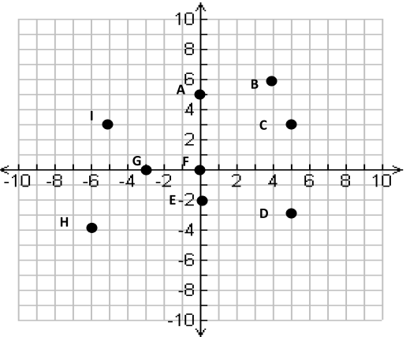

**Problems 10-13**

Find the **slope of the line joining the following points**. Use the examples in the chapter to help you. Show your work.

10) (3,7) and (-4,6)



11) (8,1) and (9,2)



12) (4,8) and (4,10)



13) (6,-2) and (9,-2)



**Problem 14-21**

**PLOT each of the following points on the same set of axes below. Please label your points with the number. (It will look like problem 1-9 above.)**

14) (2,0) 15) (0, -3) 16) (-4,2) 17) (-1,0)

18) (3, 0) 19) (-2, -6) 20) (0, 1) 21) (1,-3)

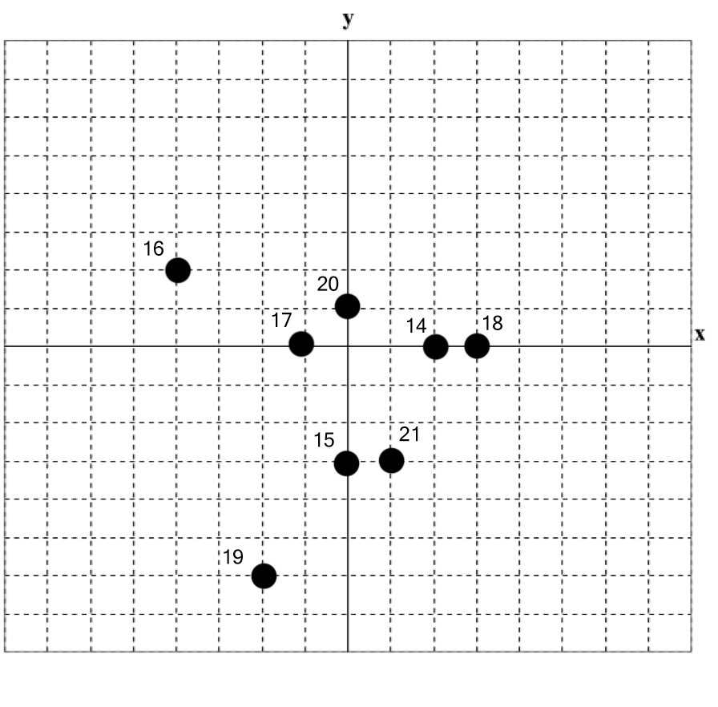

**Problems 22-24**

**Given the following equation of a line:**

**Y = -6X +4**

22) What is the slope? 

23) What is the y-intercept? 

24) What are the coordinates of this y-intercept? (0, 4)

**Problems 25-27**

**Given the following equation of a line:**

**Y = 4/5 X - 8**

25) What is the slope? 4/5

26) What is the Y-intercept? -8

27) What are the coordinates of the X-intercept? (10, 0)

**Problem 28**

Graph the following two equations (A) and (B) on the same set of axes using the grid on the next page.

(A) Y = 4x -2 (B) Y= 2x +2

Use the charts below to document your points (you only need two points per line but you can have more):

X Y X Y

0 -2 0 2

1 2 1 4

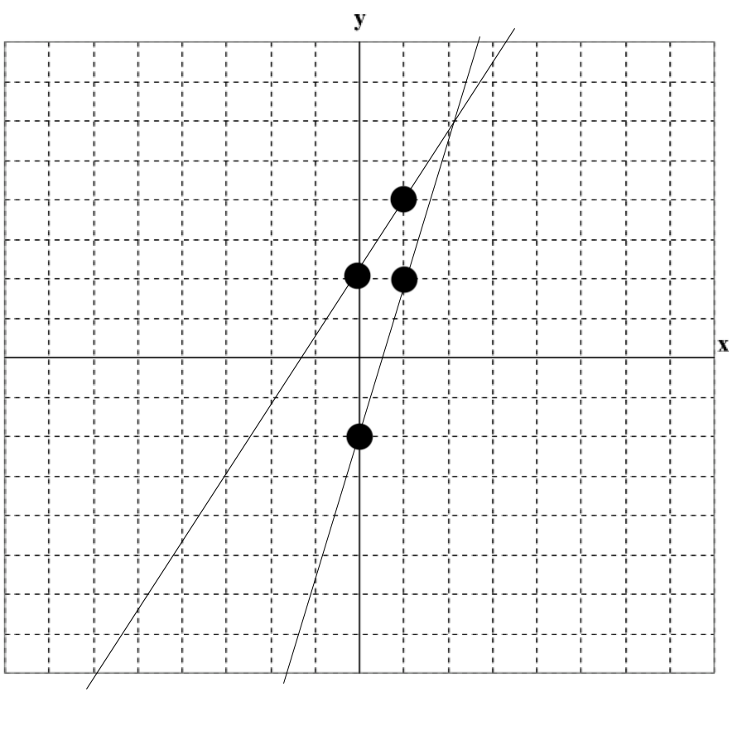

**Problem 29**

Guess the coordinates of the point of where the two lines intersect from the graph you drew above, or you can solve algebraically if you know how. Write the coordinates below.

Space to solve for intersection (calculating this algebraically is optional as you can use your graph to guess).



**Intersection:**

**(2, 6)**