Lecture Notes 4/9/14

Lesson 6.6

Other Trig Functions

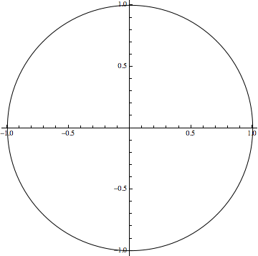

If we divide by  :



... Divide by  ?



Example 1:

 . Find all trig functions.

 .

We know that:



Sol:



Depending on the quadrant,

All students take calculus

ASTC

QI, QII, QIII, QIV

A S T C



