Math E-10 Nicholas Gallimore

Spring 2014 [ngallimore@g.harvard.edu](mailto:ngallimore@g.harvard.edu)

Problem Set 6

**Page 157: #46**.



**Page 164: #44, 46, 48, 52.**

**44.** 

**a) **

**b)** Because , we can use do the following to solve for *t*:

** **

**c) **

**46.**

**a) **

**b) **

**c)**

** **

**48.**

**a).  **

**b). **

**52.**

**a). **

**b). **



**c).  **

**Page 200: #40.**

**a). **

**b). **

**c). **

**Page 209: #24, 28.**

**24.**

**Graph of **

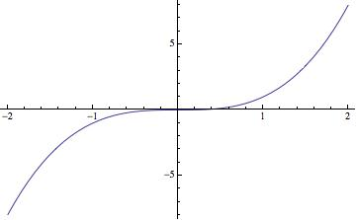

**Graph of **

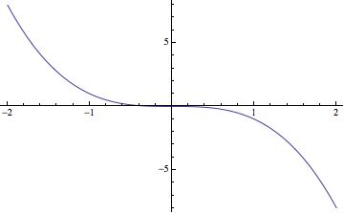

**Graph of **

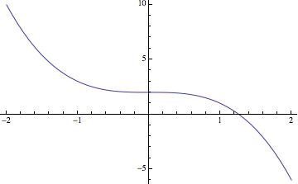

**b).**

**Graph of **

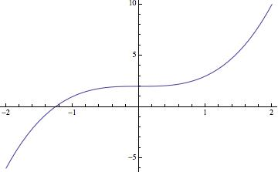

**Graph of **

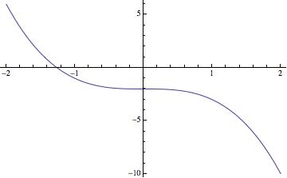

**c).**  No because: 

**28.**

**a)** The temperature is the highest between the hours that school is most likely in session.

**See attached for rest**

**Page 223: #12, 16, 20.**