Nicholas Gallimore

Problem Set 9

Math E-10, Harvard Extension

Problem 1.



Problem 2.



Problem 3.



Problem 4.



Problem 5.



Problem 6.



Problem 7.



Proof:



Problem 8.



Proof:



Problem 9.

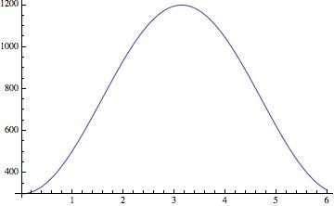

The midpoint is 750.

b).



c).

