Nicholas Gallimore

Problem Set 8

Due 4/9/14

Page 247.

Problem 16.

Period: 120

Amplitude: 10

Midline: 14

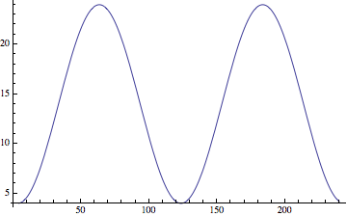

Problem 18.

Period: 5 minutes

Amplitude: 17.5 meters

Midline: 17.5 meters

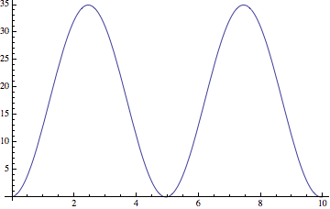

Page 255.

Problem 6.

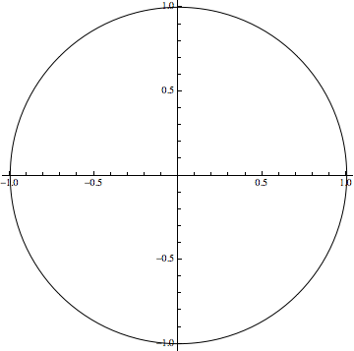



Problem 18.



Problem 32.



Page 261.

Problem 24.

If 3 radians = 30cm then 1 radian = 10cm, thus the radius is 10cm.

Problem 32.



Page 267.

Problem 18.

1. If  then 
2. If  then 

Problem 30.

a) 

b) 

Page 275.

Problem 16.

Period: 12

Amplitude: 10

Midline: 20

Problem 28.



Problem 42.

a)

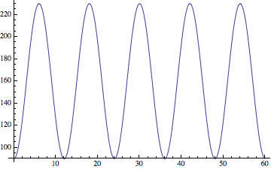

b)

When t is the time in minutes we have:



c)

