Math E-3: ASSIGNMENT 4
Problem 1

Here is a similar data set to the one given in Chapter 4. Draw or create the histogram indicated below. You may draw by hand or use a software program like Microsoft Paint to do this.
It will help if you set up some kind of tally. Thus, we will award 1 point extra credit for setting up a neat stem and leaf display.

In a large room of people, the age of each person was obtained. Here are the data:

26 43 18 42 13 65 30 18
37 23 36 47 42 16 51 41
29 15 29 31 47 53 41 34
19 22 50 43 38 32 46 60

DATA
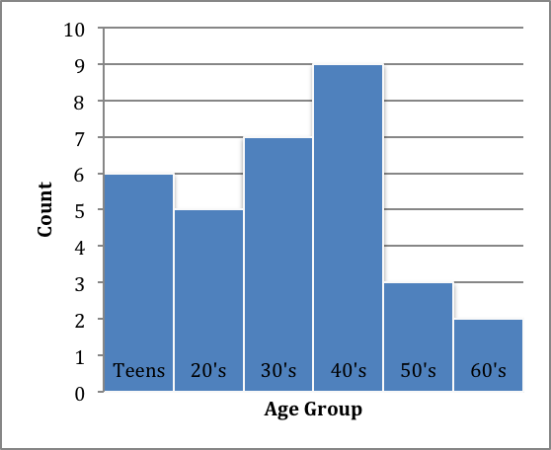

Extra Credit: Stem and Leaf Diagram:

First Pass: Second Pass:
Stem | Leaf
1 | 8 3 8 6 5 9
2 | 6 3 9 9 2
3 | 0 7 6 1 4 8 2
4 | 3 2 7 2 1 7 1 3 6
5 | 1 3 0
6 | 5 0
Stem | Leaf
1 | 3 5 6 8 8 9
2 | 2 3 6 9 9
3 | 0 1 2 4 6 7 8
4 | 1 1 2 2 3 3 6 7 7
5 | 0 1 3
6 | 0 5
Make a histogram of this data using a class interval size of 5, starting at 10.

DATA
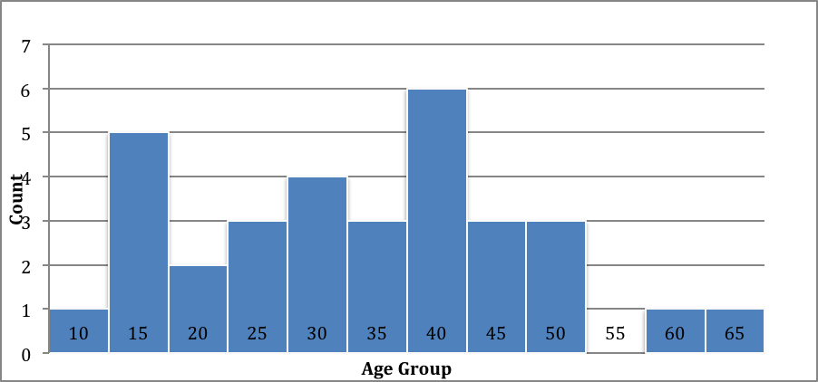

For problems 2 -6

The histogram below shows the number of students in an incoming freshman class of a local university receiving financial aid and the average income of their families.

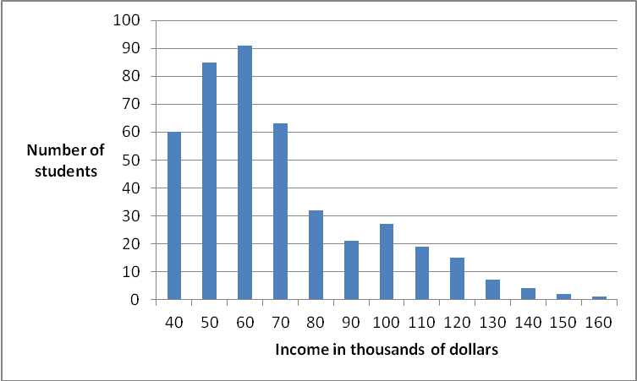

2. Can you find the exact number of freshman receiving financial aid? Why or why not?

The data set provided does not procure the proper information to compute the exact number of freshman receiving financial aid. Consider the following situation; assume that the average number of people living in a high school senior’s household consists of two parents, the student and one sibling for a total of four people. While I cannot access precise information at this time due to the current lapse in funding for the US government’s census website, let it be known that this is not an accurate approximation of the real figure. One must also note that even this unrealistic pseudo-generated figure does not satisfy the specifications required to calculate the average number of people living in each of the student’s household’s of the above data set concisely. Thus let us make one last presumption that this figure is independent of the national average, and may the reader acknowledge that while four is not the average number of people per student household from the local university mentioned above, we will still be using it in our computation. Despite that notion that the above evidence provides rigorous proof that it is not possible to compute the exact number of freshman receiving financial in the above data set, we will continue to answer any future questions which may be arise.
In order for a student to receive financial aid, the number of people in each household is taken into consideration, the mean average of the family’s income, and the student’s assets, as well as the families. The department of education calculates a figure known as the expected family contribution (EFC). A student is rewarded financial aid based upon whether the EFC is less than the average cost of attendance to attend the university. If the lather is determined true by the Department of Education, then that particular student shall receive a determination notice stating that the student is eligible for federal financial aid on a needed basis. Like wise, it is deterministically based in which the opposite event may occur; such that the student is not eligible for federal financial aid and will receive a notice from the Department of Education stating that student is ineligible due to an un-needed basis.
Given that we are not provided the name of the aforementioned university we will compute the average summation of the number of students that are determined eligible for receiving financial aid, giving the presumption that each and every individual student applied for federal aid. Note that this figure is not an actual representation of the approximate number of students receiving financial aid. Nonetheless, in regards to the lack of information, we shall compute two figures, an approximation of the number of students receiving financial aid and the approximate net summation of the students eligible for financial aid. Let D denote the set of all values for the student’s average family income, let N denote the total number of students, let T denote the total summation of all the average family incomes, such that:

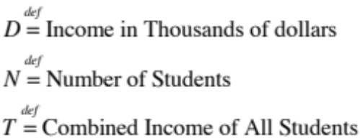

and

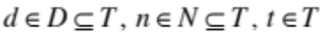,

Where d is each student’s average family income, n represents all values for the number of students at that exact same average family income (siblings both enrolled), and t is the count of income’s (n) times the particular income value (d). (n*d). Note that the summation of every element t in T is equal to T:
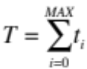

This also implies that 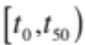 denotes the summation of all the average family incomes up to 50 (not including 50). In this case MAX is set to 100.

The same applies for D and T:

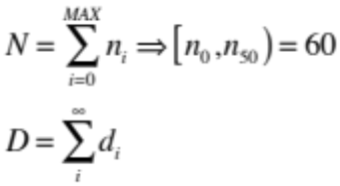

Consider the following function, f, which takes on input the values d, n, and outputs the value t:
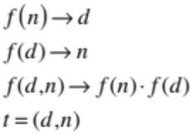

I’m going to just wave my hand at the rest real quick because I just re-read the question. (Regards)


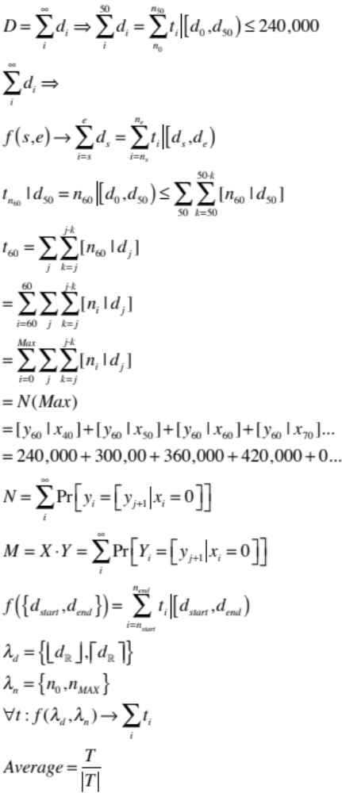

Okay, so the answer is... YES, the exact number of students receiving financial aid is N. Although it may be hard to figure out the value of N, or even count the total number of students. The Y coordinate isn’t scaled properly to common factors for every series of the total number of students in a particular income range. (A side note however, I really wish this graph included ALL the students. After all it is a little misleading considering a family with an average income of 160,000 receiving financial aid.)

3. Estimate the amount of students receiving financial aid? That is, give an approximate size.

421

4. What is missing from this graph?

The question implies that the graph displays data from the current freshman, not the incoming freshman. But most importantly, the precise average income amount’s of each family isn’t being displayed. Also there isn’t a title.

5. Describe its shape?

The graph is skewed right.

6. Estimate the average income of the students' families' receiving financial aid? (Answers will differ.)

I have two answers, one considering the average income of the students can be larger than 190,000; implying such that the amount of money one way acquire is indeed infinite thus the average would be undefined given this scenario since one cannot put a value on infinity. Regardless, I shall proceed to ask as to whether this graph is subject to change, since this data could no longer be accurate at this given moment. In spite of the lather, after much contemplation I feel as if the best possible answer to this question is the following:

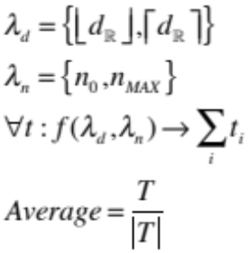

However, if the event exists in which this does not satisfy the question brought forth; I propose an alternative answer of 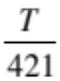.
In the event that both of the aforementioned solutions don’t agree, I propose one last solution to the question:

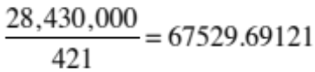

Problems 7-13

Grades for Accounting 101 quiz. The data below gives the grades on an accounting quiz. The highest grade was a 90 and the lowest, a 20.
Frequency
Grade # of Students who received that grade
20 2
50 3
60 5
70 15
80 5
90 2

7. Draw or create the histogram for this distribution of grades. (do not forget labels, including a title.)
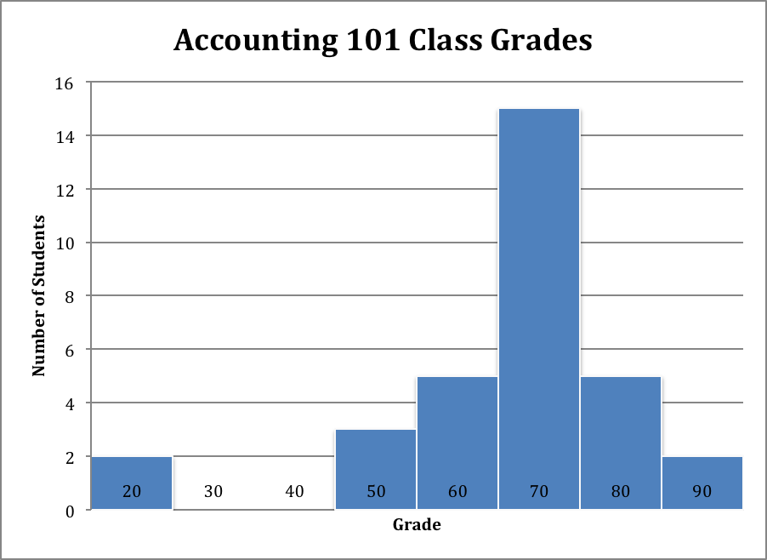

8. Describe its shape.
The histogram is considered normal. Though one could present a reasonable argument for it being skewed left if the grades started from 0.

Find the measures of center:

9. Find the mean grade (round this to 1 dp, e.g. if you got an answer of 36.325, you would round to 36.3): Subliminal - (3+3)~6.25 = 66.25

The mean grade is 66.3

10. Find the median grade
The median grade is 70.0

11. Find the mode
The mode is 70.

12. Which is greater, the mean or the median? Why?
The median, because the bulk of the data is in the 70’s and there is 10 data points less than 70 and only 7 data points greater than 70.

Find the measures of spread:

13. range
90-20 = 70

14. Calculate the standard deviation. Use the mean rounded to 1dp. (Note: You must do the calculation of the standard deviation as we did in class. I have set up the table for you to get you started. However, you must be able to set it up on an exam without benefit of notes. Round end result to 1 dp.
X | (X – x-bar) | (X – x-bar)² | f | (X – x-bar)² * f
20 | -46.3 | 2143.69 | 2 | 4287.38
50 | -16.3 | 265.69 | 3 | 797.07
60 | -6.3 | 39.69 | 5 | 198.45
70 | 3.7 | 13.69 | 15 | 205.35
80 | 13.7 | 187.69 | 5 | 938.45
90 | 23.7 | 561.69 | 2 | 1123.38

n = 32
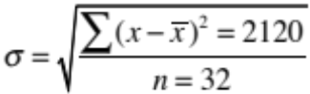 = 8.1

Problems 15-18
The table below describes the parking rates per day at 31 different parking garages in and around the city of Boston.
Parking rate Number of garages at that price
$16 3
$18.50 6
$21 8
$22.5 5
$24 4
$26 3
$45 2

15. Draw or create the histogram for this data. (Use single costs on horizontal axis.)
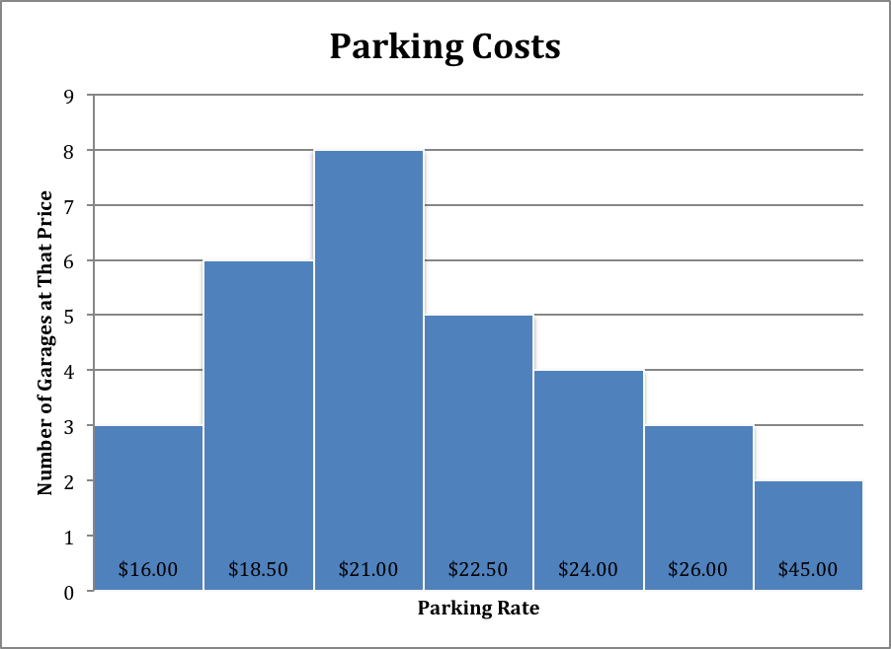

16. Calculate the mean parking rate at these garages. Round to 2 dp.
703.5 / 31 = $22.70

17. Calculate the median parking rate at these garages.
$21.00

18. What percentage of the parking garages had rates that were less than the mean parking rate?
22 / 31 = .70968 = 70.978%

Problems 19-25
Given: the following frequency table of the heights of women on a college soccer team.
Height in inches Frequency
65 2
66 5
67 7
68 10
69 6
71 5
72 2

19. Draw or create the histogram for these data. (use single heights.)
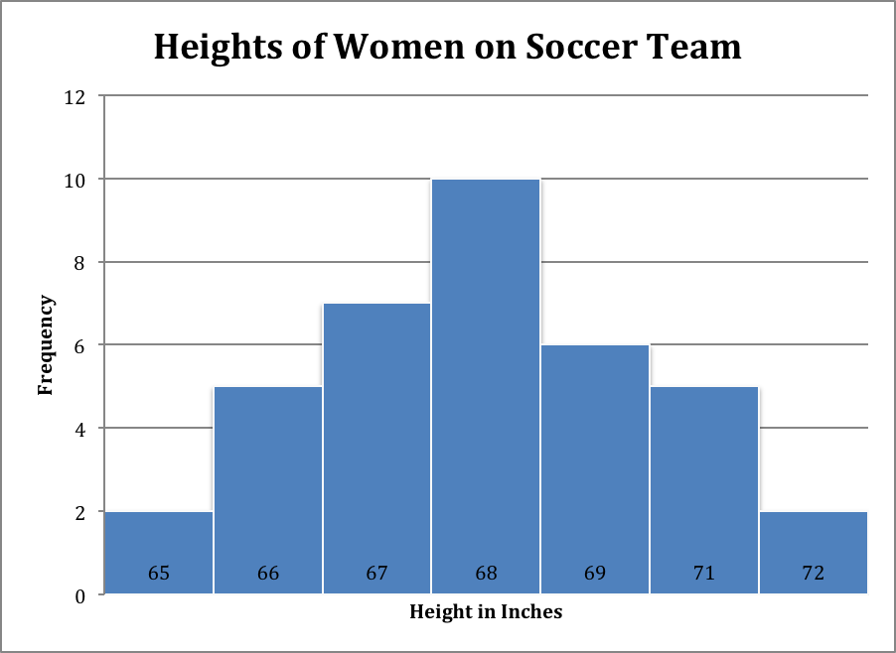
20. Describe its shape.
The histogram is normal.

Find the measures of center:

21. mean (round to 1 dp)
2522 / 37 = 68.2”

22. median
68”

23. mode
68”

Find the measures of spread, height (in inches) .
24. range
7”

25. Calculate standard deviation. Round final result to 1 dp.
X | (X – x-bar) | (X – x-bar)² | f | (X – x-bar)² * f
65 | -3.2 | 10.24 | 2 | 20.48
66 | -2.2 | 4.84 | 5 | 24.2
67 | -1.2 | 1.44 | 7 | 10.08
68 | -.2 | .04 | 10 | .4
69 | .8 | .64 | 6 | 3.84
71 | 2.8 | 7.84 | 5 | 39.2
72 | 3.8 | 14.4 | 2 | 28.8

