MATH E-3: ASSIGNMENT 3

Solve these problems:

- 17% of 600 = 102

- 3.5% of 900 = 31.5

- What % of 360 is 120? 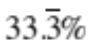

- $82.50 is 15% of what? 550

- What is 260 increased by 20%? 312

- I heard on the news a while back that Macy’s was cutting 1500 jobs, or 6% of its total workforce. What was the size of its work force before the cuts?



For Problems 7, 8, and 9, rewrite the expressions as decimals:

- 45% = 0.45

- 1/4 of 1% = 0.25 * 0.01 = 0.0025

- 5% of 25% = 0.05 * 0.25 = 0.0125

- A store offers a 15% discount on clothing; then a week later it offers another 25% discount. What is the total discount? Is it 40%? Explain. (Since no actual prices are given, you can “make up” a price to use in your calculations)

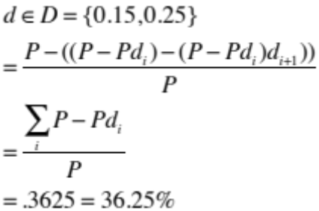

- Convert these numbers in the chart below to a fraction, decimal, or percent.

Fraction | Decimal | Percent
1 | 1.0 | 100%
1/2 | 0.50 | 50%
1/3 | 0.33... | 33.33...%
1/4 | .25 | 25%
2/3 | 0.66... | 66.66...%
1/8 | 0.125 | 12.5%
1/10 | .1 | 10%
3/5 | 0.6 | 60%
1/1000 | 0.001 | 0.00001%
99/100 | 0.99 | 99%

Use this data for problems 12 through 16:
Here are some figures relating to the Standard & Poor's 500 index from this past year. I got the data from this website, which plots charts as well as giving you numbers for a particular date:

http://moneycentral.msn.com

October 1, 2012 January 18, 2013 April 26, 2013 July 3, 2013
1428.59 1485.98 1582.24 1615.41

Clearly this has been a good time for the S&P 500! Do the following calculations:

- Find the percent increase for each of the periods October to January, January to April, April to July. Which is the biggest percent increase? Is it also the biggest amount increase? Remember to give your answers as percentages rounded to two decimal places, as we did in class.

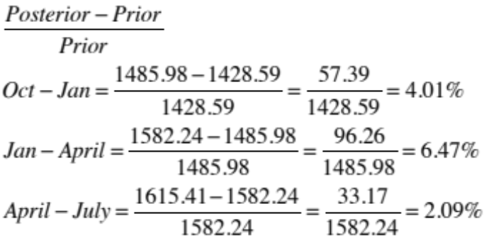

The biggest percent increase of 6.47% occurred between the period of January 18, 2013 and April 26, 2013, this period also has the biggest amount increase of 96.26.

- Calculate the percent increase going directly from October 1, 2012 to July 2013 (i.e. from 1428.59 to 1615.41).

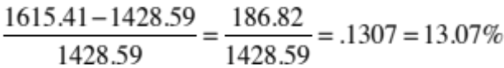

- Is sum of the three percentages in number 12 the same percentage as the one percentage calculated in the question 13? Why or why not?

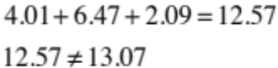

If this were the case, then the answer to problem number ten would be 40% instead of 36.25%. The S&P increase is approximately calculated by:

1615.41 = 113.07% of 1428.59 =
(102.09% of (106.47% of (104.01% of 1428.59)))

- If hypothetically the S & P were to decrease from the July 2013 figure back down to the original figure (i.e. from 1615.41 down to 1428.59), what percent decrease would this be? Is it the same as your answer for problem 13 (not counting the negative sign)? Explain.

The S & P would have to decrease by approximately 11.56% in order for it to equal 1428.59. This is not the same as an increase of 13.07% when it equaled 1428.59.
13.07% of 1428.59 is equal to 11.56% of 1615.41.

What this means is that 13.07% of 1615 is much larger than 13.07% of 1428.59.

- As of right now (close of the market on September 12, 2013, the S&P is at
1683.42. What percent increase is this from the July 3, 2013 figure?

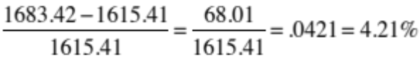

Problems 17 and 18:

Mayoral campaign spending will be brisk in the city of Boston this year, as Mayor Menino has decided to retire after many years running the city of Boston. During the 2013 campaign, the hypothetical budgets of two of the candidates are represented below. Let’s assume candidates John Connolly and Martin Walsh have six major expenses as shown in the pie charts below. At the beginning of the campaign, John Connolly estimated he would need to spend $26 million dollars and Martin Walsh estimated he would spend $24.5 million.

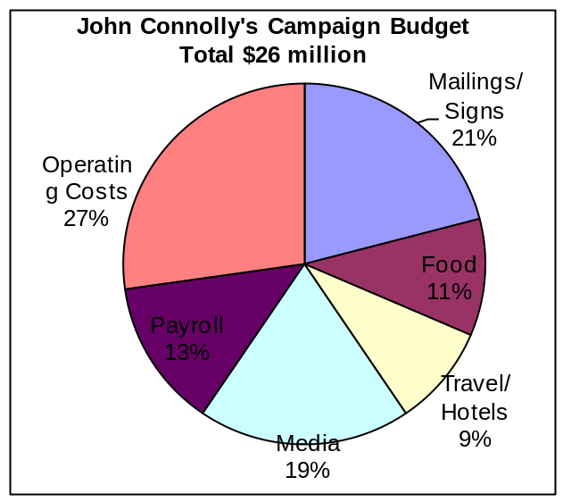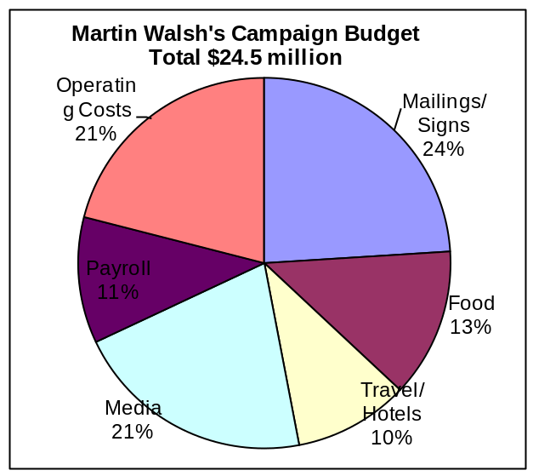

Answer the following based on the information included above and in the pie charts.
You must justify your answers by showing your work in order to get credit. Do not just give a name or a single number as the answer.

- Which candidate will spend more money on the Media?

Walsh will spend $5,145,000 and Connolly will only spend $4,940,000 on the media, thus Walsh will spend more.

- Martin Walsh wants to save some money, so he asked an aide to calculate what he should cut to save the most money. Which budget should he reduce to save more money? Should he reduce Operating Costs by 15% or cut the food budget by 25%? Show your work.

Reducing the operating costs by 15% would be 15% of 21% of 24,500,000, which is equal to 771,750.

Reducing the food budget by 25% would be 25% of 13% of 24,500,000, which is equal 796,250.

771,750 < 796,250

Therefore, in order to save the most money Walsh should cut the food budget by 25%.

Problems 19 to 22:

The Harvard Student Union is doing a study to determine which types of cereal are the most popular to serve at breakfast. The histogram below gives the total number of boxes eaten per week for five different kinds of cereals. If a histogram is difficult to read, you should make some notation to make it clear. In this case, since the number of boxes of Captain Crunch cereal is not clear, a note is given below. All the other amounts of cereals can be read from the graph below.

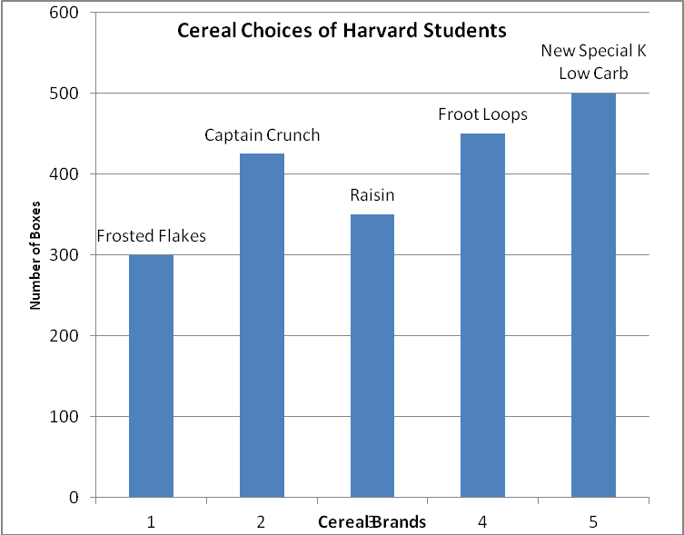

Note: The number of boxes of Captain Crunch cereal is 425.

- How many boxes of cereal are eaten every week at the Union?

300+425+350+450+500 = 2025

- What percent of the boxes consumed are produced by Kelloggs if Kelloggs makes all of the cereals except Raisin Bran and Captain Crunch?

61.73% of the boxes consumed are produced by Kelloggs.

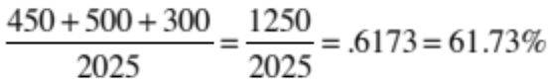

- Normally the Union pays 16 cents a box for the cereal which they purchase. However, due to an over-supply of sugar, the price of Captain Crunch and Frosted Flakes is only 12 cents a box. How much must the Union pay every week to purchase all of the cereal that it needs?

The Union must pay $295.00 if the above graph represents the total consumption per week.

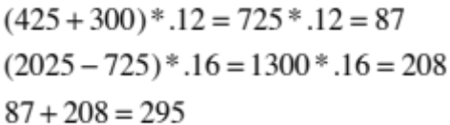

- What percentage decrease in weekly costs (not in price per box) does this drop of 4 cents represent?
The price decreased by 8.95%
