MATH E-3: Assignment 5

PLEASE BE SURE TO SHOW WORK FOR FULL CREDIT

For some of the following problems, it's quite helpful to draw diagrams. Use Pascal’s Triangle when you are working with coins or with any event that can occur in only two ways. Use the dice table for dice.

Problems 1- 4

Hint: These are simple probability problems using the basic formula for
probability. Please give your answers as decimals rounded to two decimal places.

An urn contains five blue balls, seven red balls, and three green balls and six yellow balls. You stick your hand in and pull out a ball without looking. What is the probability of the following outcomes? Please give your answers as decimals rounded to two decimal places.

1) selecting a red ball?
7 / 21 = 0.33

2) selecting a blue ball?
5 / 21 = 0.24

3) selecting a yellow ball or a green ball?
9 / 21 = 0.43

4) Assume you chose a red ball. Do NOT put it back into the Urn. You then pick another
ball from the urn. Find the probability it will be another Red ball.
7 – 1 = 6
21 – 1 = 20
6 / 20 = 0.30

Problems 5-6

Dice. These two questions involve one die.

5) What is the probability of obtaining a 3 or a 5 on ONE roll of a single die?

2 / 6 = 0.33

6) What is the probability of obtaining an odd number on one roll of a die?

3 / 6 = 0.50

Problems 7-13

Dice continued. For these problems, you must draw a dice table, and answer questions relating to two dice. Please give your answers as decimals rounded to two decimal places.

7) Draw Dice Table

 | 1 | 2 | 3 | 4 | 5 | 6
1 | 2 | 3 | 4 | 5 | 6 | 7
2 | 3 | 4 | 5 | 6 | 7 | 8
3 | 4 | 5 | 6 | 7 | 8 | 9
4 | 5 | 6 | 7 | 8 | 9 | 10
5 | 6 | 7 | 8 | 9 | 10 | 11
6 | 7 | 8 | 9 | 10 | 11 | 12

Now that you have drawn the dice table, find the probability. These problems use some abbreviations: P(4, 2 dice) means what is the probability of getting a 4 when you roll two dice. Please give your answers as decimals rounded to two decimal places.

If you roll a PAIR of dice, what is the probability that the total will be a:

8) P(7, 2 dice)

6 / 36 = 1 / 6 = 0.17

9) P(3, 2 dice)

2 / 36 = 1 / 18 = 0.06

10) P(10, 2 dice)

3 / 36 = 1 / 12 = 0.08

11) P(5, 2 dice)

4 / 36 = 1 / 9 = 0.11

12) P(<6, 2 dice)

10 / 36 = 5 / 18 = 0.28

13) P(>5, 2 dice)

6 / 36 = 1 / 6 = 0.17
Problem 14 –18
Coins. Draw Pascal’s Triangle and calculate the probability of the following coin flip problems. Please give your answers as decimals rounded to two decimal places.

14) Draw Pascal’s Triangle

1 1
1 2 1
1 3 3 1
1 4 6 4 1
1 5 10 10 5 1
5h 4h 3h 2h 1h 0h

If you flip five coins what is the probability that you will get: (Please give your answers as decimals rounded to two decimal places).

15) Two heads? (That means exactly 2 heads.)

10 / 32 = 0.31

16) Three tails?

10 / 32 = 0.31

17) At least three heads?

16 / 32 = 0.50

18) Fewer than two tails?

6 / 32 = 0.1875

Problem 19

In class we looked at the probability of winning a lottery such as Megabucks. To play, one has
to pick six numbers between 1 and 48, with no repeated numbers. The chance of your number
being the winning number is

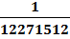 or 0.0000000815.

When the lottery first came out in Massachusetts, you only had to pick six different numbers
between 1 and 36. Do the following:

19) If you bought one ticket to this type of lottery, calculate your chance of having the winning
number under these older conditions i.e. pick six numbers between 1 and 36. Please give your
answer both as a fraction and as a decimal – this time don’t round. Just write down all the
numbers you see in the screen of your calculator, as above. (If you are using a computer, please
don’t write down more than 15 digits.)

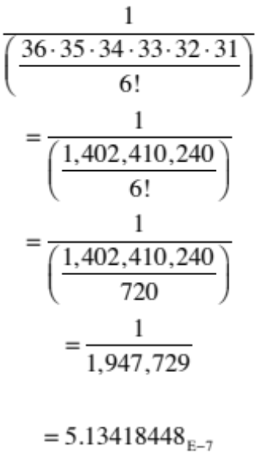

Interesting thought questions but no need to answer:
Why do you think the rules were changed?
How do you think the gambling public perceived this change?

I believe that the rules were changed due to the inclining population rate. It must’ve been the case that people were winning the lottery in too frequent intervals, thus resulting in the overall reward for a winning ticket to be small compared to that of the new style. I would perpetuate that the gambling community perceived this change in two ways; the first way in which would be negative due to the fact that the chances of each individual person winning was being decreased, and one may also view it in a positive aspect due to the increase in the amount of money awarded per jackpot.

Problems 20-25

Calculate the following-you may use the factorial key on your calculator. Some of these are a
bit tricky – you may need to do some simplifying before using your calculator.

20) 5!

120

21) 15!

1.3076744e+12

22) 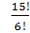

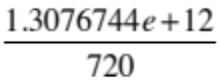

23) 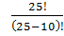

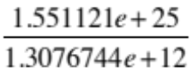

24) 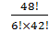

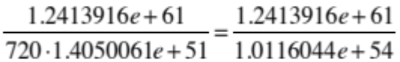

25) 0!
1

