**INTERNET SYSTEM PROGRAMMING**

PROJECT REPORT

**PROJECT ARCHITECTURE:**

This project implements three-tier architecture. The three layers of this architecture are presentation, logic and data tier. The presentation layer is the top-most level of the application which includes the user Interface. The user interface displays the form for the user to enter the user id and corresponding password. The second layer coordinates the form with the Server i.e php and make decisions based on user input. If the username or id is incorrect, it prompts the user to enter again. If the user is new, he/she must sign up before logging. The third layer is responsible for opening connection to the database and process the SQL requested by the server.

**DATABASE DESIGN:**

In our database, we stored the University of Akron Course Catalog. It includes the course id, End-date, term, Description, title, career, Section, Days, Credit, Start_time, Course, End_time, Location, Department, Instructor_Email, Start_Date, Instructor, Instruction_Mode, and Campus. We got this information from <https://www.uakron.edu/academics_majors/class-search/data/courses.json>. We parsed this JSON file in python.

**SCREENSHOTS:**

**Form**

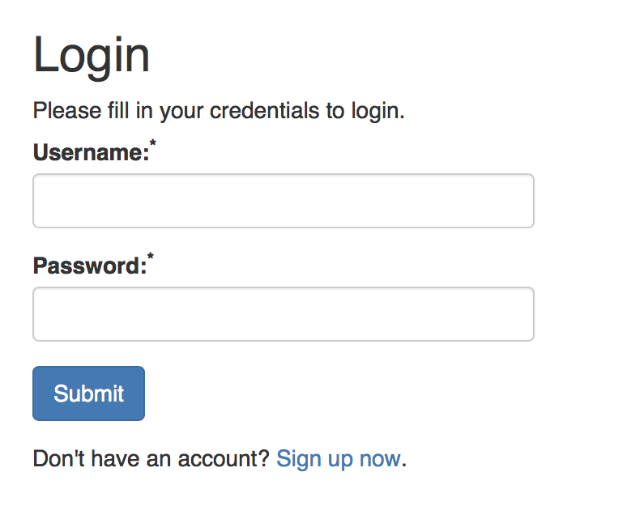

**Welcome Page:**

This implementation made it easy for the user to search and find the course information, evaluate the professor and delete the evaluation if the user wants to. To get to this page the user must register and login with their username and password. They can click on the Evaluate button to evaluate the professor.

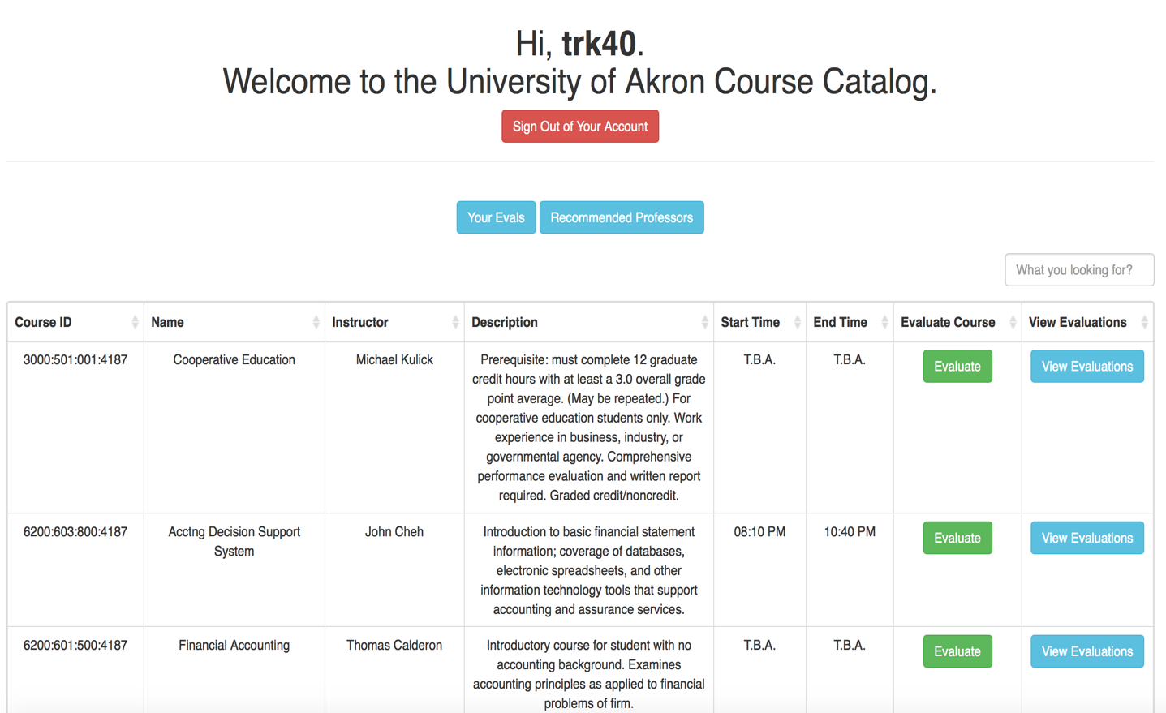

**Form for Evaluation**

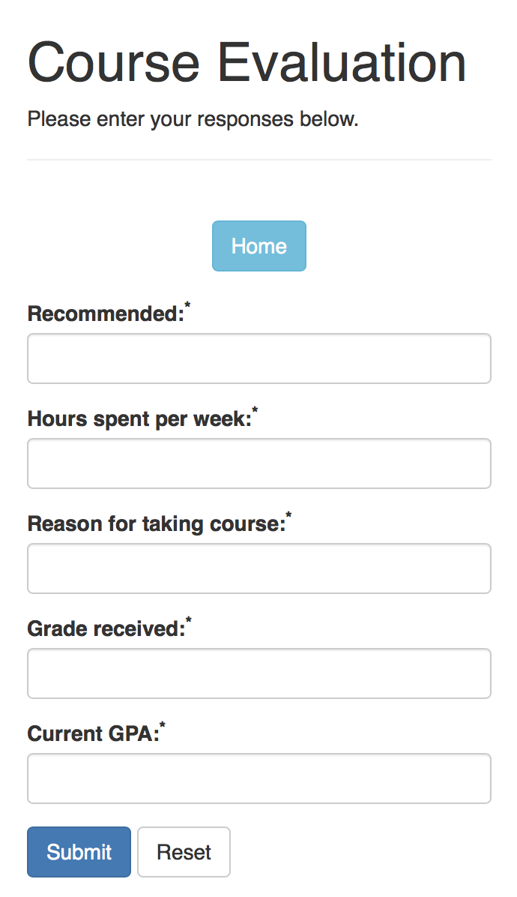

**CONTRIBUTIONS OF GROUP MEMBERS:**

**Nicholas Gallimore:**

1. Designed welcome page
2. Parsed JSON file to python script
3. Handled database/create project database
4. Wrote nuke file to drop entire database
5. Wrote Evaluate.php that displays form to evaluate a professor

**Karun Kuikel:**

1. Wrote logout.php
2. Wrote config.php that establish connection to database and close connection object
3. Executed the SQL query Insert_courses.sql on the database
4. Implemented the logic in register.php for new users
5. Wrote geteval.php that displays the evaluations

**Prakash Biswa:**

1. Designed the login form
2. Wrote stylesheet
3. Wrote mySQL statements to create tables
4. Work together with Nicholas to create project database. Contributed roughly 25% on this part.
5. Wrote deleteEvaluation.php that deletes evaluations from the database

**LESSONS LEARNED:**

The implementation of this project enhanced to existing knowledge of front end and back-end. The search is implemented in Javascript which makes the loading of the catalog information slow, in hindsight we would do this in php.

Implementing pagination to make it so that there are multiple pages of courses rather than one massive table would significantly increase the load time of the welcome page.

**PROBLEMS ENCOUNTERED:**

One of the problems encountered is having to alter the data. The data from the course catalog had upside down question mark characters that made parsing difficult, as well as having extra ' characters that had to be escaped.