**NFI Projection System (PS). User Guide.**

1. Acknowledgments
2. Terms and conventions
3. Goal
4. Users
5. General logistics
6. Projection Framework
7. PS Architecture
8. Projecting volume
9. Projecting attributes (NFI rules)
10. GY curves
    1. GY resources, CBM SIT tables
    2. Formatted NFI SIT tables
11. Accounting for disturbances
    1. Wildfire
    2. Harvesting
    3. Insects
    4. Multiple disturbances
12. PS Projection database
13. Code Implementation
    1. Directories (local system, network, CVS Mercurial)
    2. Compiling executables
    3. Checking PS updates to CVS Mercurial
    4. Developer API documentation
14. Running PS
    1. System Requirements
    2. Executing PS from CMD
    3. Configuration XML file
    4. Plot list file
15. Multiple PS programs running concurrently from different PC
16. Frequent errors
    1. No CBM mapping of NFI species
    2. No GY is available for species
    3. Incorrect combinations of jurisdiction and ecozone names
17. Useful SQL scripts
    1. Update G&Y DB data
    2. Update Wildfire DB data
    3. Update Harvesting DB data
18. Re-measurement cycle 1(2007-2017). Projected plots
19. Backwards projecting

***1.Acknowledgments***

NFI PS was created in close collaboration with NFI, CAT, NBAC and NTEMS teams, specifically:

* Graham Stinson, Werner Kurz, Carolyn Smyth, Victor Sotskov – general framework,
* Carolyn Smyth, Scott Morken – accommodating CBM3 for projecting volume,
* Graham Stinson, Paul Boudewyn, Frank Eichel, Victor Sotskov – generalised logistics, architecture, testing and validation,
* Eric Nelson – provincial G&Y SIT tables,
* Paul Boudewyn, Frank Eichel – NFI SIT tables,
* Frank Eichel – jurisdictional ecoregions, conversion of NTEMS pixel data to shapefile,
* Alex Song, Kristian Arndt, Victor Sotskov – national G&Y DB schema, national disturbance DB schema,
* Alan Wong, Josh Braidek - coding and programming,
* Scott Morken, Max Fellow, Andrew Dyk, Geordie Hobart – code review,
* Ron Hall, Rob Skakun, Guillermo Castilla – national coverage of wildfire data (NBAC)
* Joanne White, Geordie Hobart – national coverage of harvesting data (NTEMS)

***2.Terms and conventions***

* Photoplot = generic term for any or all NFI 2 x 2 km sample units located on the national sampling framework, irrespective of info source
* LC = NFI photoplot land cover layer
* Projected year = calendar year selected by the update process user to which LC attributes for all selected photoplots are projected
* G&Y = growth and yield: including either software tools that project stand growth given stand attribute information as inputs, or tables that can be used to look up stand volume (yield) given stand attributes

***3.Goal***

To project (forward and backward) photoplot land cover (LC) attributes (required for estimation) for a user-selected group of photo plots to a user-selected projection year. Required are:

* the NFI photoplot measurement data acquired most recently before the projection year,
* Natural disturbance monitoring and mapping data (areas damaged by wildfire, insects and disease, and severe weather),
* Human activity data (areas afforested, harvested, deforested),
* G&Y (growth and yield models or tables).

***4.Users***

The Projection System (PS) is operated and maintained by the NFI Project Office. It is a separate process from NFI photo plot measurement and estimation. The most recent NFI photo plot data are taken by the Projection System as inputs. The outputs of the Projection System may be taken as input by the compilation and estimation processes. Anticipated users of Projection System outputs include:

* NFI statistical estimation process (SAS programs)
* CFS and NFI collaborator agency data analysts and modellers
* External NFI data requestors

***5.a. General logistics. Projection Framework***

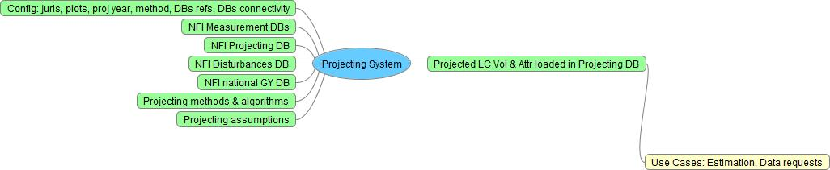

***5.b. General logistics. PS Architecture***

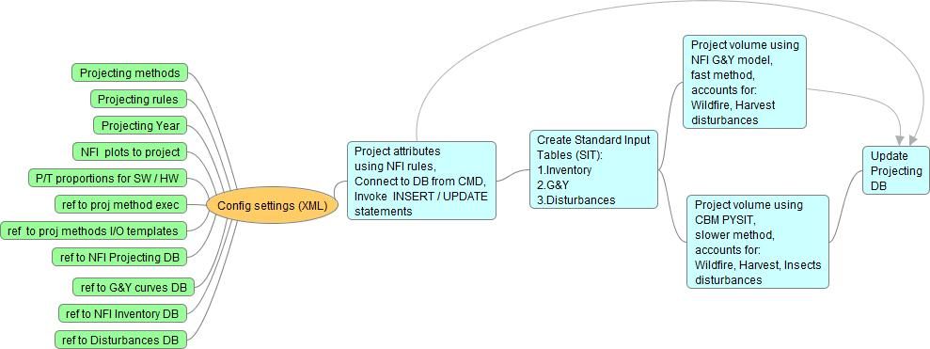

***5.c. Projecting volume***

At this time PS operation to project forward is successfully tested for 6 provinces. The potential to project backward is included into PS architecture and logistics, but have not been tested. The present version of the PS has only bone volume projection method to choose from. This method uses command line CBM module PYSIT. The reason behind choosing PYSIT is accounting for more than 200 different types of disturbances, including wildfire, harvesting, insects, deforestation, roads and landings and many other.

The input data for PYSIT includes 3 types of information: inventory information about projected plots, growth and yield information (curves) for polygon species, disturbance information over period of projection. Inventory information includes: polygons ids, polygons area, jurisdiction, ecozone, lead species names, species age. Inventory information is derived by PS program from NFI baseline DB. Growth and yield (G&Y) information includes: polygons ids, polygons area, jurisdiction, ecozone, lead species names, values of merchantable volume at different species age. G&Y information is derived from NFI national G&Y DB which includes formatted CBM G&Y curves for different jurisdictions. Disturbance information includes: polygons ids, jurisdiction, ecozone, disturbed area, mortality. Disturbance information is derived from NFI disturbance lookup table. Lookup contains results of pre-processed intersection of NFI plot grid and national disturbance coverages for wildfire (project NBAC - since 2004) and harvesting (project NTEMS - since 1986).

PYSIT processes input data to project baseline (inventory) volume to a specified year using G&Y information and accounting for specified types of disturbance over period of projection.

The output data includes: polygons ids and projected merchantable volumes for softwood and hardwood components for each year within projected period.

The general sequence of steps followed by the module “Project volume (PYSIT) and attr (rules)” to project volume is as follows:

1. Determine NFI ecozone and jurisdiction ecoregion using nfi plot ID, given jurisdiction and DB lookup table ***nfi_pp_gy.plot_juris zones***
2. Select leading species by % in polygon composition using DB table ***nfi_ppprd_baseline.pp_tree_species_comp***
3. Convert NFI gross total volume (GTV) to provincial gross merchantable volume (GMV) volume using DB table ***nfi_pp_gy.gmv_ratios*** (vegetation type and age dependant), definitions of GTV and GMV can be found in NFI document: \\nfidwarfs\nfi\Resources\Tools\Photoplot\Stand_volume_computation\NFI Stand Volume Survey Results_ver3_pb.docx
4. Select multiple curve types corresponding to selected jurisdiction, spatial unit and leading species using NFI SIT view ***nfi_pp_gy.gy_curves***
5. Select curve that best fits the gross merchantable volume at the age of the leading species and corresponds to selected leading species, curve type, jurisdiction, NFI ecozone, jurisdiction ecoregion

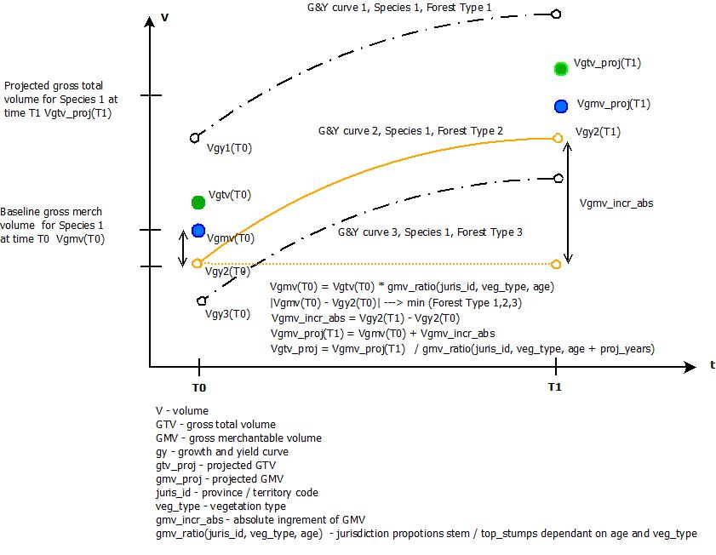

1. Calculate absolute GMV increment between T0 – T1 on the chosen curve
2. Add GMV absolute increment to baseline GMV stand volume
3. Convert projected GMV volume back to projected GTV volume

CBM command line version PYSIT is used to calculate absolute GMV increment. PYSIT has to be installed on the system running PS, for example: ***C:\CBM\pysit\upgrade_2014\Release\pysit.exe***

For its normal execution PYSIT requires:

* input file in a special format with reference to CBM3 databases and projects directories, located in directory: ***C:\CBM\pysit\upgrade_2014\Release\pysit_input.py***,
* CBM3 installed, for example: ***C:\Program Files (x86)\Operational-Scale CBM-CFS3\***

PYSIT input file is created by PS during execution using an input template and queries to NFI inventory, G&Y and disturbance databases. Input file includes 3 types of data:

* inventory data
* growth & yield data
* disturbance data

PYSIT generates csv output with projected volumes for softwood and hardwood components. This output is processed by PS to calculate absolute GMV increment.

PYSIT was configured by Carolyn Smyth to generate merchantable volume instead of biomass. This was done by assigning new values to the following PYSIT parameters:

tblAdminBoundaryDefault – set top and stump proportions to 0

tblEcoboundaryDefault – set the stemannualTurnover to be 0

A=1

B=1

A_nonmerch=1

B_nonmerch=0

K_non_merch=0

Cap_nonmerch=1;

A_sap=1

B_sap=0

K_sap=0

A1,a2,a3,b1,b2,b3,c1,c2,c3=0

Min_volume=0;

Max_volume=-10000

Low_stemwood, bark etc =0

High_stemwood, bark, etc=1000

***5.d. Projecting attributes (NFI rules)***

Projection rules depend on presence of disturbance events, disturbance type and are illustrated in Table 1.



Attributes should be projected before projecting volume. Attributes are projected by running batch CMD script ***C:\Proj_concurrent\ project_attributes.bat.*** Batch script connects to NFI DB, reads configuration file and invokes INSERT / UPDATE query file ***C:\Proj_concurrent\project_attributes.sql.*** INSERT / UPDATE statements implement the projecting rules illustrated in Table1.

***6.a. GY Resources.CBM SIT tables***

To project volume NFI PS is using CBM SIT provincial tables provided by the Carbon Accounting Team (CAT). The format of provincial SIT tables varies by province. They might include some of the following classifiers: one or more spatial classifiers (administrative areas, ecoregions), forest types or species groups, a productivity indicator, leading species, age. The volume is presented by leading species and is usually gross merchantable volume (gmv).

***6.b. Formatted NFI SIT tables***

All CBM SIT GY tables have been translated into a uniform format in NFI SIT tables with the following fields:

* juris_id
* ecozone_id
* juris_zone (jurisdiction ecoregions or other spatial unit)
* juris_species (jurisdiction species code)
* curve_type (forest types and productivity)
* age
* vol_source (used GY resource)
* vol_type (gross vs. net, total vs. merchantable)
* stand_vol_ha, m3/ha (stand volume represented by lead species)
* genus (NFI code)
* species (NFI code)
* comments

If the number of provincial classifiers exceeded this list - records were merged and average volumes were calculated. NFI SIT tables are stored in a NFI G&Y DB view ***nfi_pp_gy.gy_curves***

***7.a. Accounting for disturbances. Wildfire***

A binary model is used to account for impacts due to wildfire on projected volume and attributes. If the percentage of burned area is equal to or bigger than 50.1% of the polygon, the polygon is considered to be completely burned. Otherwise – the fire event is ignored, and the projection of volume and attributes is done as if no fire had occurred over the period of observation.

Note that this binary simplification (polygons treated as burned or not rather than sub-divided into burned and unburned portions) is made because the spatial precision of polygon segmentation is higher than the typical spatial precision of burned area mapping, and LC polygons are typically several orders of magnitude smaller than burned area polygons. In testing, the simplification was found to have minimal impact on outputs when projecting reasonably large numbers of plots while providing significant performance gains (i.e. no new LC polygons being created).

National wildfire national coverage is obtained from the NBAC project annually and stored in a NFI disturbance DB schema, ***nfi_pp_dist.*** Raw wildfire data are stored in their original format in the table ***nfi_pp_dist.dist_nbac.*** Raw data are used to update the lookup table, ***nfi_pp_dist.dist_all,*** containing information on wildfire events from 2004 and % of burned area for each NFI polygon. The lookup table is populated / updated from the results of a pre-processed overlay performed annually as new Fire, Harvest, and Insect data area obtained.

***7.b. Accounting for disturbances. Harvesting***

Binary model is used to account for the impact of harvesting on projected volumes and attributes. If the percentage of harvested area is equal to or bigger than 50.1% of the polygon, the polygon is considered to be completely harvested, otherwise – the harvest event is ignored, and the projection of attributes is done as if no harvesting had occurred over the period of observation.

A national harvesting coverage is obtained from the NTEMS project annually and stored in a NFI disturbance DB schema ***nfi_pp_dist.*** Raw harvesting data are stored in the original format in the table ***nfi_pp_dist.dist_ntems.*** Raw data are used to update the lookup table ***nfi_pp_dist.dist_all,*** containing information on harvesting events from 1986 and % of area harvested for each NFI polygon.. The lookup table is populated / updated from the results of a pre-processed overlay performed annually as new Fire, Harvest, Insects data are obtained.

***7.c. Accounting for disturbances. Insects***

At this time NFI disturbance DB includes only data (spatial and attributes) for SBW in QC. The current version of the PS handls insect disturbance using PYSIT functionality.

***7.d. Accounting for disturbances. Multiple disturbances***

In case of multiple disturbance events (fire and/or harvesting) the total disturbed area is calculated over the projection period and compared with the threshold of 50.1%. The year of the latest event is assigned as the disturbance year. This approach is taken because only the LC attributes in the projection year are of interest. Mid-projection LC attributes are not calculated by the PS. For example, the PS does not calculate volume reductions – it only reports volume in the projection year. This information can then be used, outside the PS, to analyze forest

***8. PS Projection Database***

Projected land cover volume and attributes are stored in Projection DB schema ***nfi_pp_proj.*** Schema includes tables:

* pp_proj_rules
* pp_proj_metadata
* pp_landcover
* pp_std_layer_header
* pp_std_layer_disturbance
* pp_std_layer_treatment
* pp_std_layer_origin
* pp_std_layer_tree_sp

According to NFI Photo Data Dictionary definitions, the attribute info_date is assigned the value of the projection year, and the attribute model_yr is assigned the value of the baseline info_date.

Detected harvesting events over the projected period are stored in the table ***pp_std_layer_treatment***.

1. ***Code Implementation.***

***a.Directories (local system, network, CVS Mercurial)***

The code is implemented in Python 3.3. On the local system the path to PS python files is ***C:\Proj_concurrent\ ,*** path to executables is ***C:\Proj_concurrent\dist.*** Network location of PS files and executables:

\\VIC-FAS1\nfi\OperationalDelivery\Automation\NFI_update\National\updated_code\vol_and_attr\Proj_concurrent

In control version system (CVS) Mercurial location is [***https://sleet.nfis.org/NFI/Projecting/***](https://sleet.nfis.org/NFI/Projecting/)

The code can be edited in the Python GUI IDLE or in a text editor such as Notepad++.

***b. Compiling executables***

If some updates have been done to python files the PS python code should be re-compiled using the following CMD commands:

* cd C:\Proj_concurrent\
* python setup.py py2exe

The normal compiling result is a CMD output like the following:

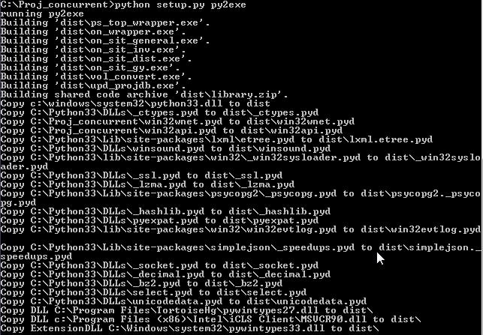

***c. Checking PS updates into CVS Mercurial***

To check out the online repository [***https://sleet.nfis.org/NFI/Projecting/***](https://sleet.nfis.org/NFI/Projecting/)***,*** create a directory on local system ***C:\Proj_concurrent\*** and issuehg commands in CMD window (assuming that hg software is installed on the local system)

* cd /d C:\Proj_concurrent\
* hg pull
* hg update

To check in online repository issue hg commands in the root directory ***C:\Proj_concurrent\***

* hg add
* hg commit
* hg push

***d. Developer API documentation***

Developer API documentation contains description of PS python packages, classes, methods and functions. It was generated by software Doxygen and is located here:

***\\VIC-FAS1\nfi\OperationalDelivery\Automation\NFI_update\National\Documentation\index.html***

***10.Running PS.***

***10.1. System Requirements to run PS:***

1. OS Windows >= 7
2. Python 3.3 should include modules:
   * LXML
   * NUMPY
   * PYWIN32_SYSTEM32
   * PYTHONWIN
   * SIMPLEJASON
     + Replace in file “ordered_dict.py” line: “…from UserDict import…” with line: “…from collection.UserDict import…”
     + Insert new line in file “compat.py”: “from imp import reload as reload_module”, and comment out the line: “from importlib import reload as reload_module”
   * WHEEL
   * SETUPTOOLS
   * WIN32
   * WIN32COM
   * WIN32COMEXT
   * PYSHP-1.2.1
   * READLINE
   * PYTHONDEV
3. MS Visual Studio 9.0
4. Windows system environment PYTHONPATH variable should include path to C:\Python33\; C:\Python33\Lib\site-packages
5. Template ***C:\CBM\pysit\upgrade_2014\Release\******pysit_input_template.py*** SHOULD NOT be modified, timestamp: 2015-04-22 1:54 pm, extra lines SHOULD NOT be added !!!
6. On pgpfc1.nfis.org there is a helper schema ***nfi_pp_proj_app***, it includes table ***proj_output***  which is used by PS and SHOUD NOT be deleted !!!

***10.2. Executing PS from CMD***

PS can be run by issuing the following commands in CMD window:

* cd /d C:\Proj_concurrent\dist
* project_attributes.bat
* ps_top_wrapper.exe ps_config.xml

***10.3. Configuration XML file***

The XML configuration and schema validation files (***ps_config.xml*** and ***ps_config.xsd***) are located in: ***C:\Proj_concurrent\dist\.*** Validation file is used by PS during execution to validate correct format of configuration file.

The following parameters can be configured in XML file:

* projection year
* jurisdiction
* reference to plot list to project
* reference to DB schemas (baseline, G&Y, disturbance, projecting)
* login credentials
* projecting method
* references to input and output files for projection method

***10.3. Plot list file***

The list of plots to project should be created as a text file in the directory: ***C:\CBM\pysit\upgrade_2014\Release\plot_list.txt***. Plot list should be created as one field file containing plot numbers, for example:

1293851

1293856

1293861

1293866

1293871

1293881

1293886

***10.4. Projection output***

The projecting process is over when the cursor in a CMD window stops blinking and the current directory is shown. If the projection process has run without error – the results of projecting volume and attributes are in the tables of schema nfi_ppp_proj: pp_std_layer_header, pp_landcover, pp_std_layer_tree_sp, pp_std_layer_disturbance, pp_std_layer_treatment

***10.5. Projection log file***

The details of projecting process and possible errors are recorded in a log file ***C:\Proj_concurrent\dist\wrapper.log.***  To find an error:

* Open log file in a notepad app
* Search for key word ‘error’ in Edit 🡪 Find menu

***10.6. Frequent errors***

All errors and exceptions caught by the PS code are recorded in PS log file C:\Proj_concurrent\dist\wrapper.log.

***a.No CBM mapping for NFI species***

This is a CBM PYSIT error.

Resolution: to add species mapping (NFI 🡪 jurisdiction) in the file on_sit_inv.py, line 63, parameter ***val_descrep***. NFI species name should be taken from the table ***nfi_dms.nfi_tree_species_lookup,*** CBM species name should be taken from the table tblSpeciesTypeDefault in the CBM Access DB ***C:\Program Files (x86)\Operational-Scale CBM-CFS3\Admin\DBs\ ArchiveIndex_Beta_Install_Vol2Bio.mdb***

***b.No GY is available for species***

This is a NFI data error. It is manifested by CBM error in log file ***wrapper.log***. The error appears after the statement “Validating CBM project”. Error is generated because number of stands in the inventory section of input file is not matching the number of stands in G&Y section. Resolution:

* Determine missing stands by running 2 python scripts in directory \\VIC-FAS1\nfi\OperationalDelivery\Automation\NFI_update\National\python_scripts: first, ***editing_input_file.py*** and second, ***missing_gy_lines.py.*** Output is a text file ***missing_gy_*.txt*** in the directory ***C:\CBM\pysit\upgrade_2014\Release,***
* For each stand in the list of missing G&Y data, update the view ***nfi_pp_gy.gy_curves*** by executing a collection of queries using: ***\\VIC-FAS1\nfi\OperationalDelivery\Automation\NFI_update\National\disturbances\multiple_disturbances\insert_missing_gy.sql***

***c. Incorrect combination of jurisdiction name and ecozone name***

This is an error generated after the PYSIT validation operation. It is caused by an incorrect combination of jurisdiction name and ecozone name in the PYSIT input file: ***C:\CBM\pysit\upgrade_2014\Release\pysit_input.py***.

The correct CBM combinations are shown in the table: nfidwarfs\nfi\OperationalDelivery\Automation\NFI_update\National\cbm_nfi_eco_mapping\cbm_nfi_eco_mapping.docx

Resolution:

* edit mapping in the file ***C:\Proj_concurrent\on_sit_inv.py***, variable ***val_discrep***, line 63,
* re-compile the PS as advised in 9.b.

***11.Multiple PS programs running concurrently from different systems***

To increase performance when projecting big datasets multiple systems can be used to run PS concurrently. The requirement is NOT to project overlapping datasets – the datasets should specify different jurisdictions, nfi units or plots. At this time PS is installed and can be run from two NFI PCs:

* PC_1 on A105292 (r.257)
* PC_2 on A125556 (r.257)

To prevent DB locks when running concurrently PC_1 and PC_2 operate on different columns in the DB table ***nfi_pp_proj_app.proj_output:*** vtot_1 and vtot_2 respectively. This is hardcoded in the python code by setting the value of parameter ***vtot***: line 222 in the file ***vol_convert.py*** and line 744 in the file ***upd_projdb.py***.

To run concurrently from 3 or 4 PCs the corresponding columns vtot_3, vtot_4 should be added to the table ***nfi_pp_proj_app.proj_output;*** also the value of parameter ***vtot*** in the python code (vol_convert.py, upd_projdb.py) should be set to vtot_3 and vtot_4 respectively on PC_3 and PC_4.

***12.Useful SQL scripts***

***a.Update G&Y DB data***

When a new NFI SIT table is available for a jurisdiction the DB update procedure is performed as a series of queries documented in: ***\\VIC-FAS1\nfi\OperationalDelivery\Automation\NFI_update\National\SQLs\ populate_with_provincial_data.sql***

***b.Update Wildfire DB data***

The NBAC project office submits to NFI annually a new national wildfire coverage as a shapefiles. After receiving the shapefile, two actions should be taken:

* Update NFI DB wildfire table ***nfi_pp_dist.dist_nbac*** with raw wildfire data
* Update NFI DB lookup disturbance table ***nfi_pp_dist.dist_all*** with new wildfire data

Both actions are performed with steps described in: ***\\VIC-FAS1\nfi\OperationalDelivery\Automation NFI_update\National\disturbances\multiple_disturbances\update_dist_nbac.sql***

The second action includes intersection of a new wildfire coverage with NFI land cover layer for a specific UTM zone in the range of 07 - 22. Results of the intersection are stored in a corresponding table in a user defined schema (for example vsotskov.nbac_utm_07). After that the table ***nfi_pp_dist.dist_all*** is updated with intersection results for each UTM zone.

***c.Update Harvesting DB data***

The NTEMS project office submits to NFI annually a new national harvesting coverage as a pixel data. Pixel NTEMS data are converted to shapefile by NFI team. After that, the table ***nfi_pp_dist.dist_all*** is updated using steps described in: ***\\VIC-FAS1\nfi\OperationalDelivery\Automation NFI_update\National\disturbances\multiple_disturbances\update_dist_ntems.sql***

***13.Re-measurement cycle 1 (2007 – 2017). Projected plots***

Number of projected plots by NFI units and jurisdictions are presented in table 2:



***Backwards projecting framework***

***General concepts***:

1. Usage of RE-MEASUREMENT data to correct EOSD / BASELINE data,

2. Plots with only post-disturbance growth are projected backwards from the year of disturbance.

***Framework:***

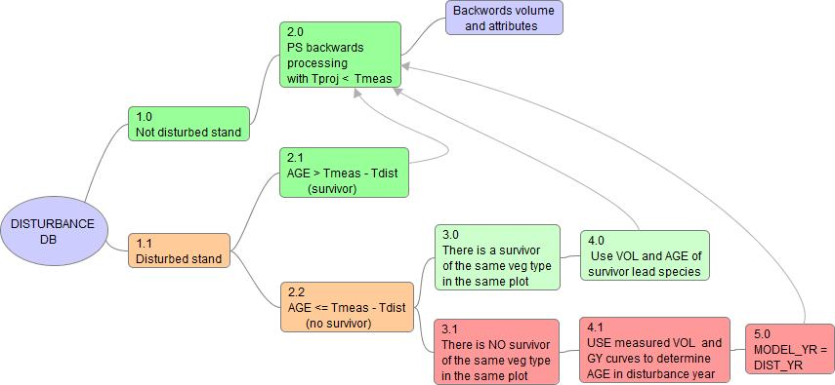

***Details of logistics:***

1.0 The stand is not disturbed,

1.1 The stand is disturbed,

2.0. Project backwards using the same approach of choosing GY as for projecting forward, Tproj < Tmeas

2.1 The lead species age > (Tmodel_from – Tdist_yr), the same approach as in #2.0.

2.2 The lead species age <= (Tmodel_from – Tdist_yr), look for lead species - survivor in the same polygon and of the same vegetation type,

3.0 There IS a lead species - survivor in the same plot and of the same vegetation type,

3.1 There is NO lead species - survivor in the same plot and of the same vegetation type,

4.0 Use VOL and AGE of found lead species - survivor to project backwards as in #2.0,

4.1 Use merchantable VOL and GY curves to determine AGE in disturbance year, proceed to #2.0,

5.0 Set PROJ_FROM year to DIST_YR, proceed to #2.0.

***Example: plot 1287031***

Measurement Info Year – 2011 (PROJ_FROM_YR)

Projected To Year – 1999

Disturbance Year – 2002 (DIST_YR)

Post-disturbance period – 9 years

19 treed polygons with vol > 1 (only those were projected backwards)

2 polygons (29, 42) are survivors, lead species of vegetation type ‘TC’,

Survivor’s age is 41 years and exceed the post disturbance period. Those polygons were backward projected according to the path in framework logistic:

* 1. 🡪 2.1 🡪 2.0

Other polygons have age 9 years and are considered as post-disturbance growth. All of these polygons have vegetation type ‘TB’ not matching the vegetation type of species survivors (TC) and therefore were projected back according to the path in framework logistic:

* 1. 🡪 2.2 🡪 3.1 🡪 4.1 🡪 5.0 🡪 2.0

In 4.1 the merchantable volume in the year of disturbance VOL(dist_yr) was determined as:

VOL(dist_yr) = VOL(meas) – VOL(GY, age = post-disturbance period)

VOL(dist_yr) was used to determine AGE(dist_yr) in the year of disturbance (2002) using GY curves and averaging by forest types.

Finally projecting backwards is done from the year of disturbance (PROJ_FROM_YR = DIST_YR), using above determined values of VOL(dist_yr) and AGE(dist_yr)