Create a new module named **booking_order_YOURNAME**, with the following specs:

**Name : Booking Order *Your Name***

**Summary : Booking Order *Your Name***

**Version : 1.0**

**Category : Sales**

Add new **Booking** Menu in **Sales** before **Orders** Menu with **Sub-Menu** and following specs:

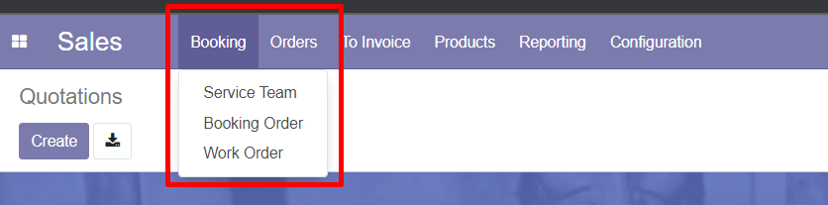

1. **Service Team** Menu**,** requirements:

* **Model**

Create new model named *service.team*

* **New Fields**

|  |  |  |  |  |  |  |  |
| --- | --- | --- | --- | --- | --- | --- | --- |
| **Name** | **String** | **Type** | **Readonly** | **Default** | **Relation** | **Required** | **On Change** |
| name | Team Name | Char | False | False | - | True | - |
| team_leader_id | Team Leader | Many2One | False | False | res.users | True | - |
| Team_member_ids | Team Members | Many2Many | False | False | res.users | False | - |

* **Views**

Create new tree and form views

***Tree View***

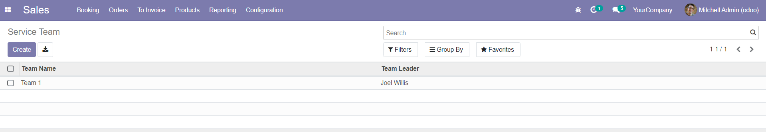

***Form View***

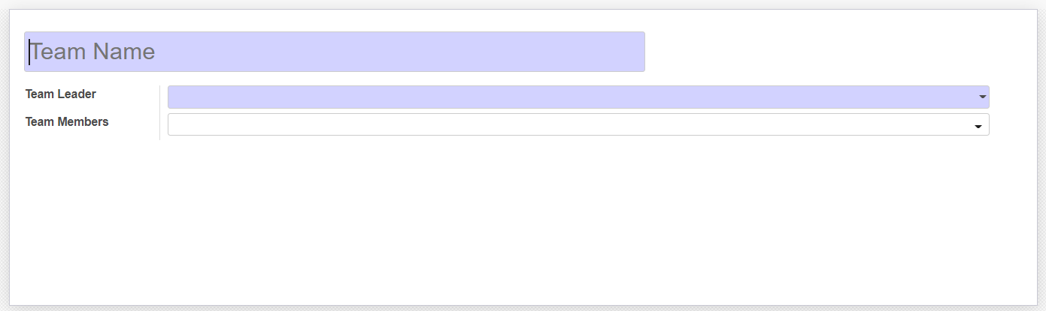

1. **Booking Order** Menu, requirements:

* **Model**

Inherit from *sale.order* model

* **Added Fields**

|  |  |  |  |  |  |  |  |
| --- | --- | --- | --- | --- | --- | --- | --- |
| **Name** | **String** | **Type** | **Readonly** | **Default** | **Relation** | **Required** | **On Change** |
| is_booking_order | Is Booking Order | Boolean | True | **True** if accessed from *Booking Order* Menu, else, **False** | - | **-** | **Show** *Booking Order Tab* if True, else, **Hide** |
| team_id | Service Team | Many2One | False | False | res.users | **True** if is_booking_order = True else **False** | Autofill team_leader_id and team_member_ids |
| team_leader_id | Service Team Leader | Many2One | False | team_id.team_leader_id | res.users | **True** if is_booking_order = True else **False** | - |
| team_member_ids | Service Members | Many2Many | False | team_id.team_member_ids | res.users | **True** if is_booking_order = True else **False** | - |
| booking_start | Booking Start | Datetime | False | current time / booking_end – 1 day | - | **True** if is_booking_order = True else **False** | Change booking_end = booking_start + 1 day |
| booking_end | Booking End | Datetime | False | booking_start + 1 day / current time + 1 day | - | **True** if is_booking_order = True else **False** | Change booking_start = booking_end – 1 day |

* **Views**
* Re-use *sale.view_order_tree* for tree view
* Inherit *sale.view_order_form* for form view
* *Booking Order* menu (tree and form) will only show *sale.order* which ­*is_booking_order* = **True**.

***Tree View***

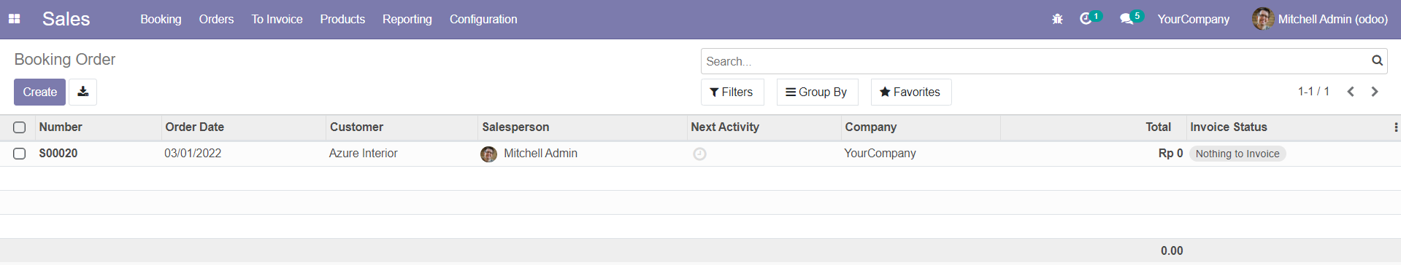

***Form View***

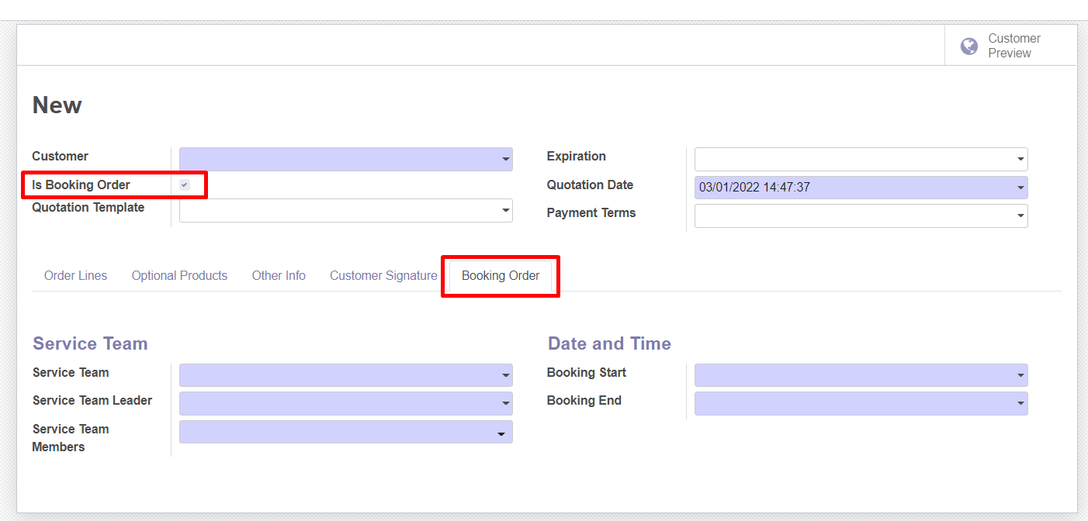

1. **Work Order** Menu, requirements:

* **Model:**

Create new model named *sale*.*work.order*

* **Fields**

|  |  |  |  |  |  |  |  |
| --- | --- | --- | --- | --- | --- | --- | --- |
| **Name** | **String** | **Type** | **Readonly** | **Default** | **Relation** | **Required** | **On Change** |
| name | WO Number | Char | True | ‘New’ | **-** | True | **-** |
| sale_order_id | Booking Order Ref | Many2One | True | False | sale.order | False | - |
| team_id | Service Team | Many2One | False | False | res.users | True | Autofill team_leader_id and team_member_ids |
| team_leader_id | Service Team Leader | Many2One | False | team_id.team_leader_id | res.users | True | - |
| team_member_ids | Service Members | Many2Many | False | team_id.team_member_ids | res.users | True | - |
| planned_start | Planned Start | Datetime | False | current time / planned_end – 1 day | - | True | Change planned_end = planned_start + 1 day |
| planned_end | Planned End | Datetime | False | planned_start + 1 day / current time + 1 day | - | True | Change planned_start = planned_end – 1 day |
| date_start | Date Start | Datetime | True | False | - | True | - |
| date_end | Date End | Datetime | True | False | - | False | - |
| state | Status | Selection   * ‘pending’ * ‘in_progress’ * ‘done’ * ‘cancel’ | True | ‘pending’ | - | True | - |
| notes | Notes | Test | False | False | - | False | - |

* **Views**

Create new tree and form views

***Tree View***

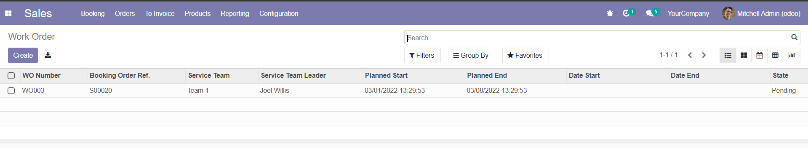

***Form View***

