Name: Kevin Gunawan  
NIM: 2201829981

1. From the downloaded data we can identify discrete and continuous random variables. Discuss about those variables.

2. We can also calculate mean and variance each for discrete and continuous random variables

1. A discrete variable is a variable whose value is obtained by counting while a continuous variable is a variable whose value is obtained by measuring. The difference between discrete random variable and continuous random variable is a discrete random variable has a countable number of possible values for example is the outcome number of a dice roll while a continuous random variable takes all values in a given interval of numbers that’s value can’t be counted/listed exactly for example is the mass of a random person in a classroom. From the downloaded data, we can identify the discrete and continuous random variables, which is:

* Discrete random variables:
  + price
  + minimum_nights
  + availability_365
  + number_of_reviews
  + calculated_host_listings_count
* Continuous random variable:
  + Latitude
  + Longitude
  + Reviews_per_month

Mean of discrete random variables:

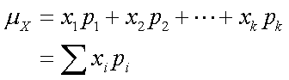

Variance of discrete random variables:

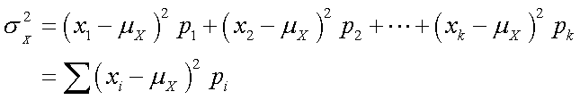

Mean of continuous random variables:

$$E\left(x\right)= \int_{a}^{b}{xf\left(x\right)dx}$$

Variance of continuous random variables:

2. In Assignment3.py

<https://github.com/nflhm/ML-Assignment3_Kevin_Gunawan_2201829981>