A ______________ Proposal Presented to the Faculty of the

**${Title}**

School of Engineering, Architecture and Information Technology

Department of ${Course}

Saint Mary’s University

Bayombong, Nueva Vizcaya

In Partial Fulfillment of the Requirements for the Degree

Bachelor of Science in ${Course}

${Student_MultiLine}

${Adviser}

May 2023

**TABLE OF CONTENTS**

Title Page i

Table of Contents ii

List of Figures ii

List of Tables ii

CHAPTER I INTRODUCTION

Background of the Study 1

CHAPTER II METHODOLOGY

Data Gathering pp

Data Analysis pp

Ethical Considerations pp

REFERENCES pp

APPENDICES pp

Appendix X *(pertinent appendices as per department, if there are any)*  pp

Appendix X Student Researcher’s Letter of Intent for Prospective Adviser-Promoter pp

Appendix X Adviser-Promoter Acceptance Form pp

Appendix X Agreement on Promotership pp

Appendix X Certificate of Approval pp

Appendix X Communication Letters *(if there are any)* pp

CURRICULUM VITAE pp

**LIST OF FIGURES**

Figure No. Title Page

1. Poblacion South Site 15
2. Market Vicinity 20

**LIST OF TABLES**

Table No. Title Page

1. Matrix of Related Studies 15
2. SWOT Analysis 20

***LIST OF DAGRAMS (for BSAR)***

Diagram No. Title Page

1. Planning Process 15
2. Construction Process 20

**CHAPTER I**

**INTRODUCTION**

* 1. **Background of the Study**

As time passes, the growth of a specific area develops, incorporating various trends and advancements to boost a specific community. Solano is well-known

**Figure 1**

*Poblacion South Site*

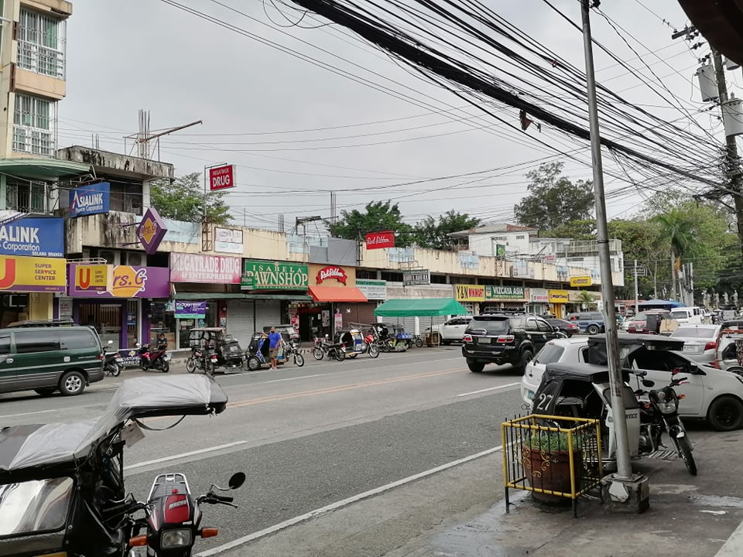

Source: *(if taken from a different material)*

Inserting Figures

1. Insert Text Box
2. Set Text Box width to 6.0”
3. Format Text Box to Cambria 12, *single spacing*
4. Skip 1 space
5. Enter **Figure** **number** (Bold), no period after
6. Enter *Figure title* (Regular, italic)
7. Insert 1 space
8. Insert Figure
9. Insert 1 space
10. Source: (if taken after a different material)
11. Set Text Box to **Wrap > Square** (enables moving vertically on page)
12. May also use **Wrap > In Line With Text** (whichever is more manageable)

**Table 1**

*Land Slope Category in the Municipality of Solano*

|  |  |  |  |  |
| --- | --- | --- | --- | --- |
| **CODE** | **CATEGORY** | **DESCRIPTON** | **AREA (Has)** | **PERCENT** |
| M | Below 18 | Level to nearly level | 7,591.7082 | 73.72 |
| P | 18-30 | Rolling to Hilly | 1,267.2660 | 12.31 |
| Q | 30-50 | Steep Hill to Mountainous | 1,002.1782 | 9.73 |
| R | Above 50 | Very steepy mountainous | 437.4078 | 4.25 |
| **Total** |  |  | 10,298.5603 | 100.00 |

Source: *(if taken from a different material)*

Inserting Tables (APA v7)

1. Insert Text Box
2. Set Text Box width to 6.0”
3. Format Text Box to Cambria 12, *single spacing*
4. Skip 1 space
5. Enter **Table** **number** (Bold)
6. Enter *Table title* (Regular, italic)
7. Insert 1 space
8. Insert Table
9. Format table as above (no vertical borders)
10. Insert 1 space
11. Source: (if taken after a different material)
12. Set Text Box to **Wrap > Square** (enables moving vertically on page)

***REMOVE Border lines of Text boxes before printing the FINAL manuscript for BINDING***

**CHAPTER 2**

**METHODOLOGY**

* 1. **Background of the Study**

This is the start of methodology. Edit this part according to what you have in your paper.

**REFERENCES**

Ocampo, J. (2021). *Greenbelt Case Study*. Retrieved October 18, 2022, from https://www.scribd.com/document/535861383/Greenbelt-Case-Study#

Gilles, S. (2014). *Determining Amenity Values of Green Open Spaces in Shopping Malls: The Ayala Greenbelt Park Experience*. Retrieved October 18, 2022, from https://www.academia.edu/5772254/Determining_Amenity_Values_of_Green_Open_Spaces_in_Shopping_Malls_The_Ayala_Greenbelt_Park_Experience_full_paper

*SM Aura: A Haven of Business and Pleasure.* (2013). Retrieved October 18, 2022, from https://kmcmaggroup.com/research-insights/2013/sm-aura-a-haven-of-business-and-pleasure/

Setting the REFERENCES section

1. Highlight the entire entries
2. Set to Align Left
3. Apply this Paragraph setting…

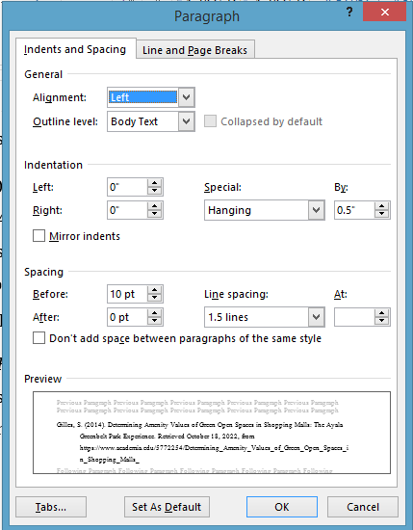

1. Remove Hyperlinks.
2. No underlines.
3. Arrange alphabetically according to authors.
4. INCLUDE BOOKS AVAILABLE FROM THE SMU LIBRARY (ULRC)

**Appendix A Student Researcher’s Letter of Intent for Prospective**

**Adviser-Promoter**

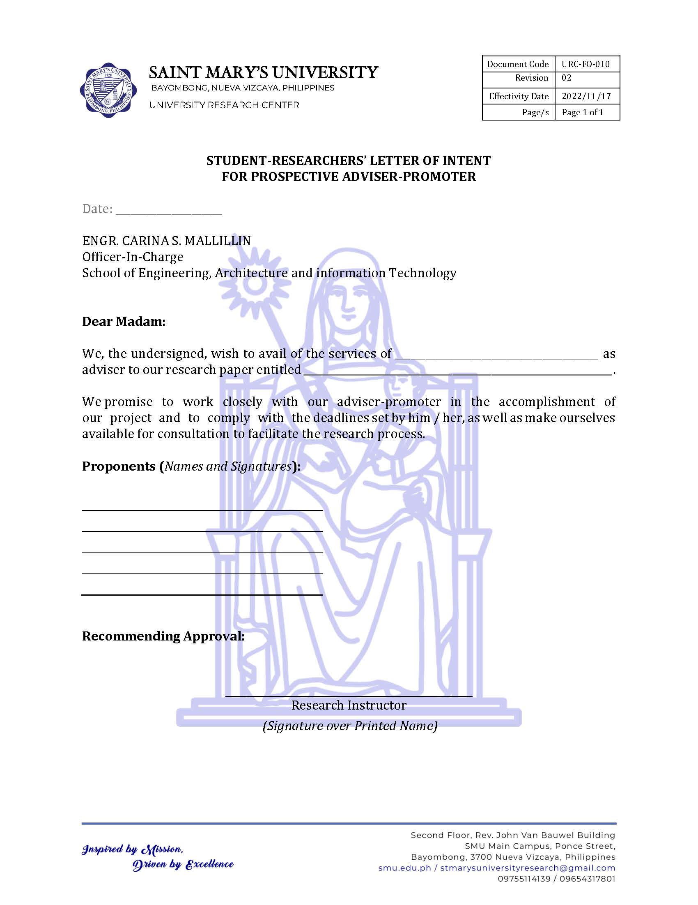

**Appendix B Adviser-Promoter Acceptance Form**

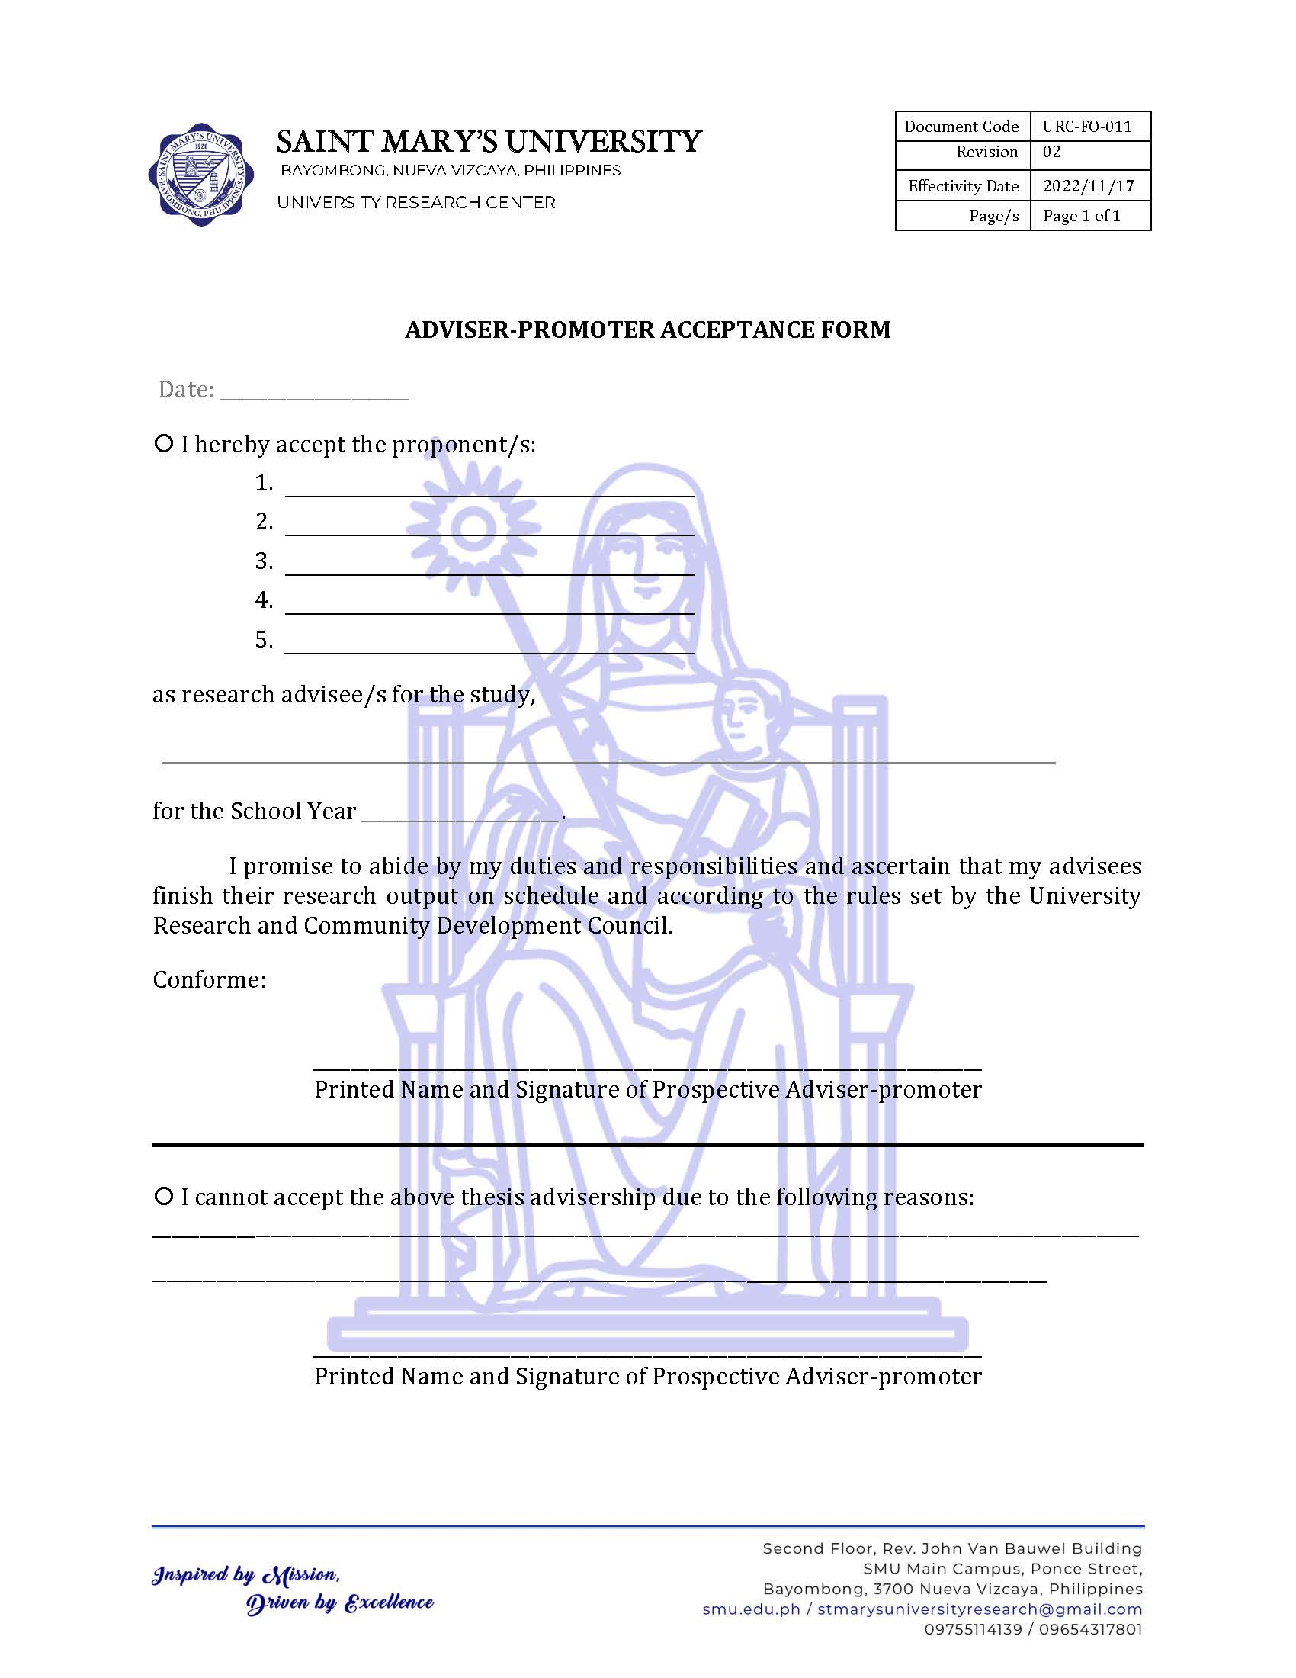

**Appendix C Agreement on Promotership**

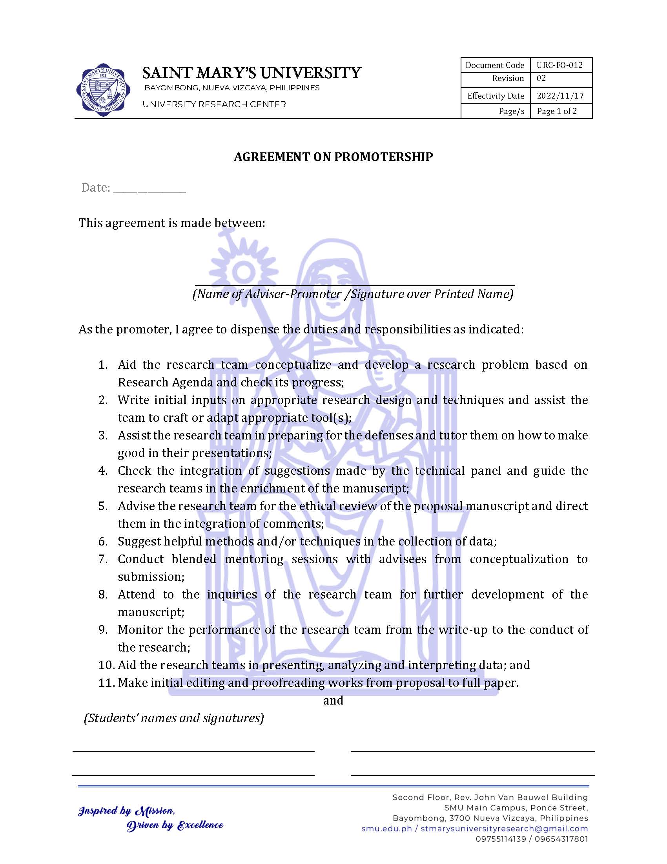

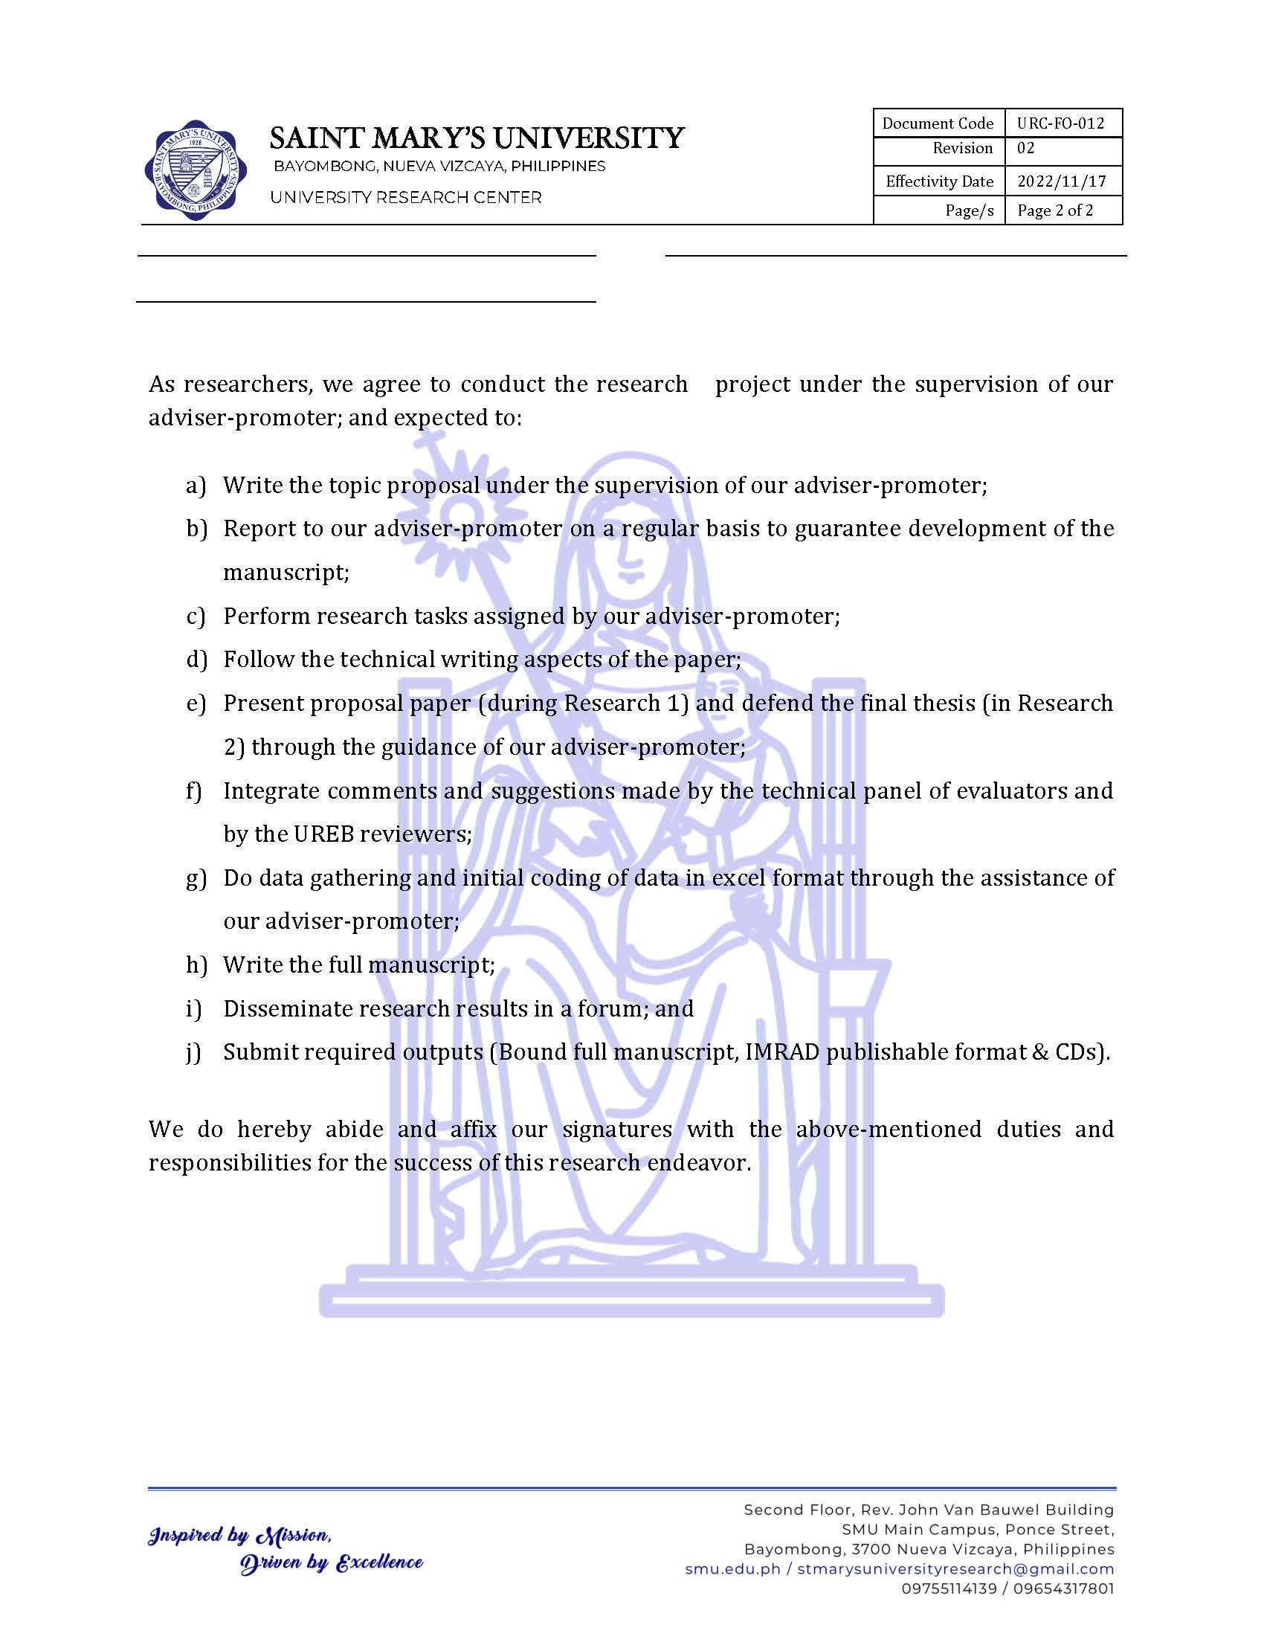

**Appendix D Certificate of Approval**

*(Issued by UREB after your application)*

**Appendix X Communication Letters** *(if there are any)*

**OFFICIAL CO-CURRICULAR TRANSCRIPT**

(Photo)

|  |  |
| --- | --- |
| **Name:** |  |
| Address: |  |
| Email address: |  |
| Contact number: |  |

|  |  |  |  |
| --- | --- | --- | --- |
| **PERSONAL INFORMATION** | | | |
| Age: |  | Date of Birth: |  |
| Civil Status: |  | Place of Birth: |  |
| Religion: |  | Father’s name: |  |
|  | Mother’s name: |  |

|  |  |  |
| --- | --- | --- |
| **EDUCATIONAL BACKGROUND** | | |
|  | **Name of School** | **Date completed** |
| Tertiary |  | September 14, 2022 |
| Secondary |  |  |
|  |  |
| Elementary |  |  |

|  |  |  |  |  |  |
| --- | --- | --- | --- | --- | --- |
| **MARIAN CORE VALUES** | | | | | |
| **EXCELLENCE** (It refers to academic/ scholastic accomplishments and involvement in non-academic activities wherein the students develop knowledge, competencies, and skills) | | | | | |
| **Award** | | | **Event / Competition** | | **Date** |
|  | | |  | |  |
|  | | |  | |  |
|  | | |  | |  |
|  | | |  | |  |
| **INNOVATION** (It refers to creative output such as research papers, capstone projects, systems developed, and students’ involvement in literary, arts and visual performances) | | | | | |
| **Involvement** | | | | **Seminar / Convention** | **Date** |
|  | | | |  |  |
|  | | | |  |  |
|  | | | |  |  |
|  | | | |  |  |
|  | | | |  |  |
|  | | | |  |  |
| **COMMUNION** (It refers to students’ involvement in school and community activities and leadership / trainings attended / conducted) | | | | | |
| 1. **SCHOOL INVOLVEMENT** | | | | | |
| **Designation** | **Organization** | | | | **Date** |
|  |  | | | |  |
|  |  | | | |  |
|  |  | | | |  |
|  |  | | | |  |
| 1. **LEADERSHIP TRAININGS/SEMINARS** | | | | | |
| **Involvement** | **Seminar / Training** | | | | **Date** |
|  |  | | | |  |
|  |  | | | |  |
|  |  | | | |  |
|  |  | | | |  |
| **PASSION FOR CHRIST’S MISSION** (It refers to students’ involvement in spiritual and pastoral activities) | | | | | |
| **Involvement** | | **Event** | | | **Date** |
|  | |  | | |  |
|  | |  | | |  |
|  | |  | | |  |
|  | |  | | |  |
|  | |  | | |  |

*Note: Delete unused rows. Removed table borders when done.*

|  |
| --- |
| **TECHNICAL SKILLS / COMPETENCIES** |
|  |
|  |
|  |
|  |

**OFFICIAL CO-CURRICULAR TRANSCRIPT**

(Photo)

|  |  |
| --- | --- |
| **Name:** |  |
| Address: |  |
| Email address: |  |
| Contact number: |  |

|  |  |  |  |
| --- | --- | --- | --- |
| **PERSONAL INFORMATION** | | | |
| Age: |  | Date of Birth: |  |
| Civil Status: |  | Place of Birth: |  |
| Religion: |  | Father’s name: |  |
|  | Mother’s name: |  |

|  |  |  |  |  |  |  |
| --- | --- | --- | --- | --- | --- | --- |
| **EDUCATIONAL BACKGROUND** | | | | | | |
|  | **Name of School** | | | | | **Date completed** |
| Tertiary |  | | | | | September 14, 2022 |
| Secondary |  | | | | |  |
|  | | | | |  |
| Elementary |  | | | | |  |
| **MARIAN CORE VALUES**  **EXCELLENCE** (It refers to academic/ scholastic accomplishments and involvement in non-academic activities wherein the students develop knowledge, competencies, and skills) | | | | | | |
| **Award** | | | | **Event / Competition** | | **Date** |
|  | | | |  | |  |
|  | | | |  | |  |
|  | | | |  | |  |
|  | | | |  | |  |
| **INNOVATION** (It refers to creative output such as research papers, capstone projects, systems developed, and students’ involvement in literary, arts and visual performances) | | | | | | |
| **Involvement** | | | | | **Seminar / Convention** | **Date** |
|  | | | | |  |  |
|  | | | | |  |  |
|  | | | | |  |  |
|  | | | | |  |  |
|  | | | | |  |  |
|  | | | | |  |  |
| **COMMUNION** (It refers to students’ involvement in school and community activities and leadership / trainings attended / conducted) | | | | | | | |
| 1. **SCHOOL INVOLVEMENT** | | | | | | | |
| **Designation** | | **Organization** | | | | **Date** | |
|  | |  | | | |  | |
|  | |  | | | |  | |
|  | |  | | | |  | |
|  | |  | | | |  | |
| 1. **LEADERSHIP TRAININGS/SEMINARS** | | | | | | | |
| **Involvement** | | **Seminar / Training** | | | | **Date** | |
|  | |  | | | |  | |
|  | |  | | | |  | |
|  | |  | | | |  | |
|  | |  | | | |  | |
| **PASSION FOR CHRIST’S MISSION** (It refers to students’ involvement in spiritual and pastoral activities) | | | | | | | |
| **Involvement** | | | **Event** | | | **Date** | |
|  | | |  | | |  | |
|  | | |  | | |  | |
|  | | |  | | |  | |
|  | | |  | | |  | |

|  |
| --- |
| **TECHNICAL SKILLS / COMPETENCIES** |
|  |
|  |
|  |
|  |

**OFFICIAL CO-CURRICULAR TRANSCRIPT**

(Photo)

|  |  |
| --- | --- |
| **Name:** |  |
| Address: |  |
| Email address: |  |
| Contact number: |  |

|  |  |  |  |
| --- | --- | --- | --- |
| **PERSONAL INFORMATION** | | | |
| Age: |  | Date of Birth: |  |
| Civil Status: |  | Place of Birth: |  |
| Religion: |  | Father’s name: |  |
|  | Mother’s name: |  |

|  |  |  |  |  |  |  |
| --- | --- | --- | --- | --- | --- | --- |
| **EDUCATIONAL BACKGROUND** | | | | | | |
|  | **Name of School** | | | | | **Date completed** |
| Tertiary |  | | | | | September 14, 2022 |
| Secondary |  | | | | |  |
|  | | | | |  |
| Elementary |  | | | | |  |
| **MARIAN CORE VALUES**  **EXCELLENCE** (It refers to academic/ scholastic accomplishments and involvement in non-academic activities wherein the students develop knowledge, competencies, and skills) | | | | | | |
| **Award** | | | | **Event / Competition** | | **Date** |
|  | | | |  | |  |
|  | | | |  | |  |
|  | | | |  | |  |
|  | | | |  | |  |
| **INNOVATION** (It refers to creative output such as research papers, capstone projects, systems developed, and students’ involvement in literary, arts and visual performances) | | | | | | |
| **Involvement** | | | | | **Seminar / Convention** | **Date** |
|  | | | | |  |  |
|  | | | | |  |  |
|  | | | | |  |  |
|  | | | | |  |  |
|  | | | | |  |  |
|  | | | | |  |  |
| **COMMUNION** (It refers to students’ involvement in school and community activities and leadership / trainings attended / conducted) | | | | | | | |
| 1. **SCHOOL INVOLVEMENT** | | | | | | | |
| **Designation** | | **Organization** | | | | **Date** | |
|  | |  | | | |  | |
|  | |  | | | |  | |
|  | |  | | | |  | |
|  | |  | | | |  | |
| 1. **LEADERSHIP TRAININGS/SEMINARS** | | | | | | | |
| **Involvement** | | **Seminar / Training** | | | | **Date** | |
|  | |  | | | |  | |
|  | |  | | | |  | |
|  | |  | | | |  | |
|  | |  | | | |  | |
| **PASSION FOR CHRIST’S MISSION** (It refers to students’ involvement in spiritual and pastoral activities) | | | | | | | |
| **Involvement** | | | **Event** | | | **Date** | |
|  | | |  | | |  | |
|  | | |  | | |  | |
|  | | |  | | |  | |
|  | | |  | | |  | |

|  |
| --- |
| **TECHNICAL SKILLS / COMPETENCIES** |
|  |
|  |
|  |
|  |

**OFFICIAL CO-CURRICULAR TRANSCRIPT**

(Photo)

|  |  |
| --- | --- |
| **Name:** |  |
| Address: |  |
| Email address: |  |
| Contact number: |  |

|  |  |  |  |
| --- | --- | --- | --- |
| **PERSONAL INFORMATION** | | | |
| Age: |  | Date of Birth: |  |
| Civil Status: |  | Place of Birth: |  |
| Religion: |  | Father’s name: |  |
|  | Mother’s name: |  |

|  |  |  |  |  |  |  |
| --- | --- | --- | --- | --- | --- | --- |
| **EDUCATIONAL BACKGROUND** | | | | | | |
|  | **Name of School** | | | | | **Date completed** |
| Tertiary |  | | | | | September 14, 2022 |
| Secondary |  | | | | |  |
|  | | | | |  |
| Elementary |  | | | | |  |
| **MARIAN CORE VALUES**  **EXCELLENCE** (It refers to academic/ scholastic accomplishments and involvement in non-academic activities wherein the students develop knowledge, competencies, and skills) | | | | | | |
| **Award** | | | | **Event / Competition** | | **Date** |
|  | | | |  | |  |
|  | | | |  | |  |
|  | | | |  | |  |
|  | | | |  | |  |
| **INNOVATION** (It refers to creative output such as research papers, capstone projects, systems developed, and students’ involvement in literary, arts and visual performances) | | | | | | |
| **Involvement** | | | | | **Seminar / Convention** | **Date** |
|  | | | | |  |  |
|  | | | | |  |  |
|  | | | | |  |  |
|  | | | | |  |  |
|  | | | | |  |  |
|  | | | | |  |  |
| **COMMUNION** (It refers to students’ involvement in school and community activities and leadership / trainings attended / conducted) | | | | | | | |
| 1. **SCHOOL INVOLVEMENT** | | | | | | | |
| **Designation** | | **Organization** | | | | **Date** | |
|  | |  | | | |  | |
|  | |  | | | |  | |
|  | |  | | | |  | |
|  | |  | | | |  | |
| 1. **LEADERSHIP TRAININGS/SEMINARS** | | | | | | | |
| **Involvement** | | **Seminar / Training** | | | | **Date** | |
|  | |  | | | |  | |
|  | |  | | | |  | |
|  | |  | | | |  | |
|  | |  | | | |  | |
| **PASSION FOR CHRIST’S MISSION** (It refers to students’ involvement in spiritual and pastoral activities) | | | | | | | |
| **Involvement** | | | **Event** | | | **Date** | |
|  | | |  | | |  | |
|  | | |  | | |  | |
|  | | |  | | |  | |
|  | | |  | | |  | |

|  |
| --- |
| **TECHNICAL SKILLS / COMPETENCIES** |
|  |
|  |
|  |
|  |