ORM + JPQL

General part

* *Explain the rationale behind the topic Object Relational Mapping and the Pros and Cons in using a ORM*.  
  Se den anden word fil, med same spørgsmål.
* Discuss how we usually have queried a relational database  
  Vi har typisk brugt jpa og jdbc der har kunne lave direkte sql kald til databasen
* Discuss the methods we can use to query a JPA design and compare with what you explained above  
  Jeg har primært brugt namedqueries, der binder sig på det object du prøver at hente. Og så bliver kaldt gennem entitymanageren.   
  Derudover burger jeg typisk find itl at søge.

Practical part

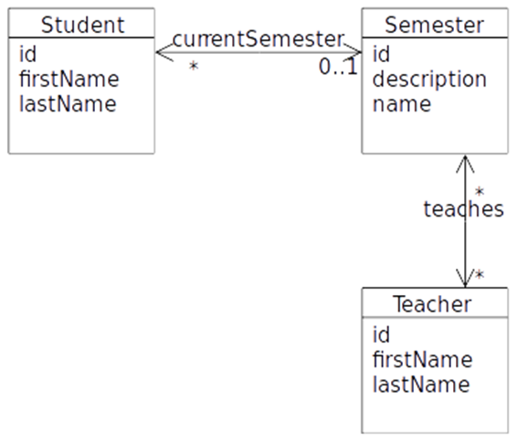The exercise requires this [script](https://github.com/Cphdat3sem2017f/StartcodeExercises/blob/master/ORM-JPA/ExamPreparationJPQL.sql) and you must set up a MySQL database as described below:

* Execute  (from Workbench or whatever you prefer) the script given above and verify that the database *ExampPreparationJPQL* was created with tables and data.
* Create a new plain Maven Java Project with NetBeans to hold the code for this project.

The script created four tables (why FOUR)  which simulates a very simple semester system with *students*, *teachers* and *semesters*, as sketched in this Object-model.

The script also inserted **6** students, **3** semesters and **3** teachers, and assigns relationships between them.

**A)** Use NetBeans to create a set of matching Entity Classes (see hints at the end). Make sure you understand what was created, and that you understand how classes and tables are related (almost a guaranteed discussion topic for the exam)

**B)** Investigate the generated Entity classes and observe the NamedQueries generated by the Wizard.

**C)** Create (preferable in a facade-class)  Dynamic Queries (or if possible, use a named Query generated by the wizard) to solve the following problems:

1. **Find** all Students in the system
2. **Find** all Students in the System with the first name Anders
3. **Insert** a new Student into the system
4. **Assign** a new student to a semester (given the student-id and semester-id)
5. Had the student above already been assigned to a semester he would suddenly be a member of two semesters, but still only have one reference back to the newest assigned semester. Fix this problem, preferably without losing historical information.
6. **Find** (using JPQL) all Students in the system with the last name And
7. Find (using JPQL) the total amount of all students
8. **Find** (using JPQL) the total number of students, for a semester given the semester name as a parameter.
9. **Find** (using JPQL) the total number of students in all semesters.
10. **Find** (using JPQL) the teacher(s) who teaches on most semesters.
11. Often (as in almost always) we don’t want a result that matches an Entity class, but a result that matches a specific customer requirement for a specific request.

Create a new package, mappers and add a class StudentInfo to the package. Add these **public** properties to the class:

public String **fullName**;

public long studentId;

public String classNameThisSemester;

public String classDescription;

*Note: Since the Semester represents the current Semester, and there are only one (or zero) semesters for a Student, semester-info can easily be encapsulated inside the StudentInfo class.*

Add a constructor that takes all the necessary arguments (create fullName from firstname and lastname)

Now create a method (using JPQL) with the following signature to return a list of all Students, encapsulated as StudentInfo’s.

**List<StudentInfo> getStudentInfo()**

1. Create a method, similar to the one above, but which returns a single StudentInfo, given a students id as sketched below:

**StudentInfo getStudentInfo(long id)**

**Hints:** For the last two → Read about *Result Classes* here: <https://www.objectdb.com/java/jpa/query/jpql/select>

**Hints: (How to create Entity Classes from an existing Database with NetBeans)**

Start the Wizard: **EntityClasses from Database..**.

**On the page "Database Tables"**

Select the Database Collection

Add All tables

Press Next

**On the page "Entity Classes"**

Rename package to entity

De-select "Generate JAXB Annotiations"

Press Next

**On the page "Mapping Options"**

De-select "Use Column Names in Relationships

**Press Finish**