Accessing the Twitter API From R
Things you will need:
- You will need an email address to register with Twitter.
- A phone number to register the twitter account as a developer account. If you do not want to give away a personal phone number, register for a free google voice account: https://www.google.com/voice , Twitter will send you a verification code via text that you can access in your google voice inbox.
- The R packages: twitteR and devtools
Steps to access twitter through R:
- In order to access the twitter api through R, you will need a twitter account. Please go to http://www.twitter.com and sign up for an account. You do not need to give any personal information other than an email of your choosing to verify your account. Twitter will send you an email for verification.
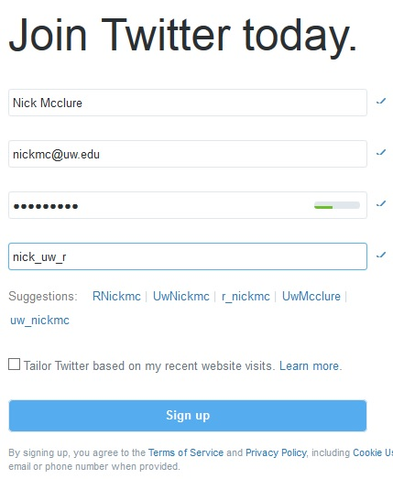

- Register your twitter account as a developer account. Visit: https://dev.twitter.com/ . Twitter has recently switched the api to something called ‘fabric’. Twitter will ask you for a team or company name- just enter anything you wish here.
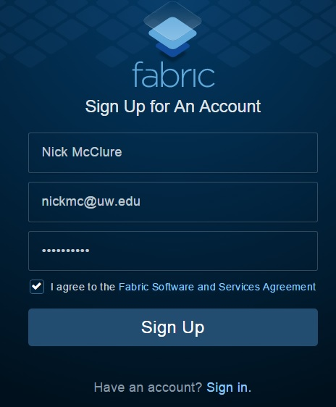
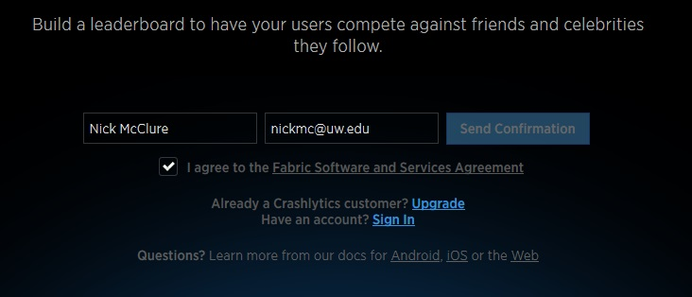

- Know that it might take a while for your account to be confirmed. It took me about 4 hours, and the fine print says it can take up to 48 hours.
- Once you are confirmed with a developer account, we need to register an ‘application’. This just lets Twitter know that you will be accessing your account and searching via a program and not a browser. Go to: https://apps.twitter.com/ and sign in. You will see that you have no apps and all you have to do is click on ‘Create New App’.
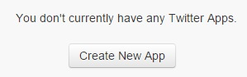
- After you clicked on create new app, you have to agree to many terms and conditions. You will also have to fill out a name and description and website. Since this is for academic purposes, fill out whatever you wish for the name/description and you can put the pce-datascience link in the website: http://www.pce.uw.edu/certificates/data-science.html
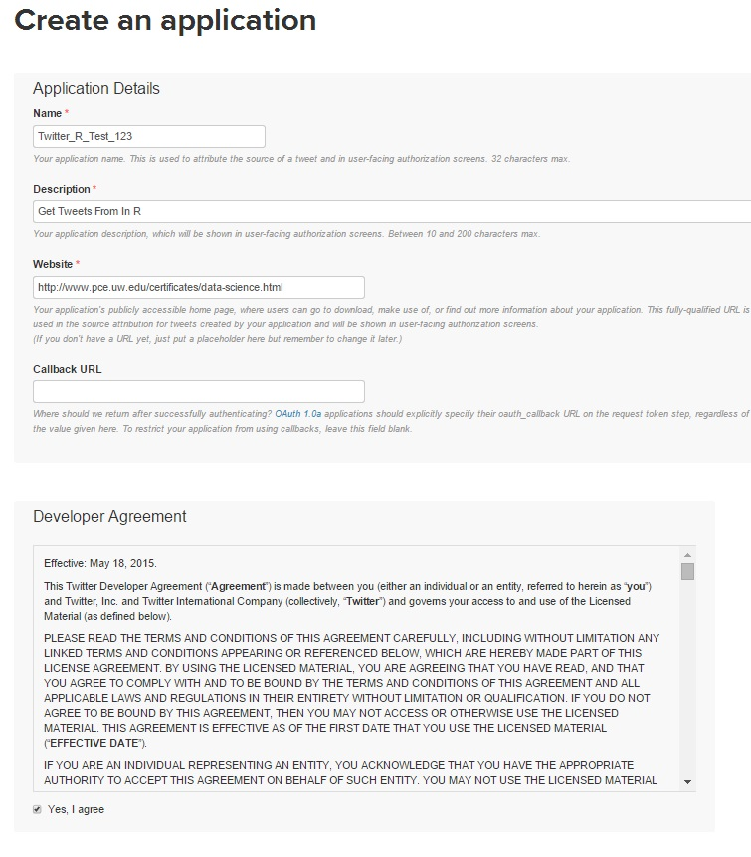
- Next, click on your app, and select ‘keys and access tokens’. Here is where you will get the four strings you need to input in your R program: The Consumer Key, The Consumer Secret, The Access Token, and the Access Token Secret.
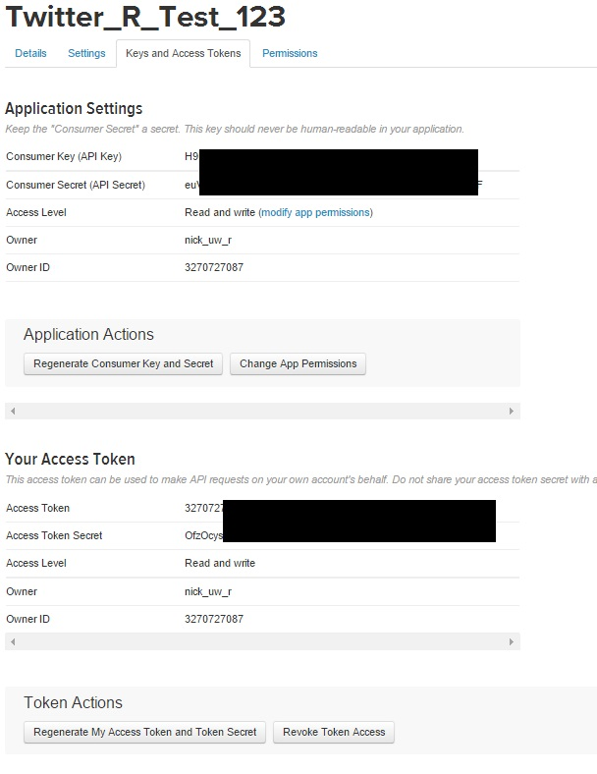
- Now we are ready to deal with R. In order not to have our secret keys floating around in programs that others will see, I prefer to stick them in a csv file. This csv file will have one row (two with a header) and four columns. We will load this into R and query Twitter through R.
- If we saved our csv file under ‘twitter_cred.csv’ we can run the following code:
library(twitteR)
library(devtools)
devtools::install_version("httr", version="0.6.0", repos="http://cran.us.r-project.org")
library(httr)

The above code will load the library ‘twitteR’. We need to load the library ‘devtools’ so that we can access a previous installation of the package ‘httr’. Normally the twitteR package would automatically load httr, but it loads a newer version that is incompatible with the twitteR api in R. So we then force install and load httr, version 0.6.0.
twit_cred = read.csv('twitter_cred.csv', stringsAsFactors=FALSE)

TWITTER_CONSUMER_KEY = twit_cred$TWITTER_CONSUMER_KEY
TWITTER_CONSUMER_SECRET = twit_cred$TWITTER_CONSUMER_SECRET
TWITTER_ACCESS_TOKEN = twit_cred$TWITTER_ACCESS_TOKEN
TWITTER_ACCESS_SECRET = twit_cred$TWITTER_ACCESS_SECRET

setup_twitter_oauth(TWITTER_CONSUMER_KEY, TWITTER_CONSUMER_SECRET,
TWITTER_ACCESS_TOKEN, TWITTER_ACCESS_SECRET)
Here we load our twitter credentials, save them in variables and setup the connection to the twitter api. NOTE: when you run ‘setup_twitter_oauth’, R will ask you if you want to run in cache. Answer ‘1’ (yes) to this question. After that, we can query R:
ds <- searchTwitter('#datascience', locale=NULL, geocode=NULL,n=500)

Know that this ‘searchTwitter’ function has many, many options. We can search in different locations too. Type ‘?searchTwitter’ to learn more. Also read the documentation on the twitteR package here:
http://cran.r-project.org/web/packages/twitteR/twitteR.pdf

