Nicole Forke

03 May 2020

Web 335

Assignment 1.4 - Data Models

Object Relational Diagrams:

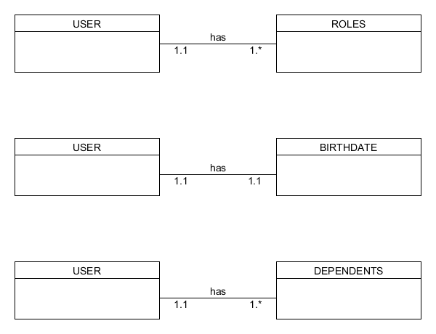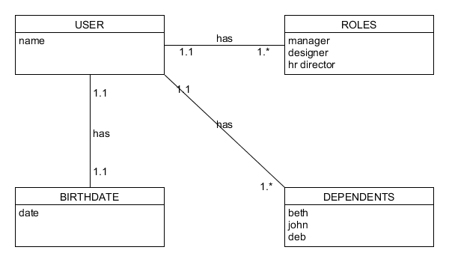

NoSQL Data Structure:

