Nicole Forke

04 May 2020

Web 335

Assignment 2.2 - NodeShopper ORD

Object Relational Diagrams:

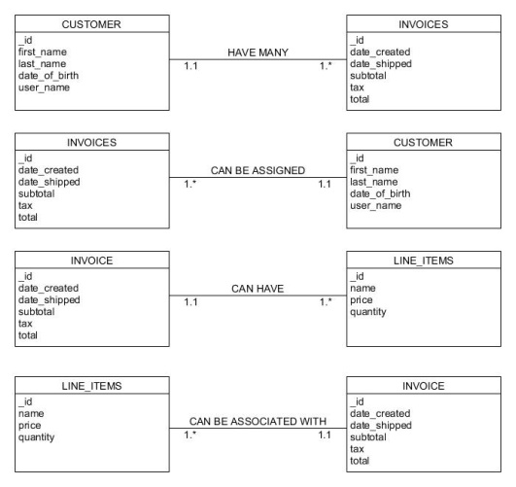

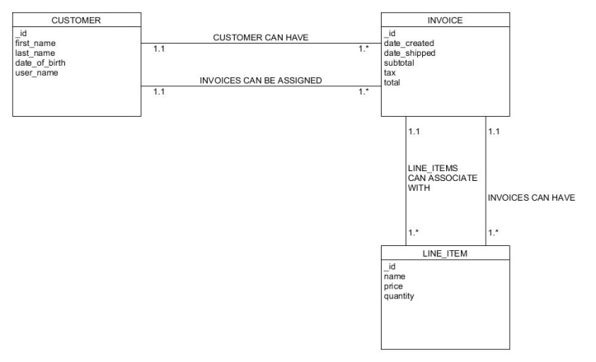

NoSQL Data Structure:

