Nicole Forke

09 May 2020

Web 335

Assignment 2.3 - NodeTech ORD

Object Relational Diagrams:

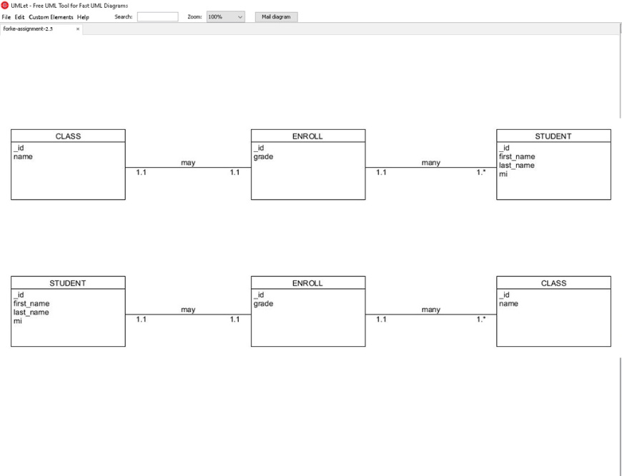

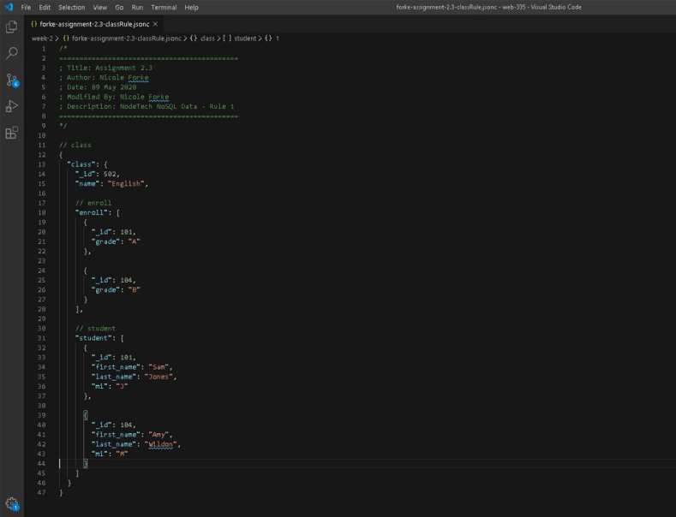NoSQL Data Structure:

