Nicole Forke

16 May 2020

Web 335

Assignment 3.3 - NodeBookCo

Normalized ORD Diagram:

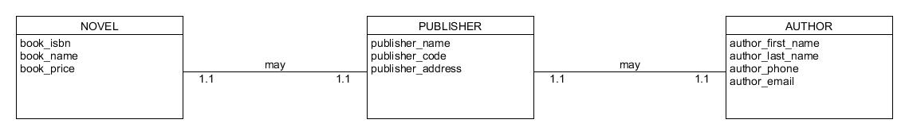

NoSQL Document Diagram:

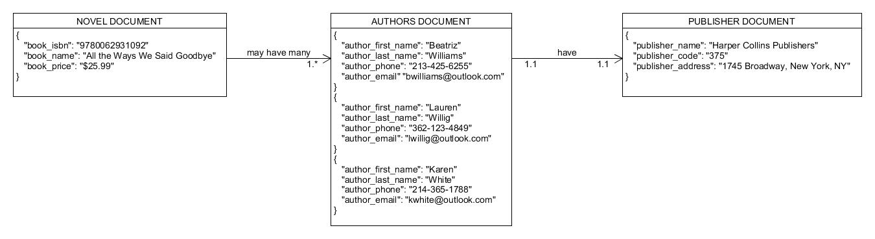

ORD Business Rules:

a NOVEL may have many AUTHORS

AUTHORS have one PUBLISHER

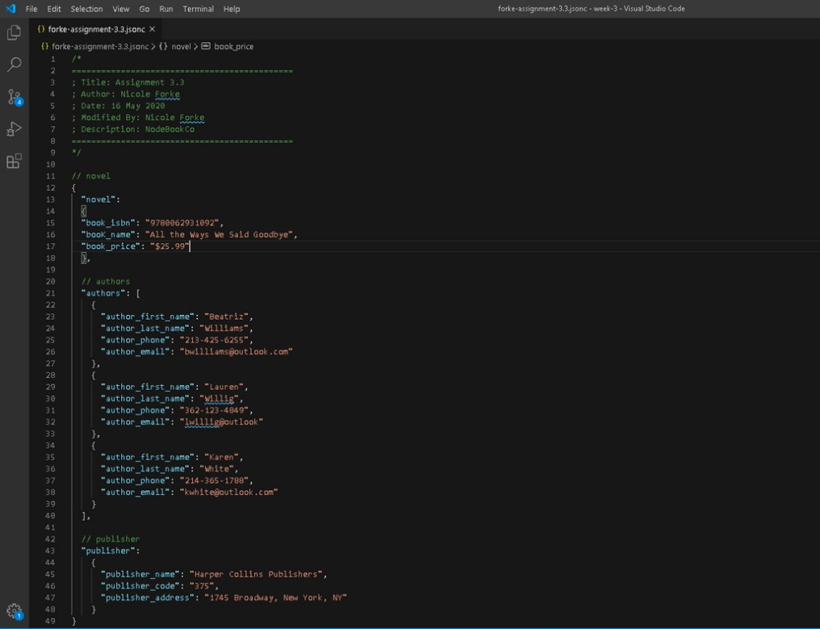NoSQL Data Structure: