Nicole Forke

22 May 2020

Assignment 4.2

Web 335

Finished Installation

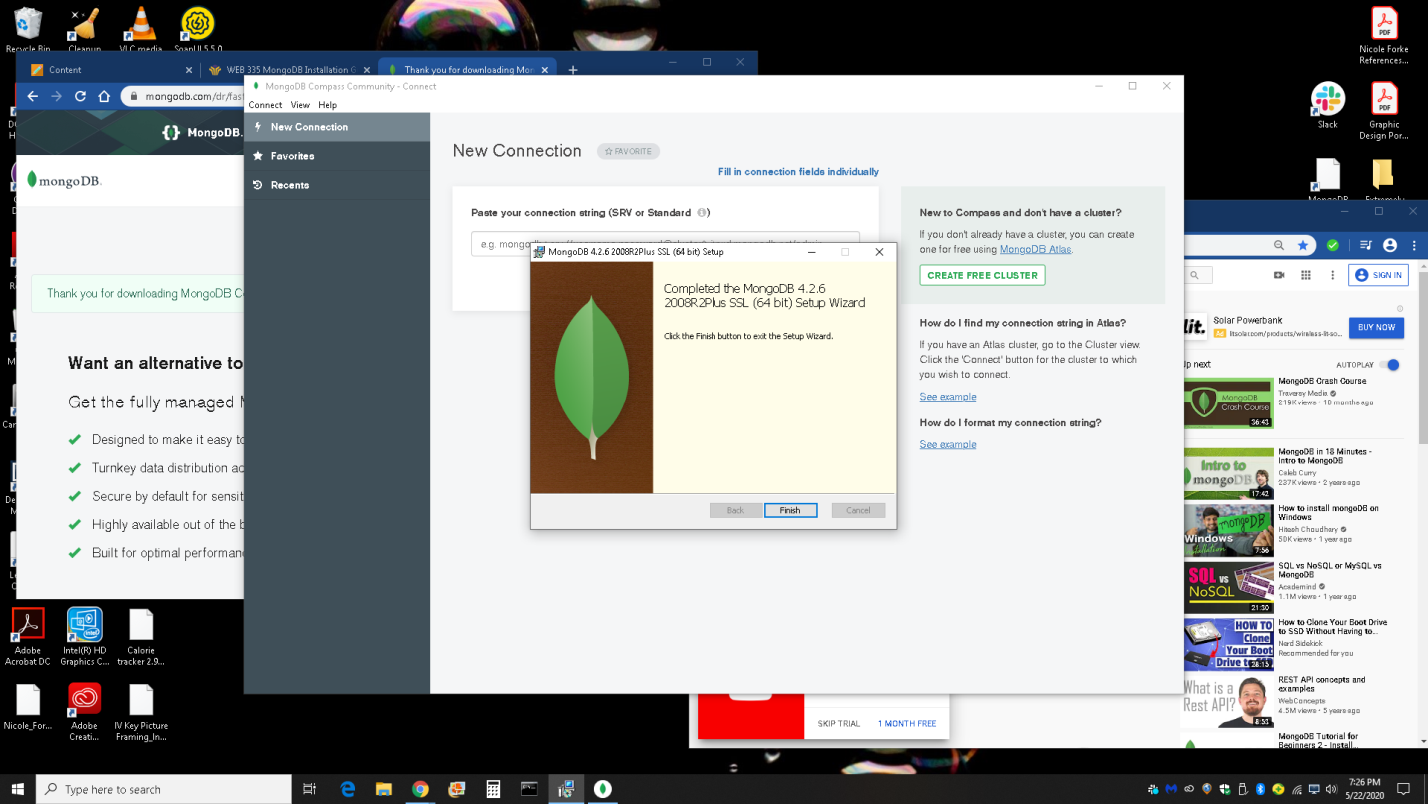

MongoDB Started

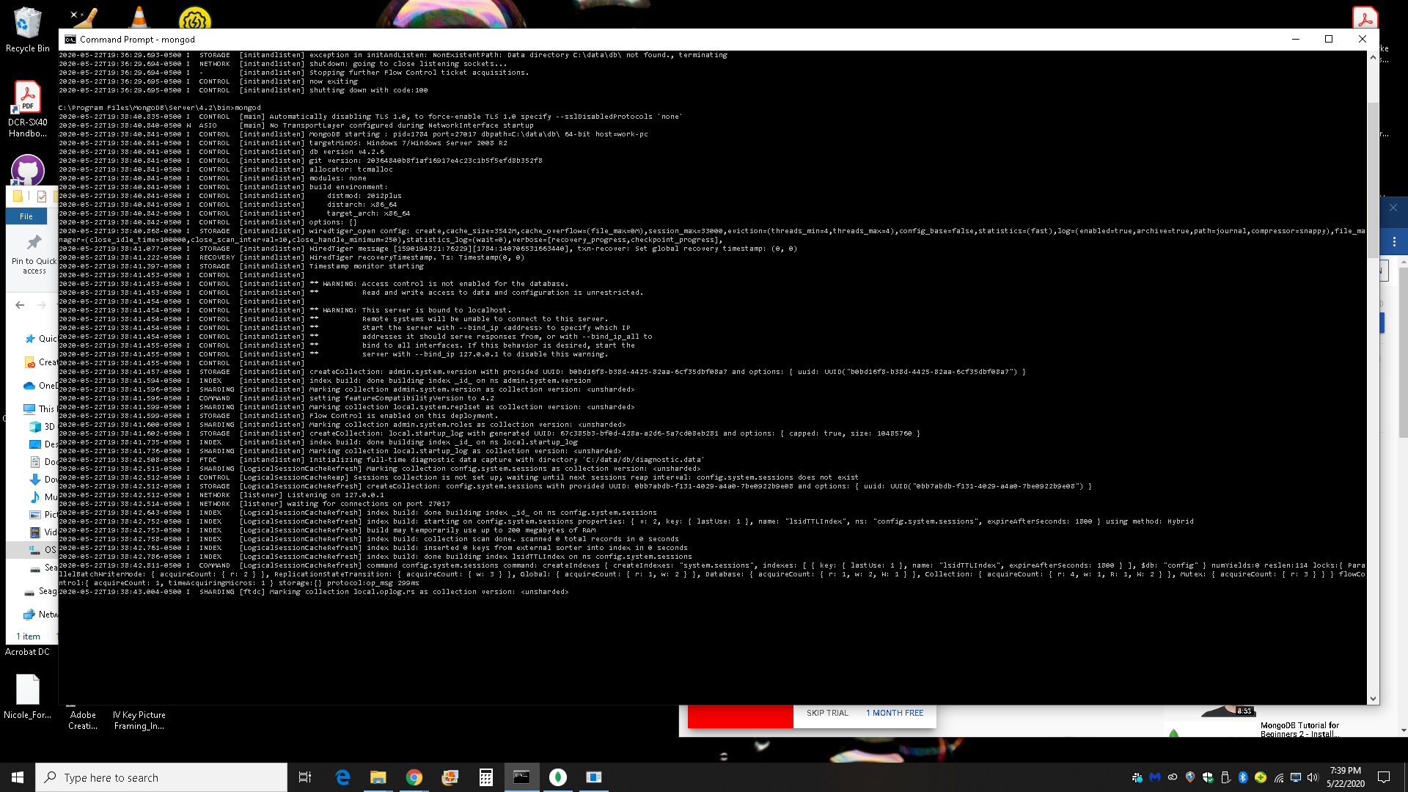

MongoDB - Entered mongod.exe - "Waiting for connections on port 27017"

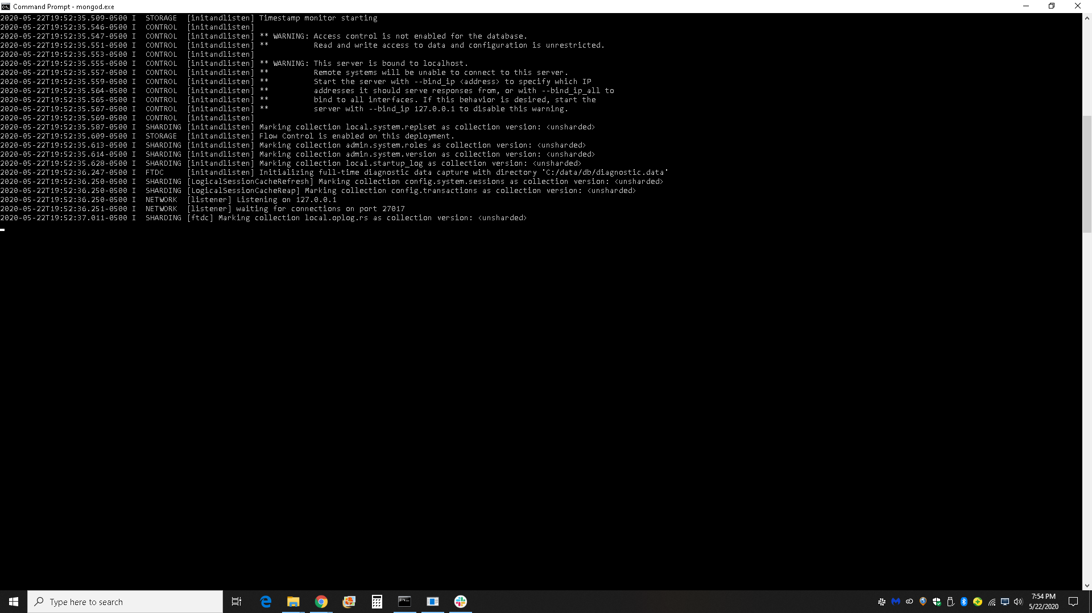

MongoDB Compass Opened

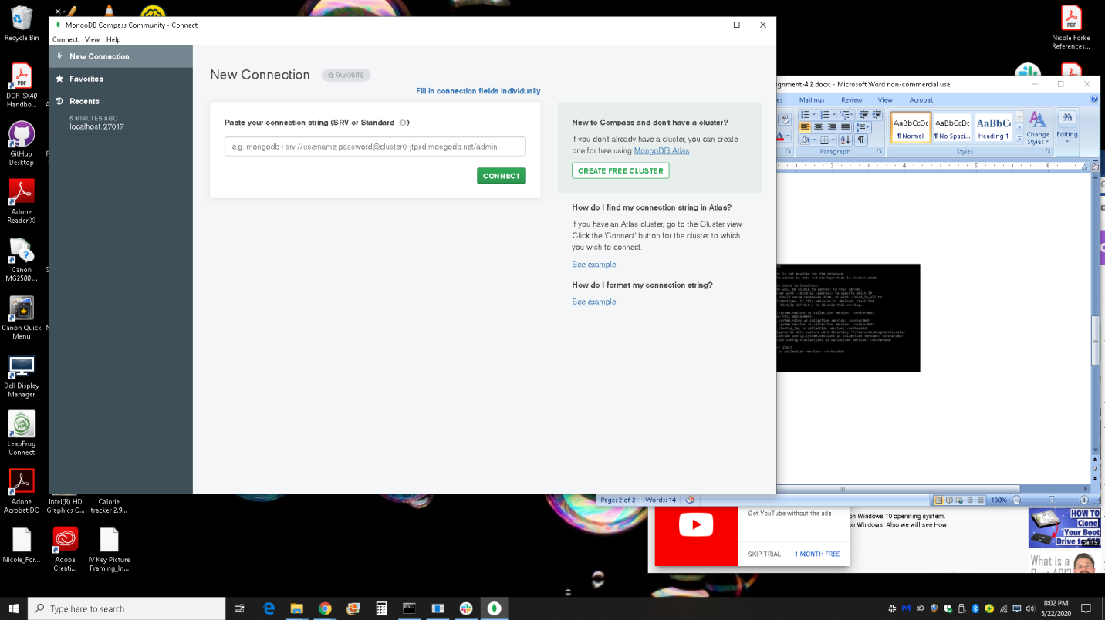

MongoDB Compass - Connected to Host

