Nicole Forke

22 May 2020

Assignment 4.3 - MongoDB Shell

Web 335

MongoDB Shell Started

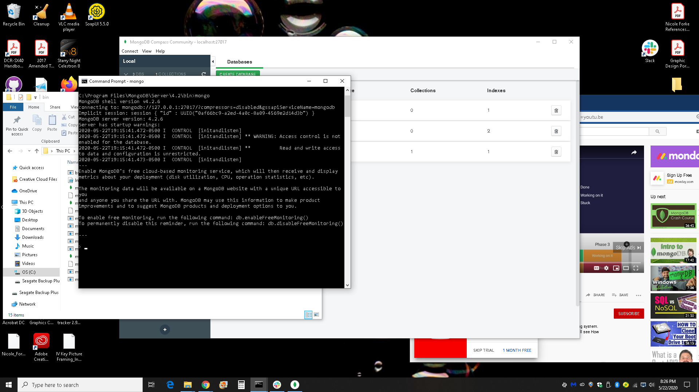

Called helloWorld function

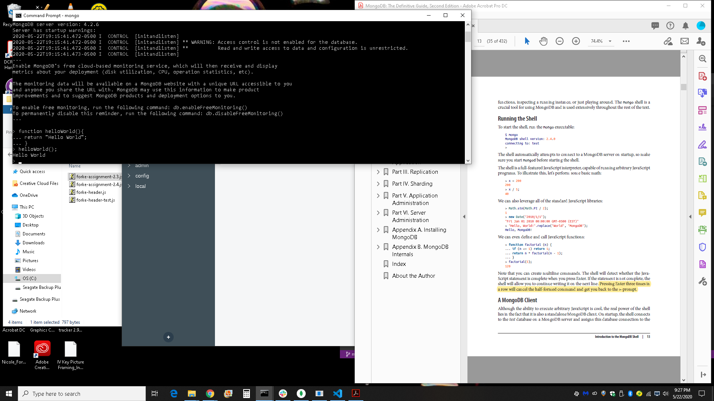

Called myWorld function

