Nicole Forke

23 May 2020

Assignment 4.4 - MongoDB in Action

Web 335

MongoDB Compass Database Created

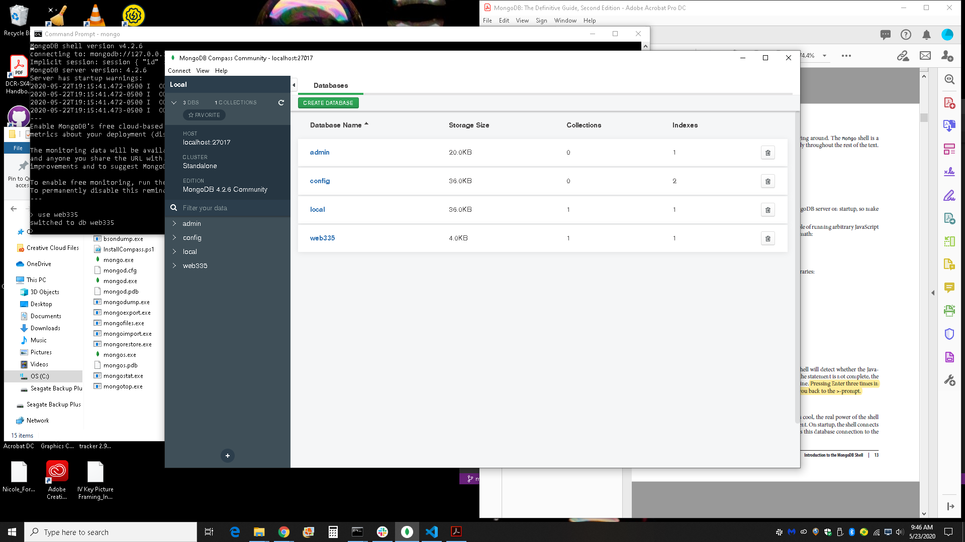

Inserted Users in MongoDB Compass

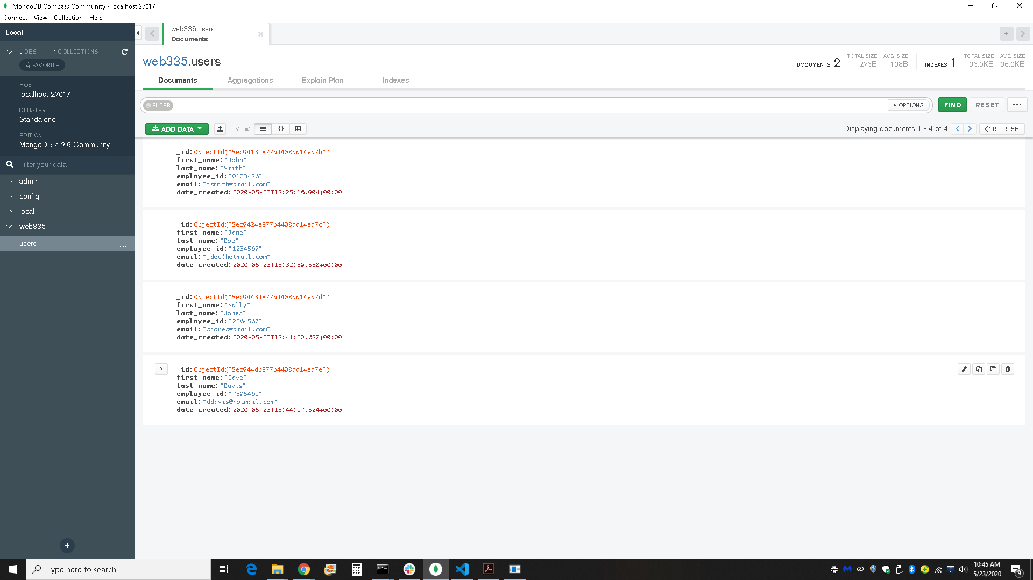

Inserted User in MongoDB Shell

