Nicole Forke

30 May 2020

Assignment 5.2 - Query Documents

Web 335

Filtered by "employee_id"

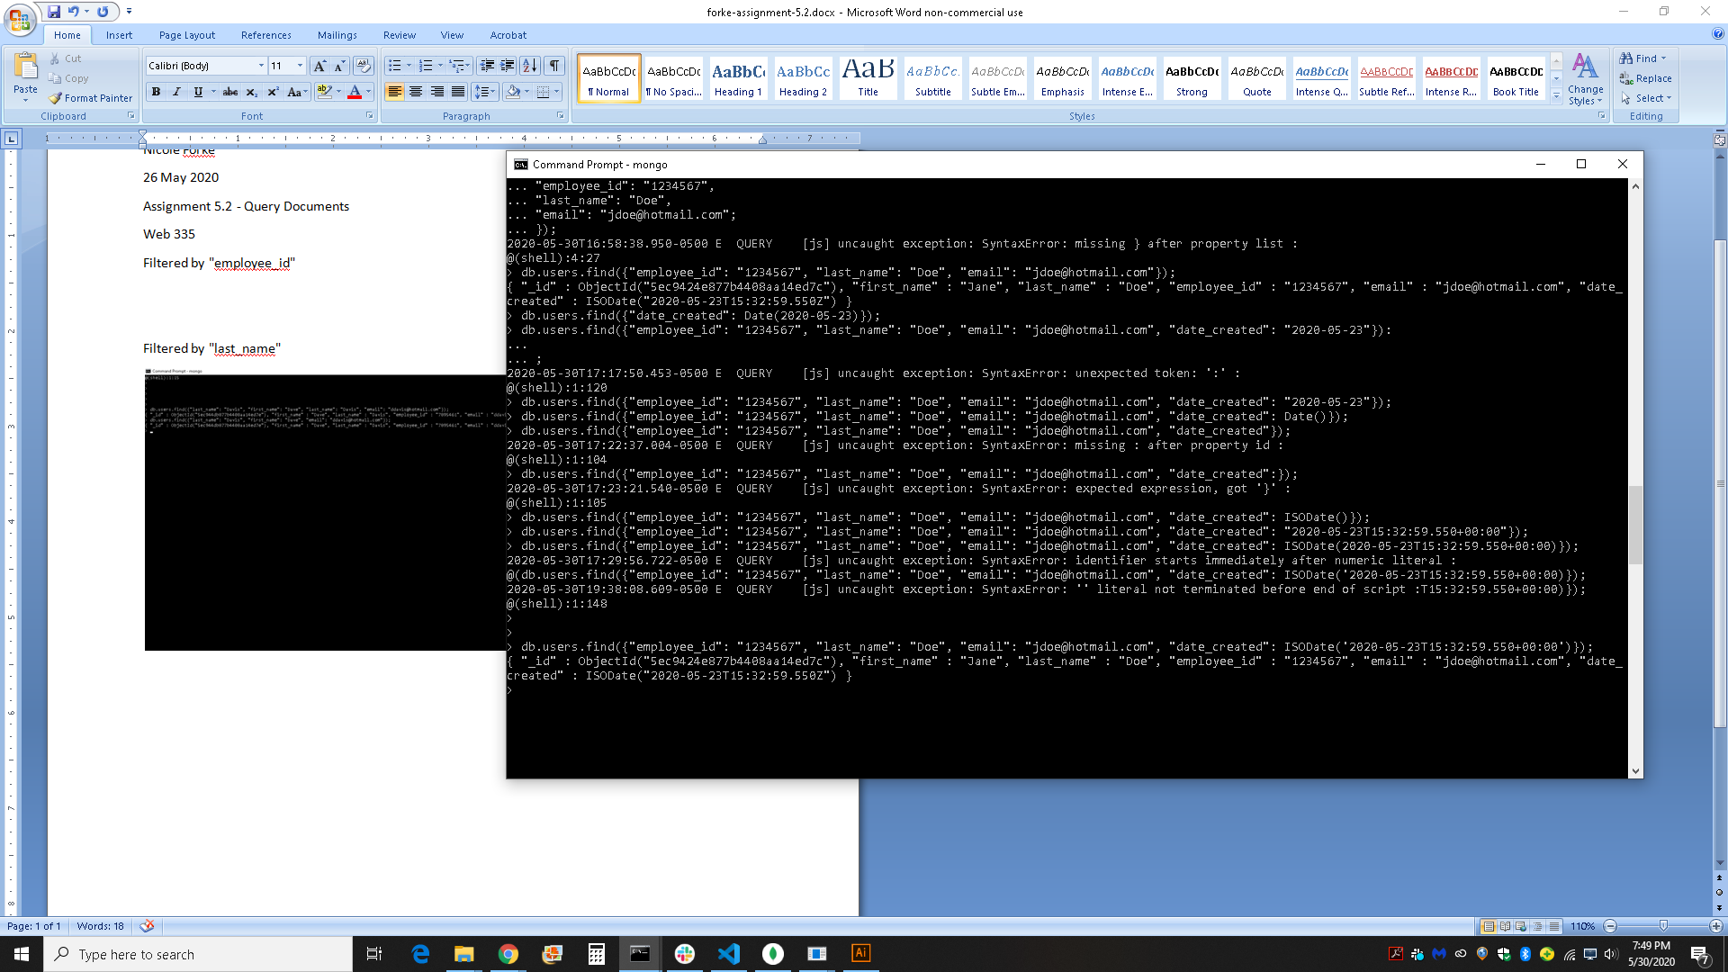

Filtered by "last_name"

