Nicole Forke

30 May 2020

Assignment 5.3 - Upserting Documents

Web 335

First findOne() Operation

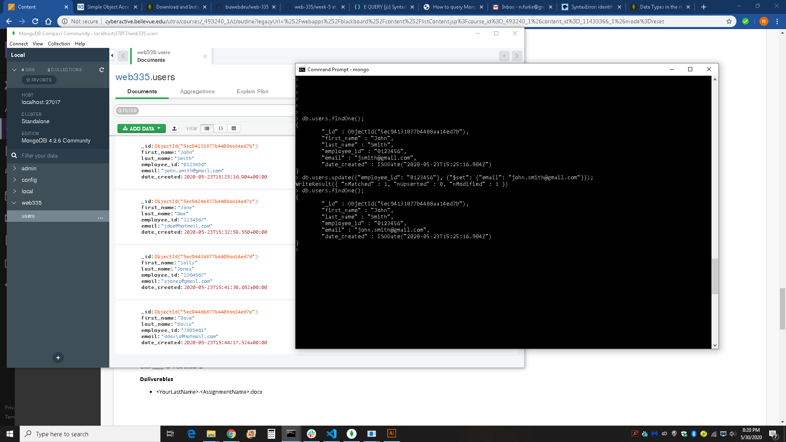

Update() Operation



Second findOne() Operation



Updated MongoDB

