Nicole Forke

30 May 2020

Assignment 5.4 - Deleting Documents

Web 335

remove() Operation

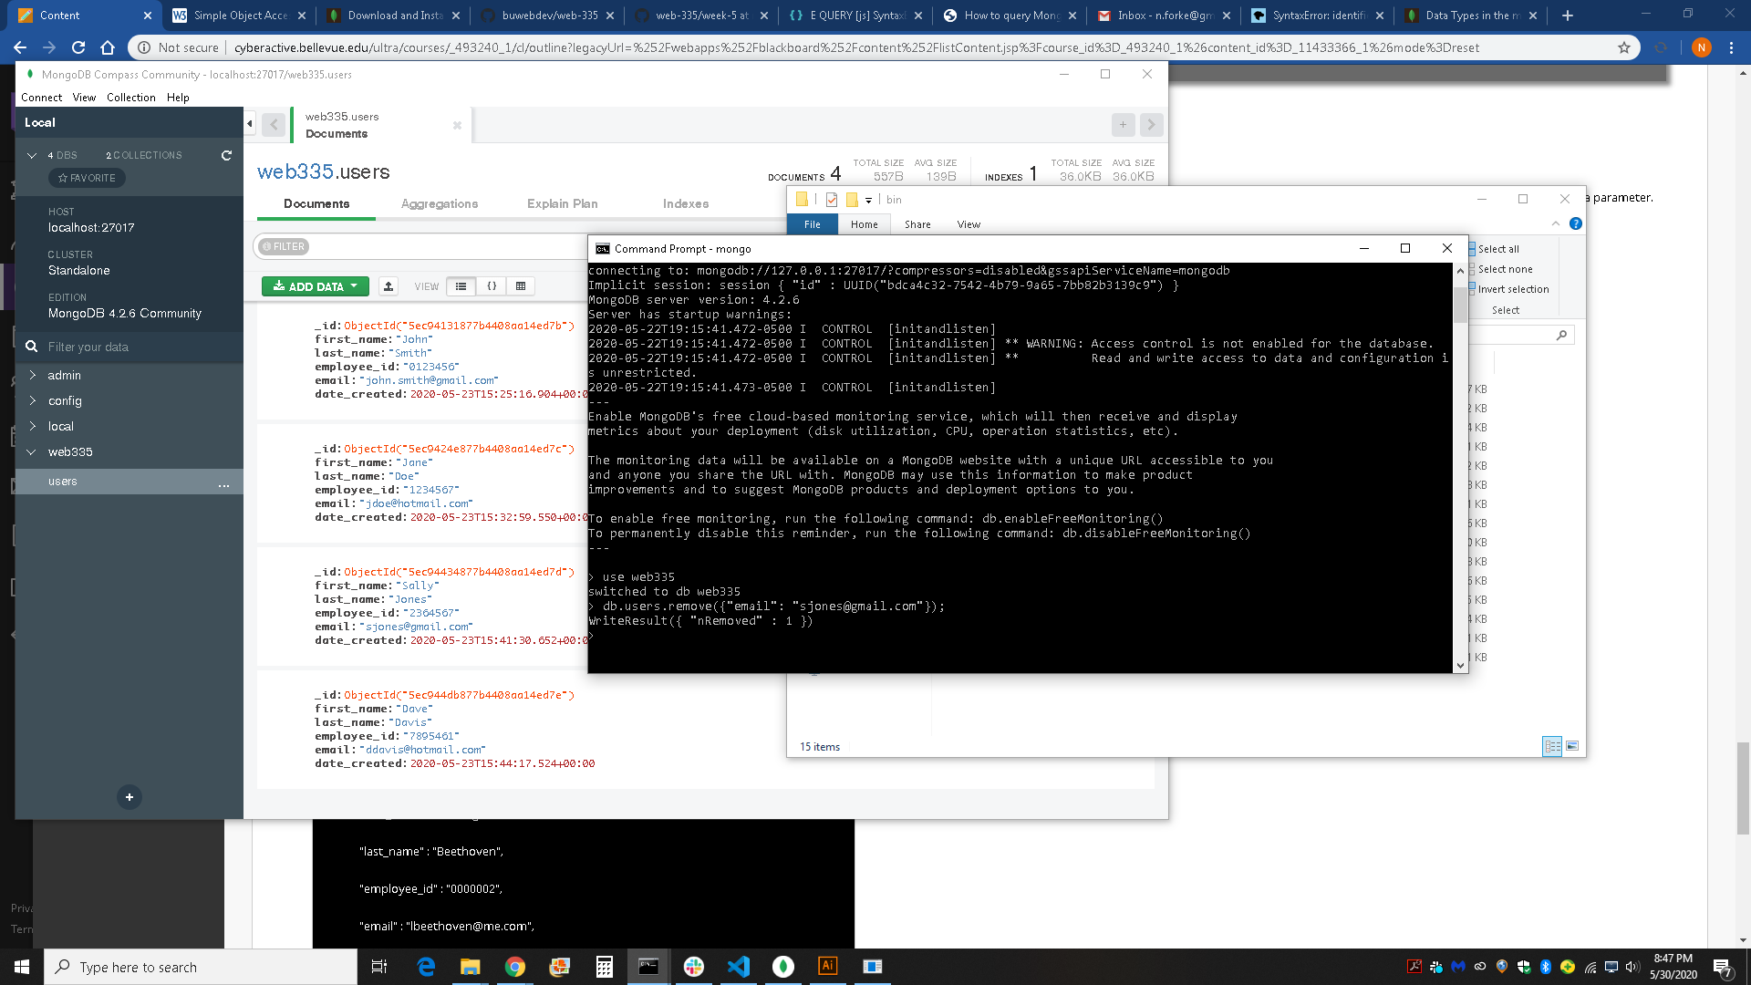

find() Operation to validate remove() operation

