Nicole Forke

20 June 2020

Assignment 8.2-Anaconda

Anaconda Navigator

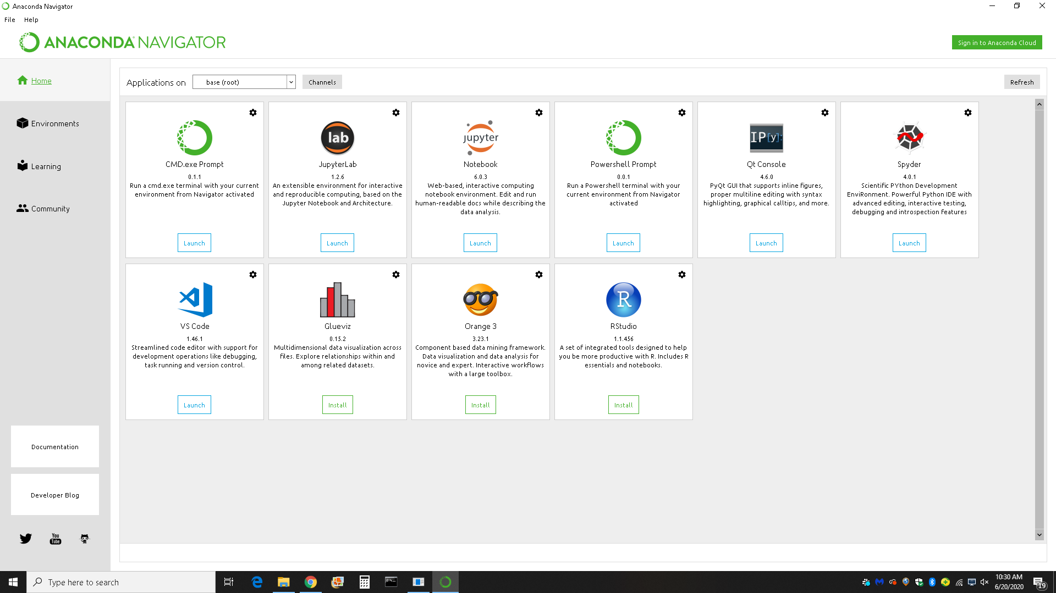

Visual Studio Code - Add Python Extension

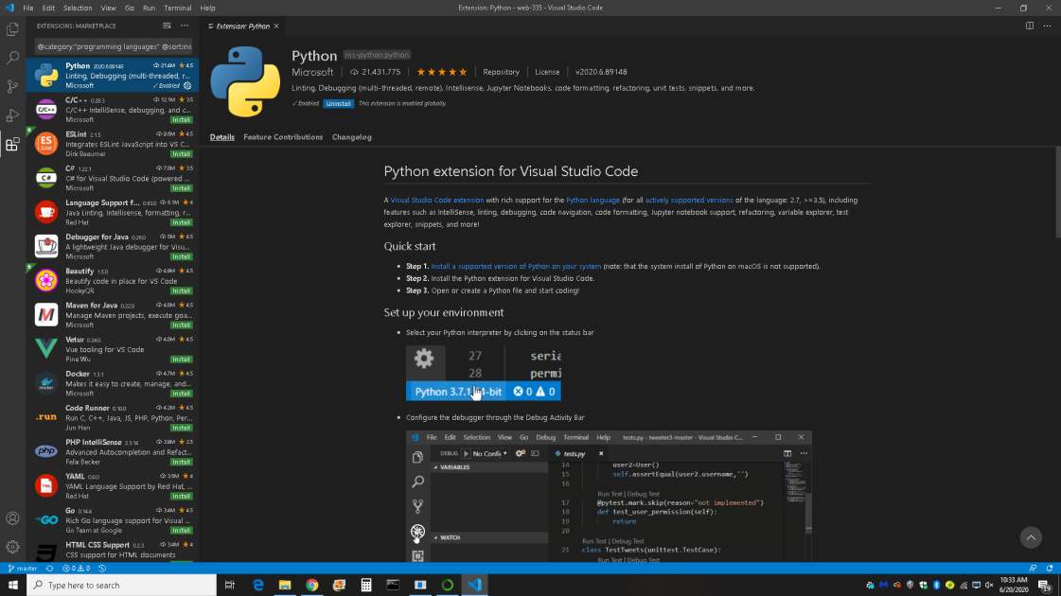

Hello World Code in Terminal

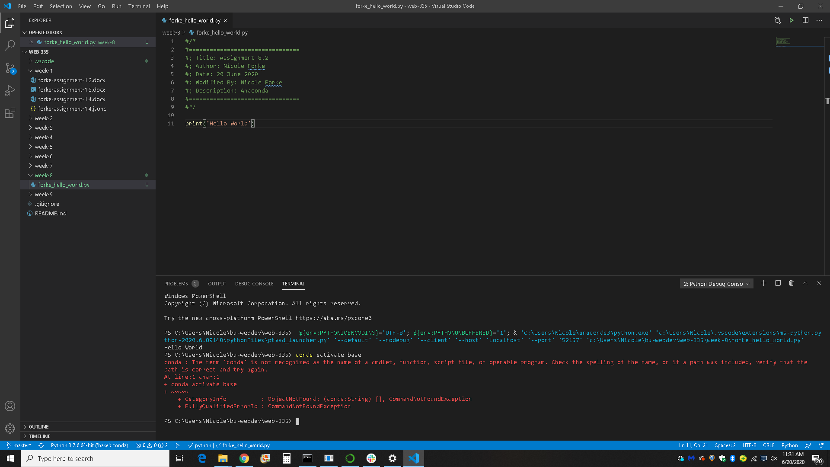

Hello World in Debug Console

