Nicole Forke

09 May 2020

Web 420

Assignment 2.3 - API Gateway Part II

Solutions Directory

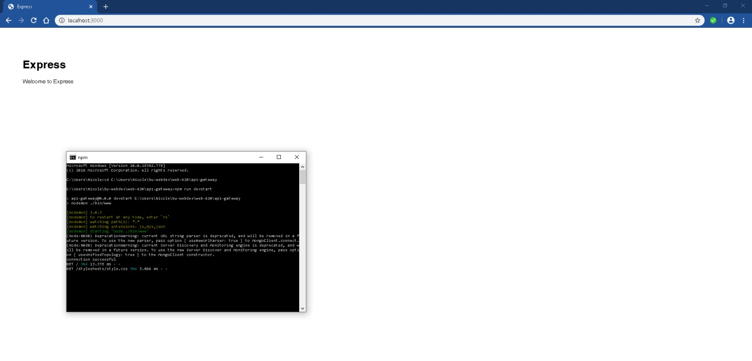

GET Request

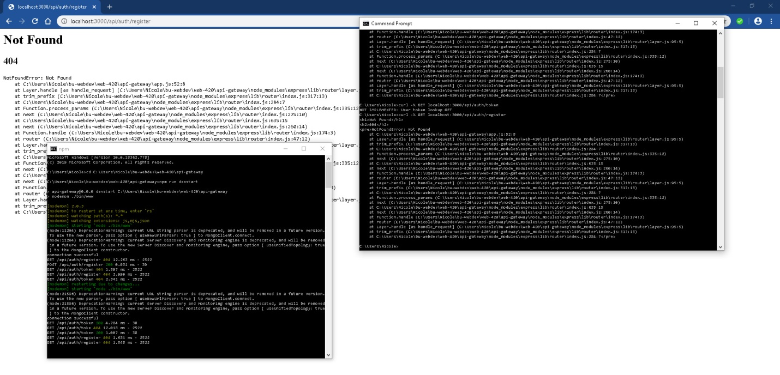

POST Request

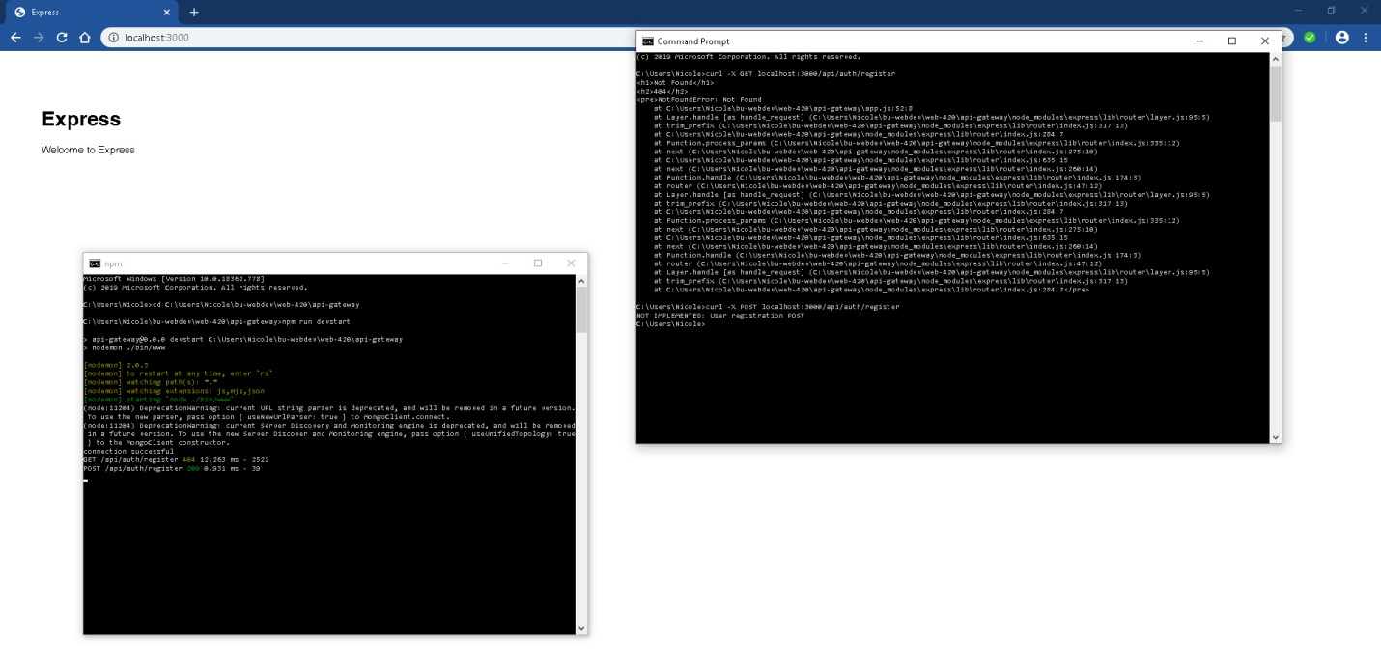

GET Request

