Nicole Forke

15 May 2020

Assignment 3.2 - SOAPUI

Web 420

Java Install

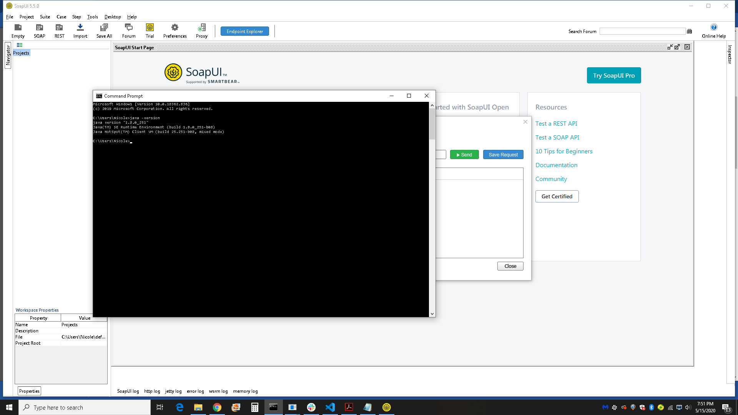

SOAPUI

