Nicole Forke

Assignment 3.4 - SOAP Unit Test

16 May 2020

Web 420

Request

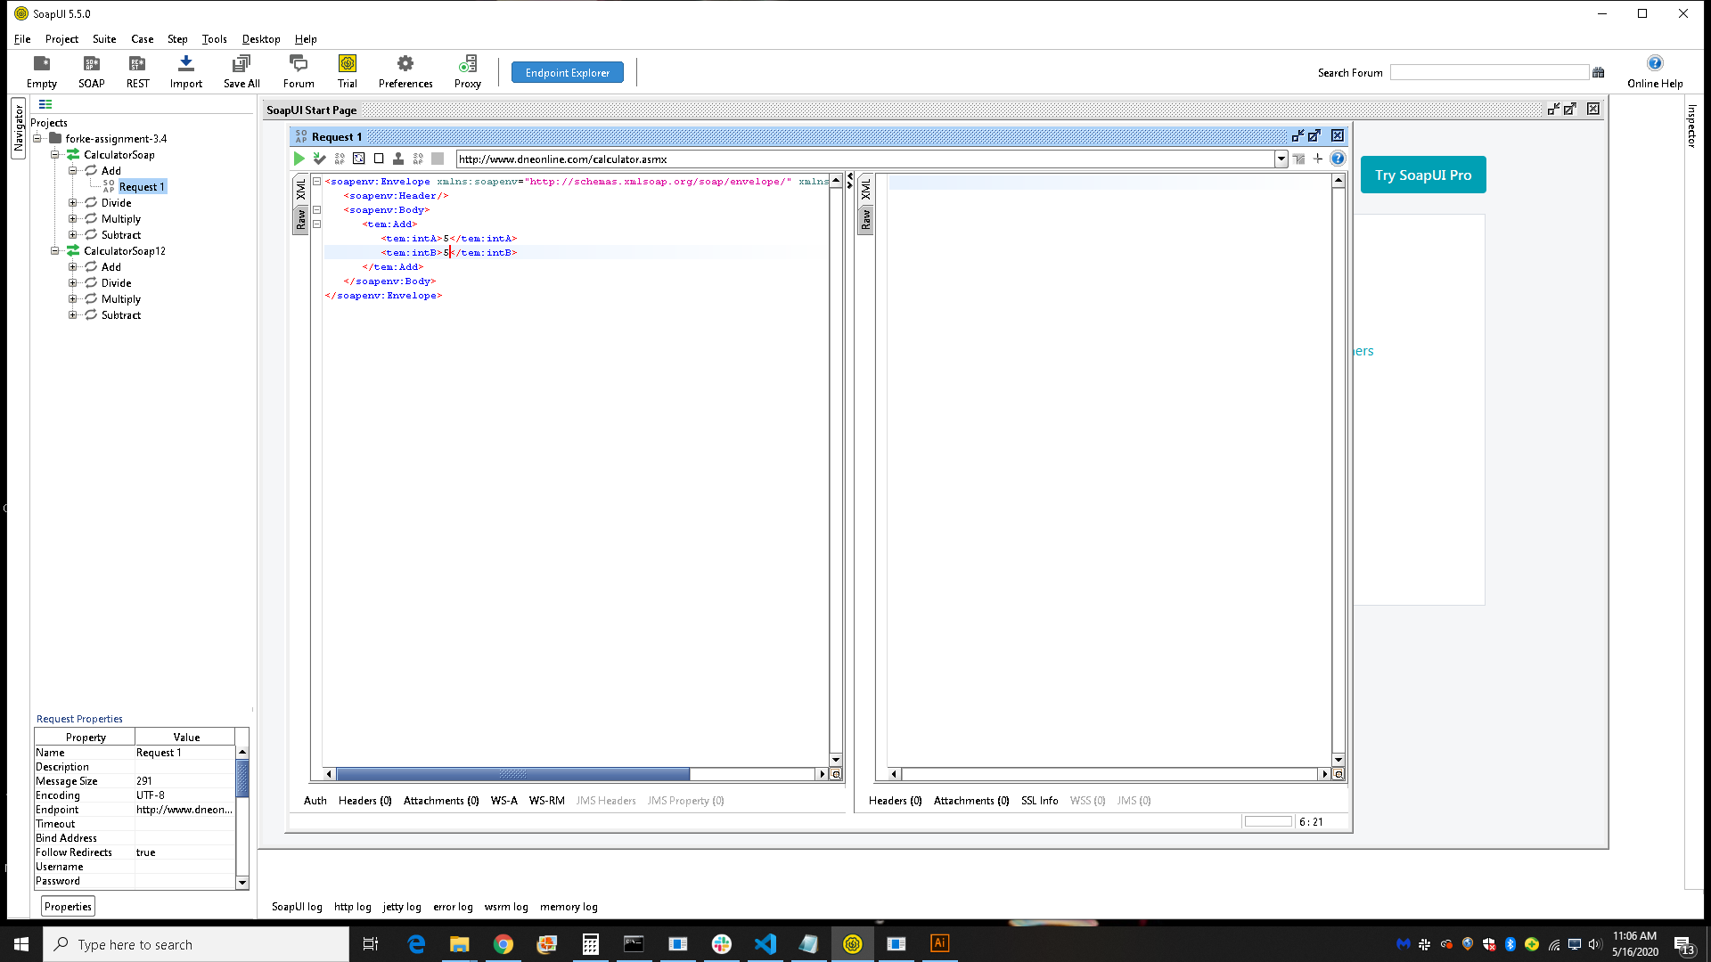

Response

