Nicole Forke

23 May 2020

Assignment 4.3 - API Gateway Part III

Web 420

Solution Directories

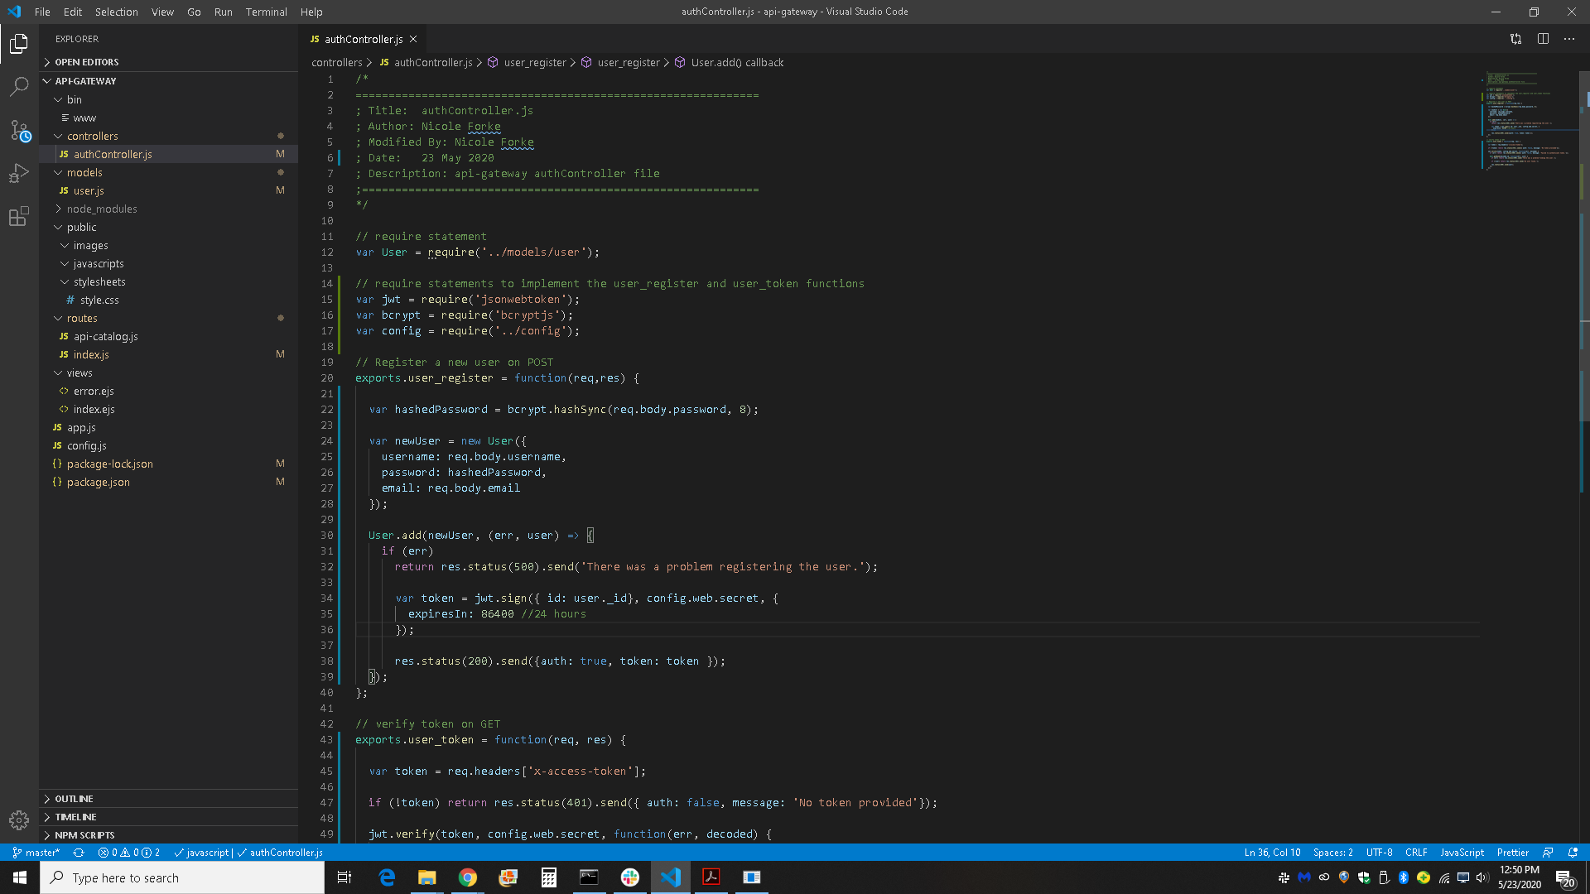

CLI Window

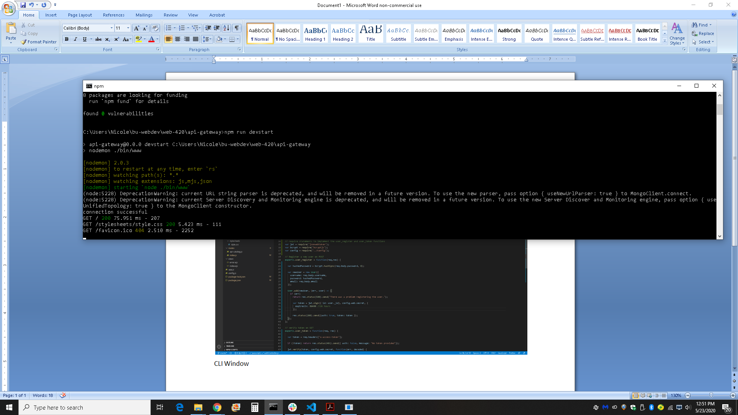

Solution in Web Browser

