Nicole Forke

23 May 2020

Assignment 4.4 - API Gateway Unit Test 01

Web 420

Response in SoapUI

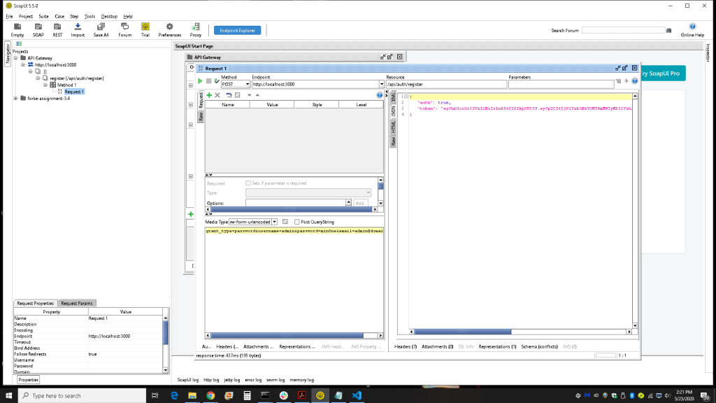

Terminal Window Output

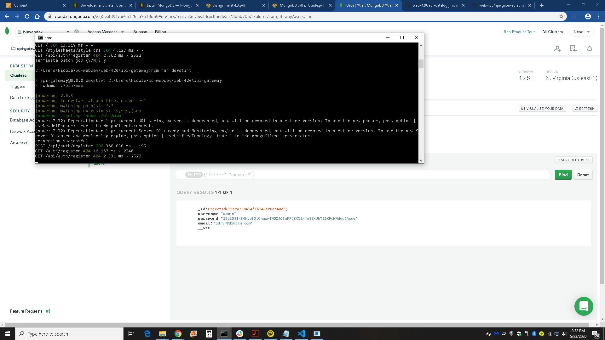

mLab API Gateway Database Added Entry

